**Data Bricks Project Work**

1. **Architecture**

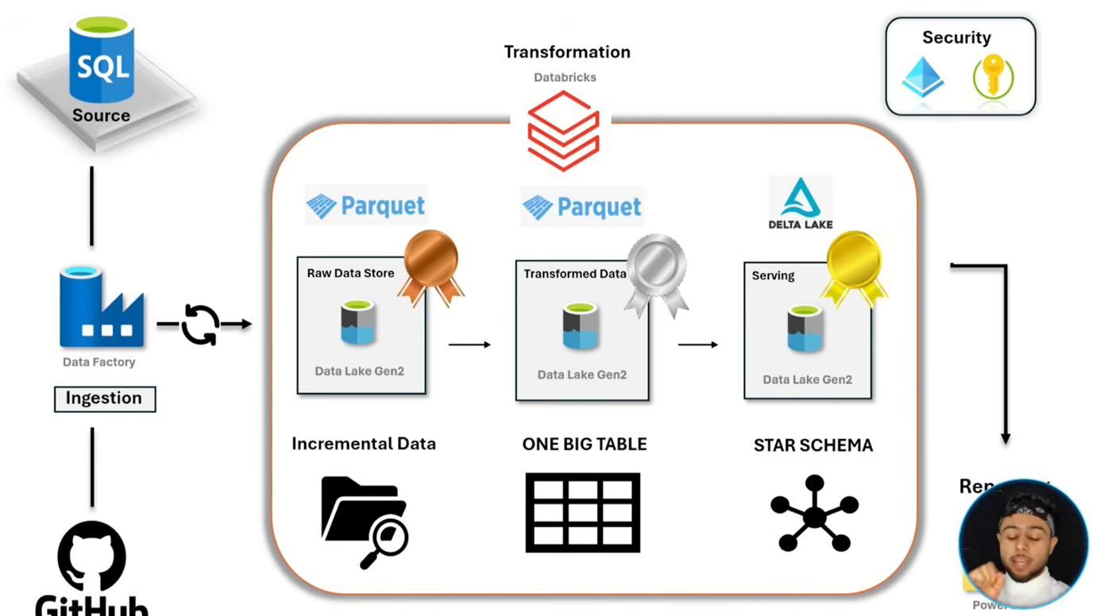



1. Data Source – Azure SQL Data Source
2. Git hub Repository -Pull the data from Github Repository to Azure SQL Data Source
3. ETL Tools -Azure Data Factory 🡪 After Azure SQL data source to connect pipeline to Azure data factory. It is advance Pipeline
4. Bronze layer🡪 Data Factory to add data in bronze layer with increment load data only. That is why is advance data pipeline create CDC(Change data capture) ,lookup files and store procedure
5. Parquet 🡪it is file format
6. After land bronze layer then use Databricks. The databricks transform the data in silver layer and add data in Delta Lake format or gold layer
7. Unity Catalog 🡪 it is unity is the unified Solution govern of the data to apply data quality check and more. **It is hint**

Project Overview:

1. This is fact table data. which is present in Bozen layer

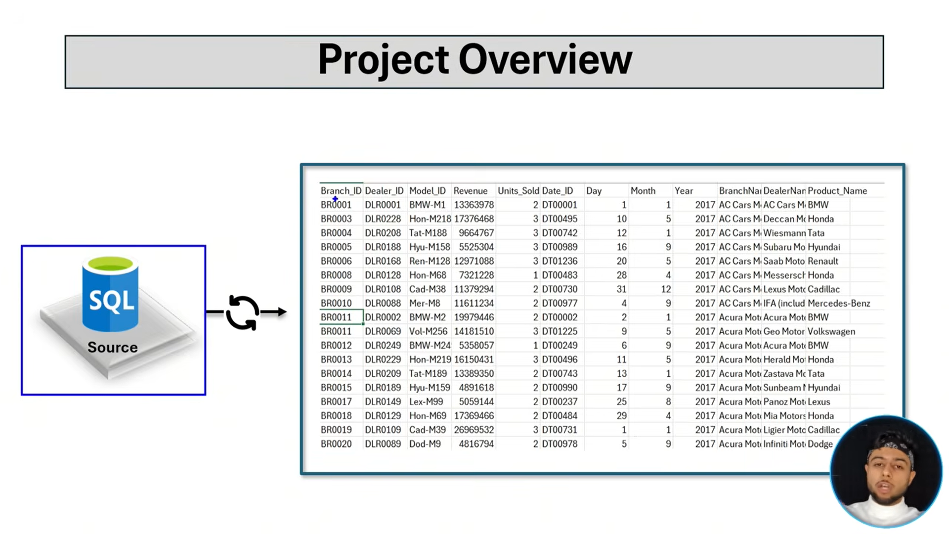

1. Silver layer –fact table into fact and dimension table and final connect each dimension table in one fact table

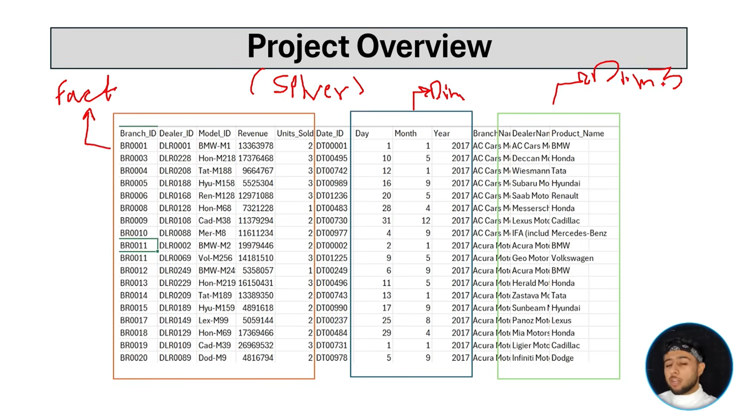

1. Data will load in Incremental load. Because past data cannot load again and again

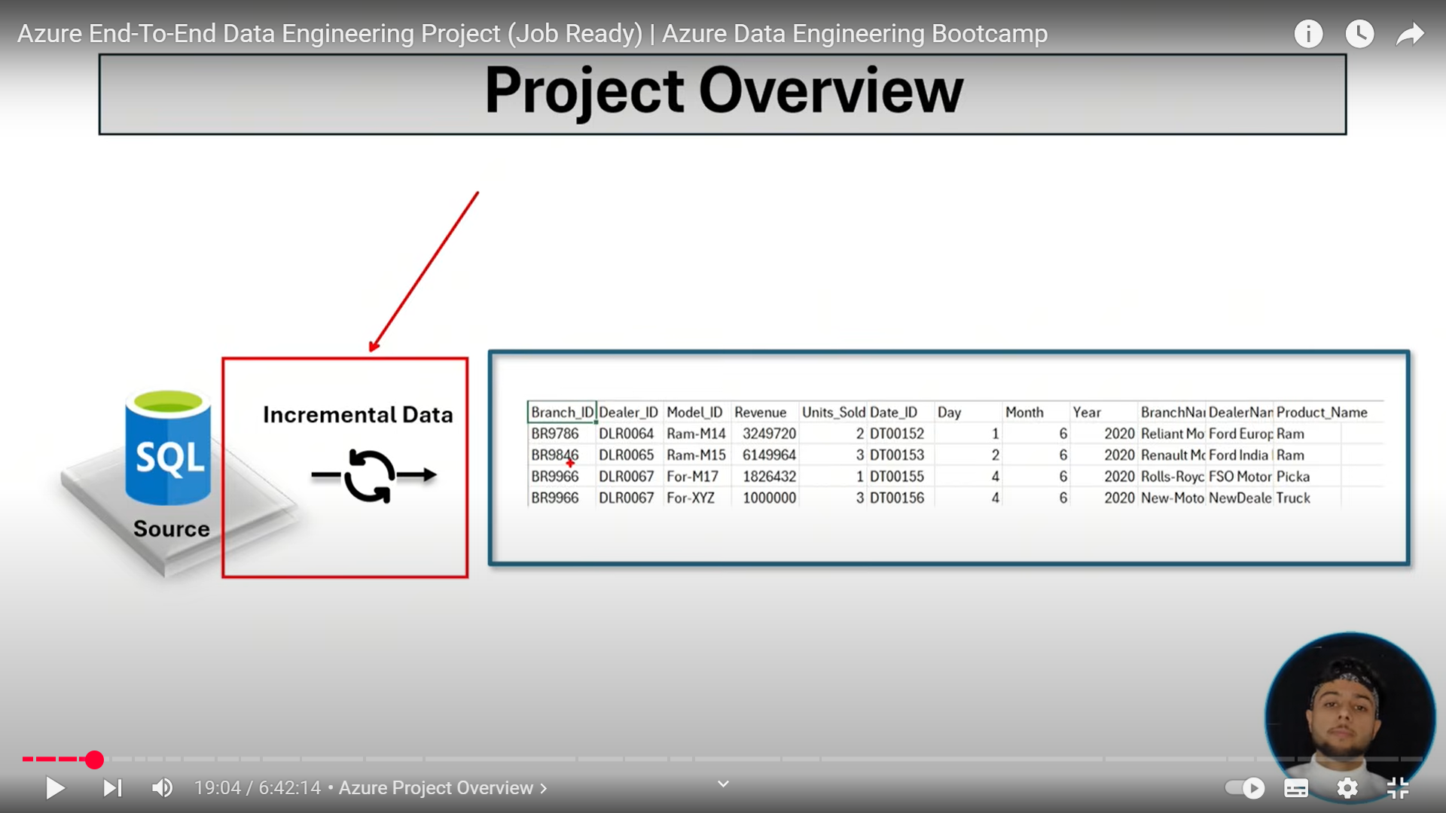

**Prerequisite:**

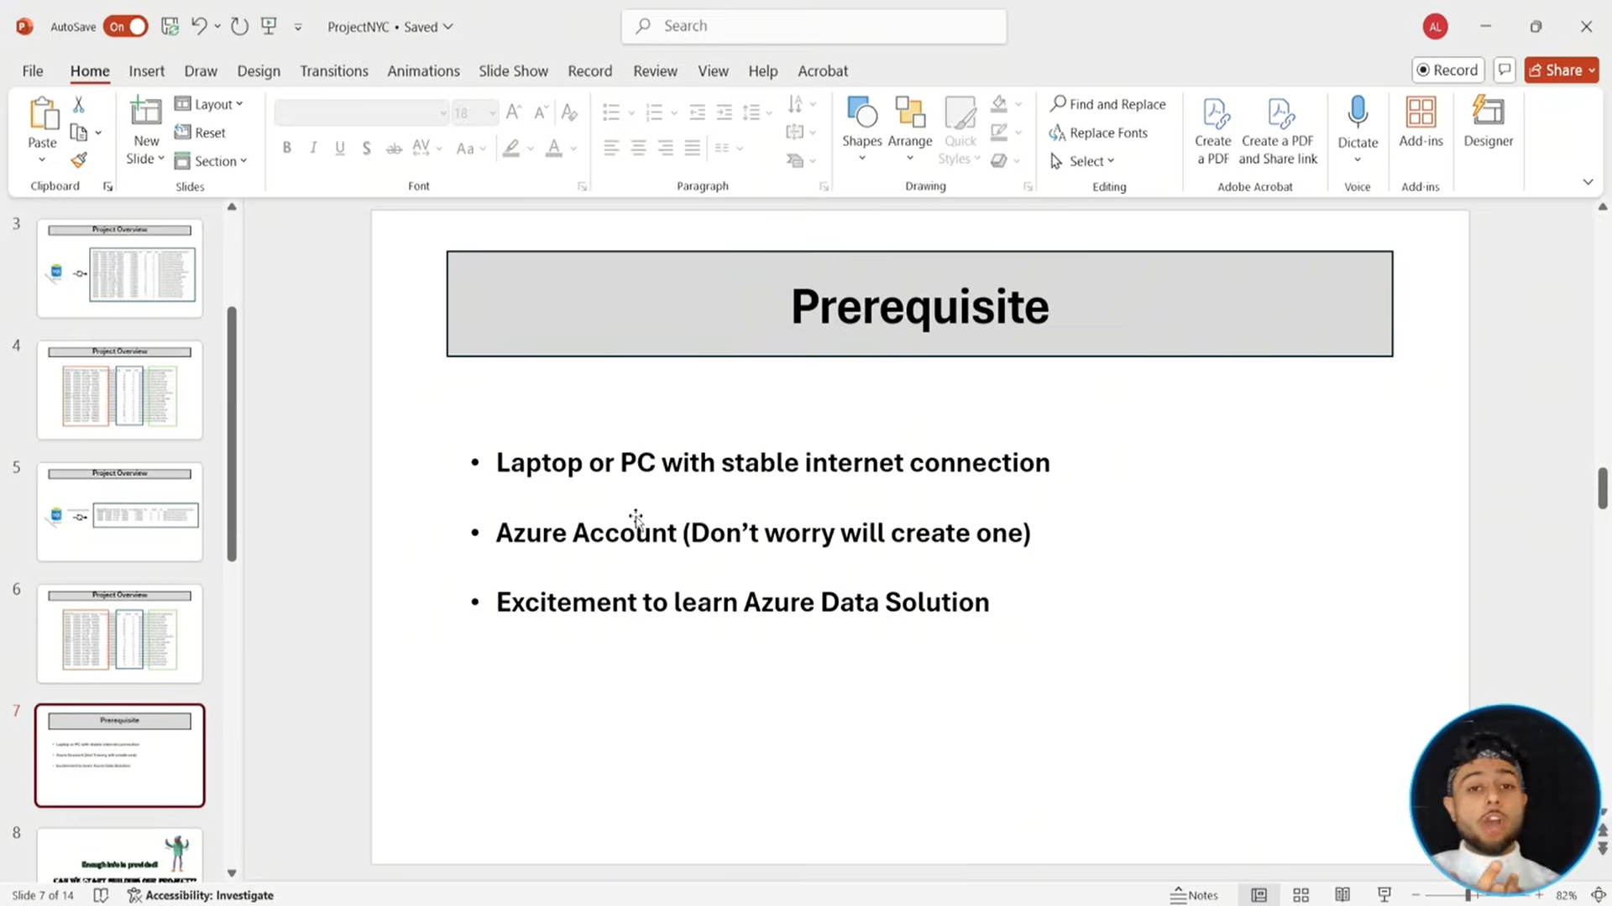

Sample Dataset Website-

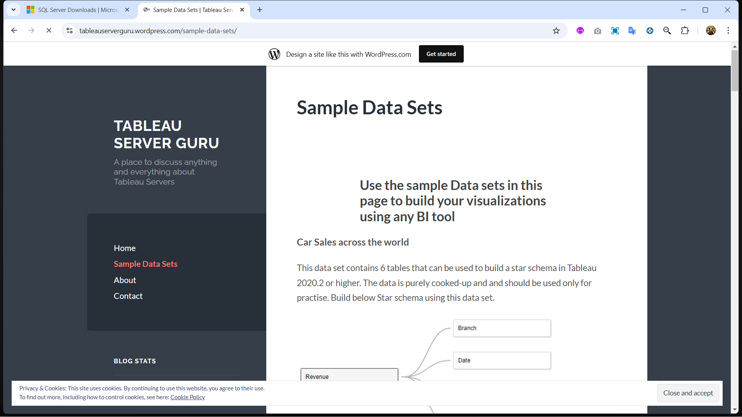

--Github Dataset

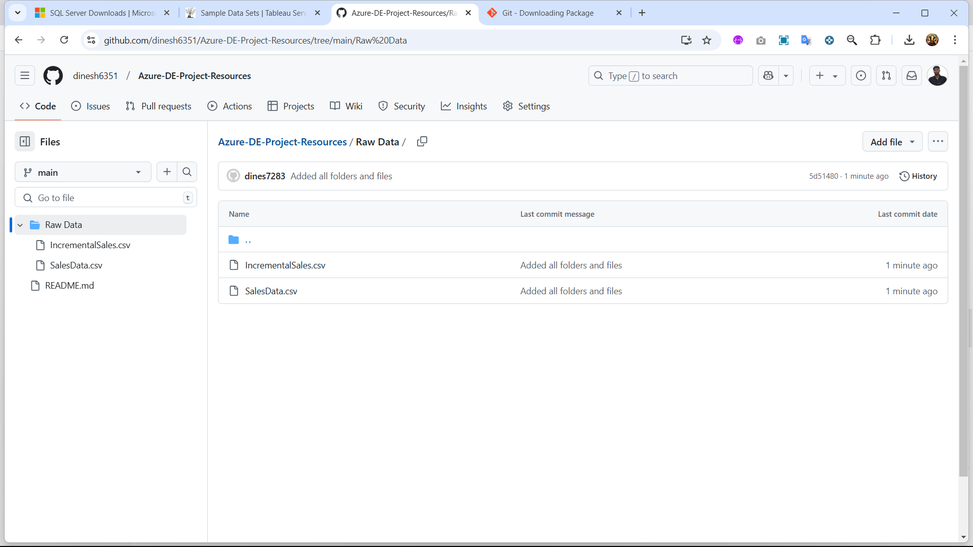

* Sales Data have present all Transactions records
* Sample

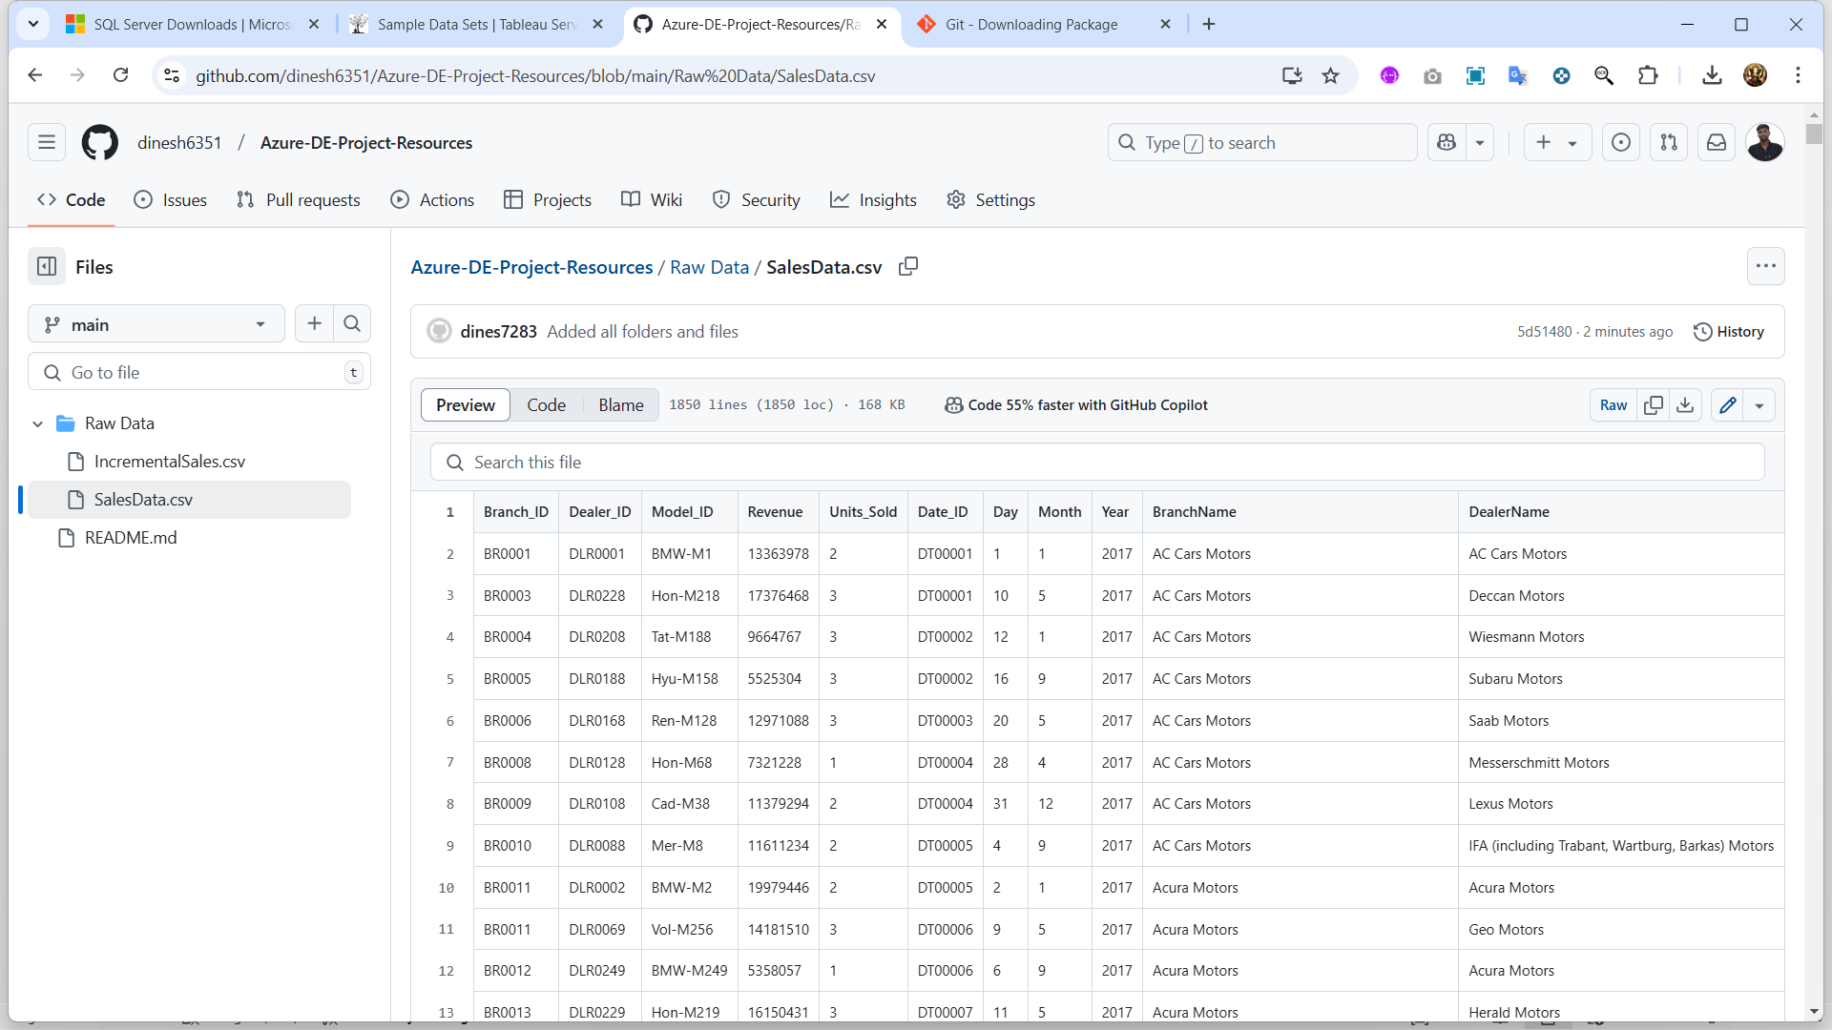

Azure part

--Resource group – store all the information like data lake, catelog , unitity and more

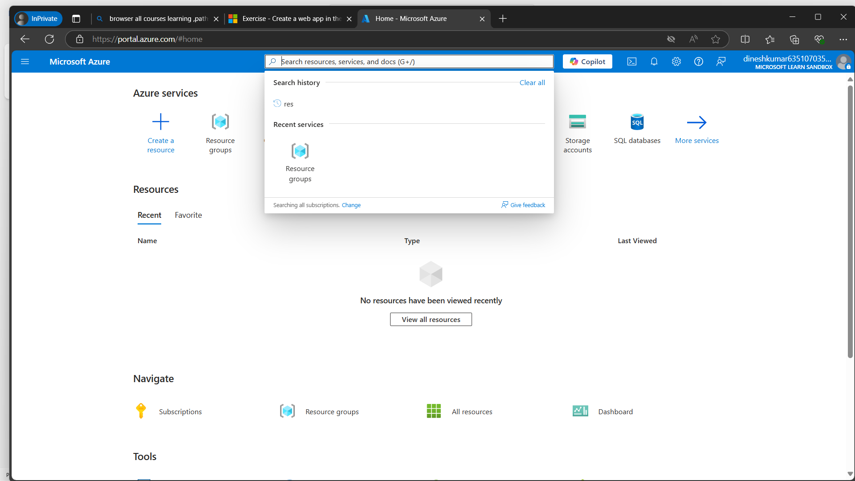

Create resource group:

Home🡪 search resource group

By create resource group

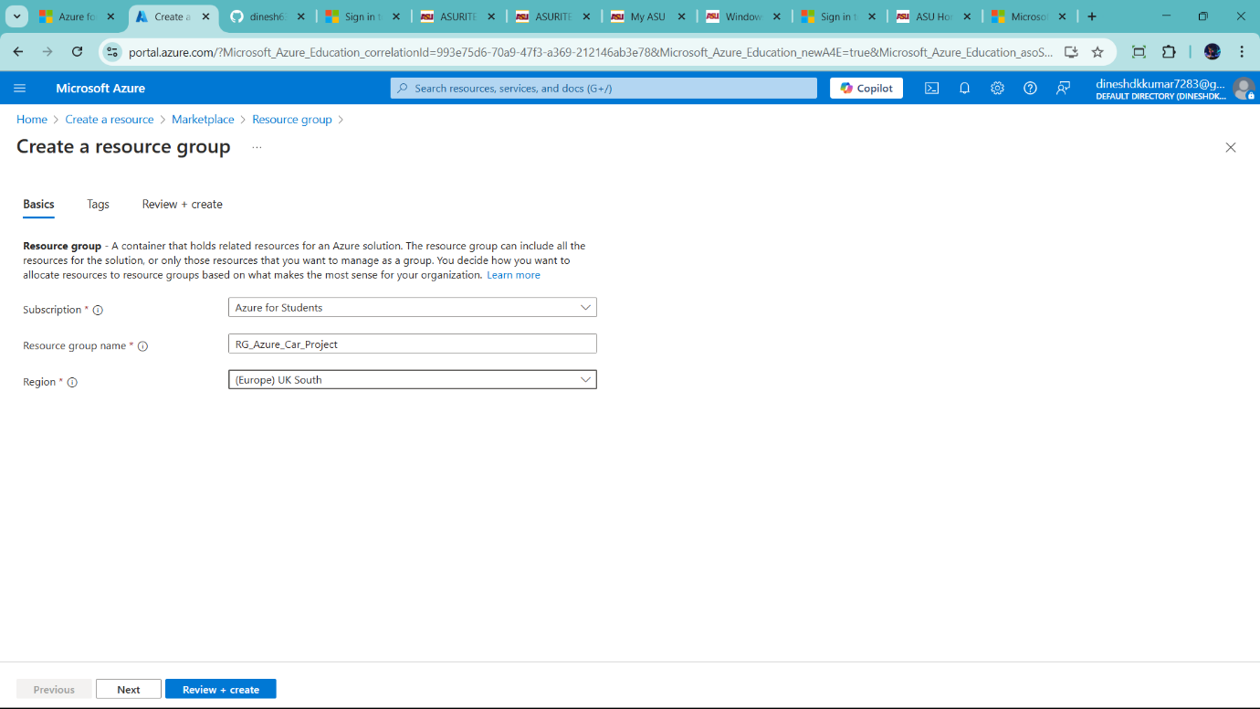

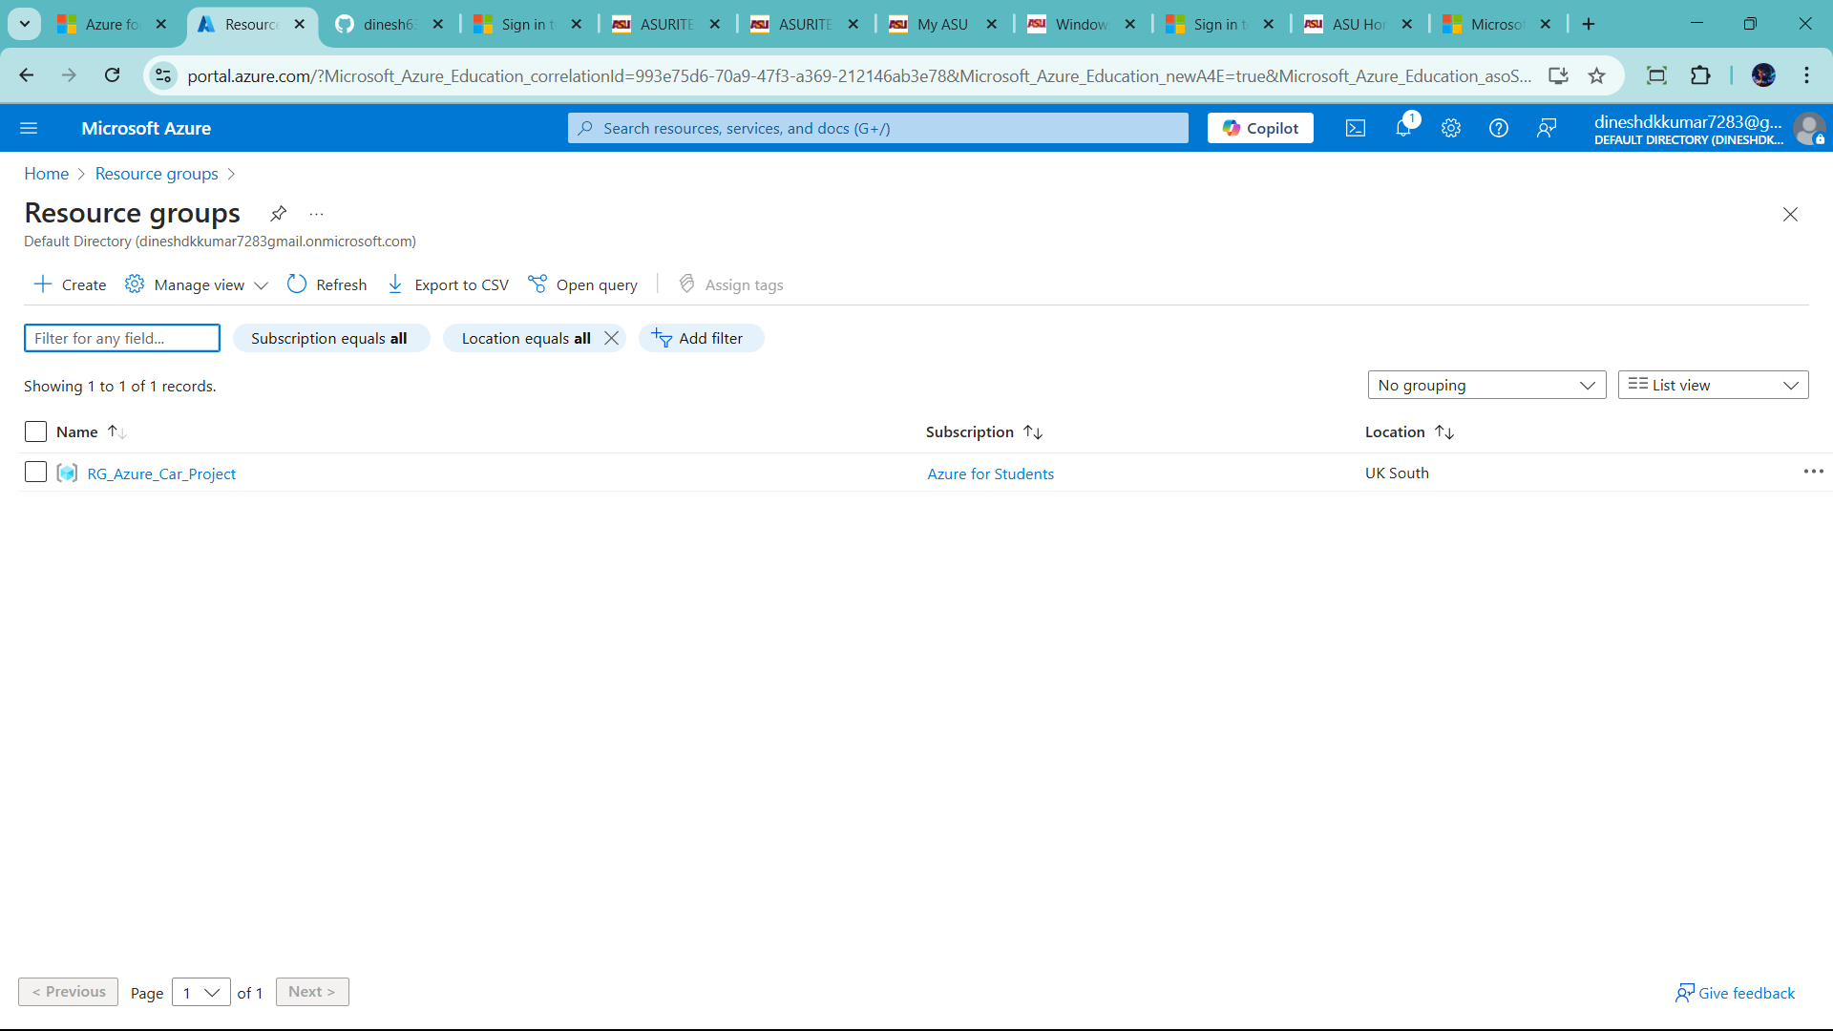

1. Create Data Lake
2. Not source 🡪 because souce going to sql database
3. After create Data Lake 🡪 to create two resource data factory and sql Databases

--Let Start

1) click create 🡪 search storage account

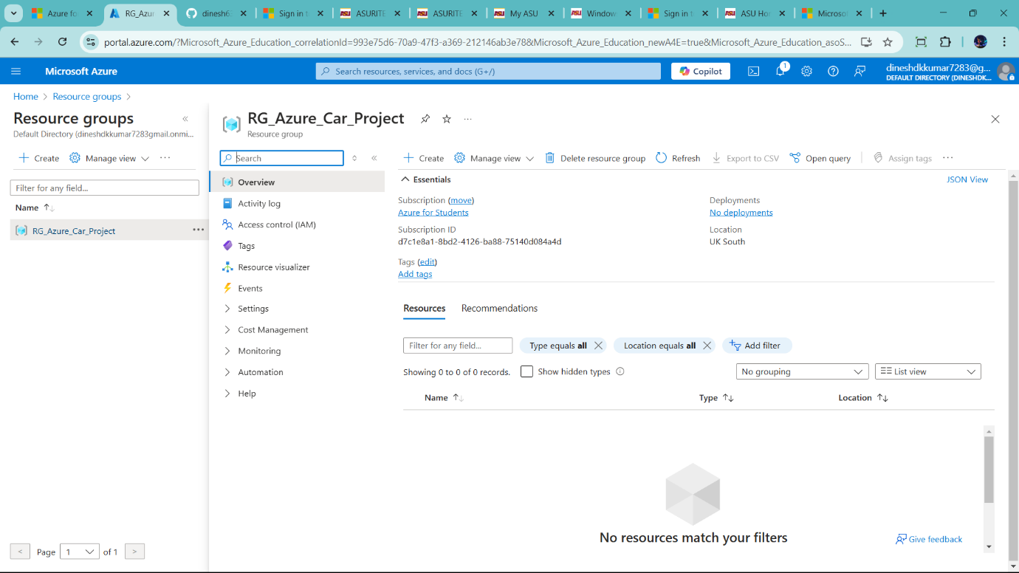

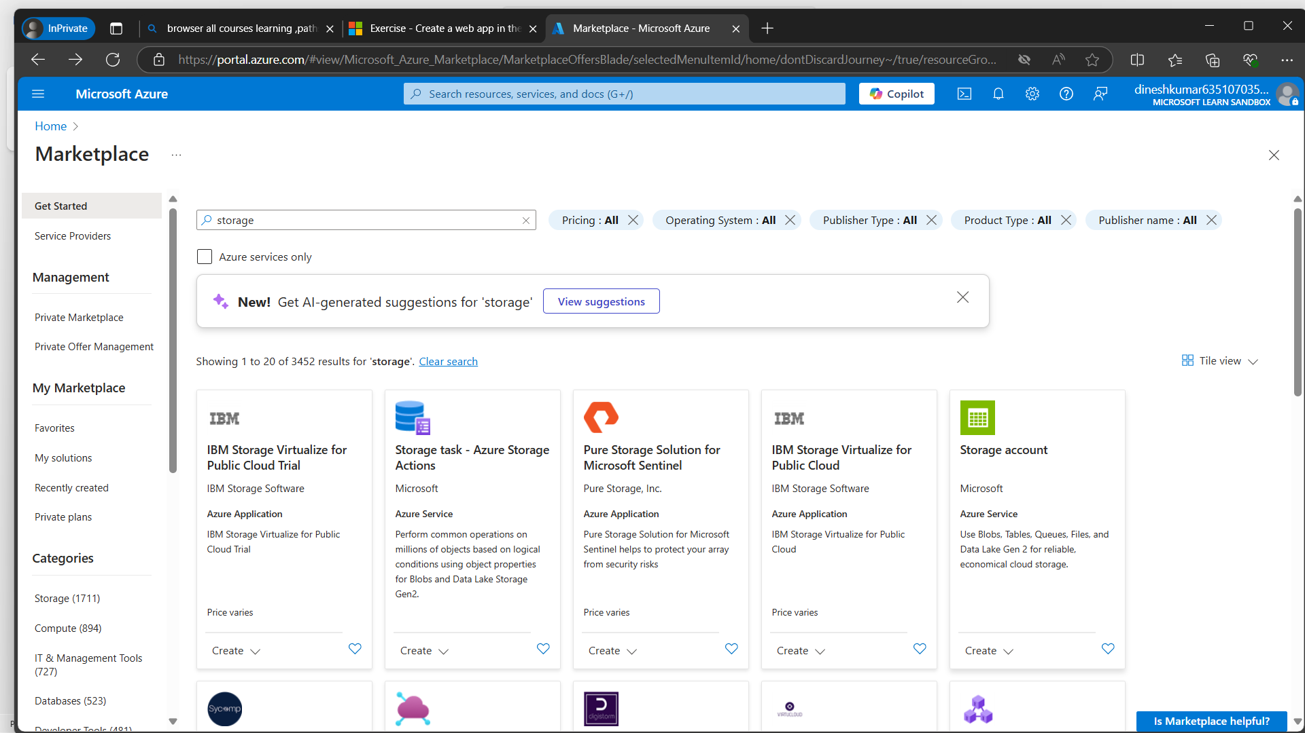

Create storage account and convert into data lake

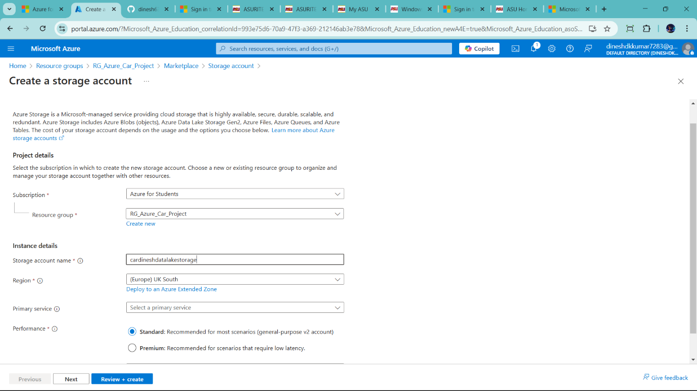

I use LRS for reduce cost. Because data store in same data centre



Click next

And **!important** click Enable hierarchincal namespace 🡪 it means create data lake instance of block storage

--cold check point enable 🡪 it is cost very very low it store one month only

🡪HOT- acces the data every day

🡪Cool 🡪 once a month

🡪Cold 🡪6 month once

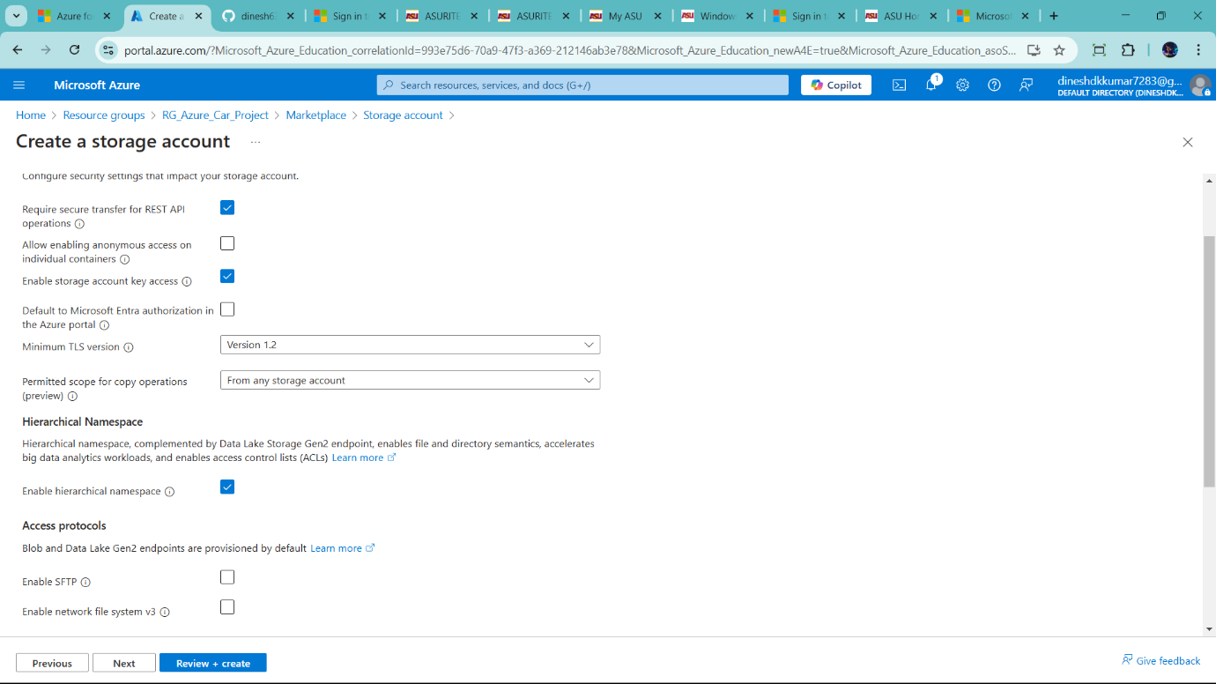

We use HOT – now for learning

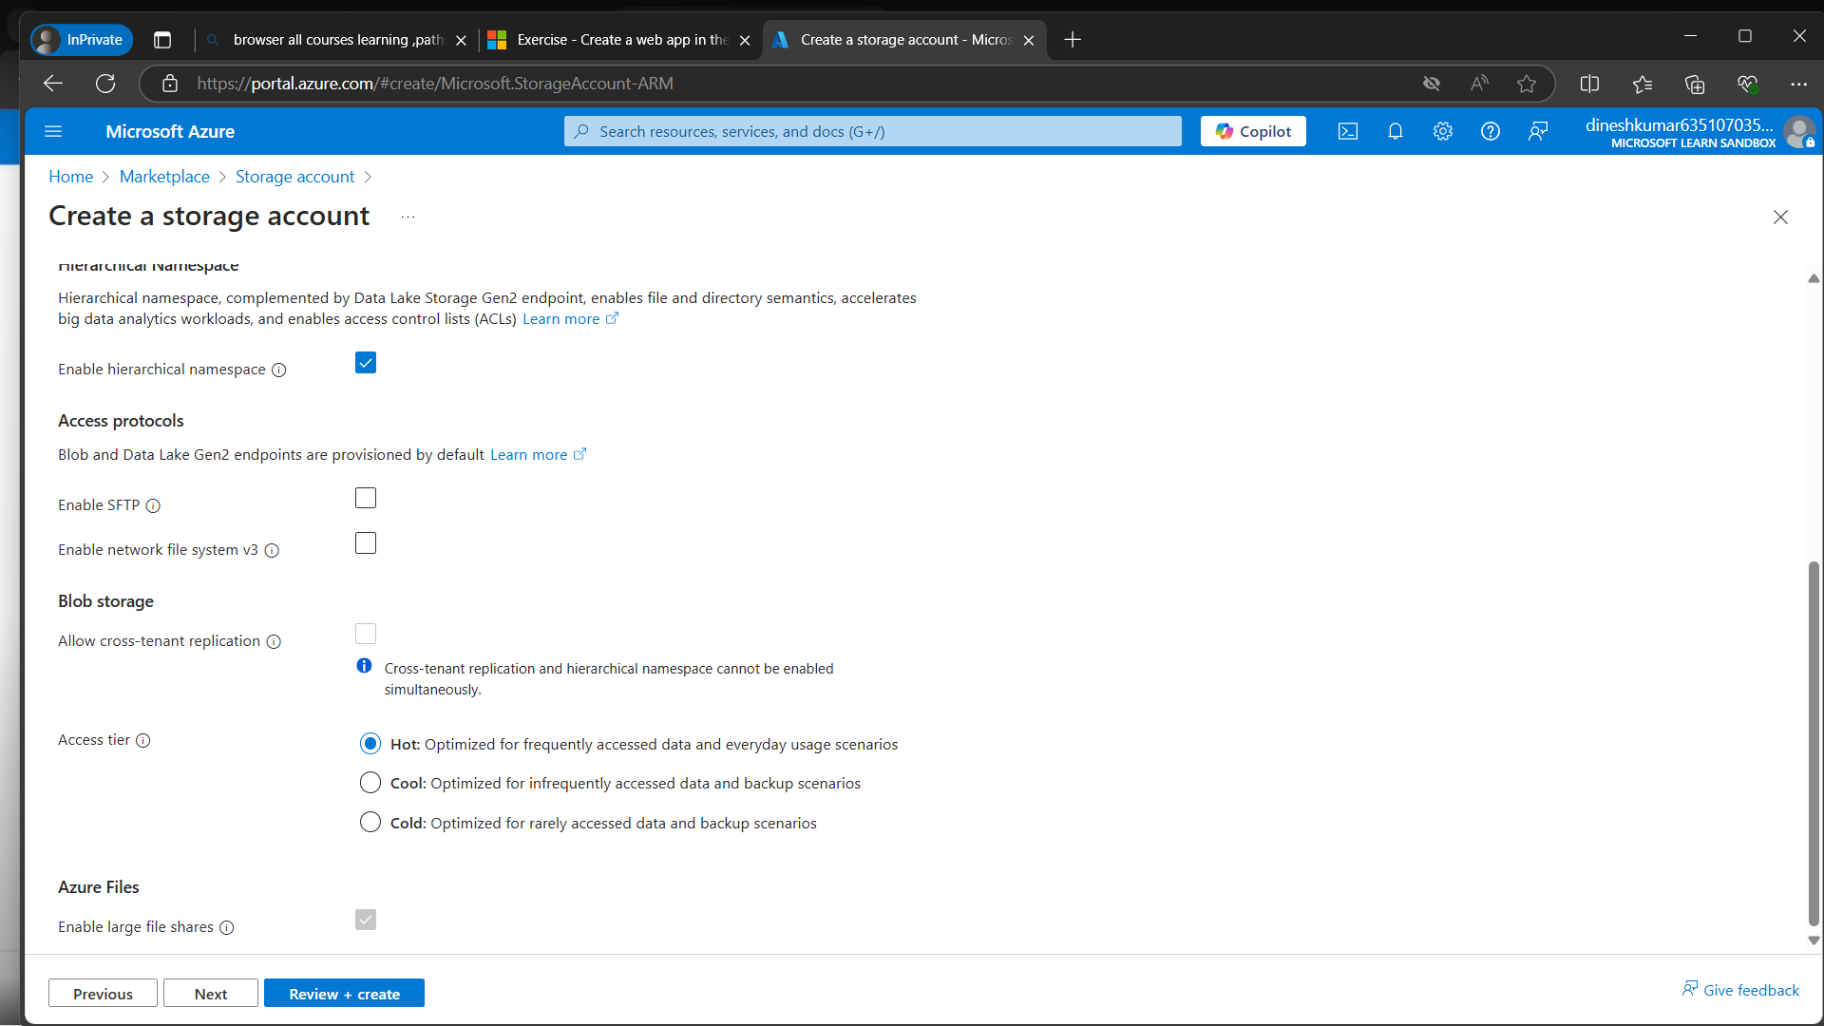

Finally review + create

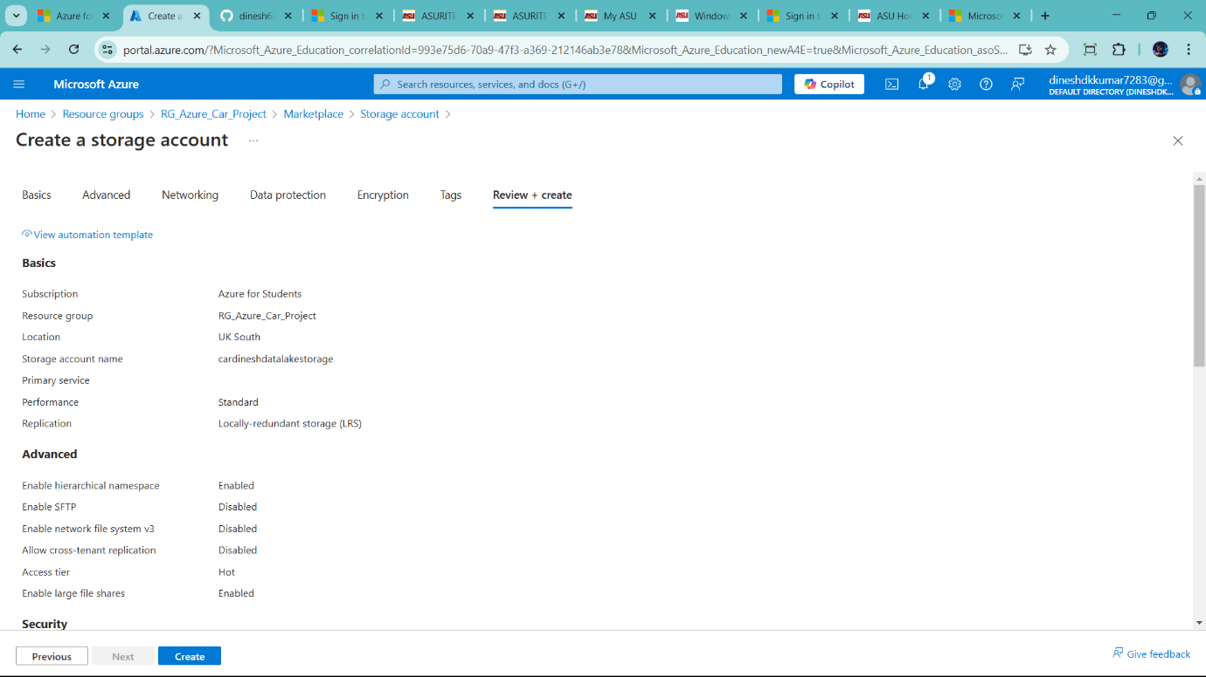

Finally click create –it is data lake

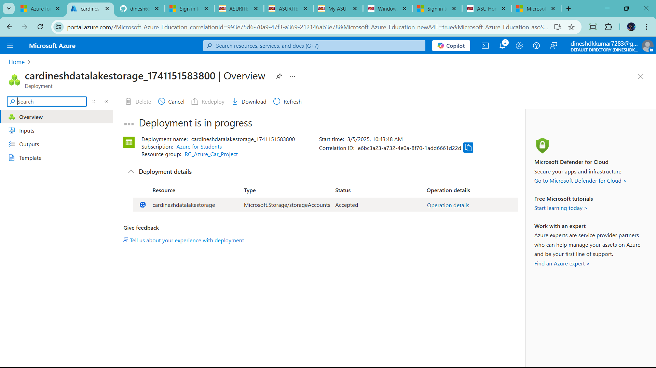

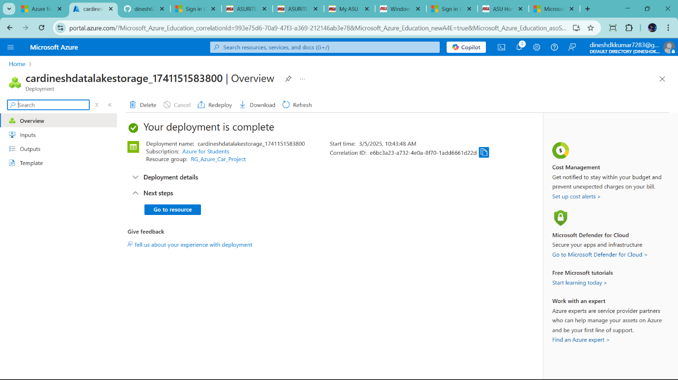

Successfully create data lake

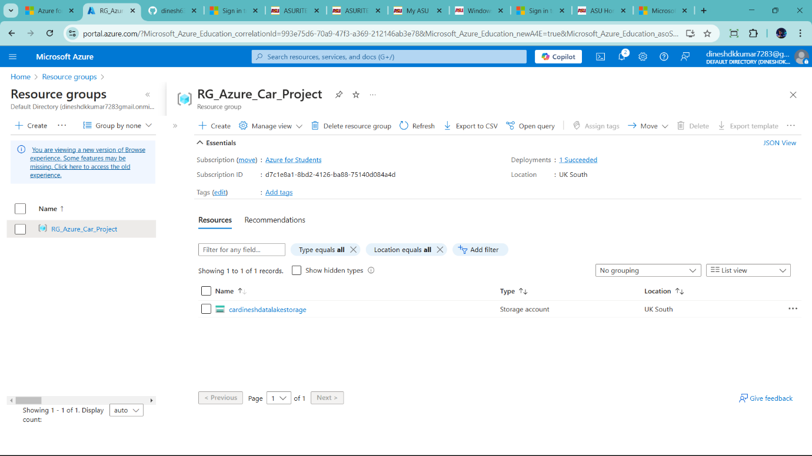

Now create Data factory

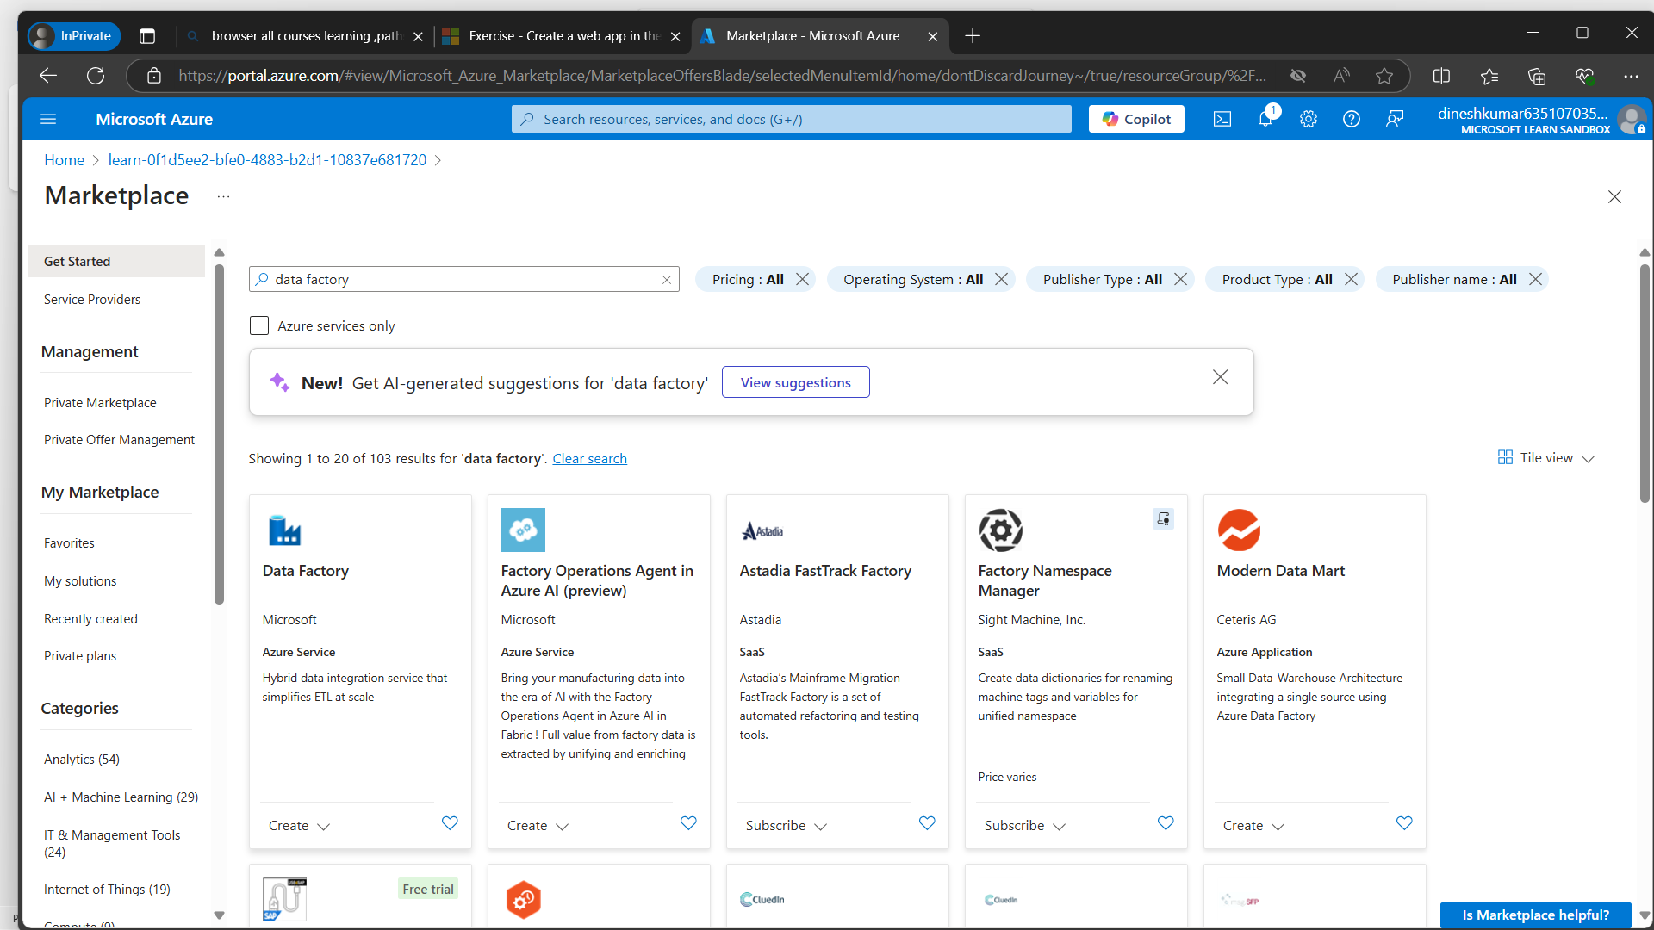

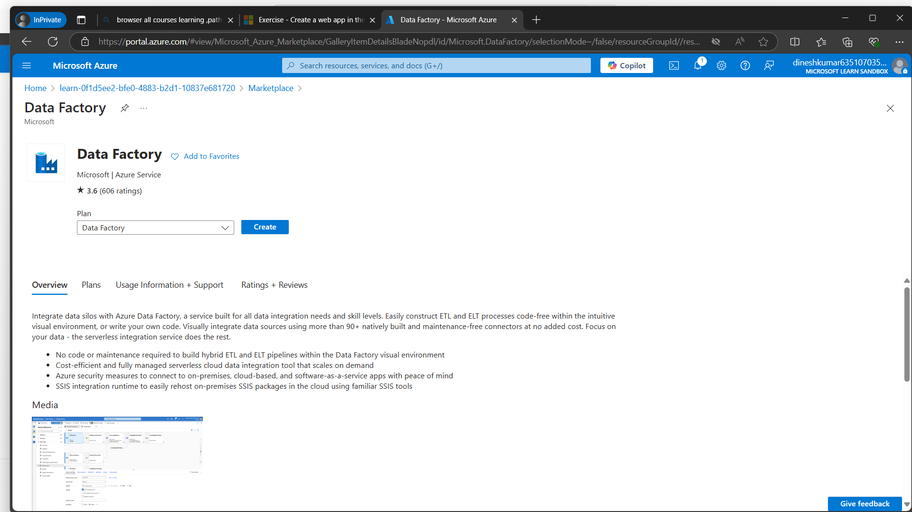

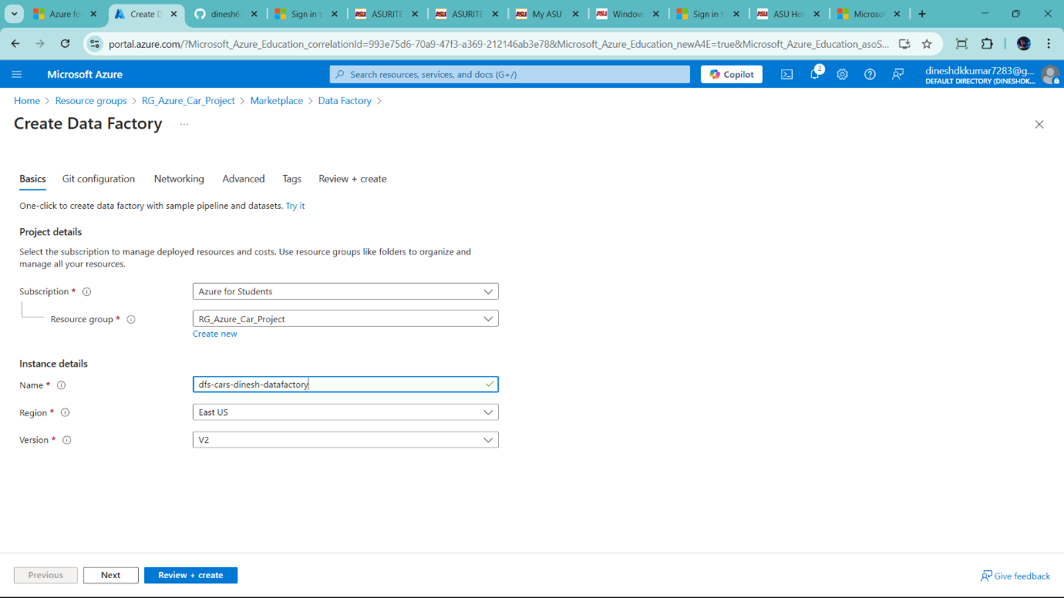

Click review + create

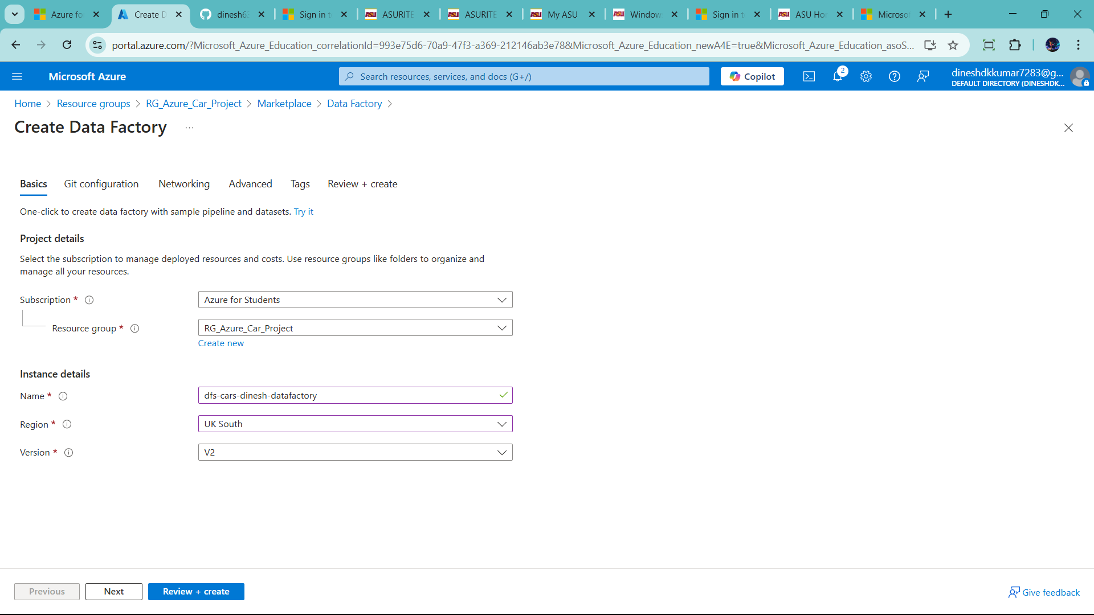

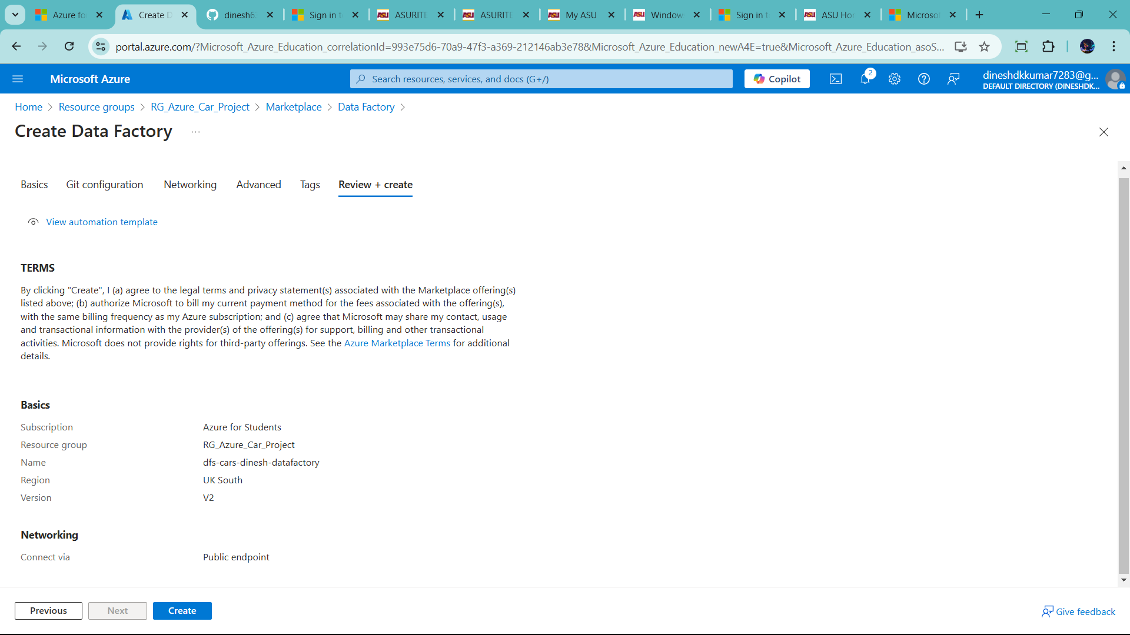

Finally click create to success full generate data factory

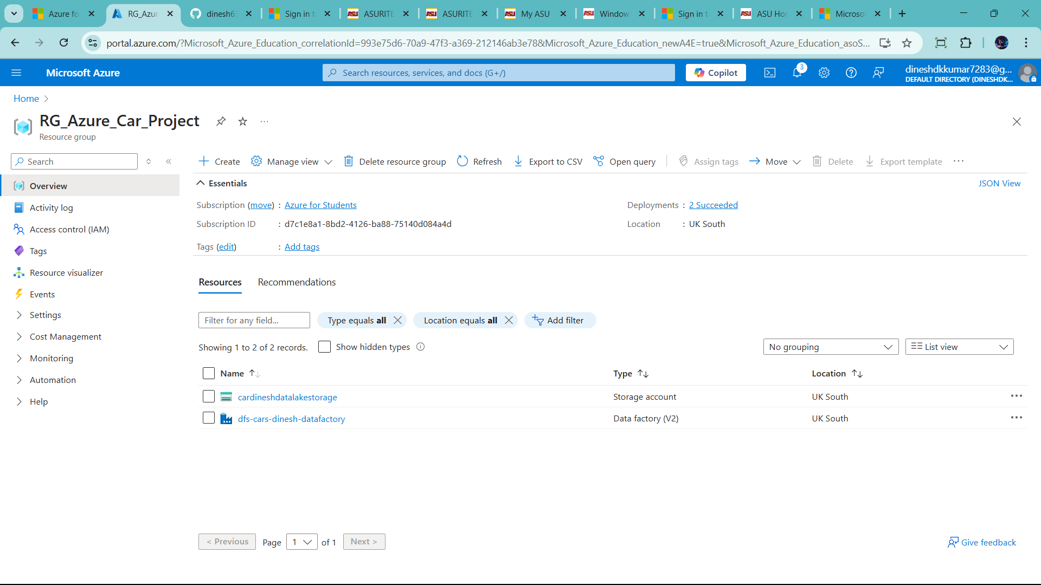

Now we Create third Resource Azure SQL DB

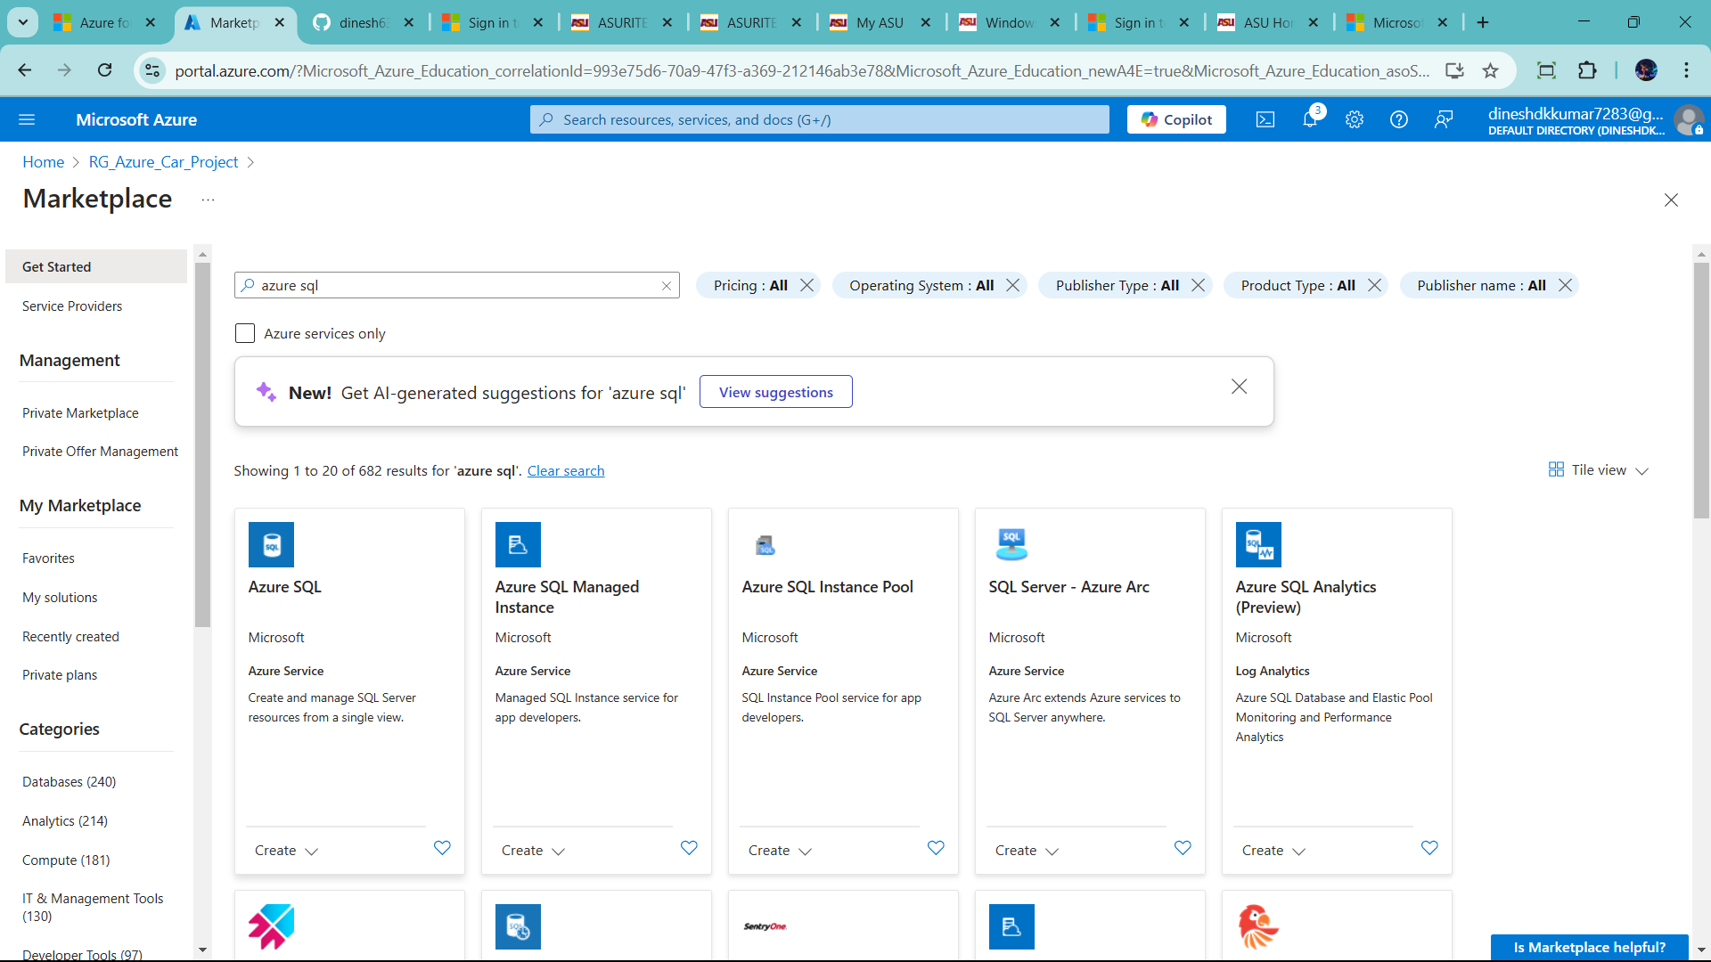

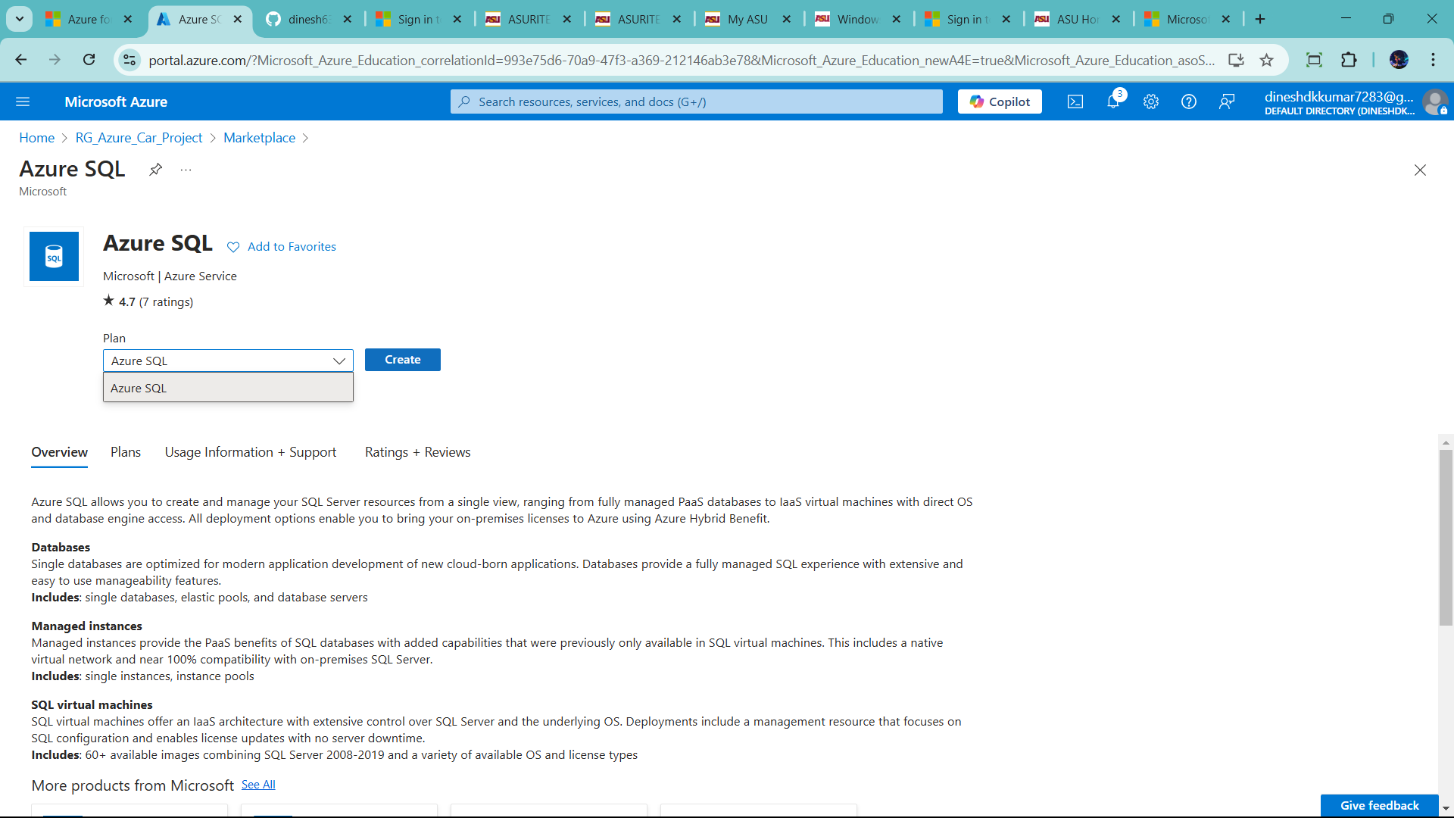

Click create

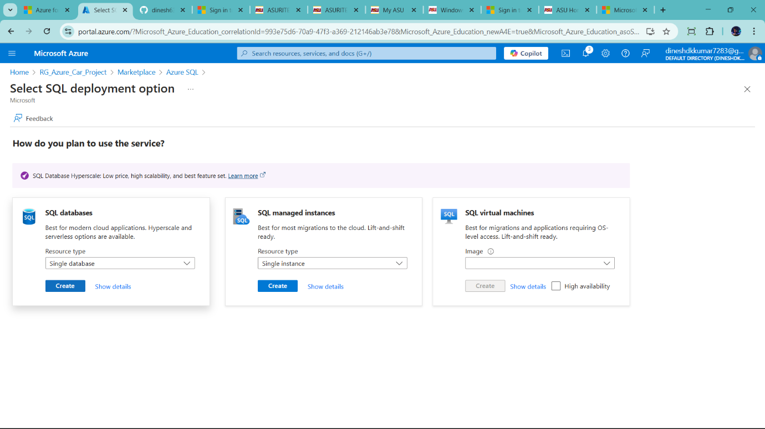

Click sql datbases for storage purpose only.

Click create

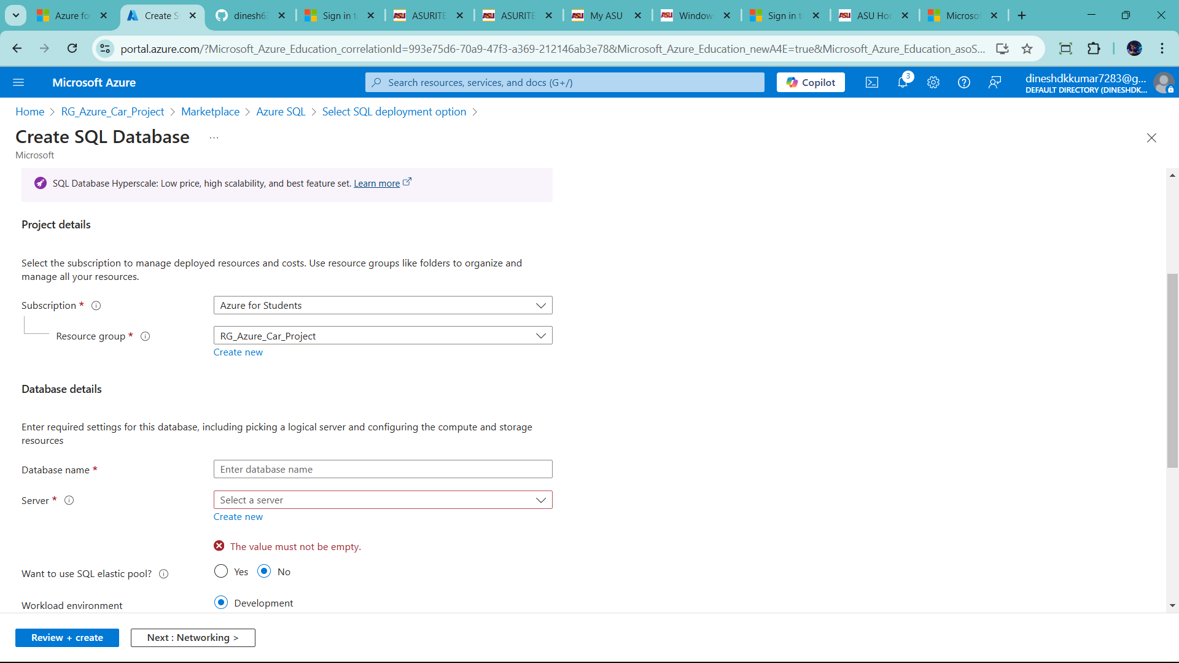

Fill database name and server

We donot have server. So create server So click new

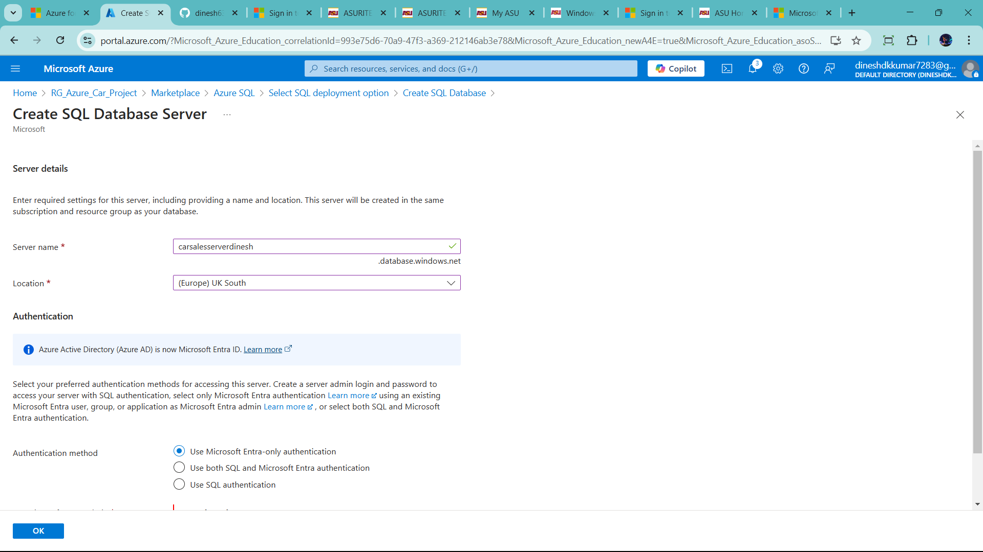

* Use both sql and Microsoft entra autenication in authentication method
* Set admin name and password
* Name🡪 admindinesh password 🡪DIN123@kum

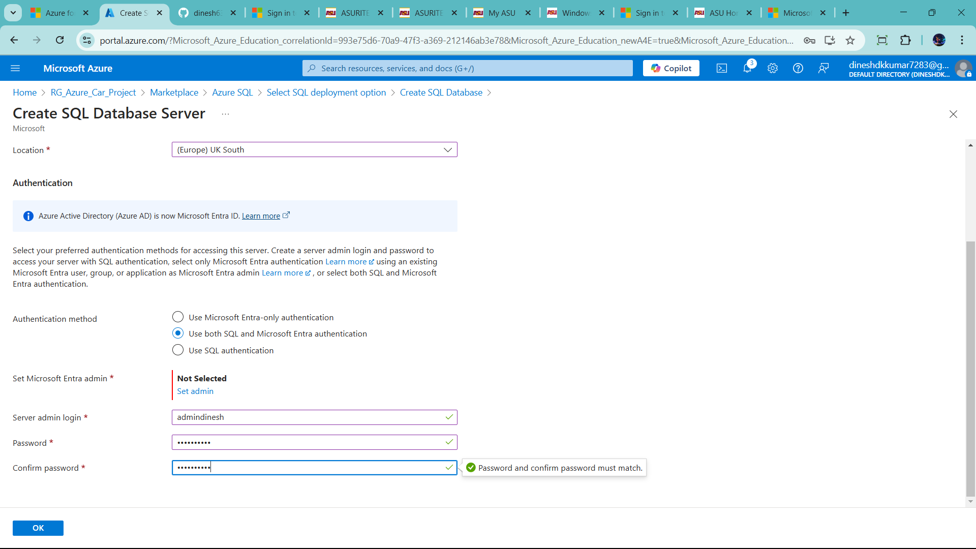

Than click set admin 🡪

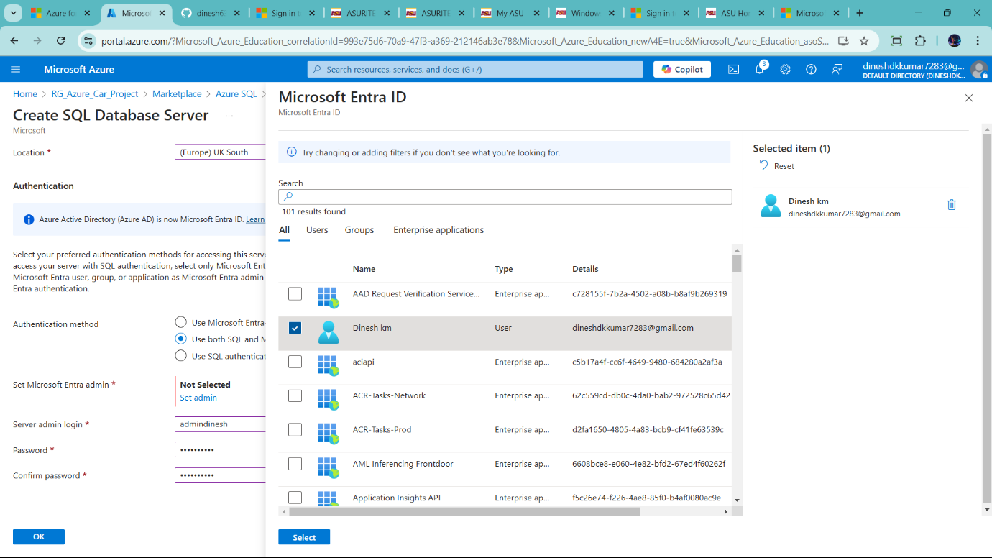

Final click ok

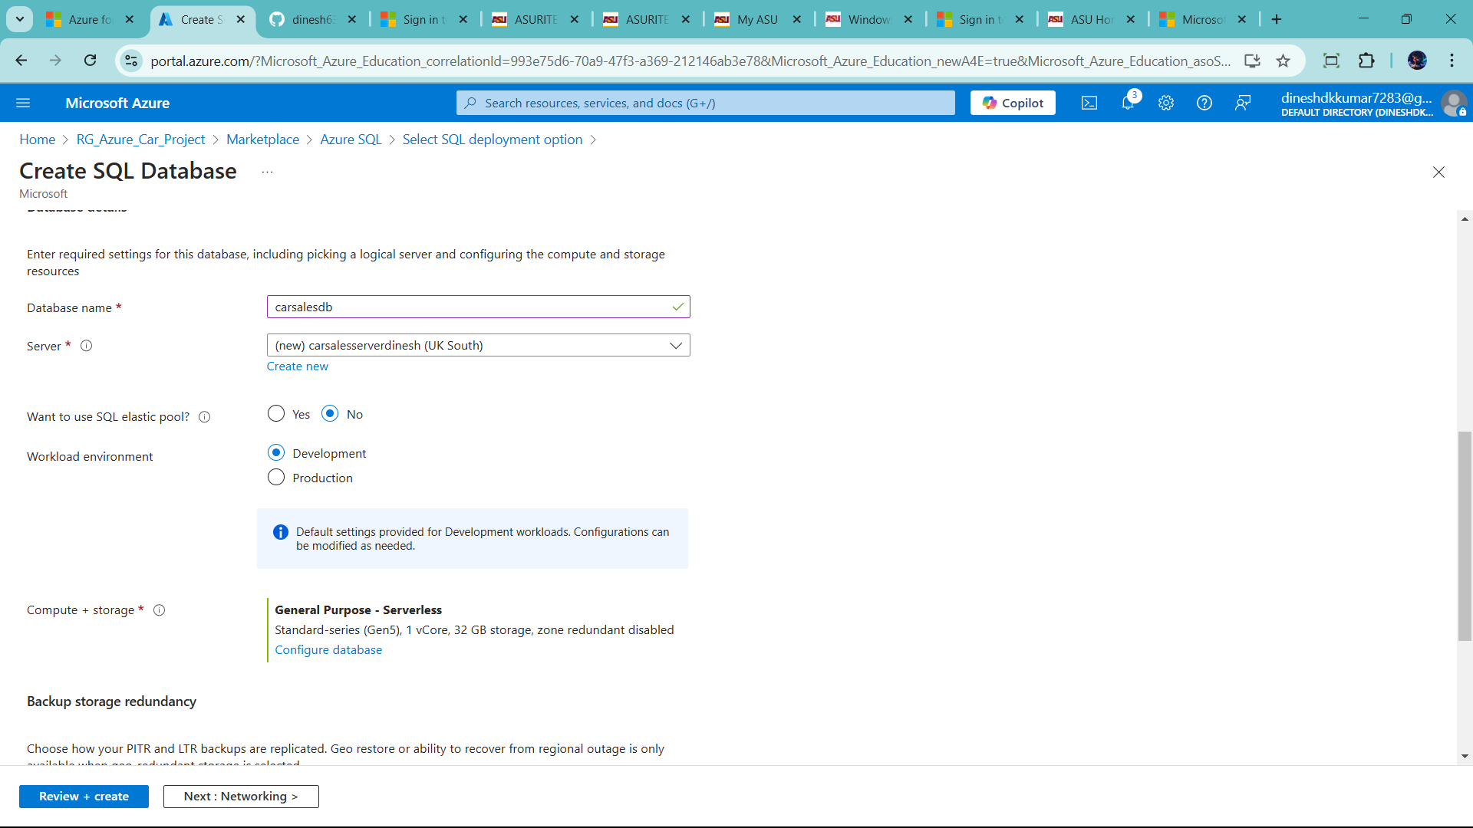

When set up your perfernce

1) workload environment 🡪 Development

2) compute + storage 🡪 click configure database (for less storage)

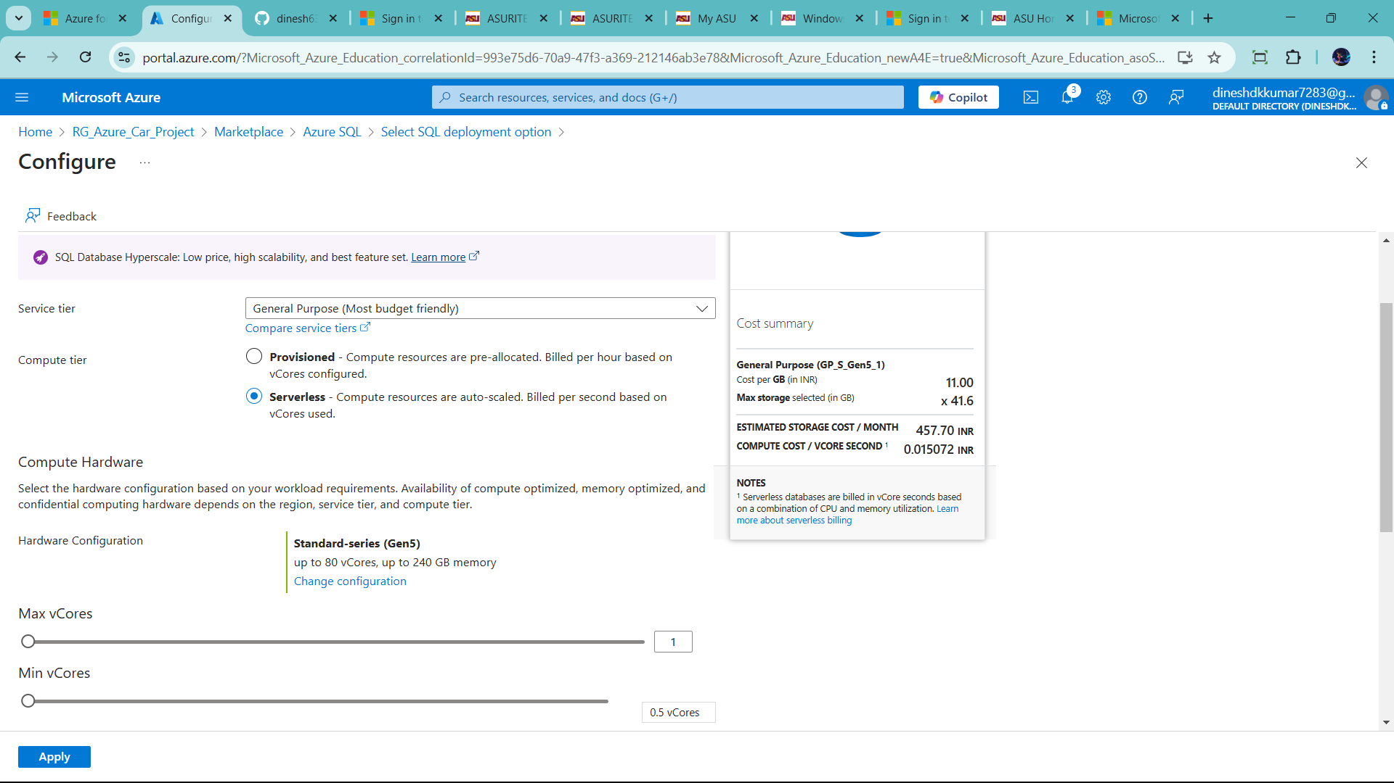

Than click apply

Backup storage redundancy 🡪 check to Local- redundant backup storage(for less)

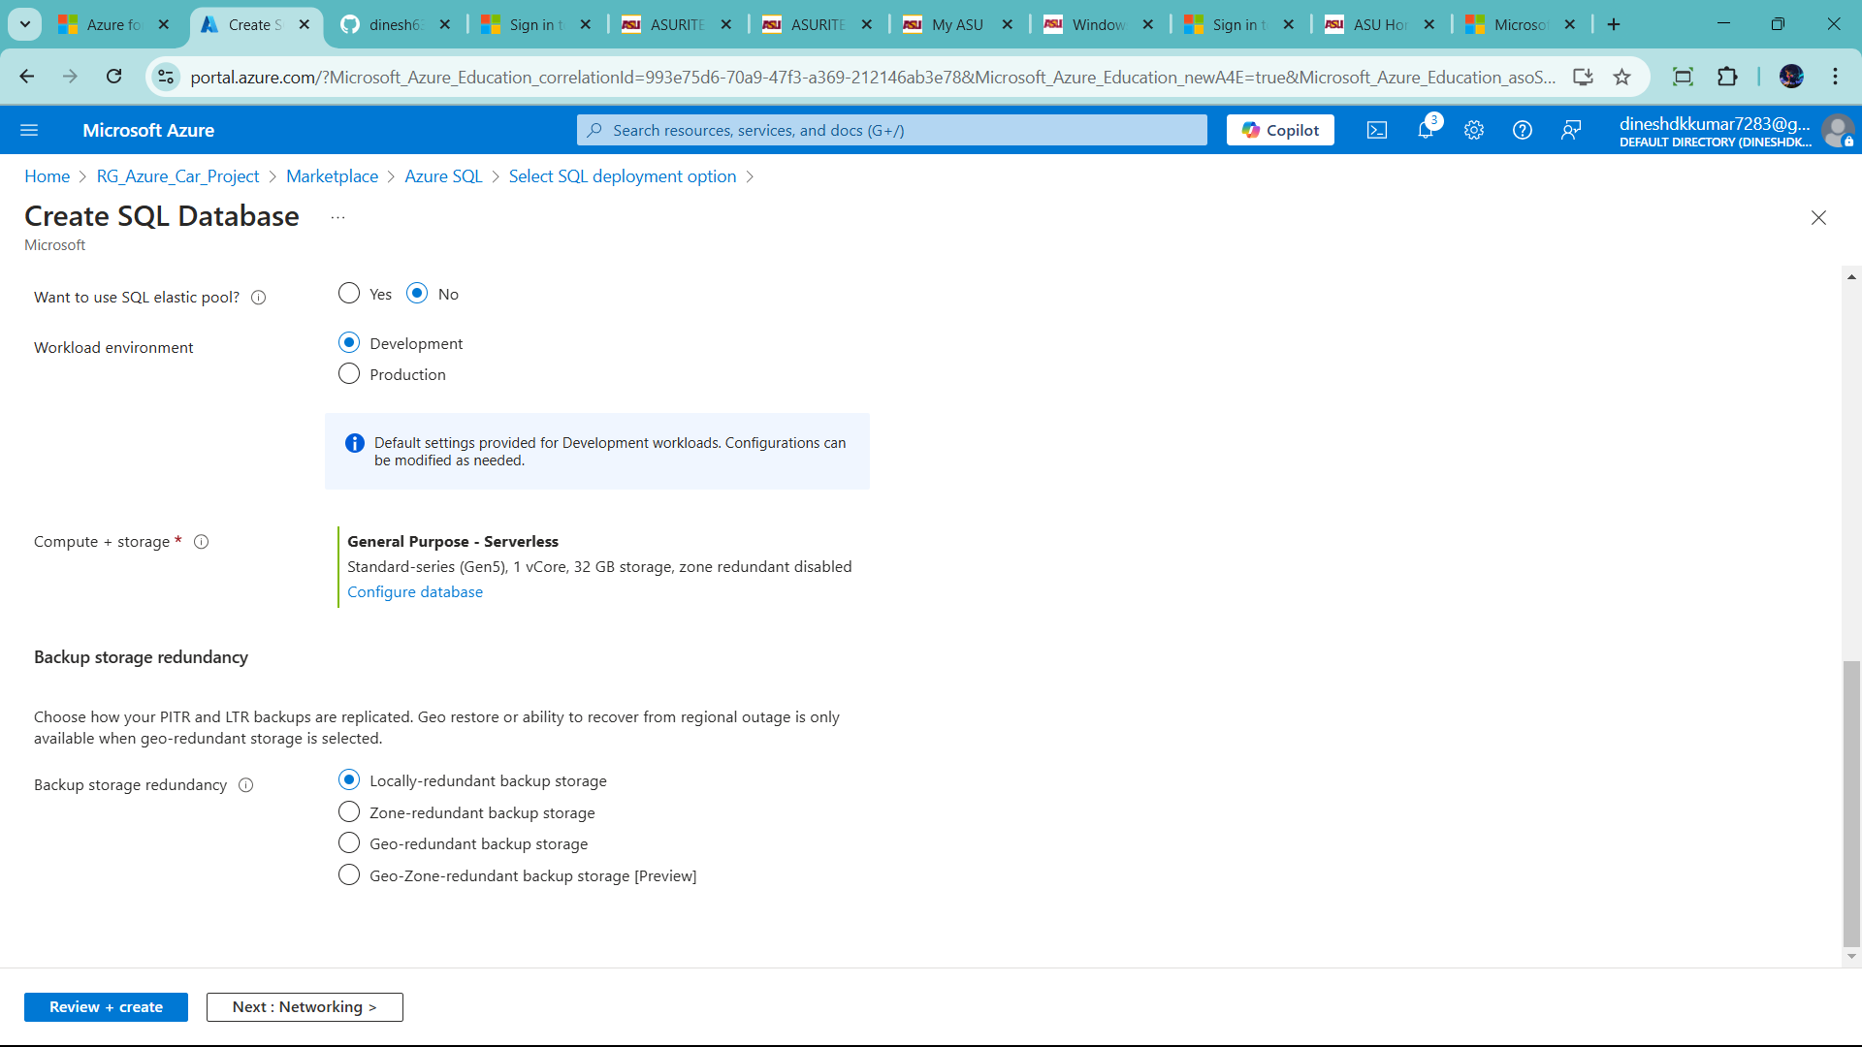

Click Next:Networking

Change connectivity method 🡪public endpoint

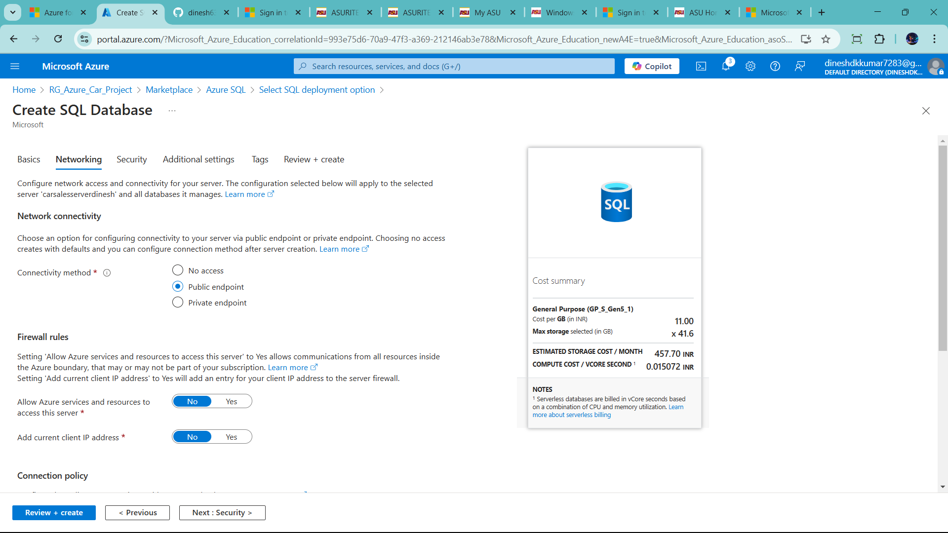

Click Next: Securtiy

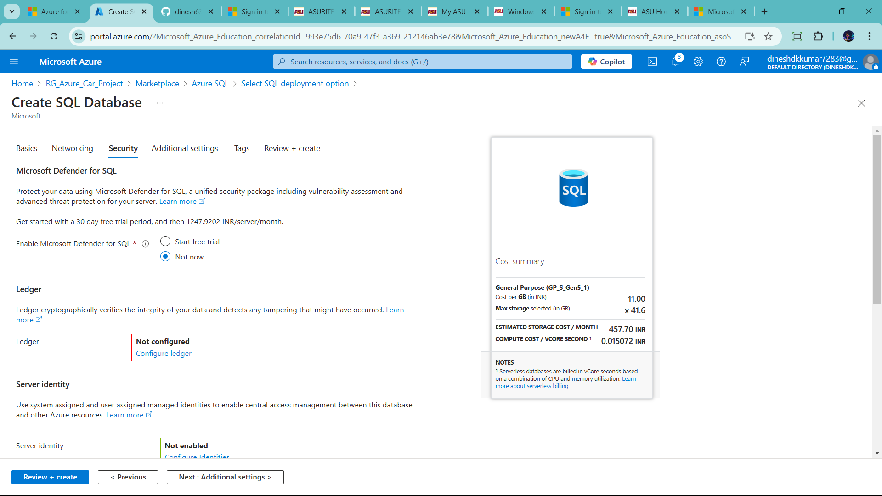

Click review+create

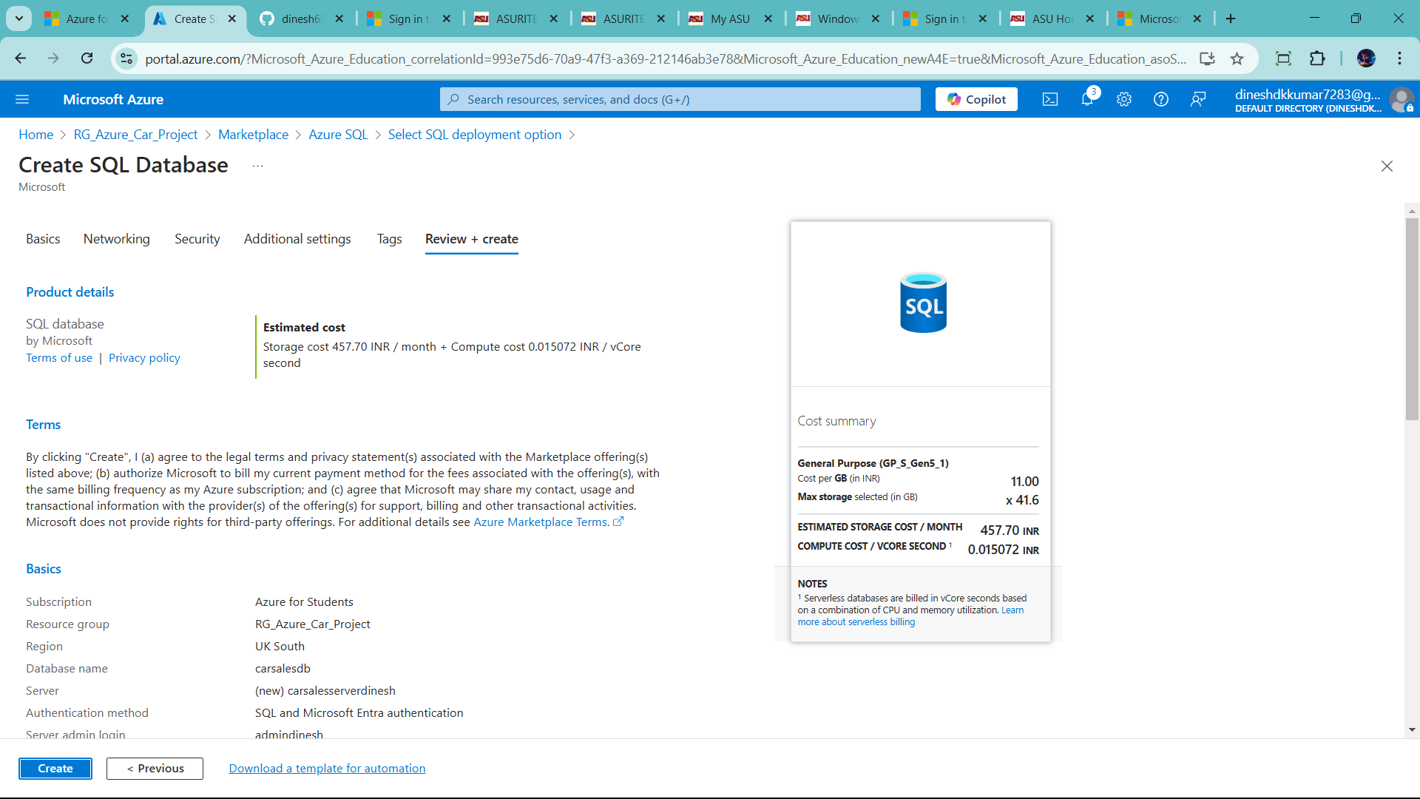

Click create

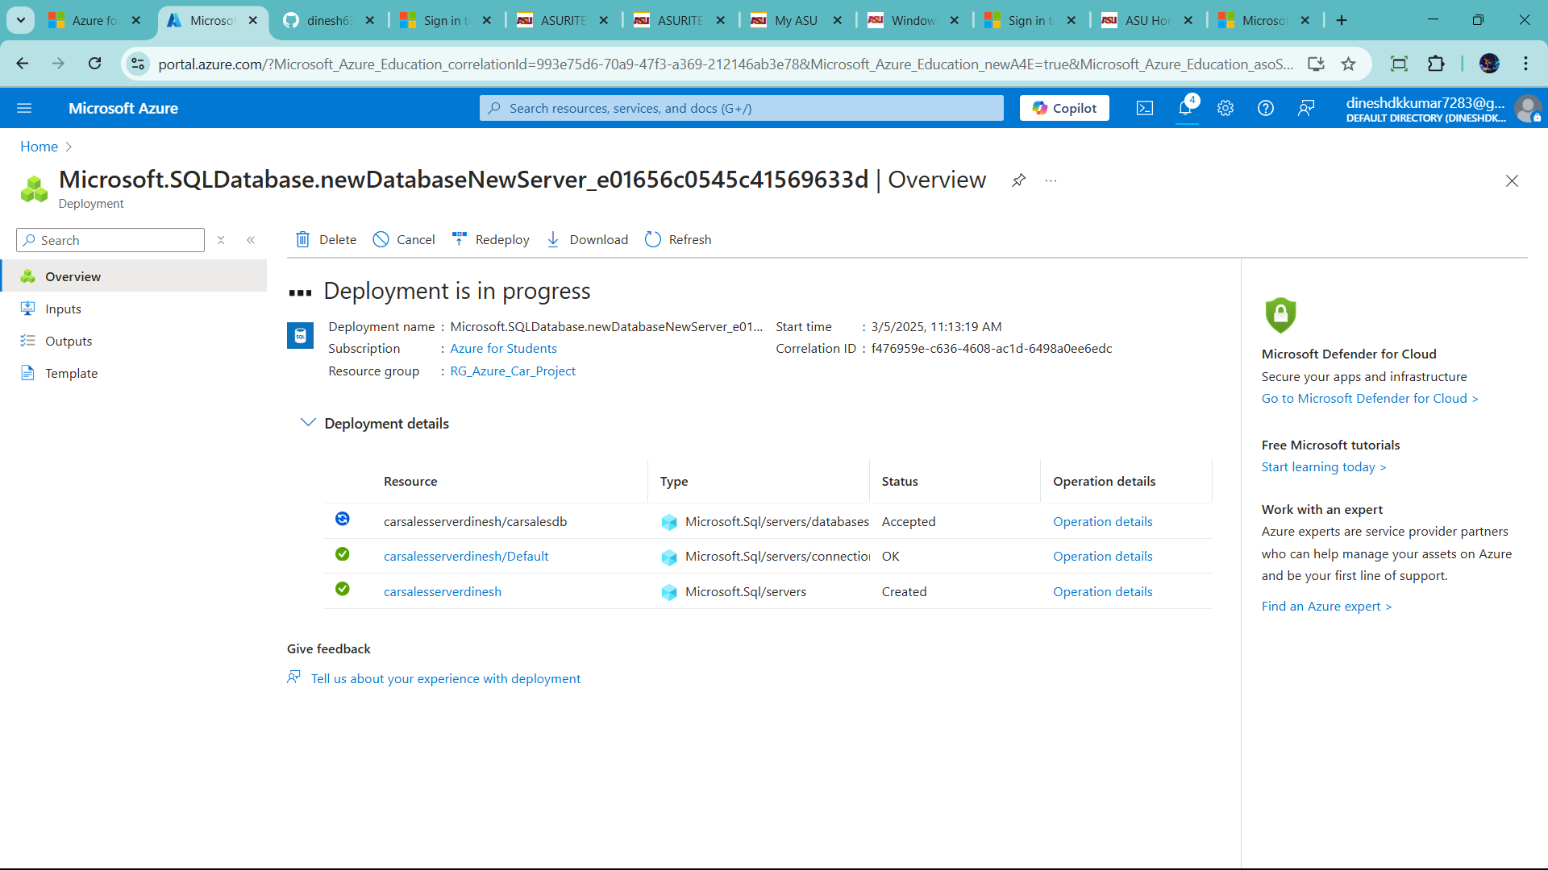

Finally complete sql setup

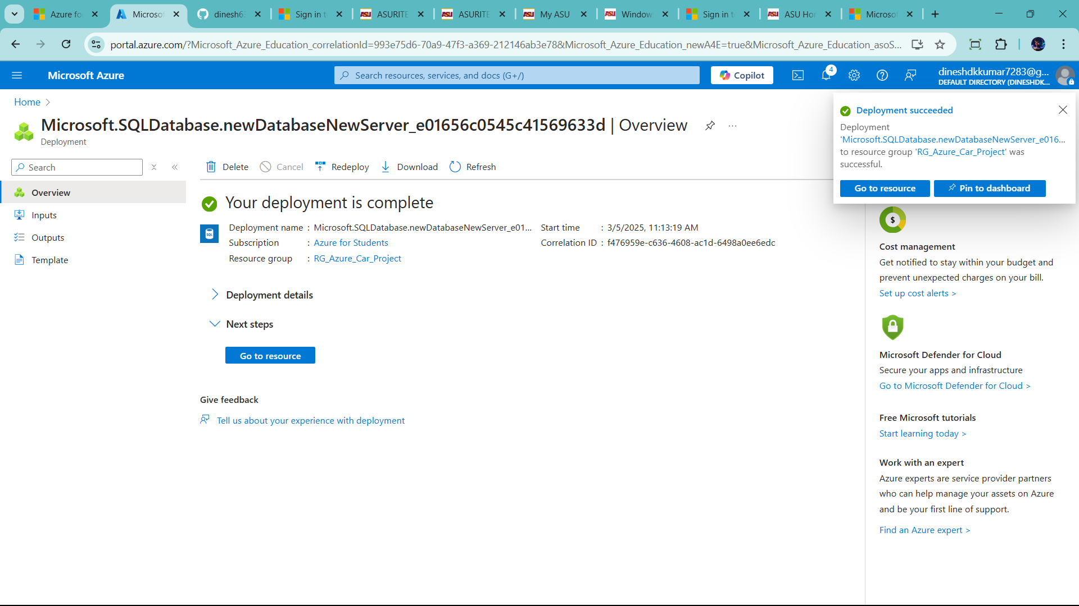

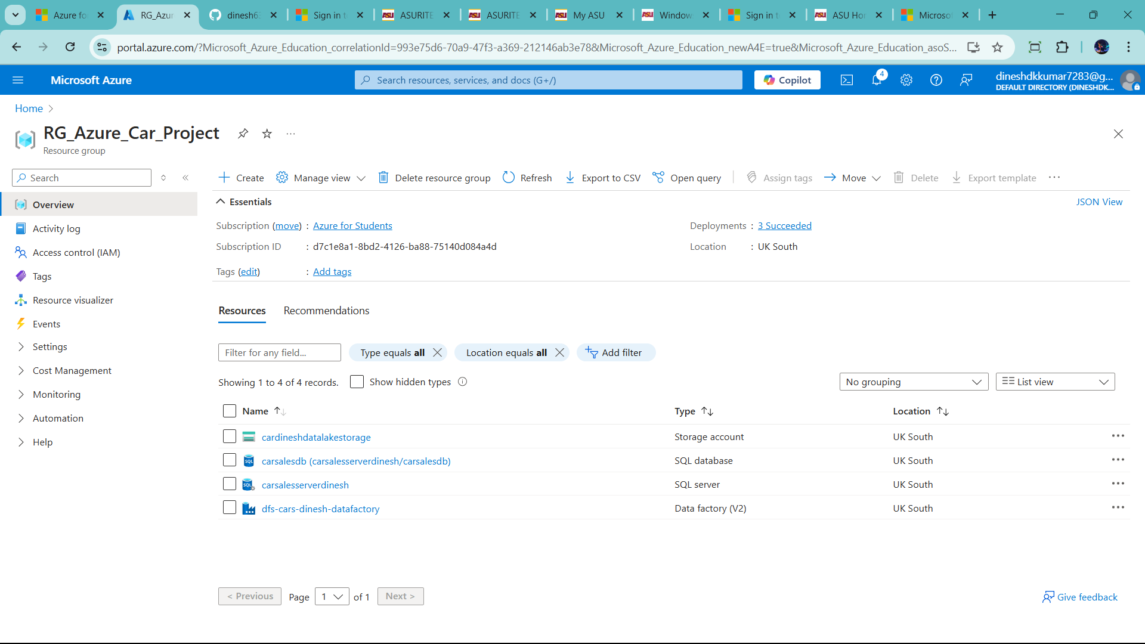

Now create datalake in brozen,silver and Gold

Click resource manager 🡪 cardineshdatalakesstorage

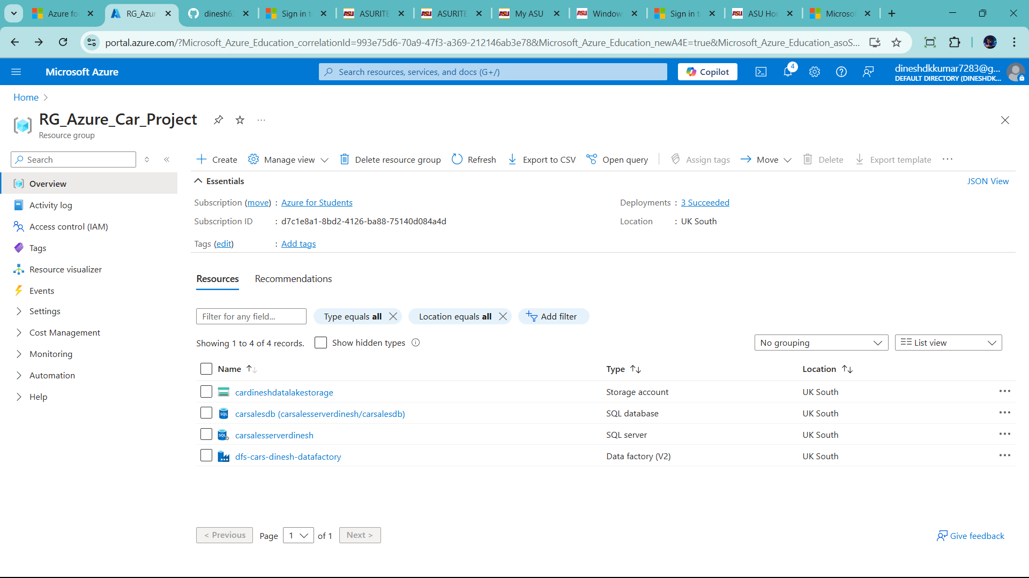

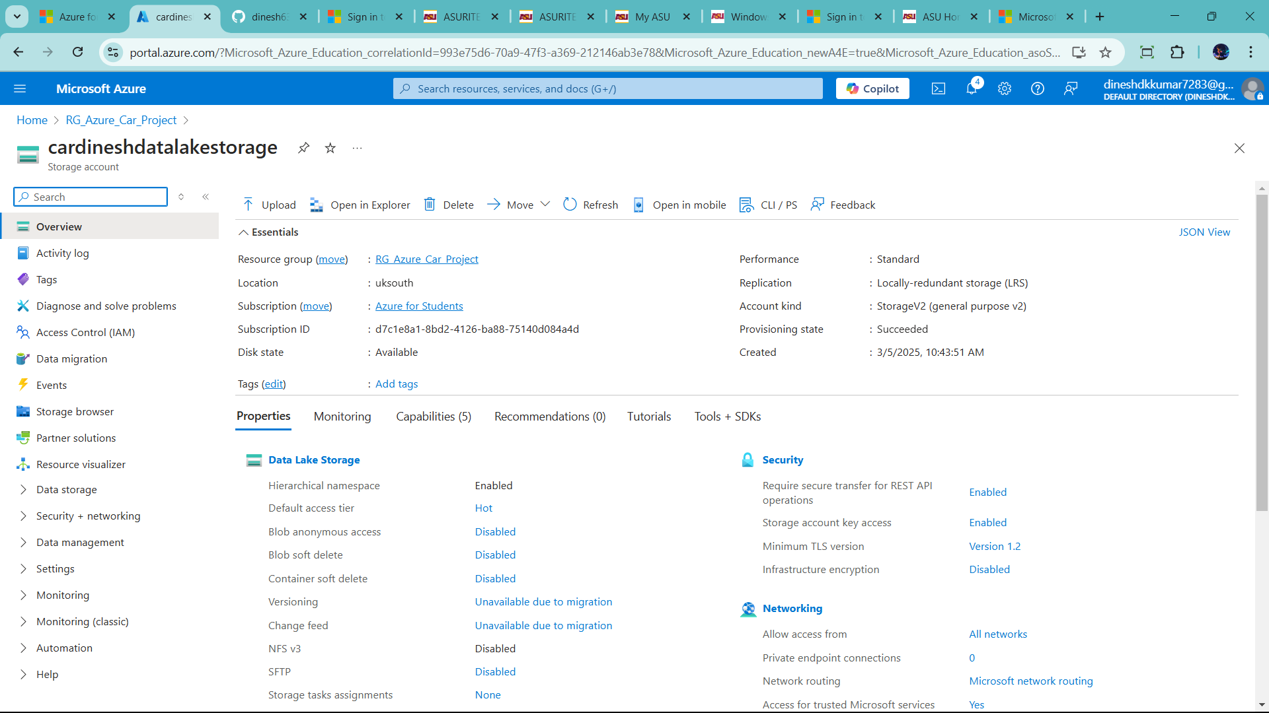

Click container prepare data layers brozen,silver,gold

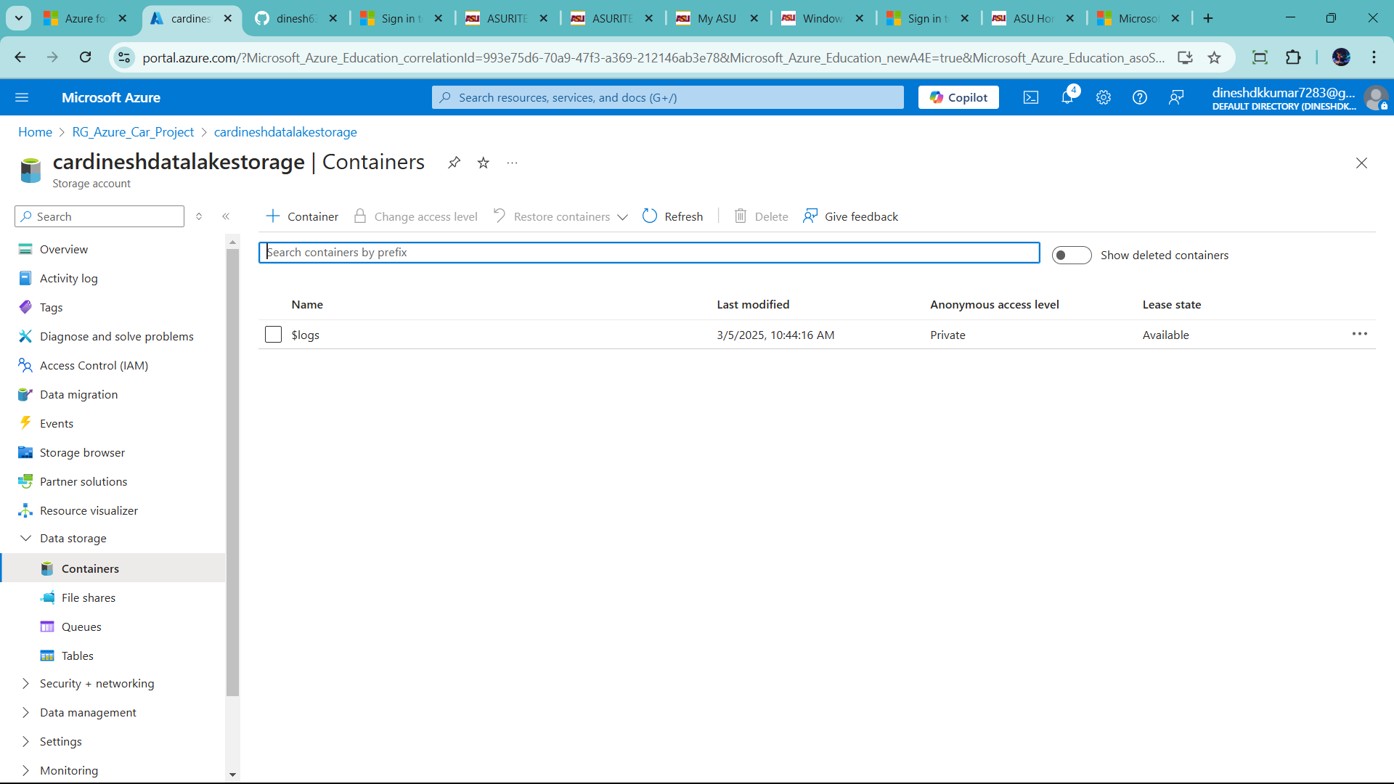

Click container 🡪 write brozen

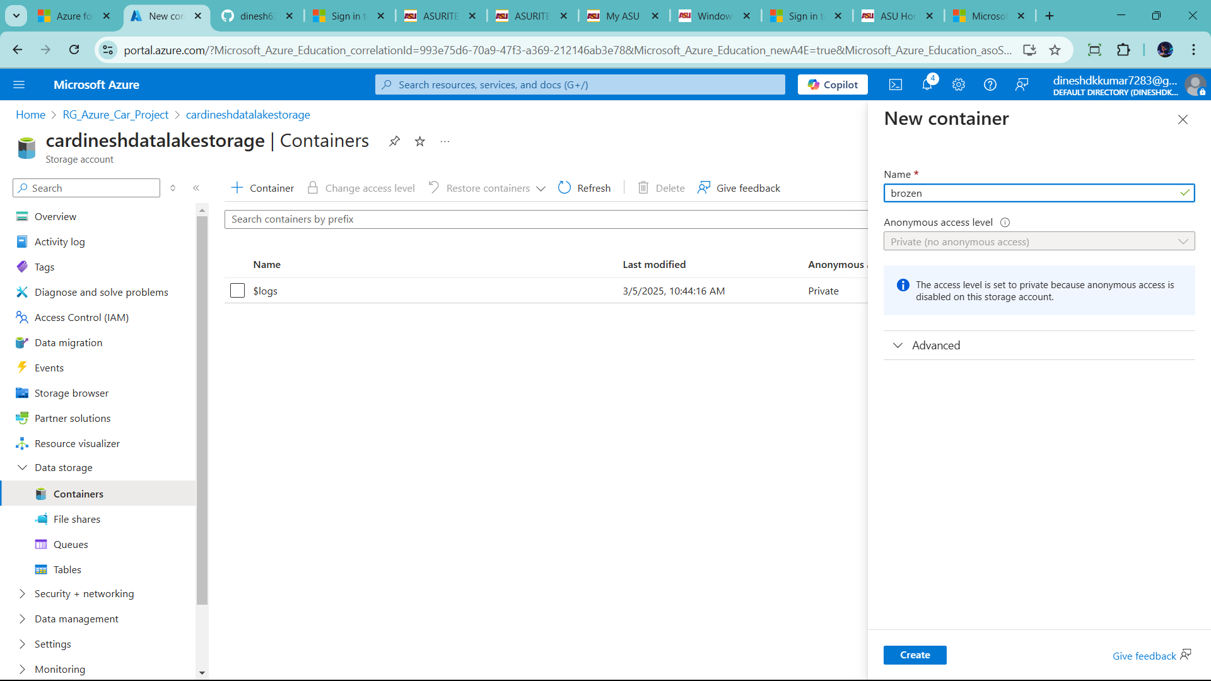

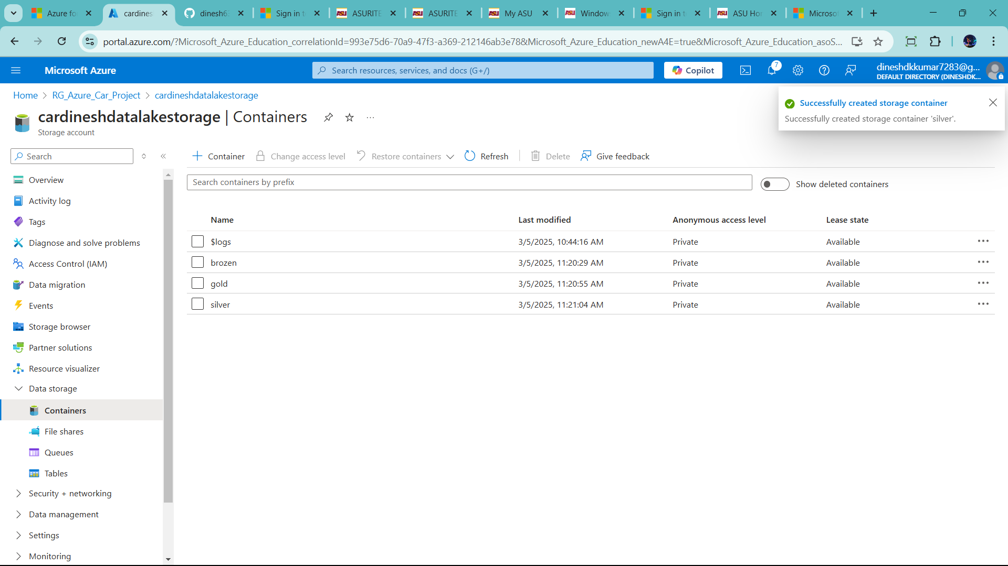

Click carsalesserverdinesh (SQL server)

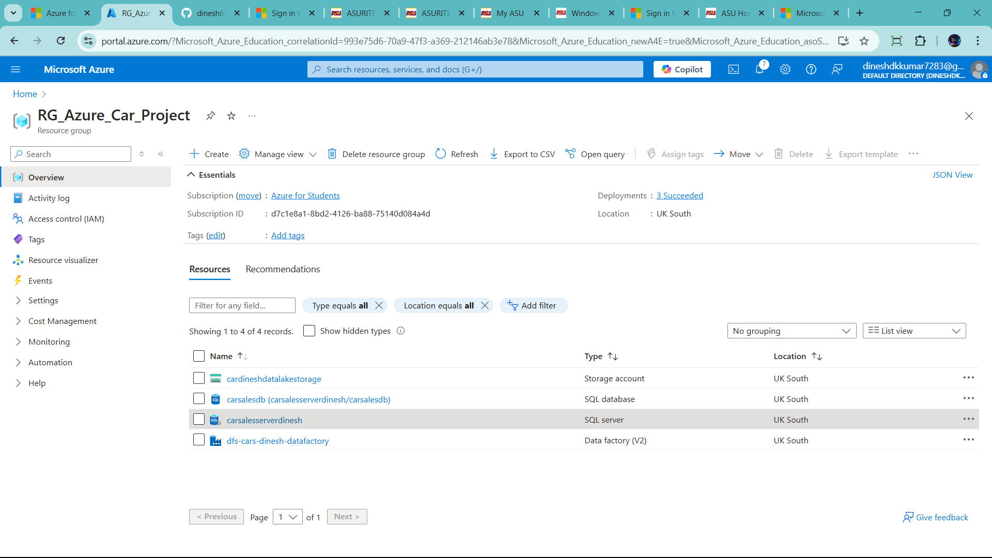

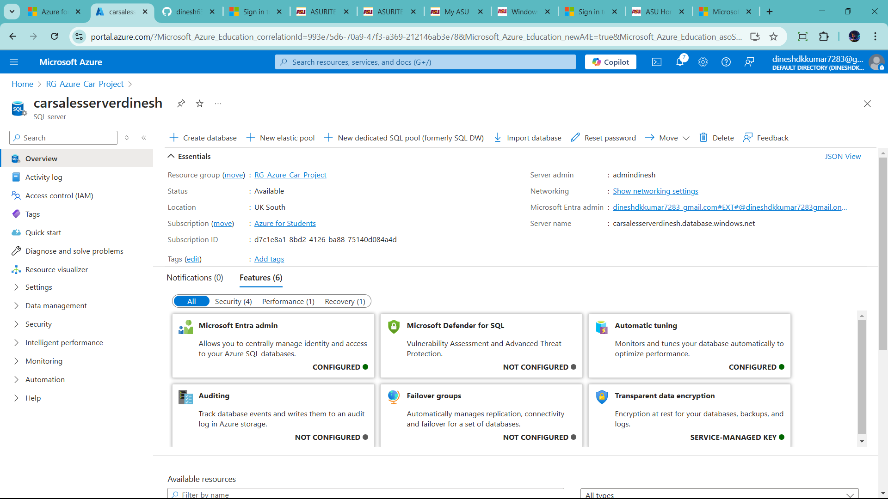this method add more data bases as you preference

This is databased already create previse

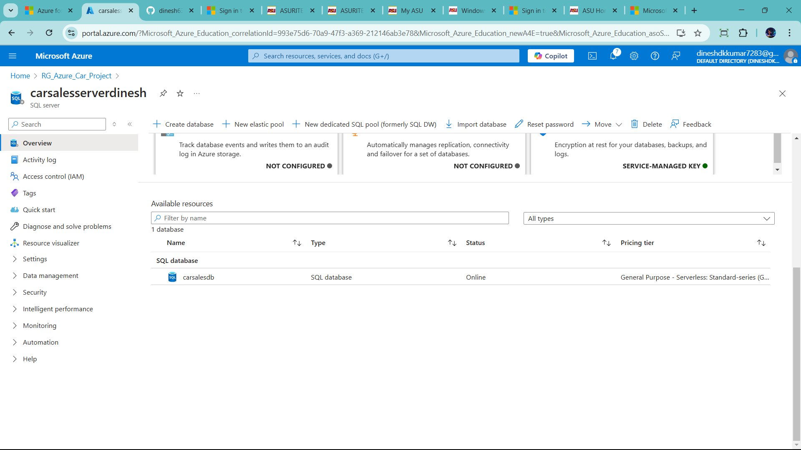

Click carsalesdb 🡪then click query editor(preview)

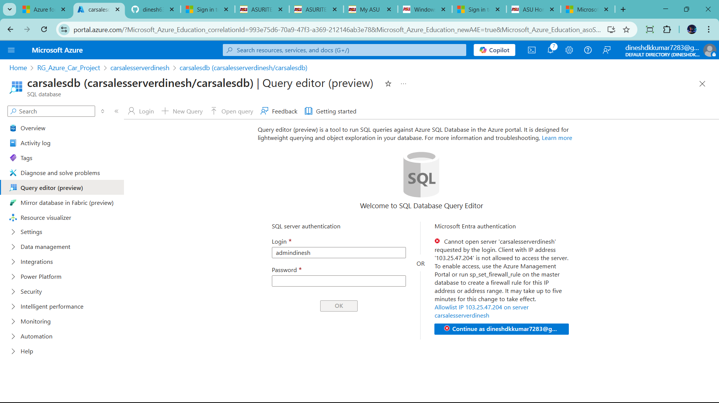

Click allowlist IP (server less card)

After remove error than add admin and password

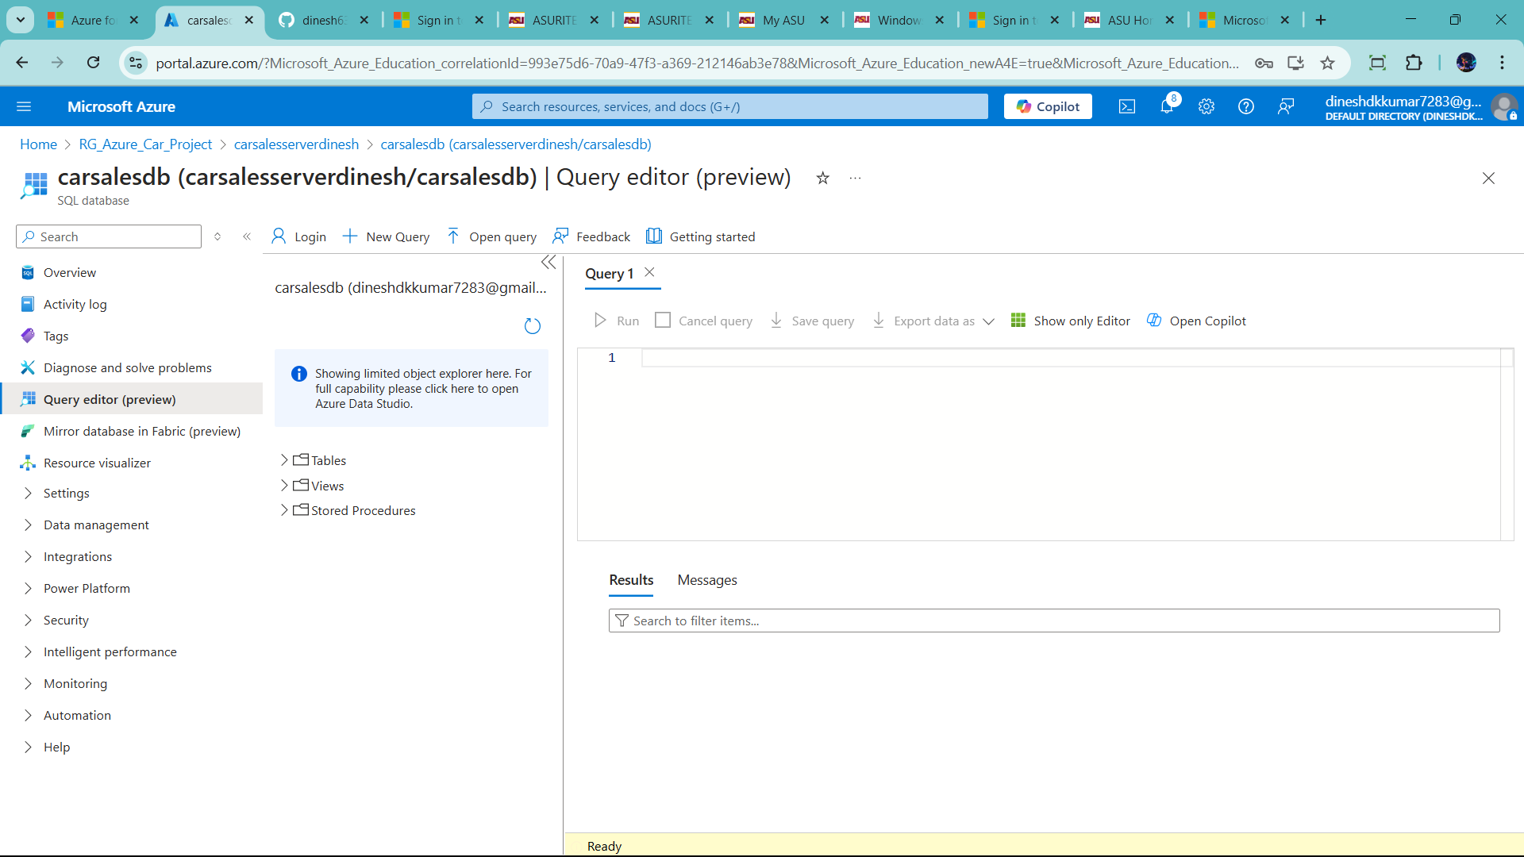

Lets See Source data in github

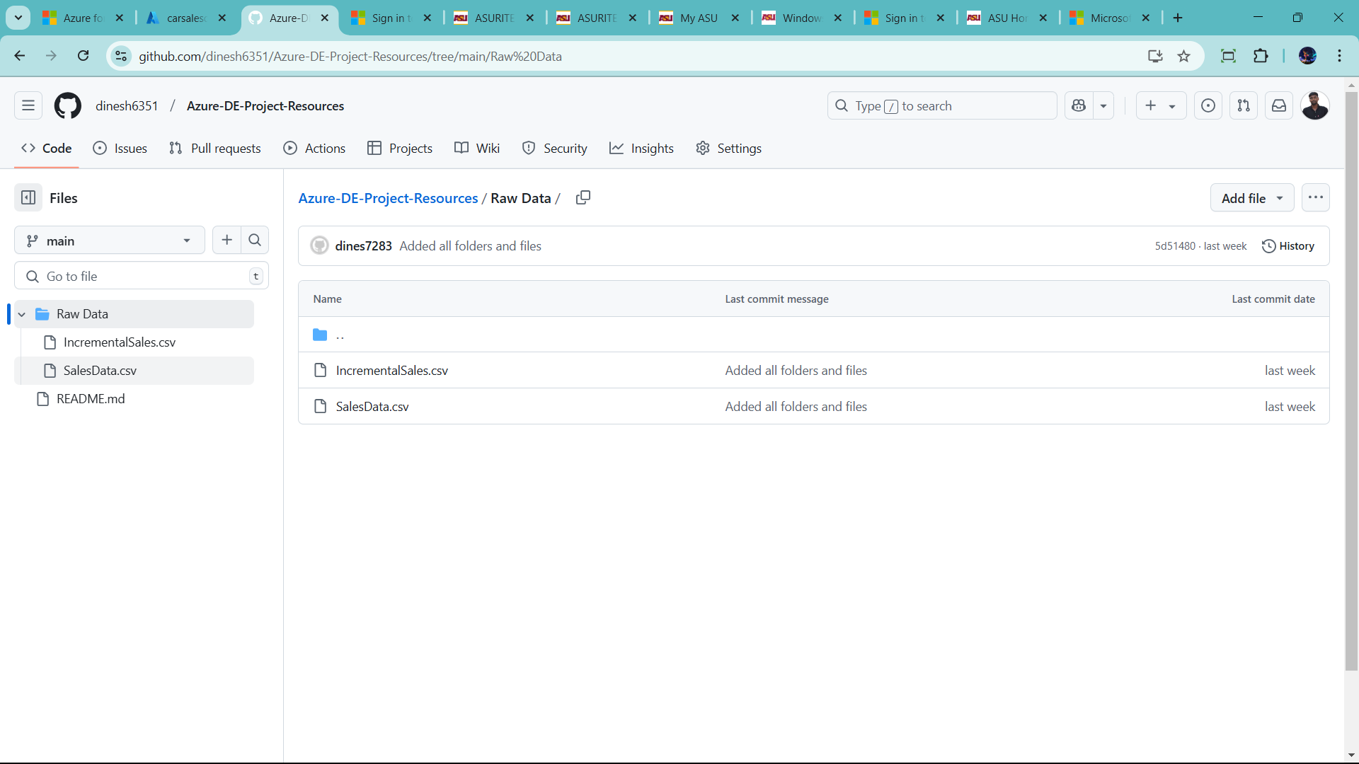

Let start create source table in Azure SQL

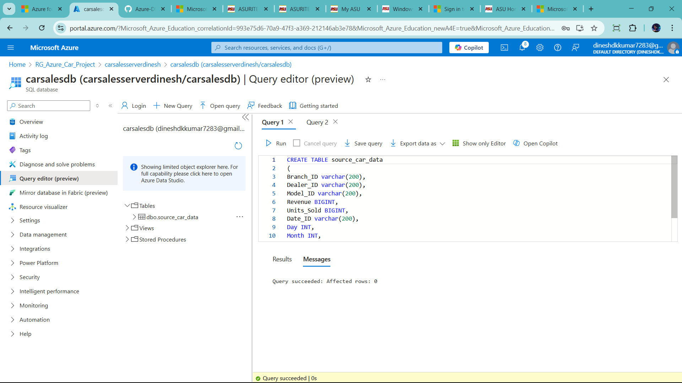

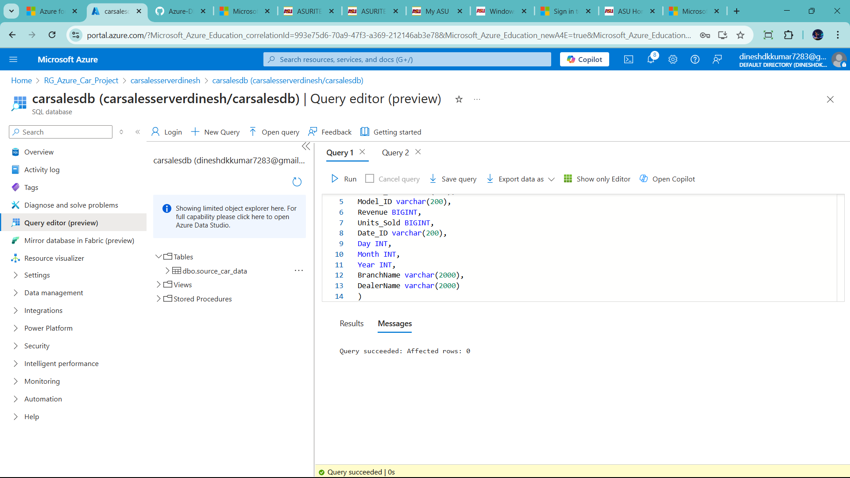

Check table create or not

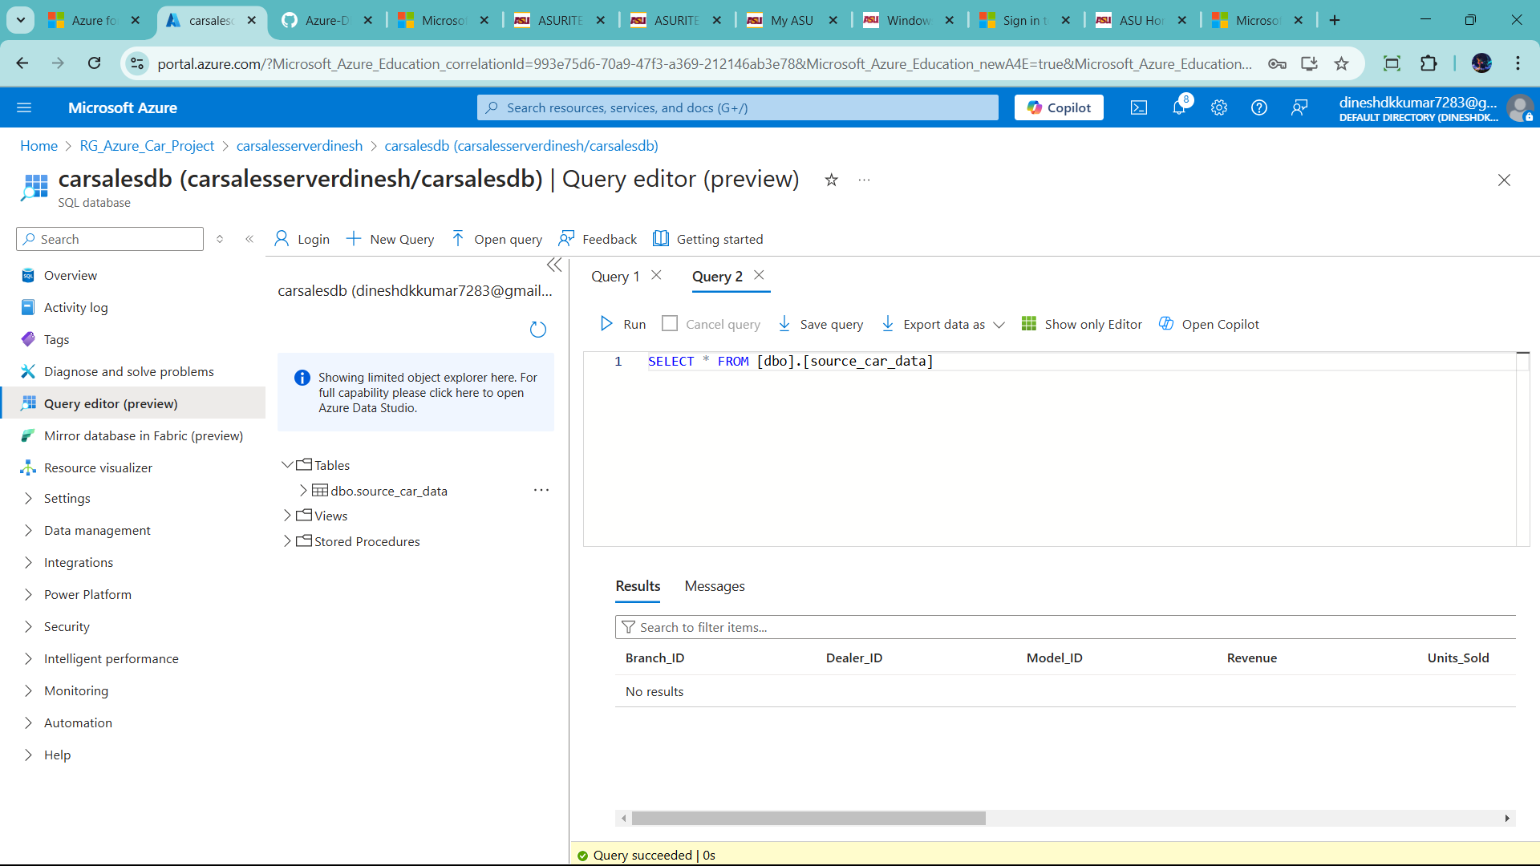

CREATE TABLE source_car_data

(

Branch_ID varchar(200),

Dealer_ID varchar(200),

Model_ID varchar(200),

Revenue BIGINT,

Units_Sold BIGINT,

Date_ID varchar(200),

Day INT,

Month INT,

Year INT,

BranchName varchar(2000),

DealerName varchar(2000)

)

🡪data lake ready

🡪sql server ready

Now Strat build Data factory

🡪pull the data from github to azure

🡪let’s start

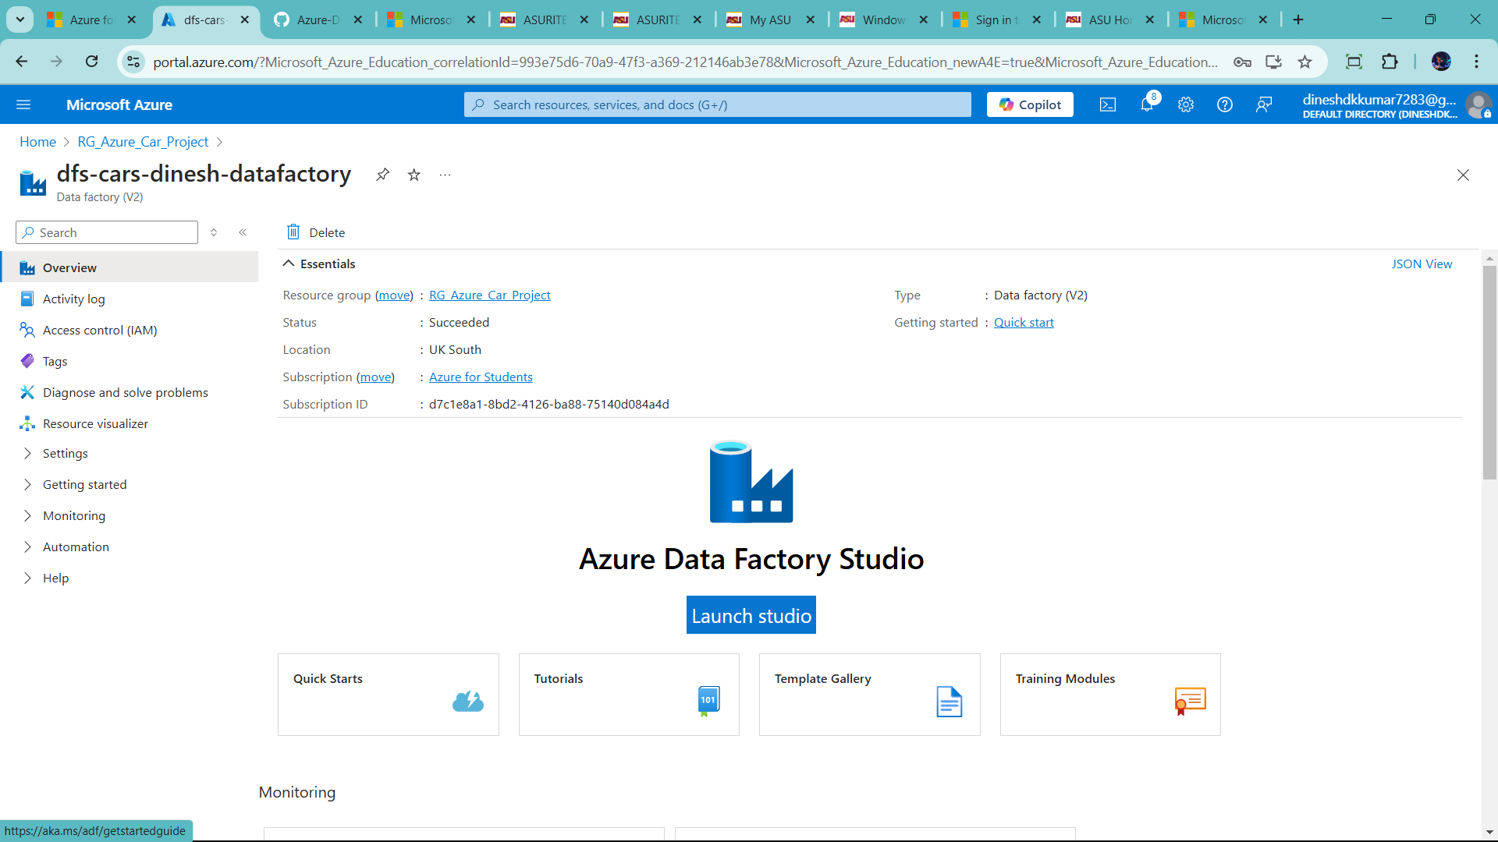

🡪click launch studio

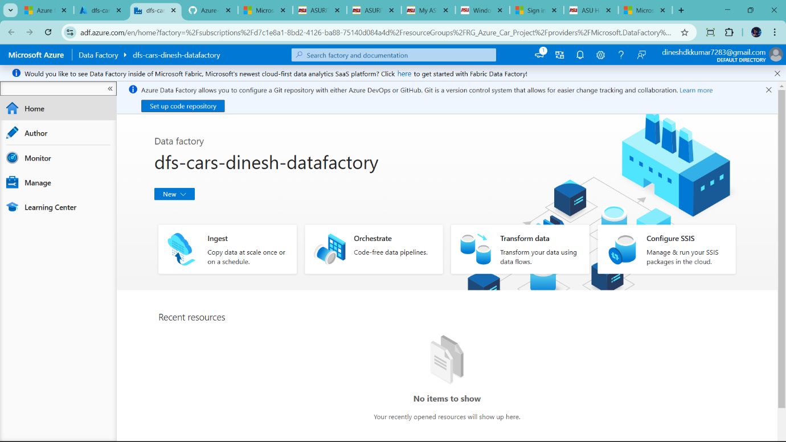

1) Author 🡪use for craft the pipe lines 🡪main one

2) Monitor 🡪 Monitor the pipline(all logs)

3) Manage 🡪 manage all the tools like github repostory,connection, all the trigger and more

4) finally learning tap

Now Start with Author tap and start build piple

Step1) click author

Step2) click pipeline and add new pipeline

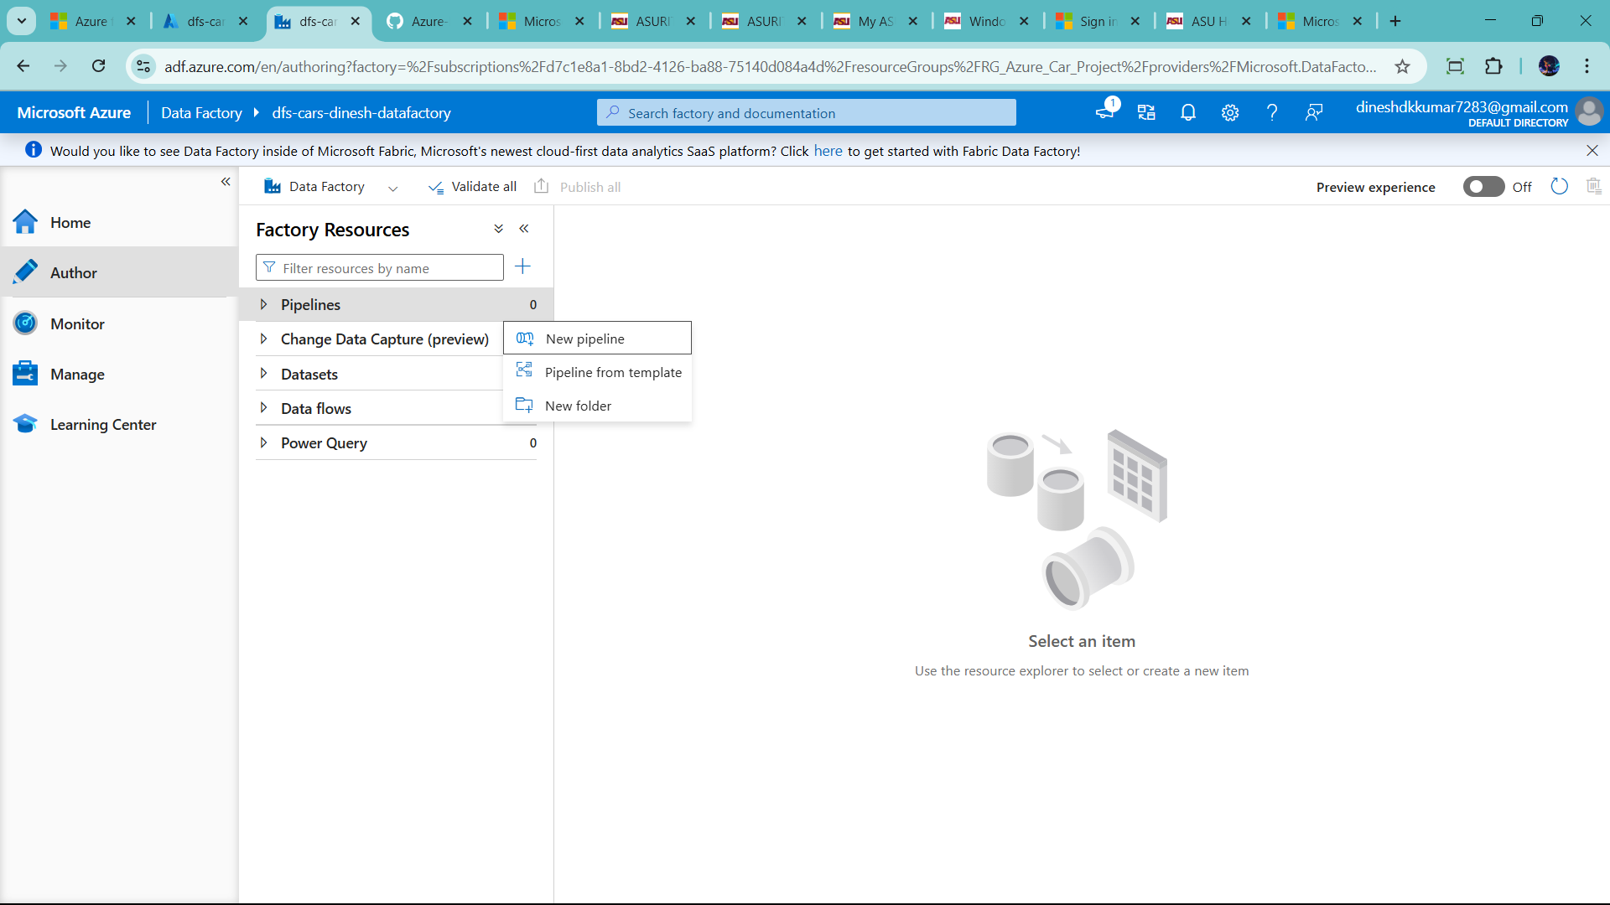

How to connection work

Github -------🡪 Data Factory ----------🡪 SQL

Load increment data

1) copy activity in data factory 🡪 migrate data one location another

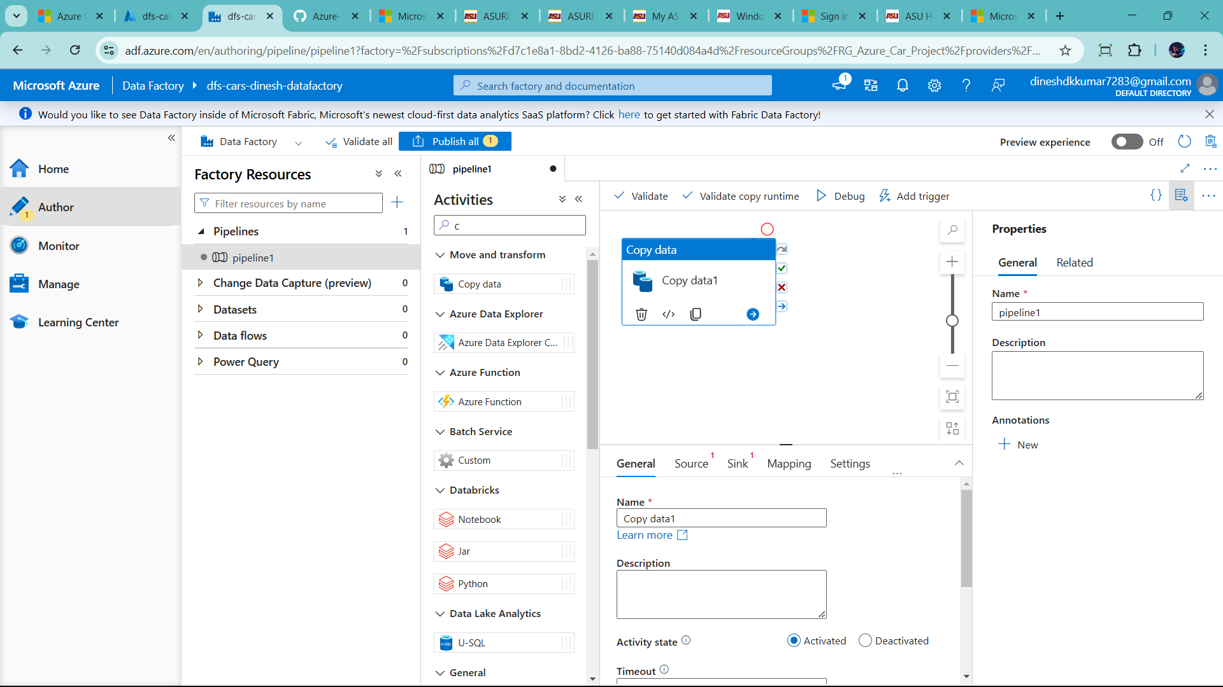

It is connection with source

Two side to manage the copy data activity one is below source and another is manage tab’

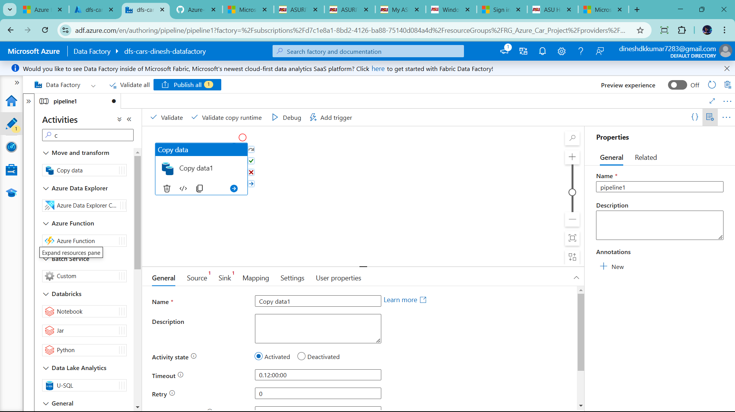



Another one

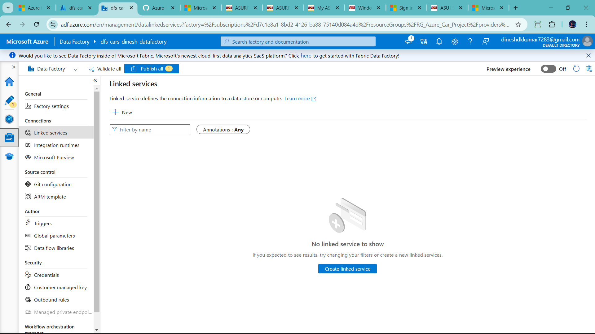

Go to manage tab 🡪click linked service 🡪 click + new

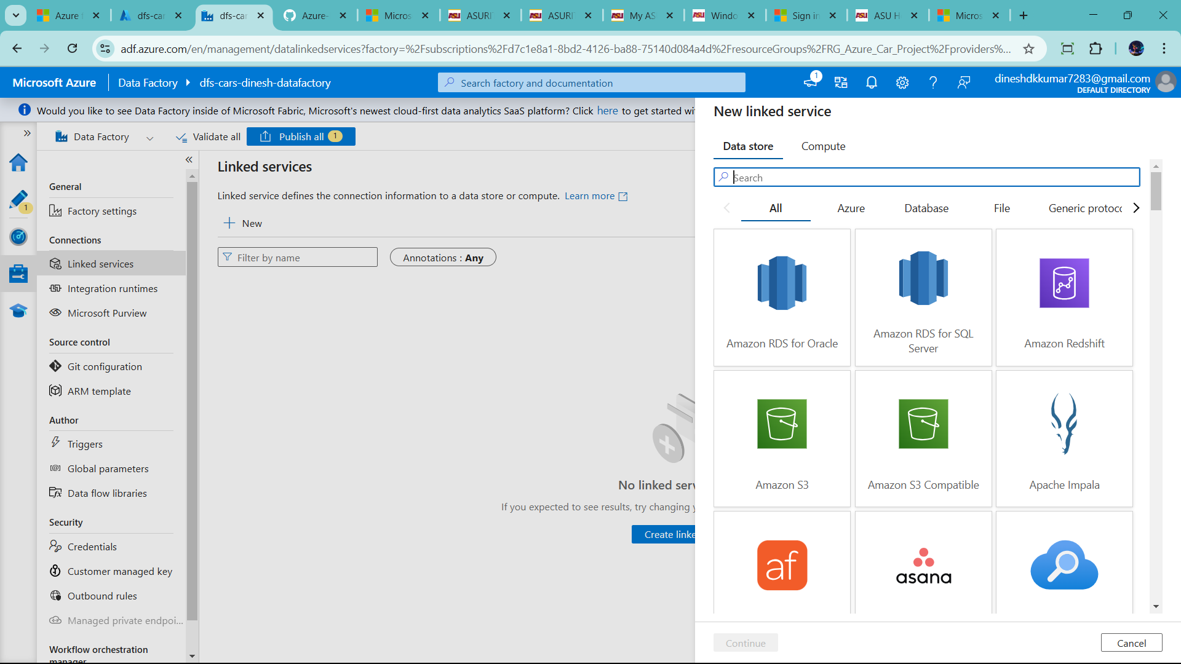

Search http 🡪for github resporitory

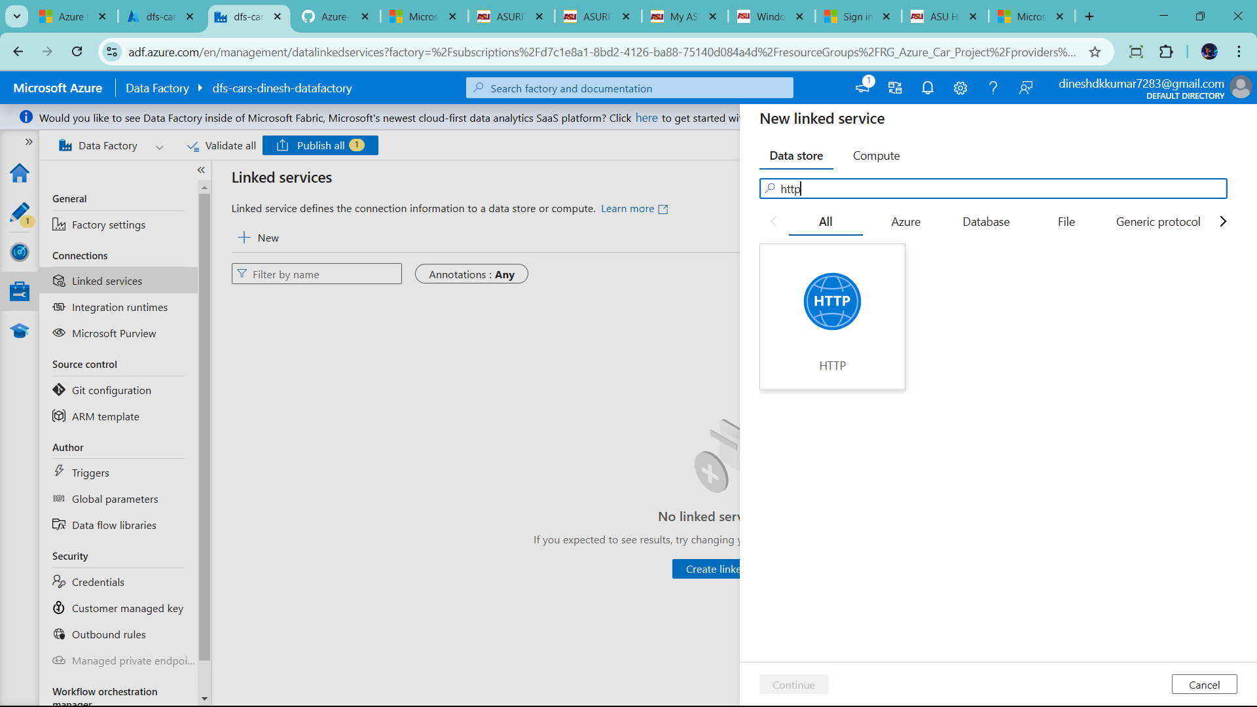

Click http 🡪 add name ls_github 🡪 add base url (find raw url in github)

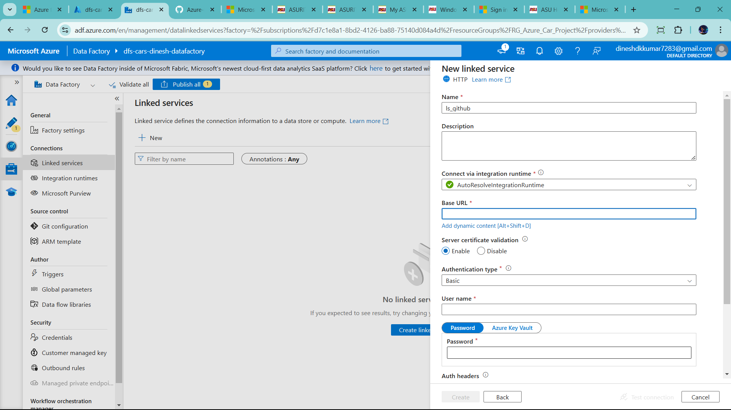

In github

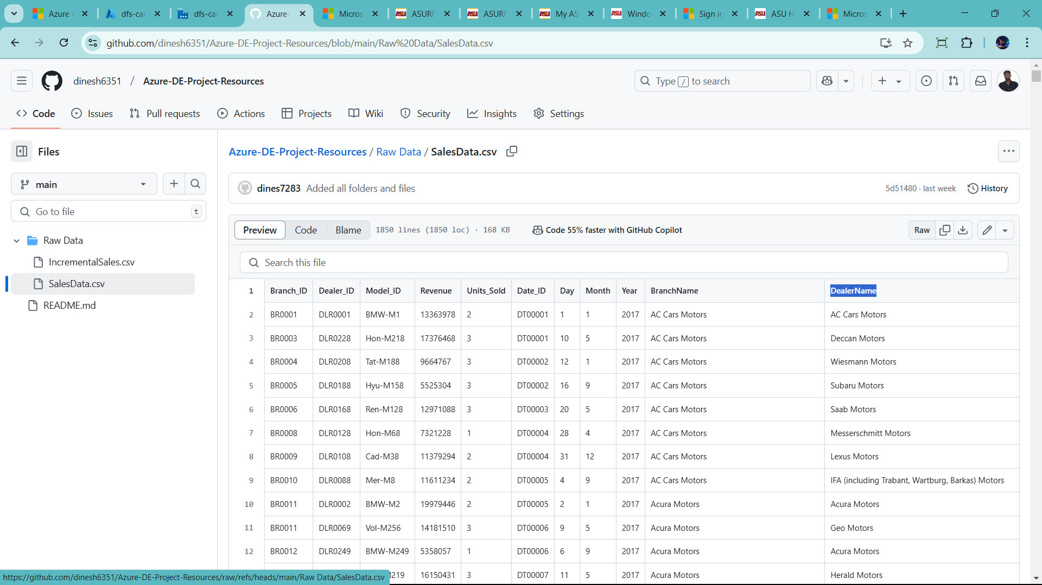

Click raw

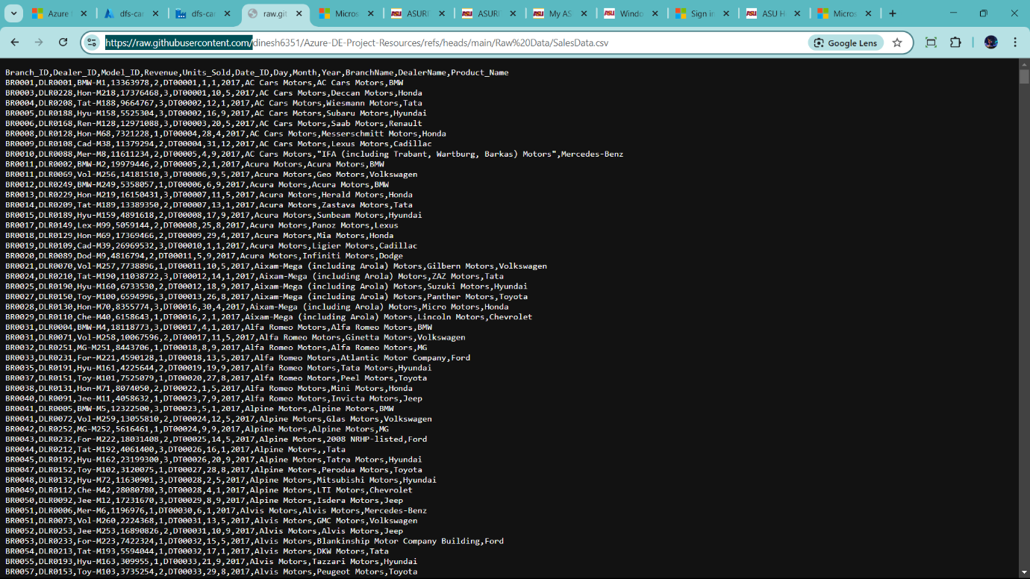

Than copy that url add in bases url in add link service

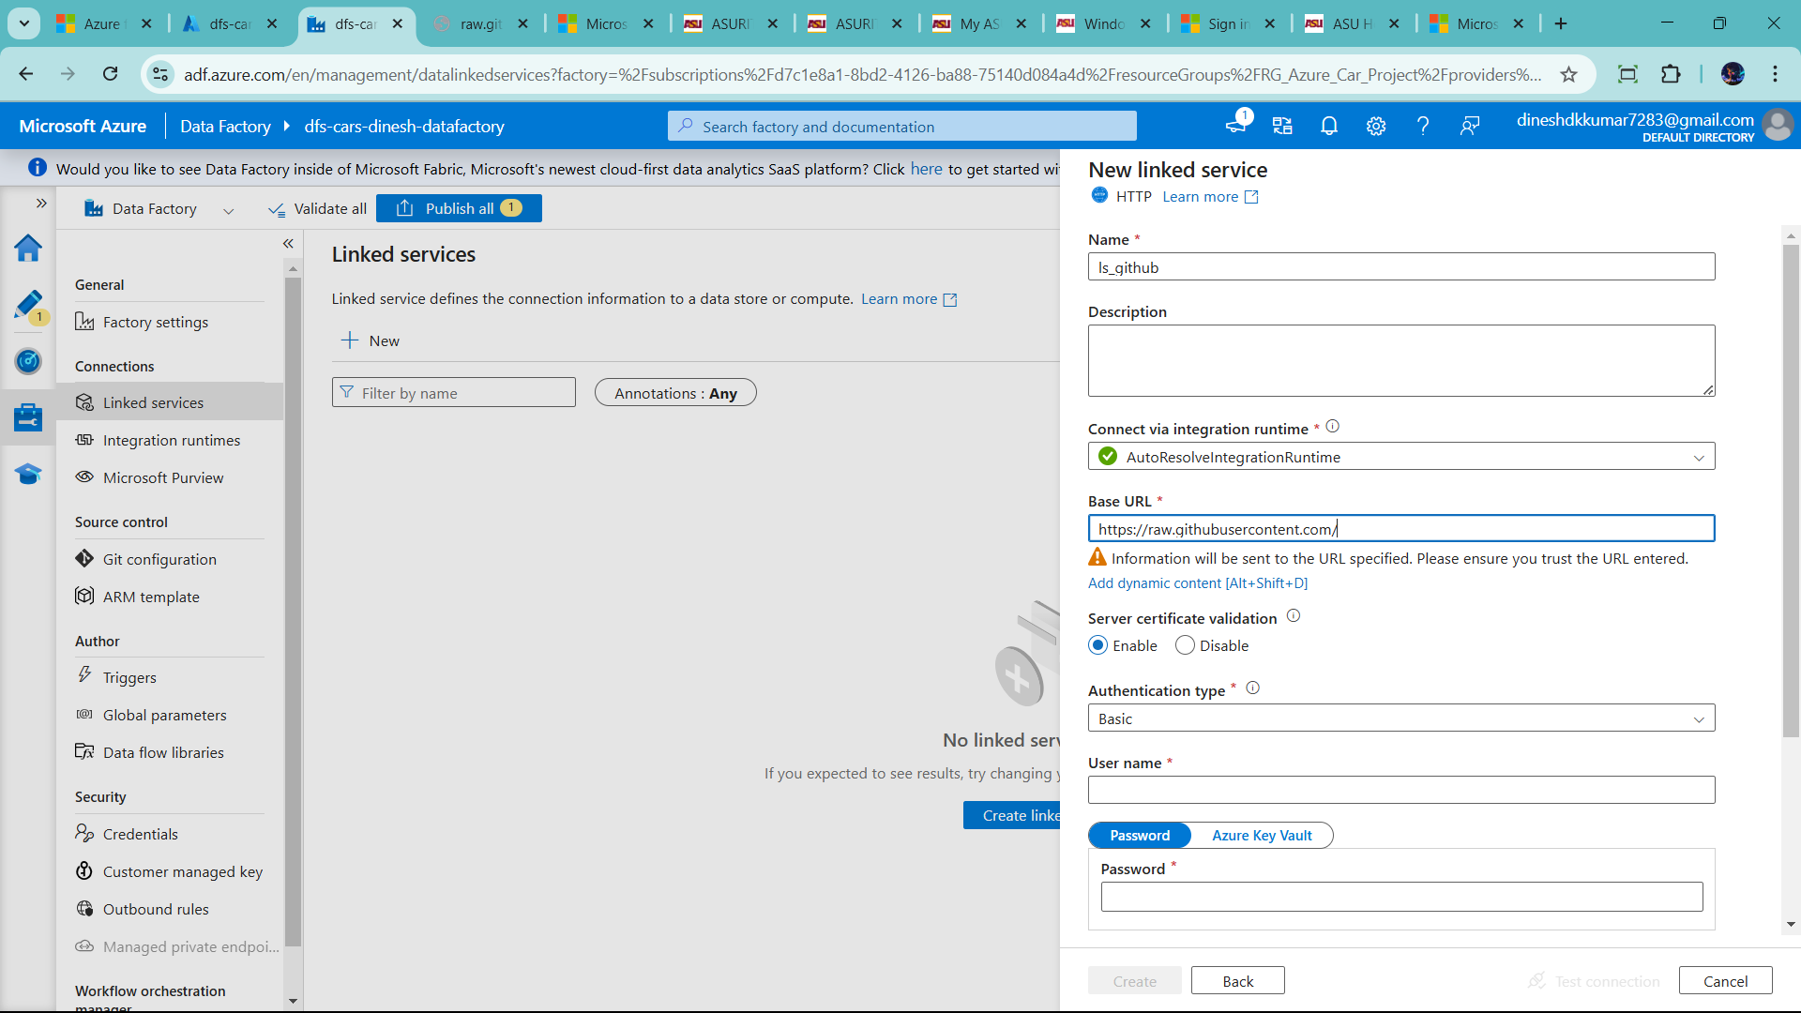

Authentication type chage Anonymos

And test the connection

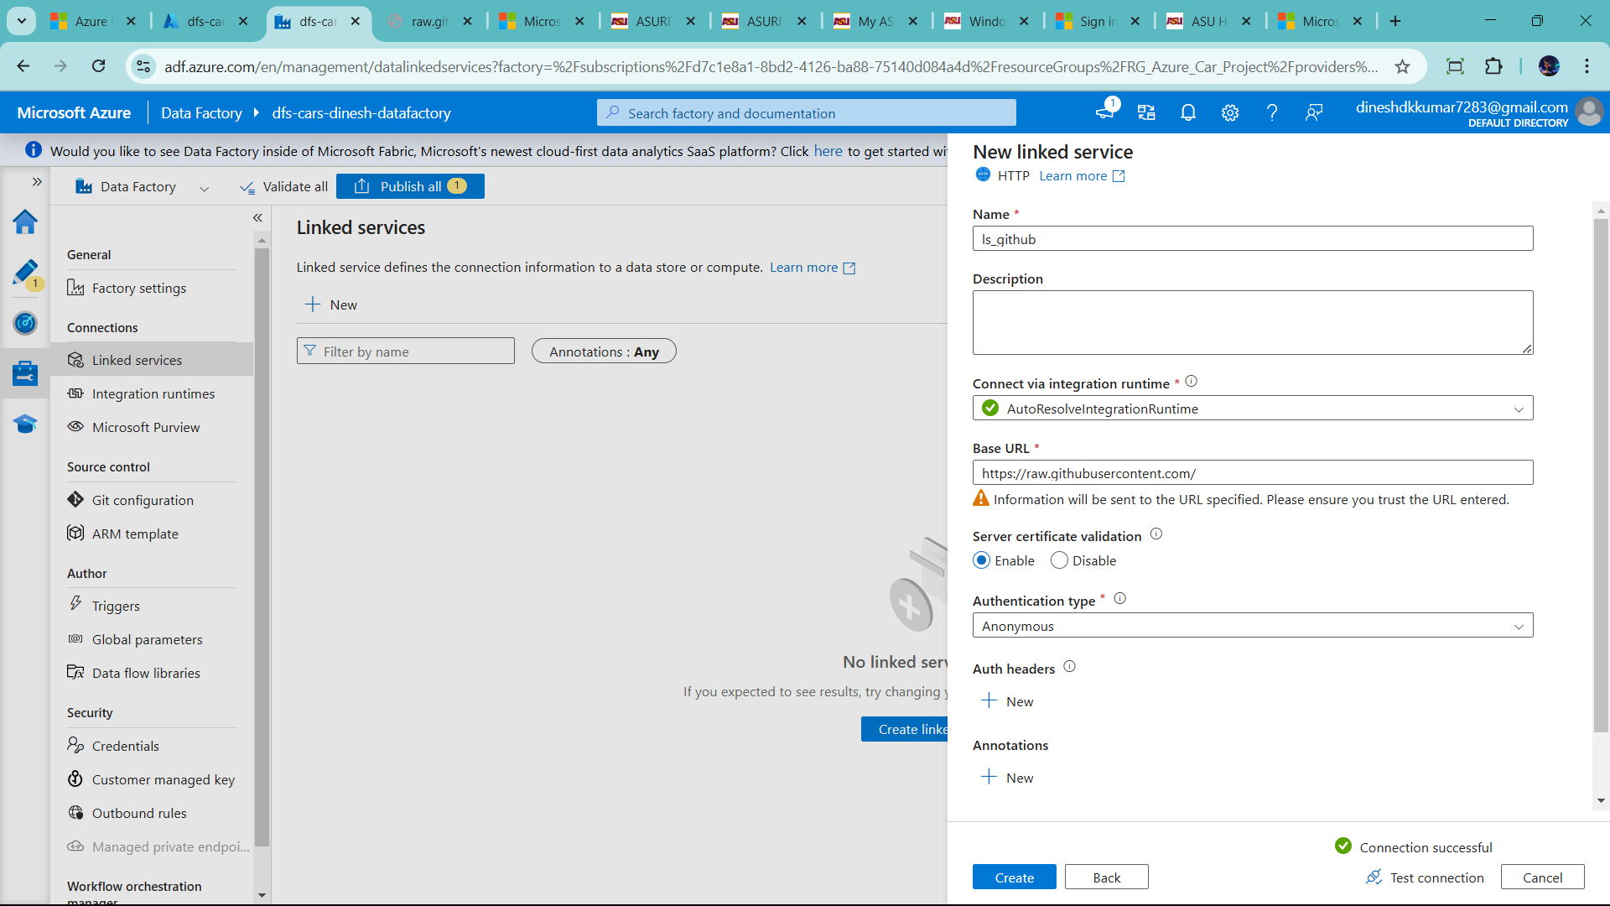

Click Create

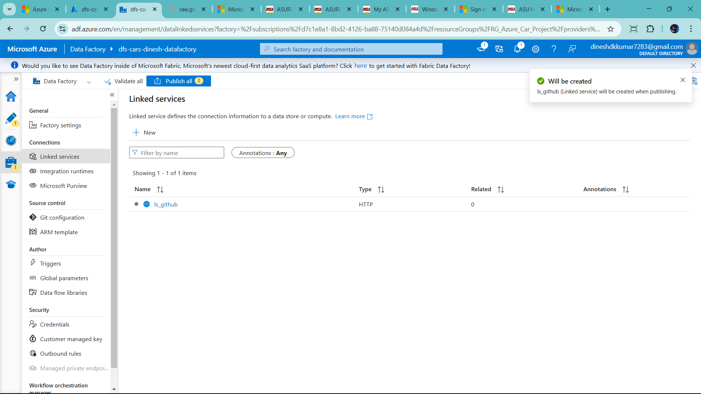

Now create another connection to push data in azure sql db

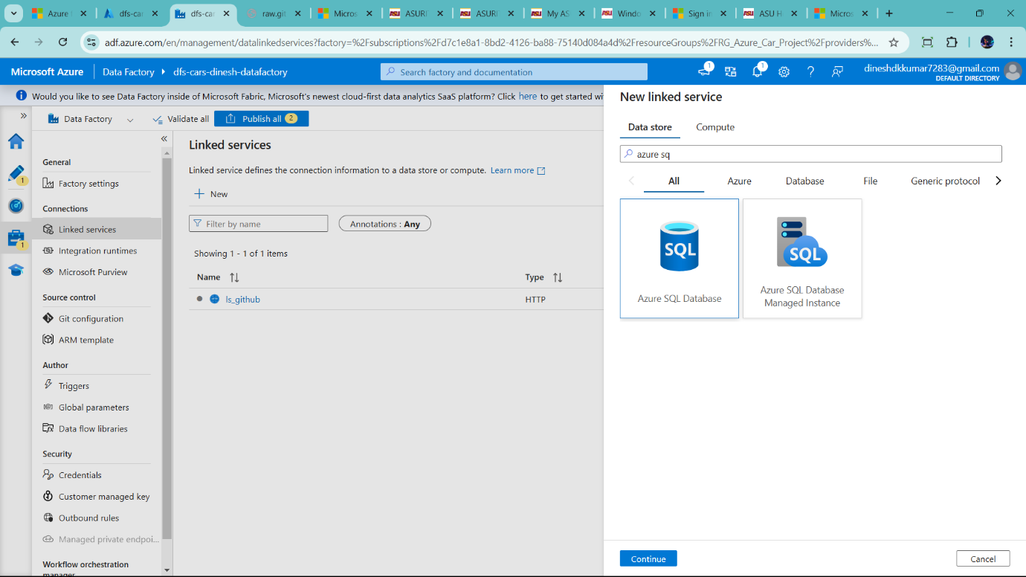

Add name ls_sqlDB 🡪 change azure subscription 🡪azure of student (like) 🡪add server name 🡪

Add databases name and password (already created)

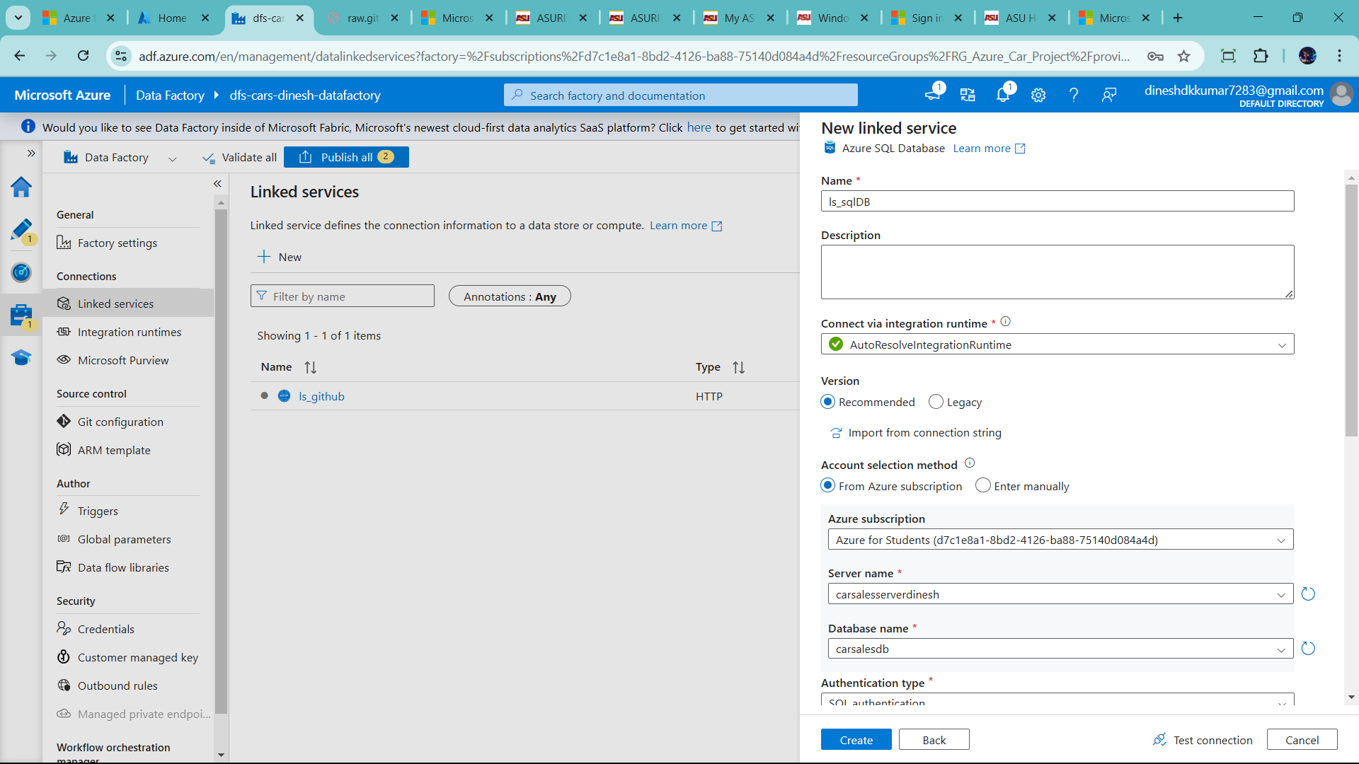

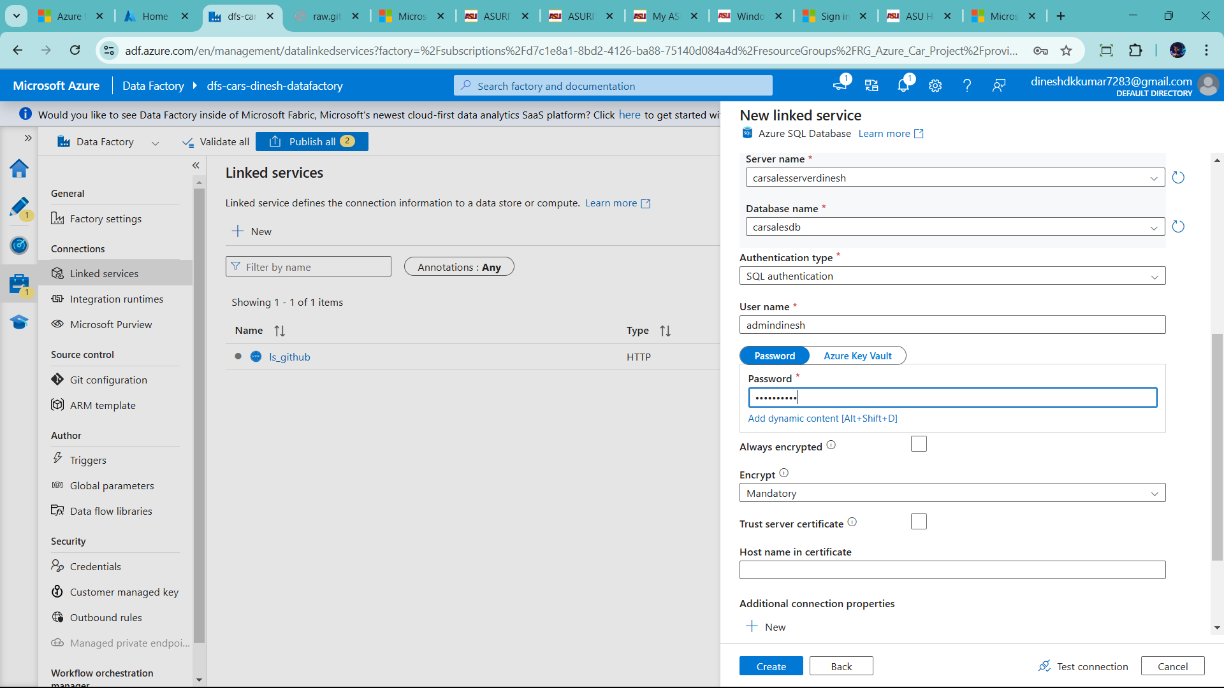

Test the connect show error 🡪 the give some security add in sqlserver

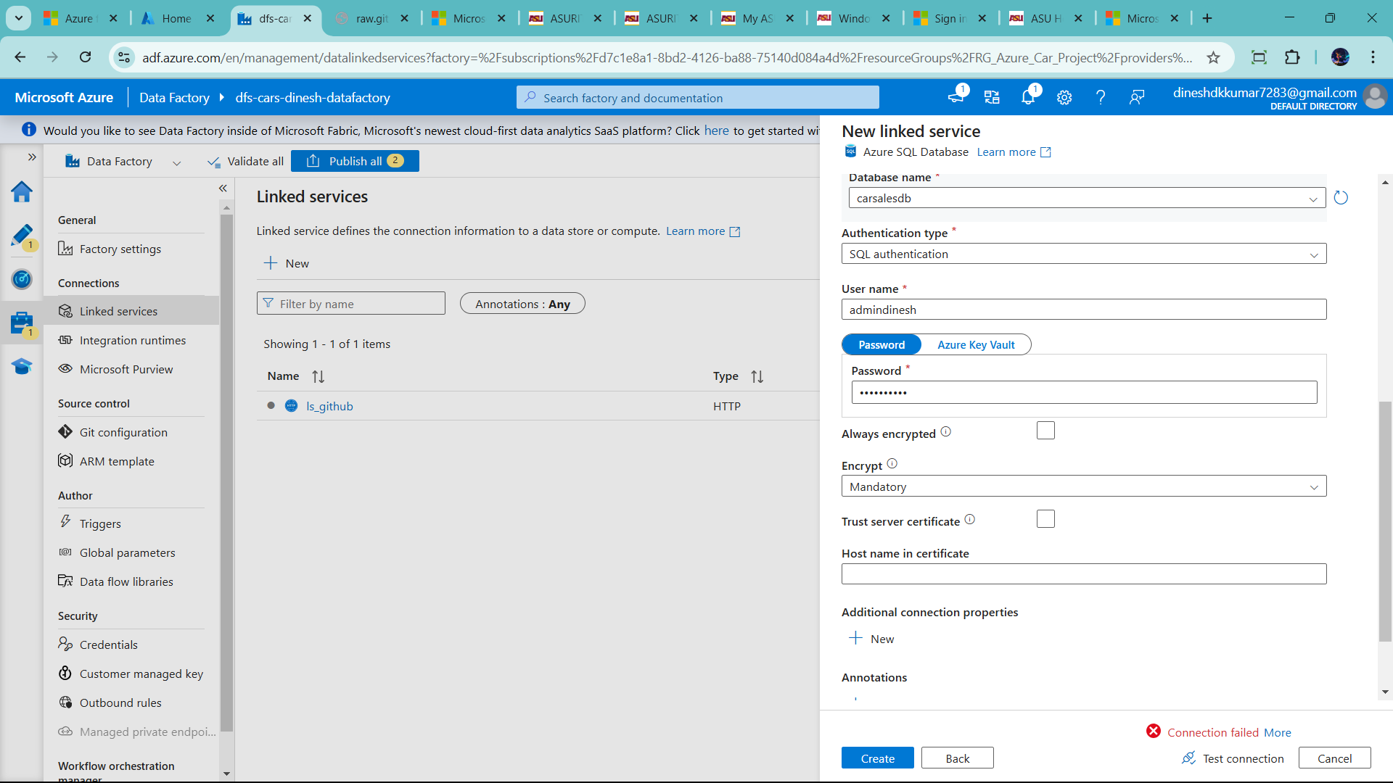

Let change it

Click server

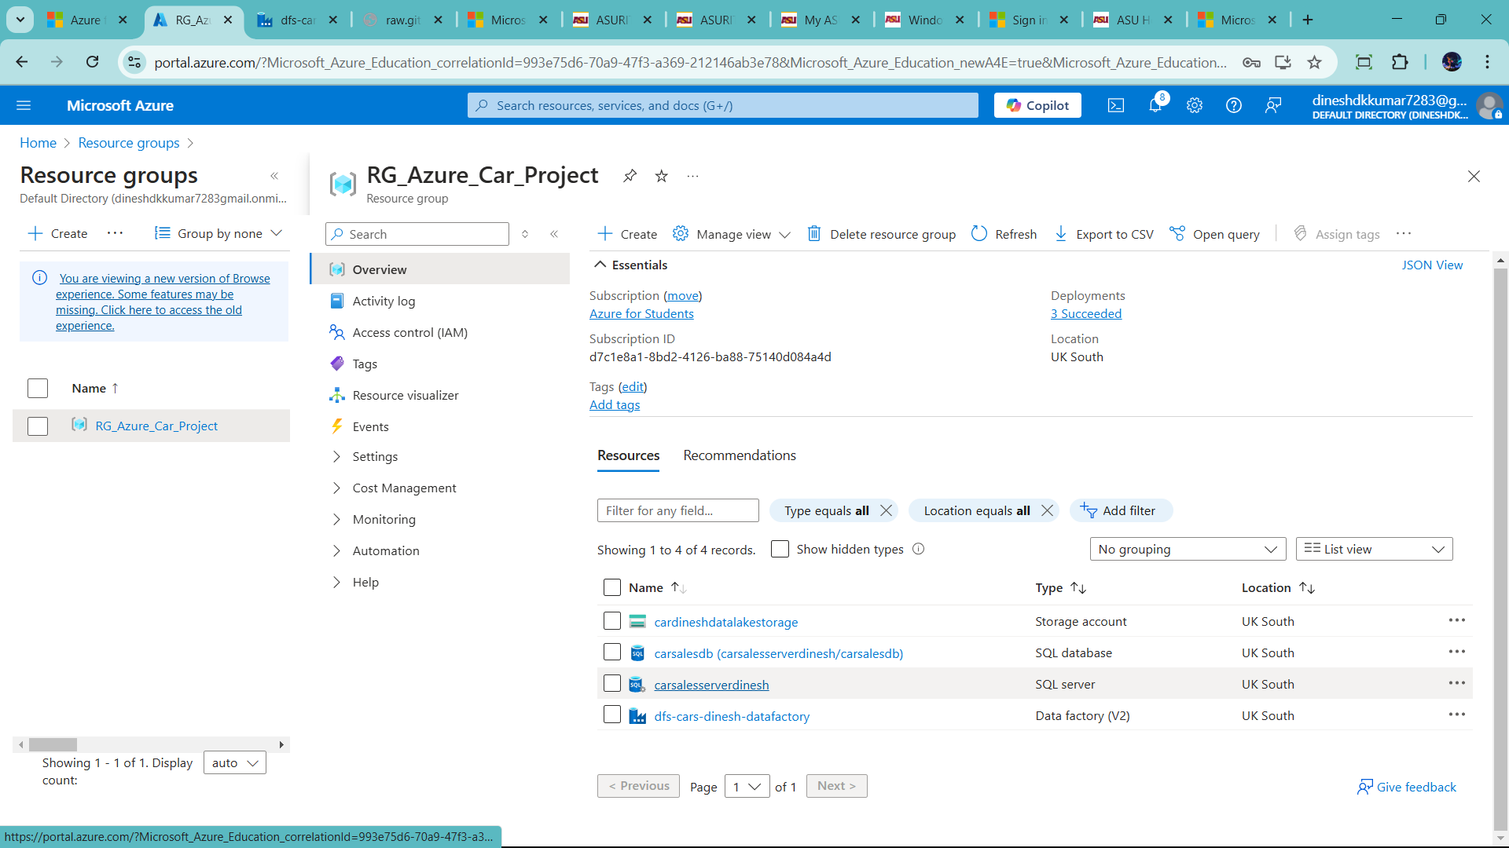

They show error because it is only selected networks

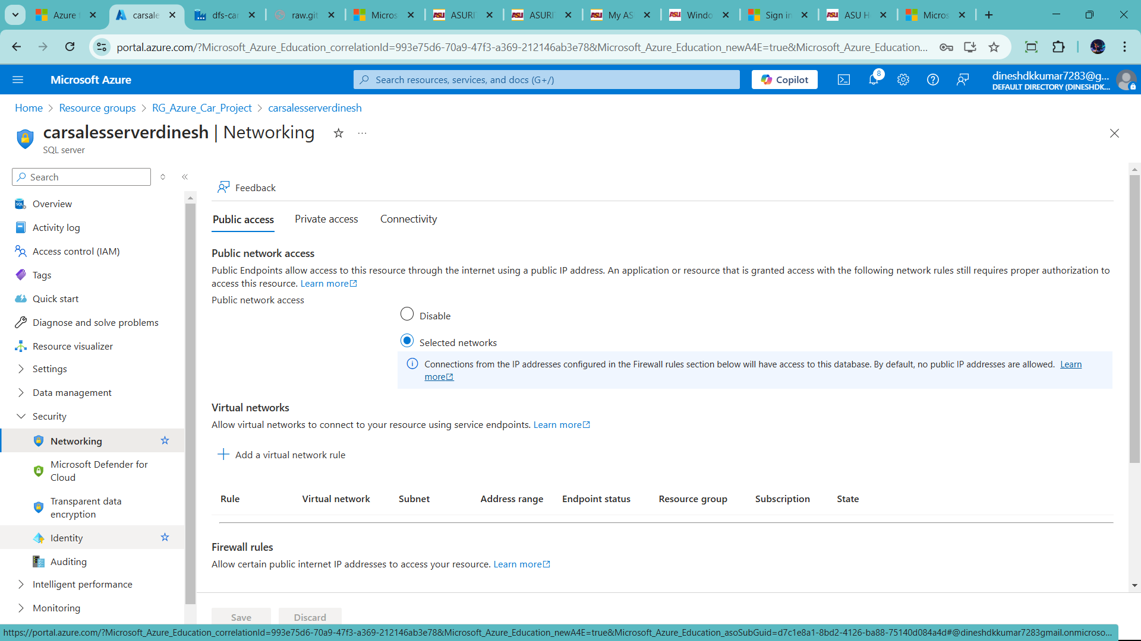

So when click allow all the network ip address. So check the box in exception

And save it

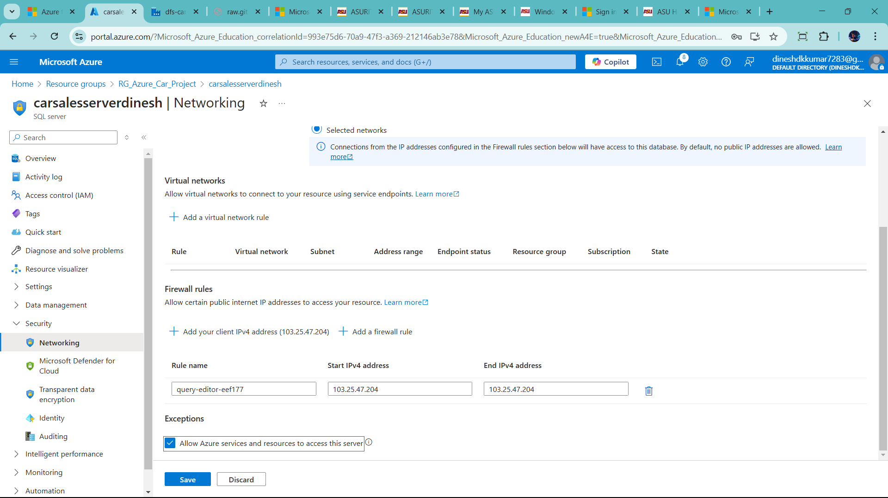

Now success full

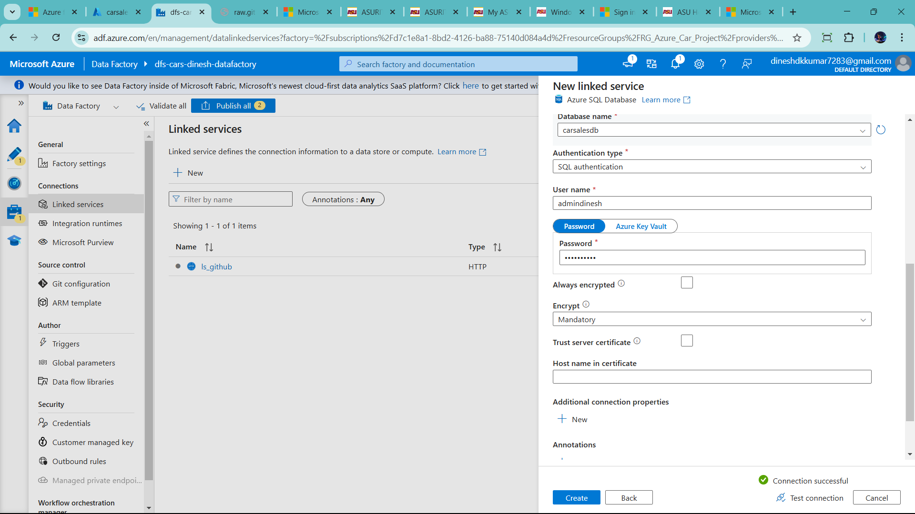

Now create two activity in this pipline

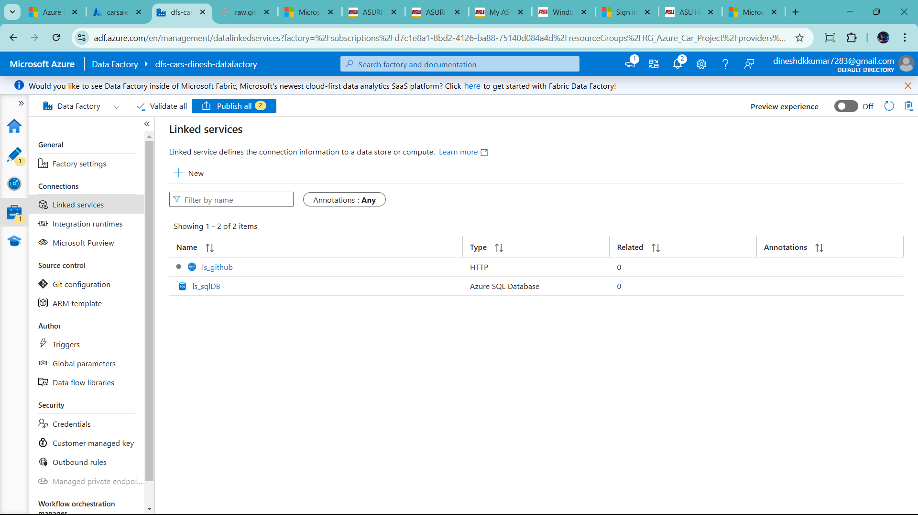

Now click Author to create pipeline

First click the copy data 🡪 then click source

Let create parameter dataset because it is dynmanic dataset

So click +new

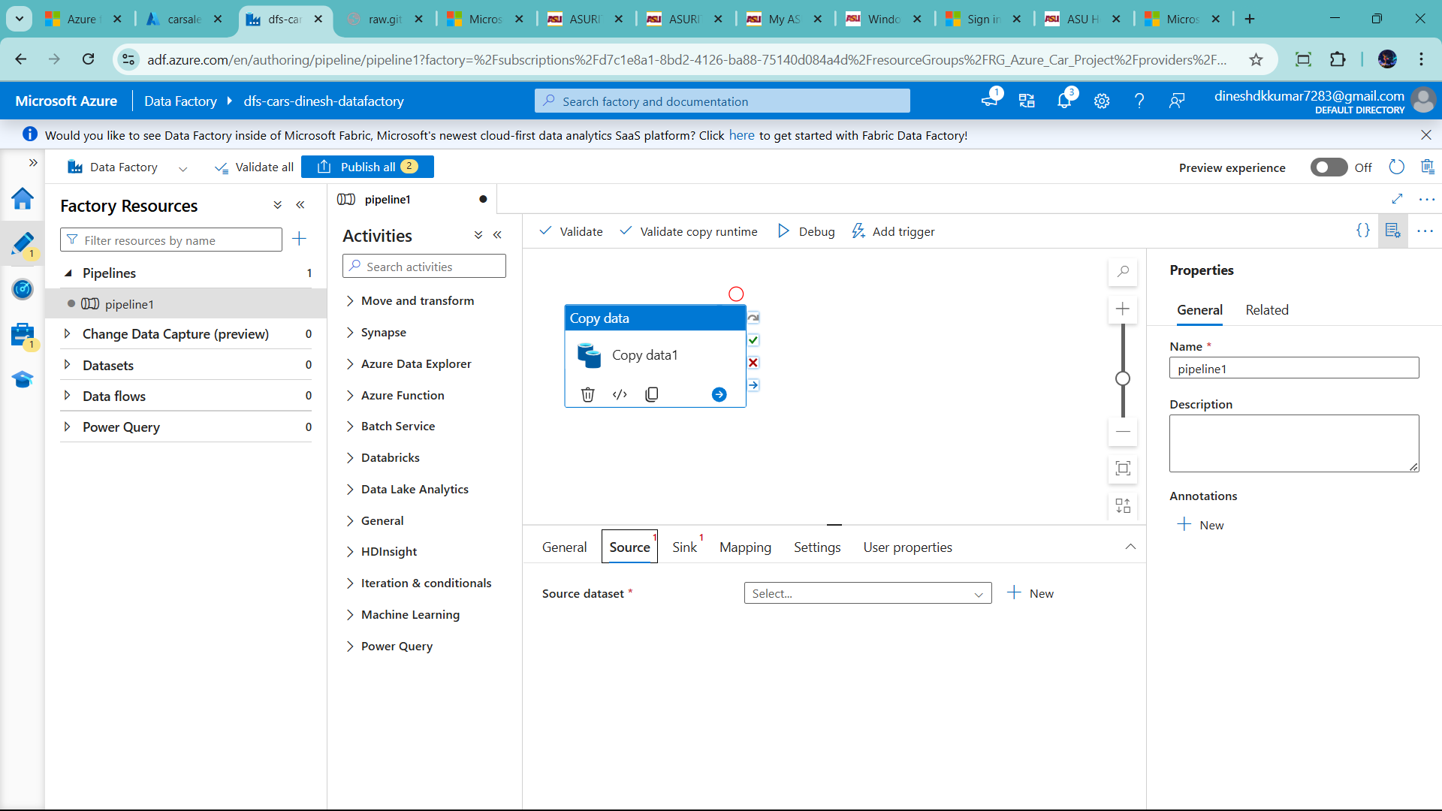

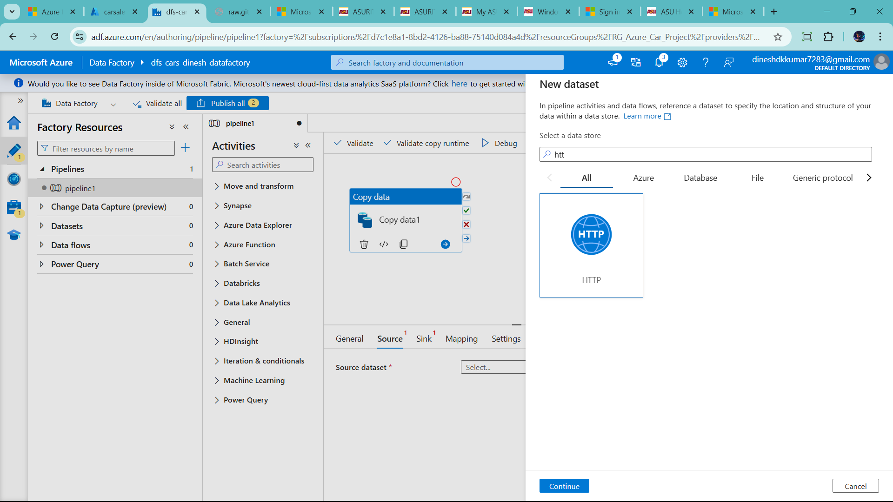

Csv

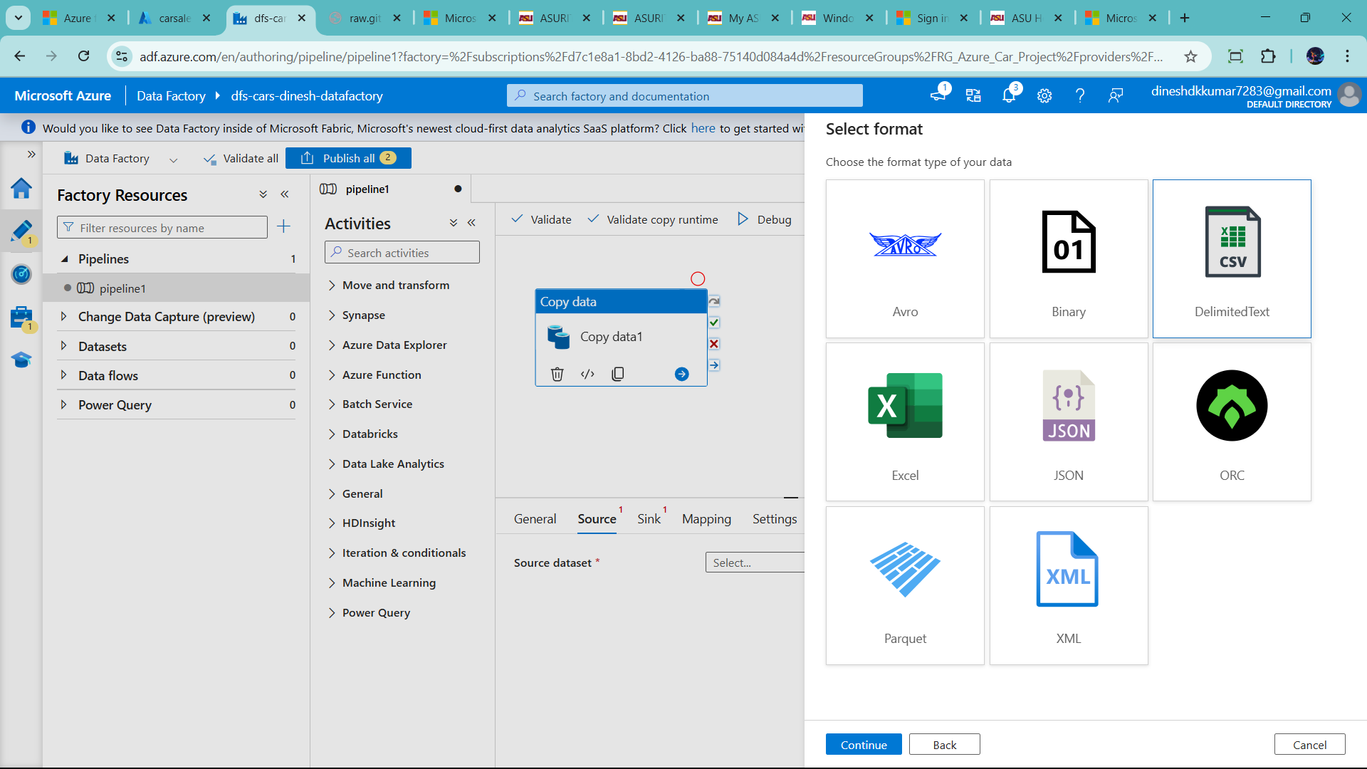

Now add name, add linked service,and releative url

This releative url

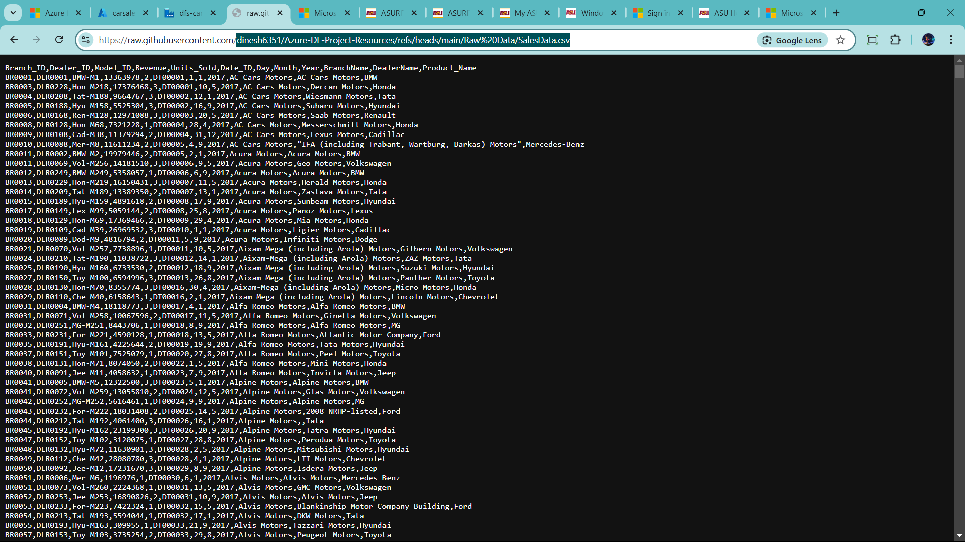

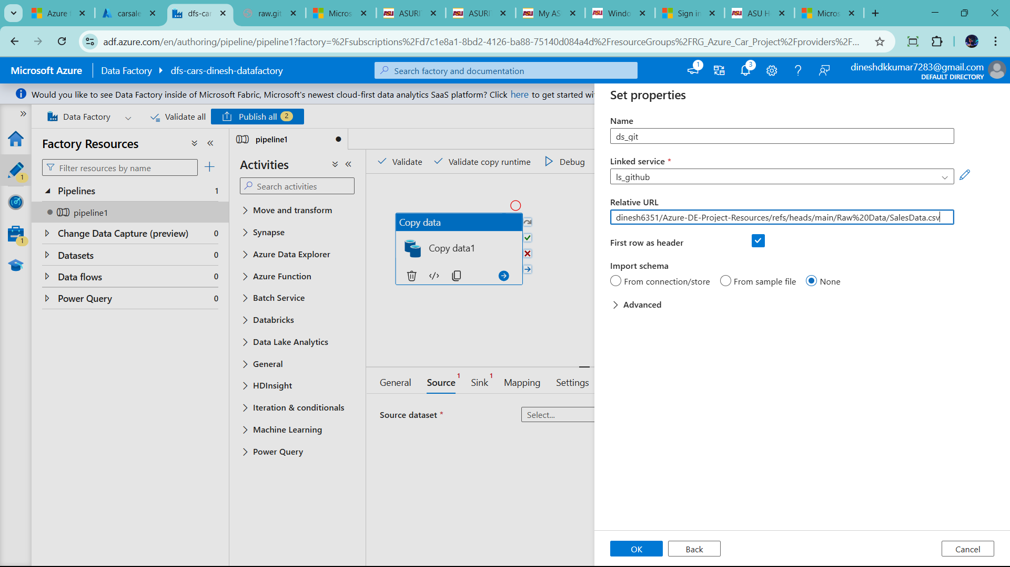

Because create dynamic to add csv file as incremental load

Now add parameter in this dataset

So ,click advance option and open this dataset

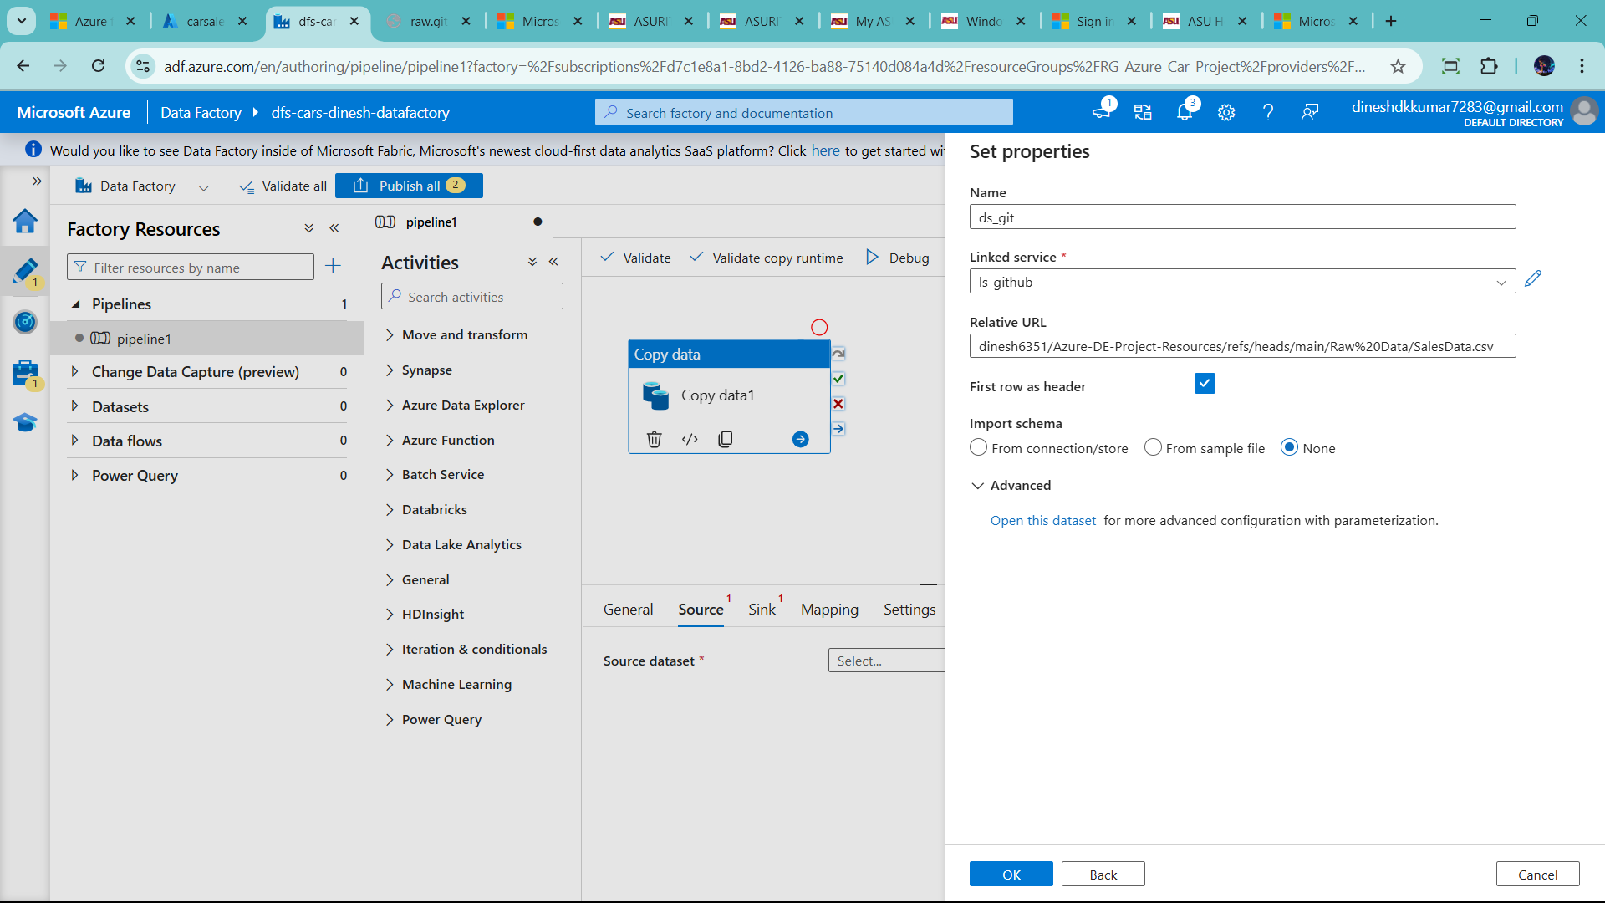

Than click parameter tap and click new

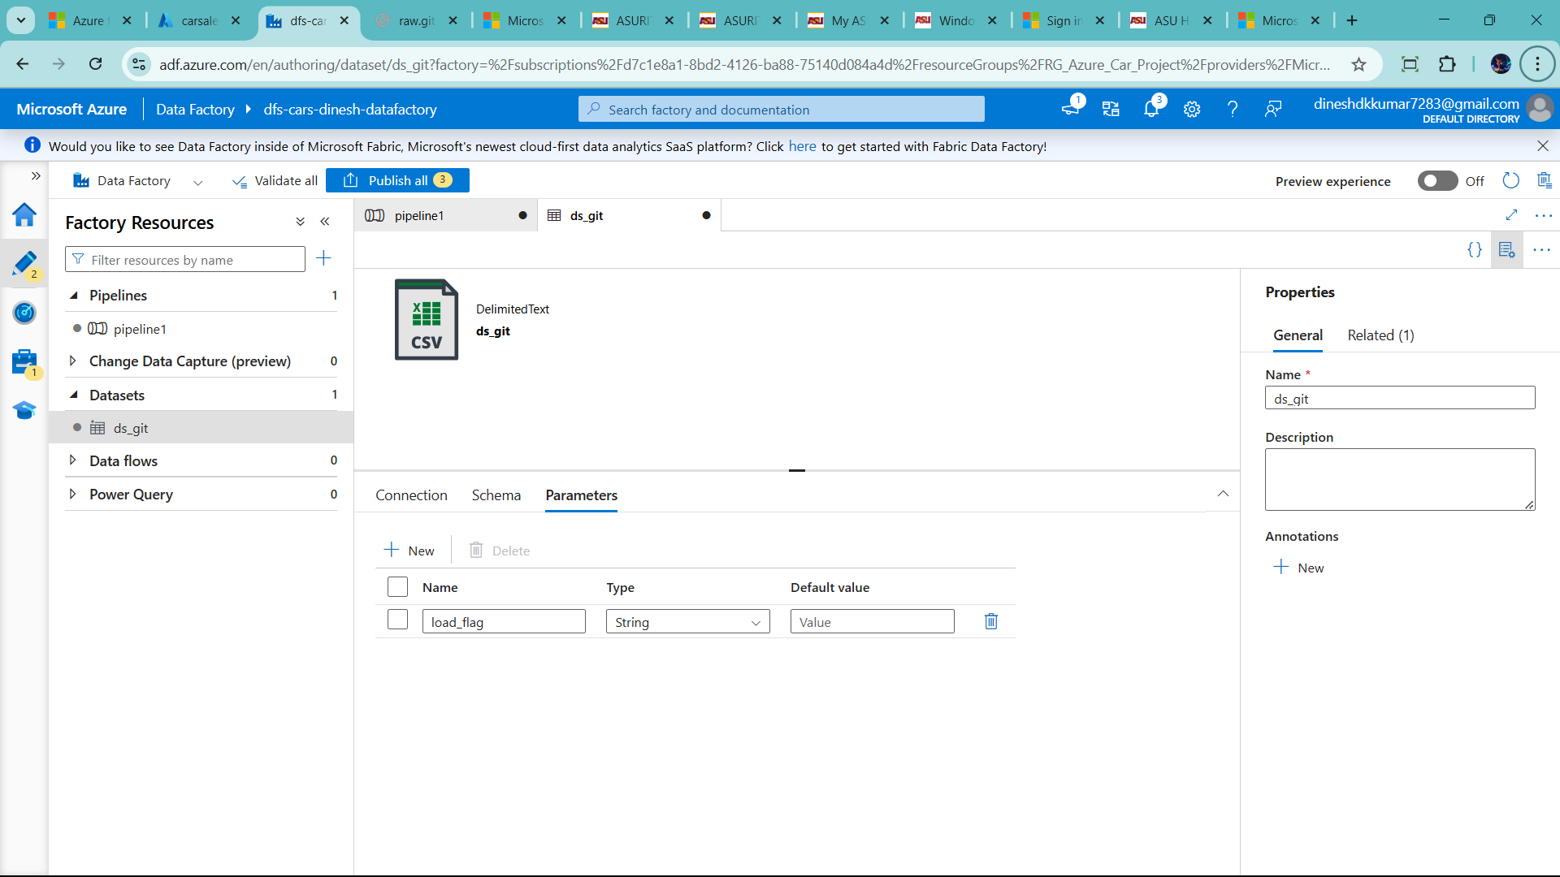

Go back to connection and click on releative url And clicl dynamic content show below

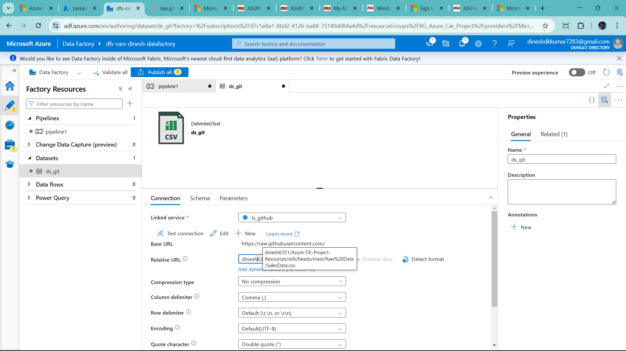

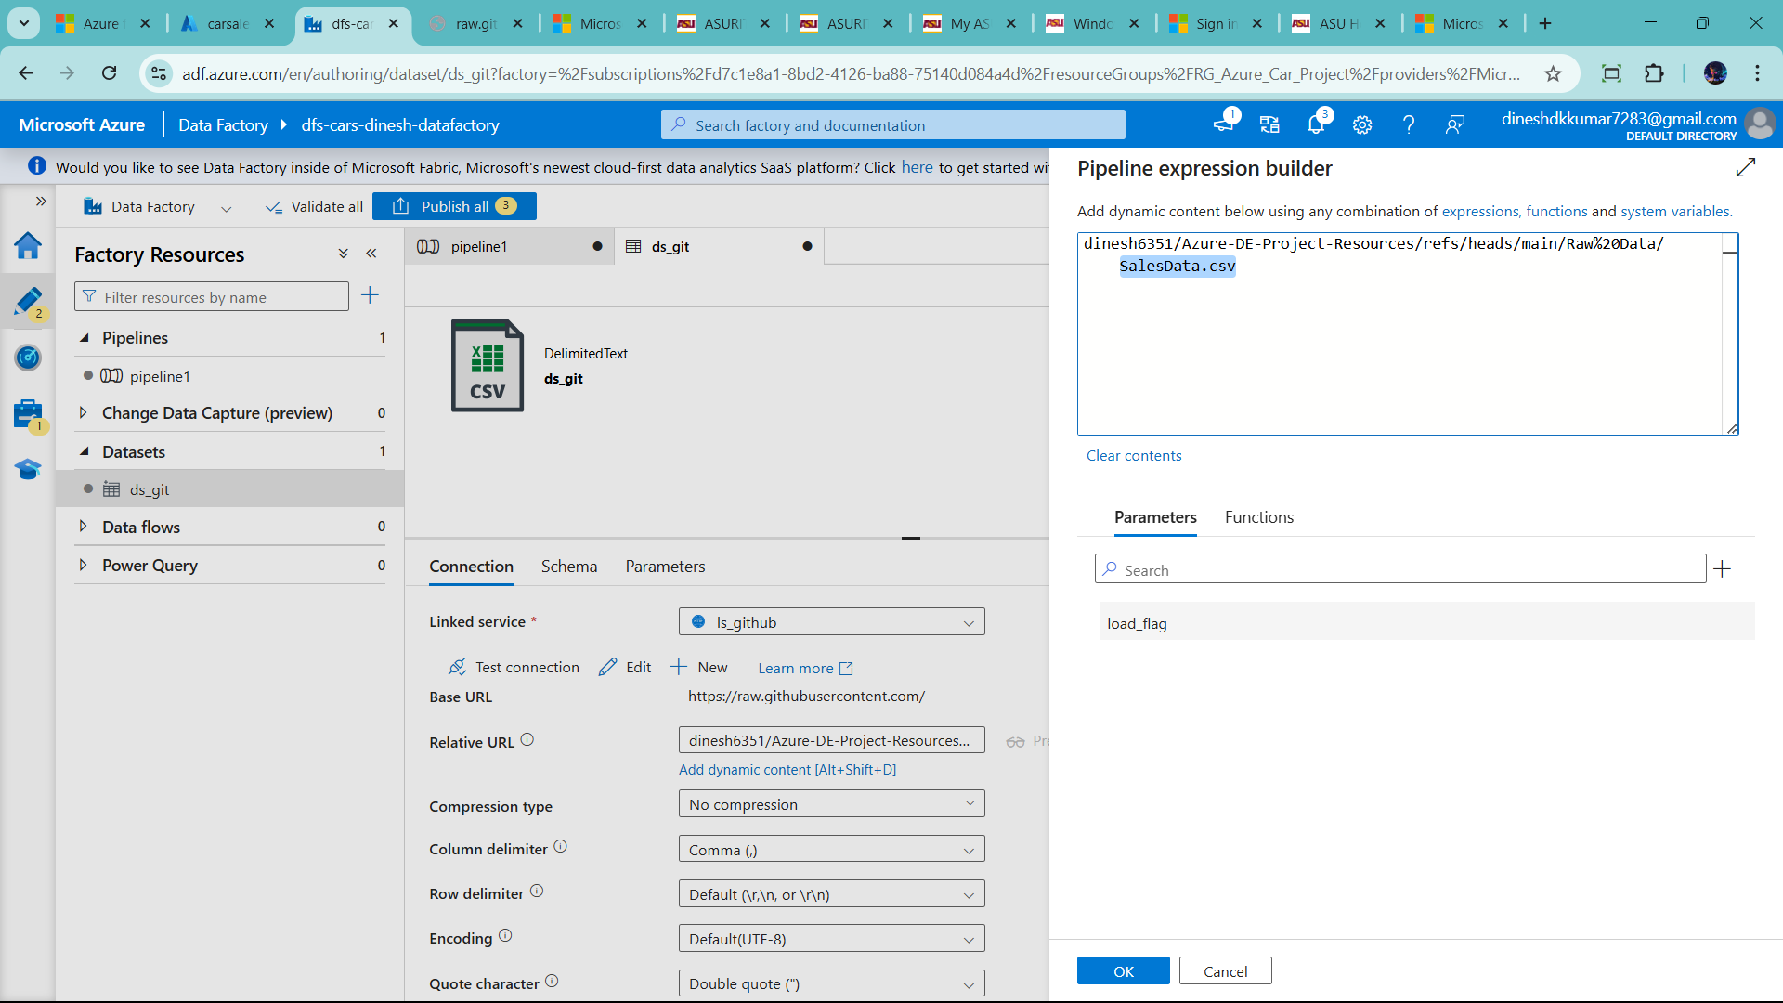

Select SalesData.csv =🡪click load_flag 🡪

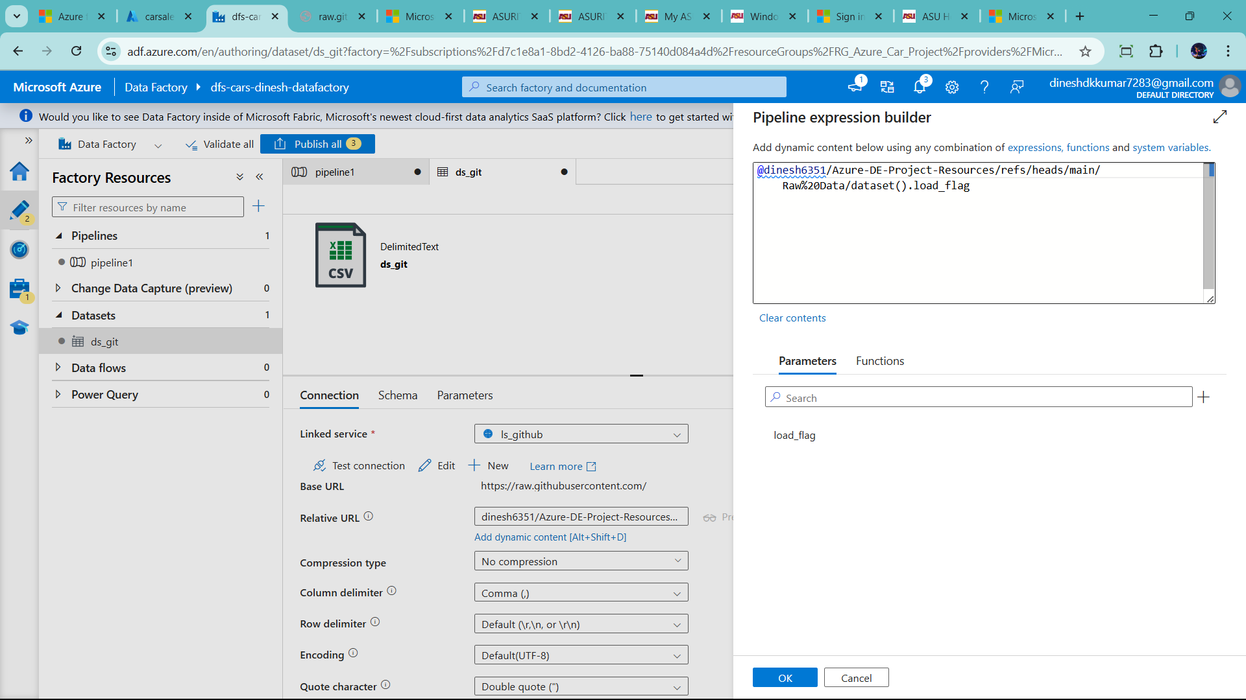

Now change string to varable

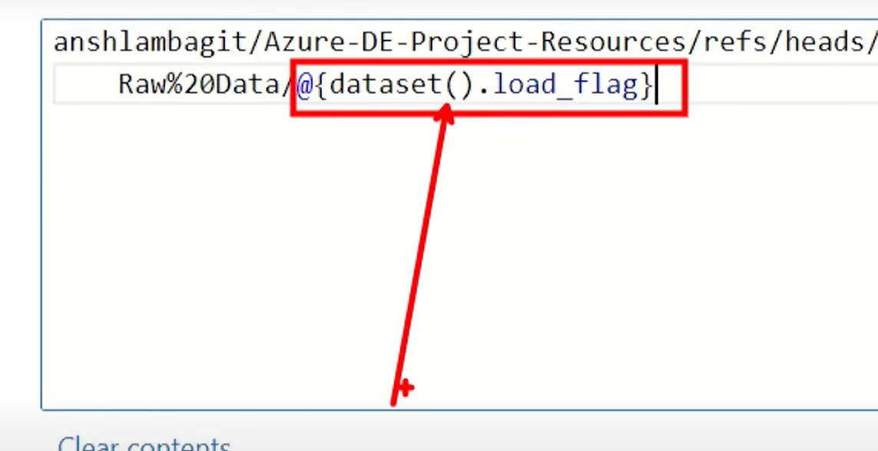

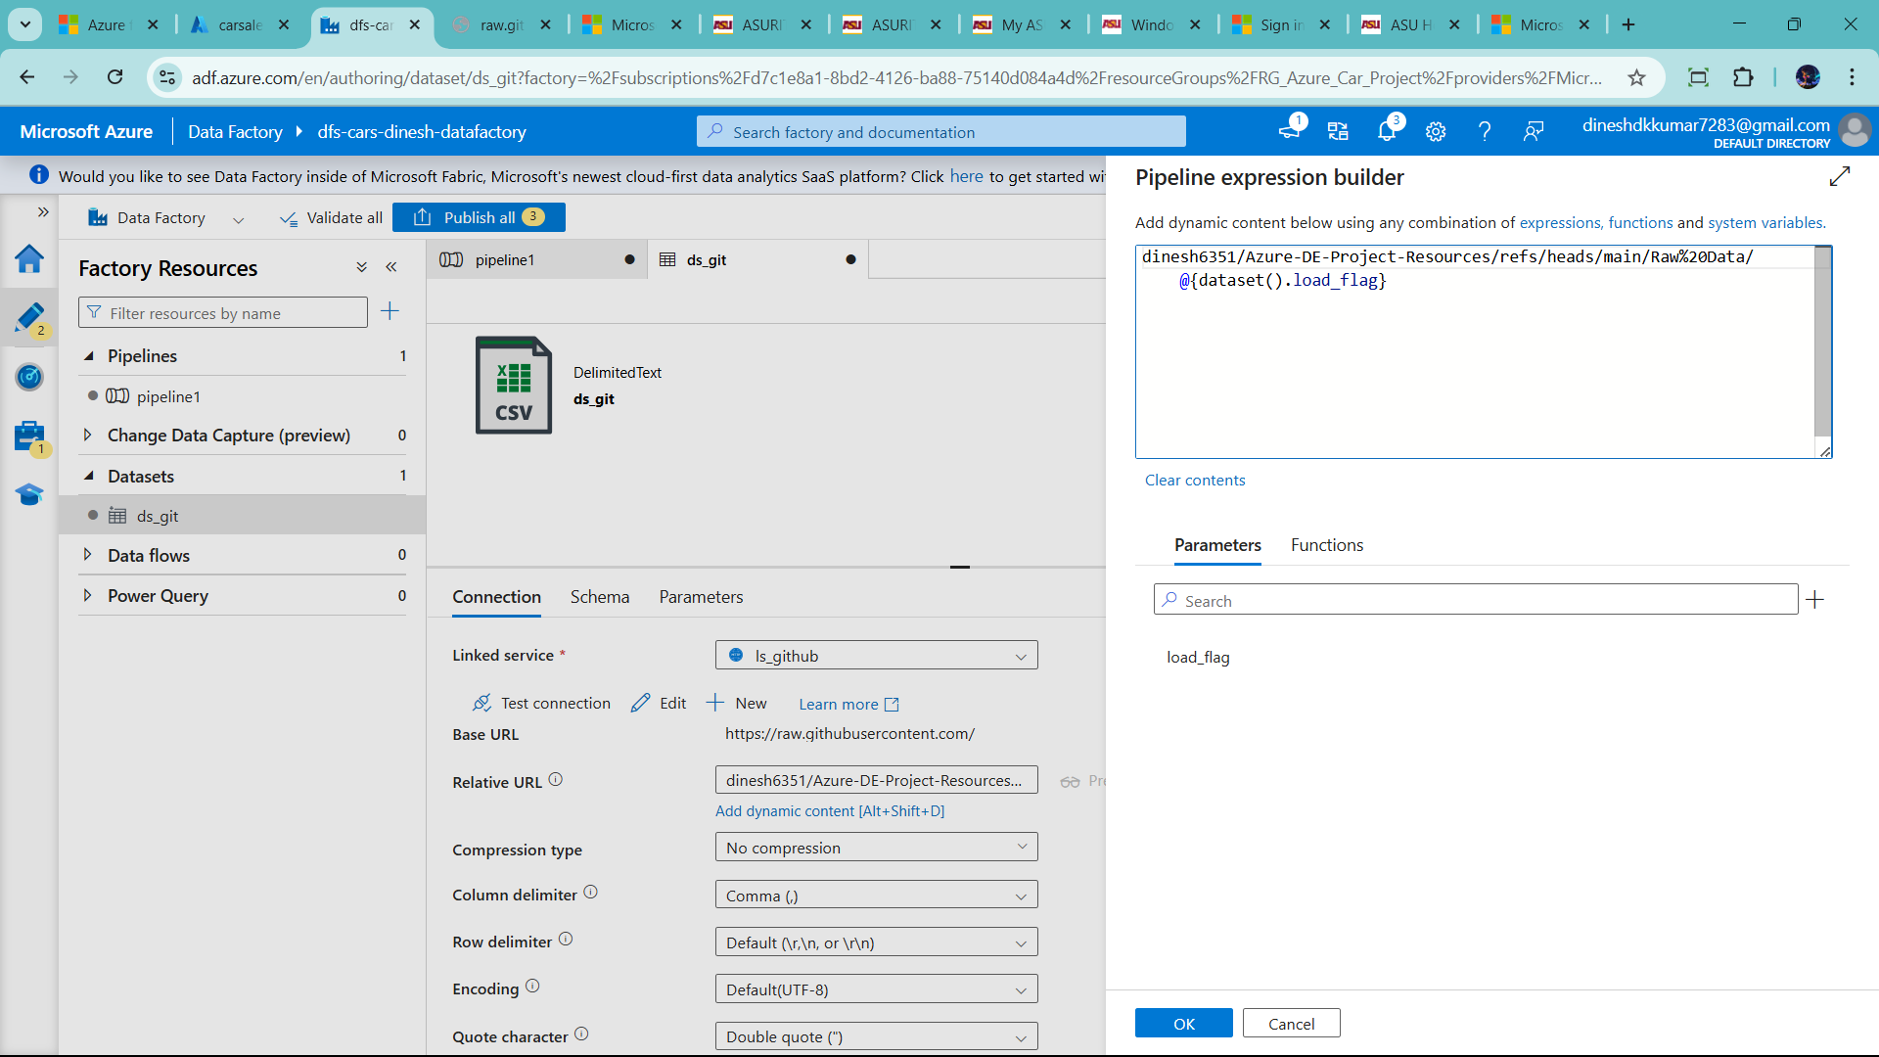

Now click ok and go to pipeline1/source_prep

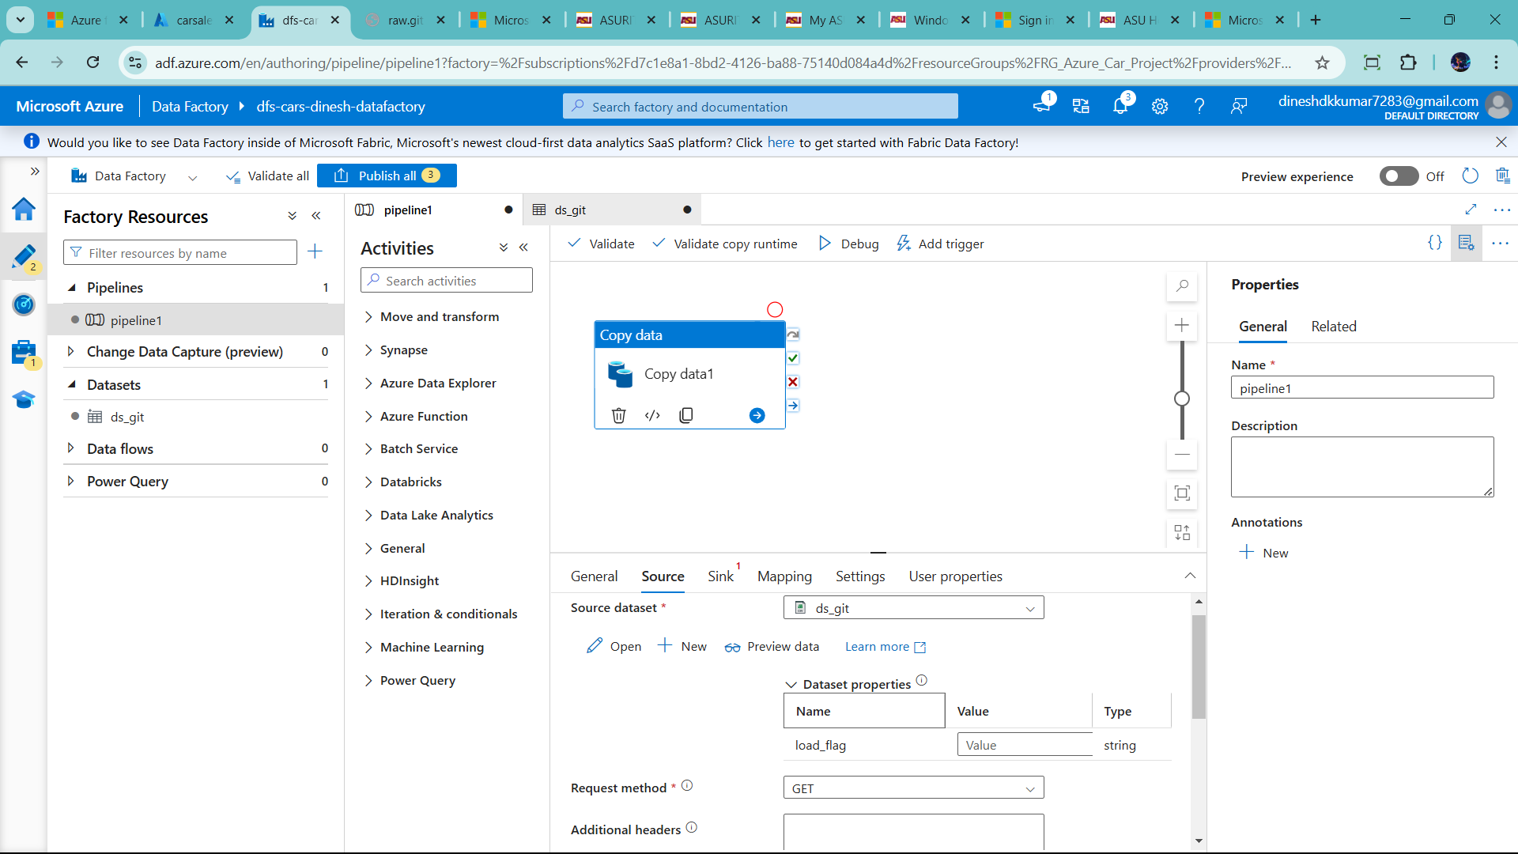

Ask to add value

So I add SalesData.csv and click preview data

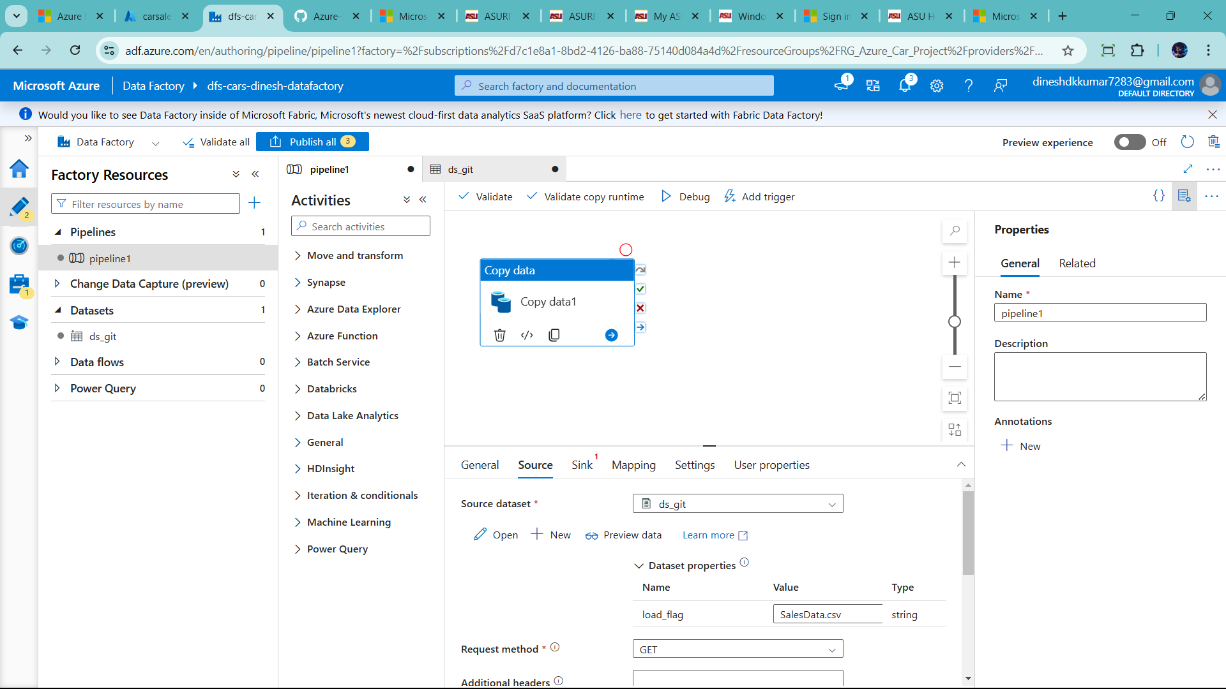

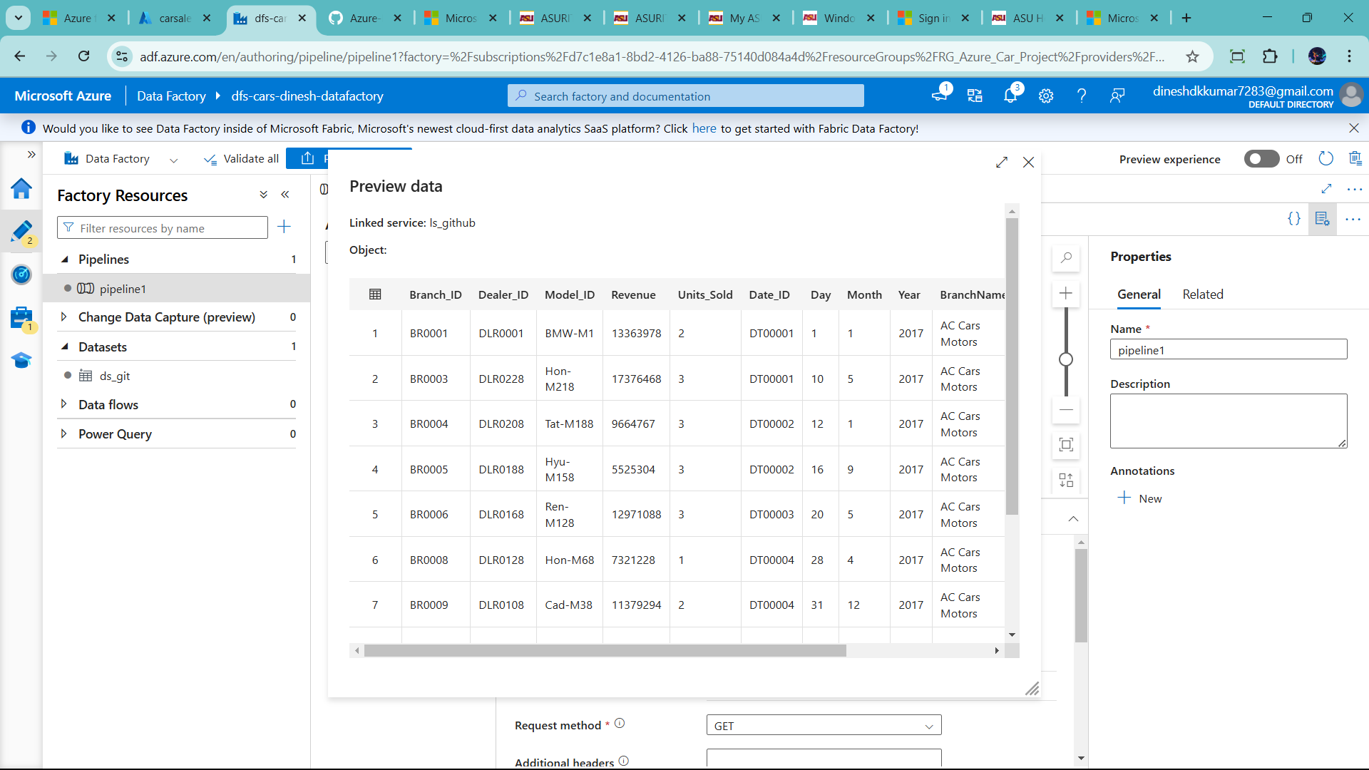

Now Click sink 🡪 click new 🡪type azure sqldatabase 🡪click ok

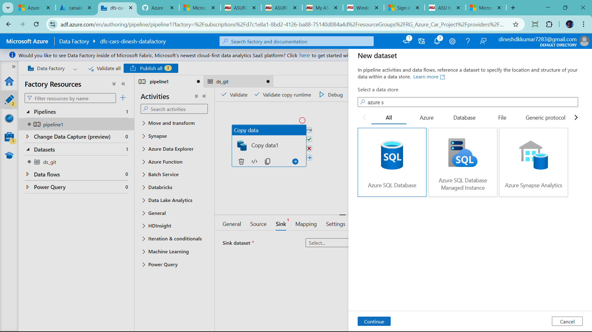

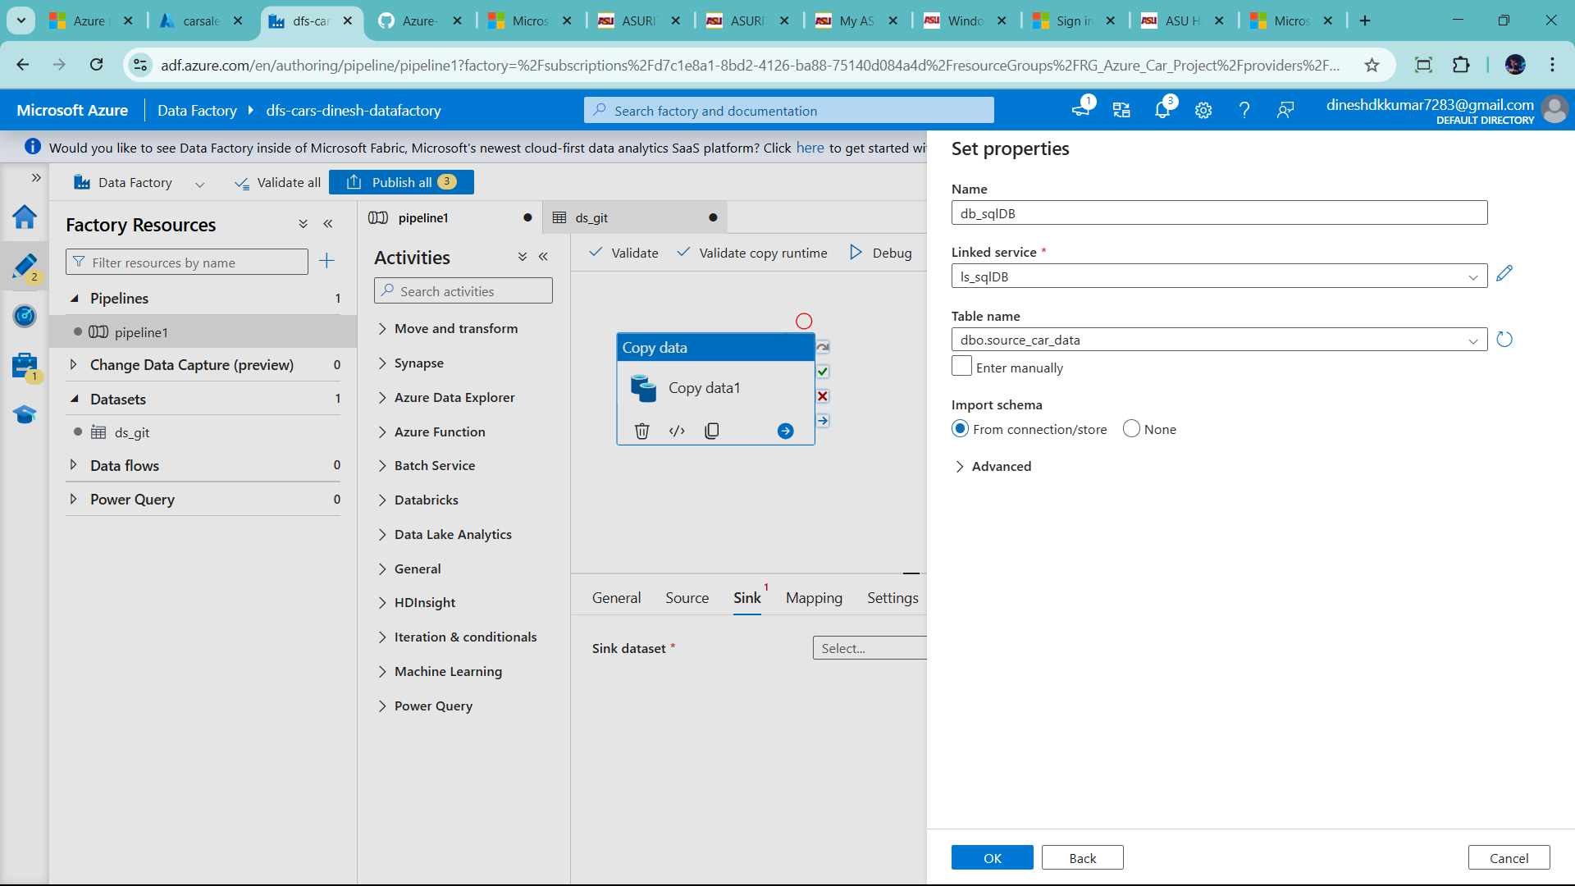

Now click mapping and import schema

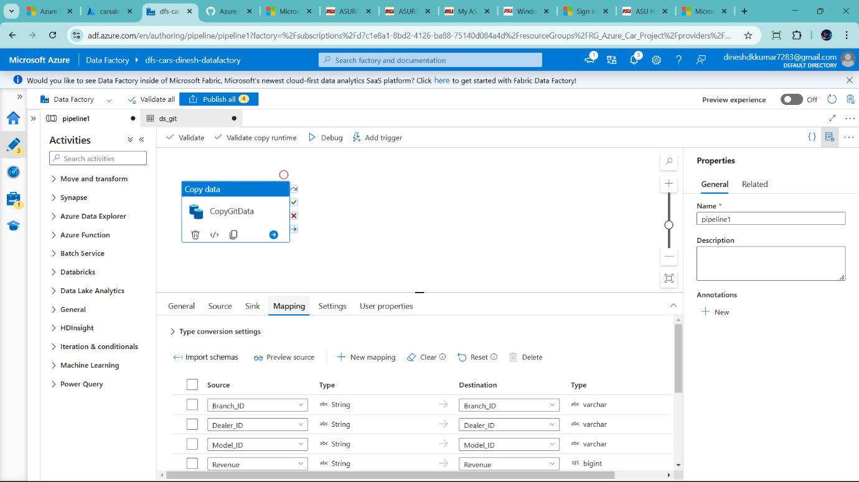

Now load the data in sql db , so click Debug

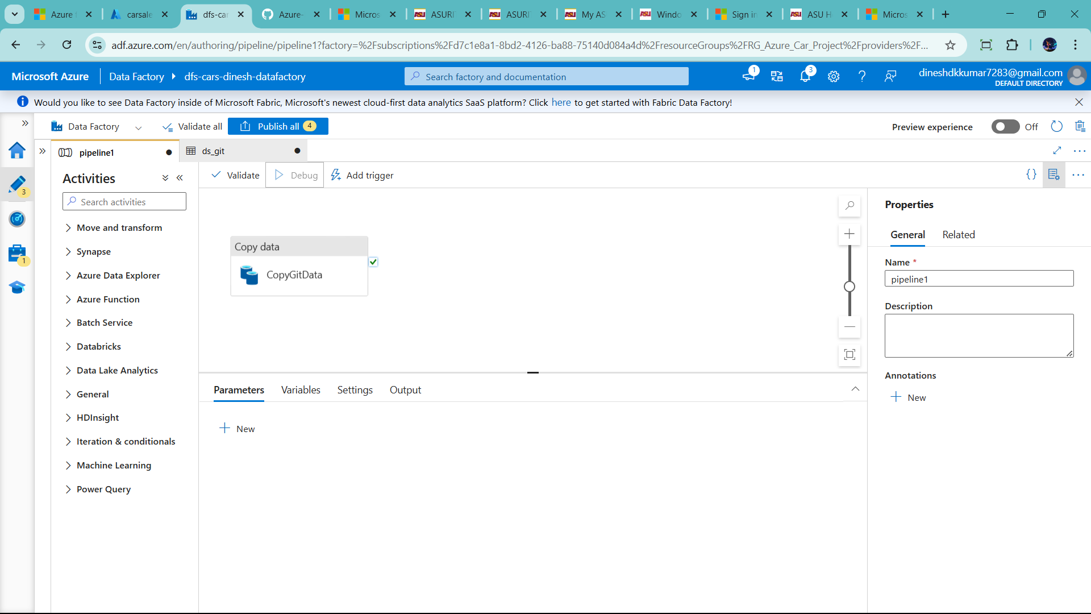

Success 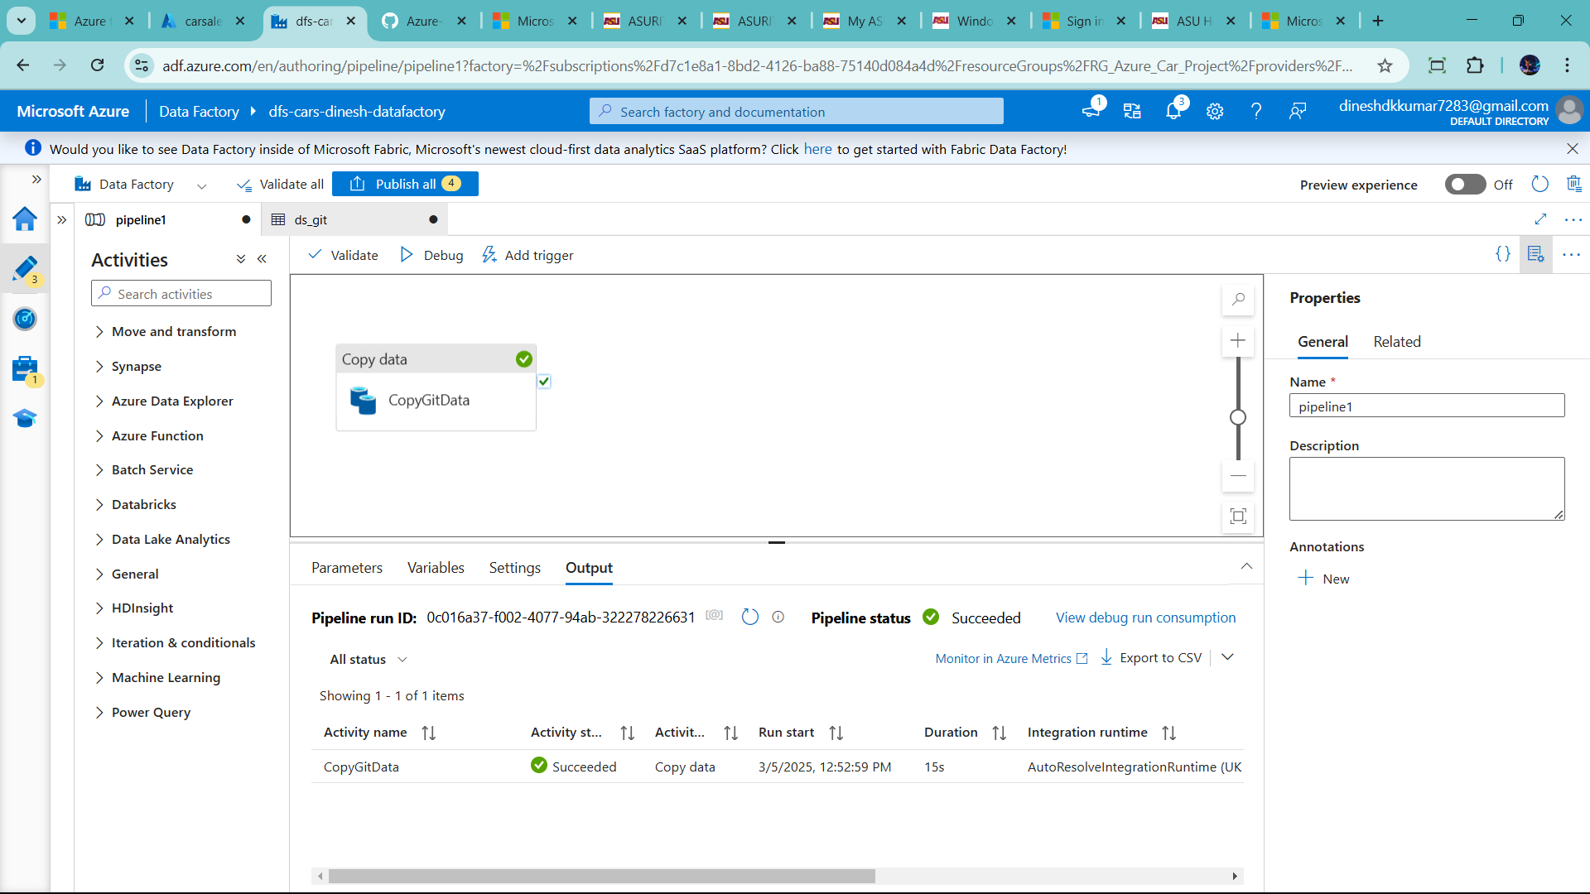

Dynamic ETL pipeline in Azure Data factory

Now the public the data , so click publishing and publish

🡪it source-prep pipline publish success

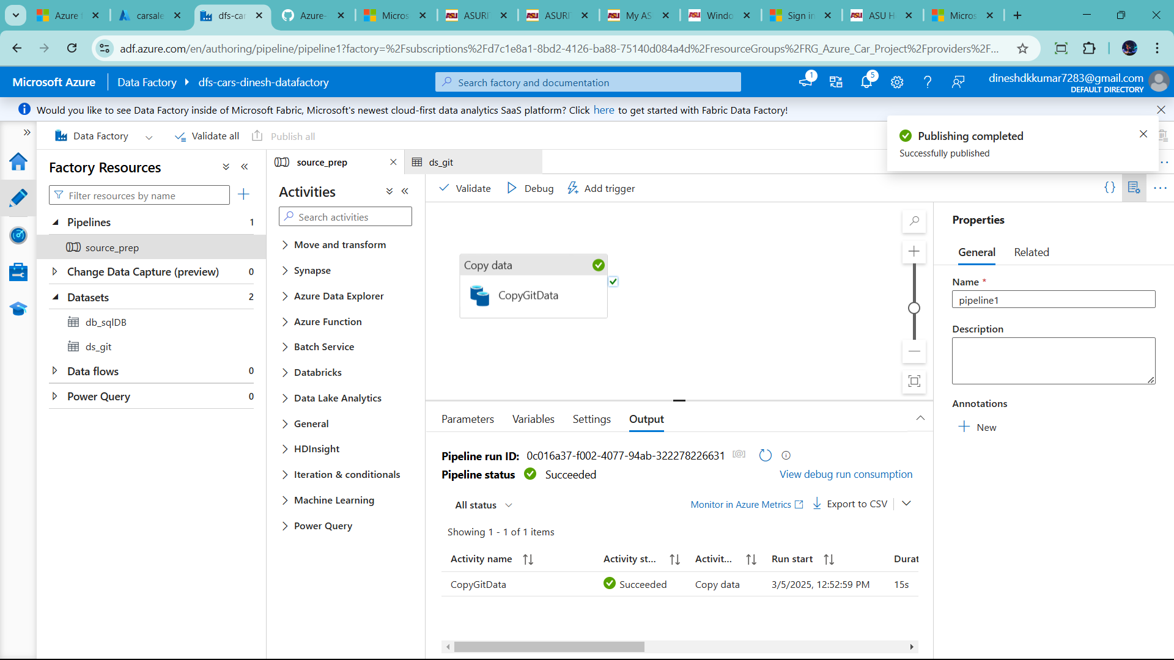

Now create new pipeline for incremental load

Click pipeline🡪new pipline 🡪 name: incremental_data_pipeline

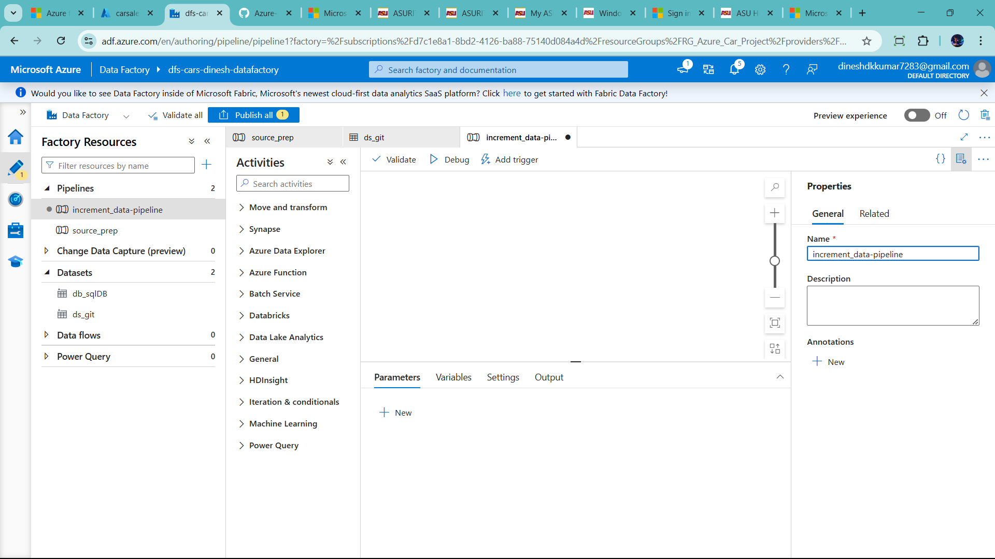

Incremental loading in Azure data factory

In this create two pipline in incremental load

1) initial load pipeline

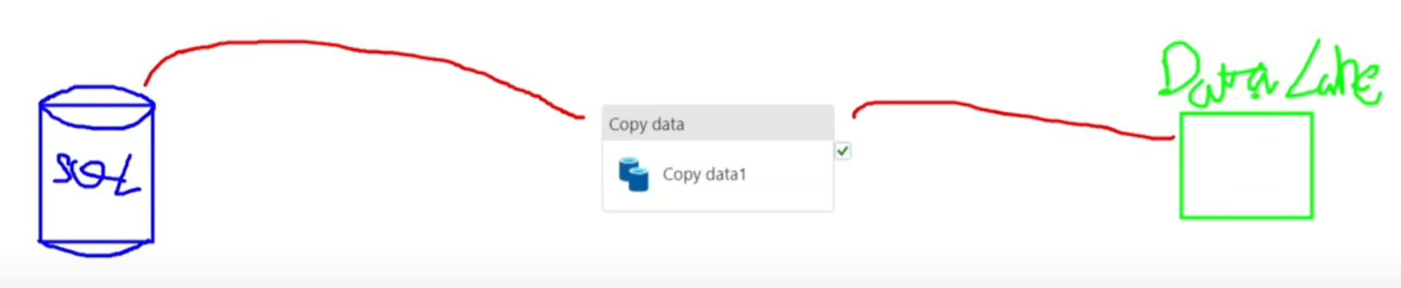

This is initial load . it load all the data to store in datalake

First time consider in instial load pipeline and after first time increment load pipeline use

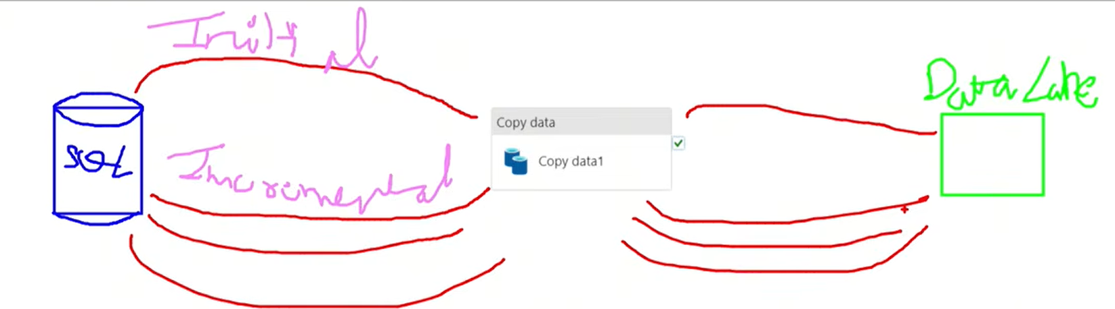

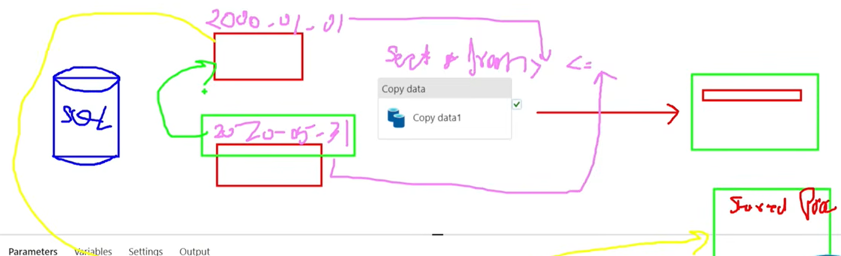

Last date add in store procedure to use for incremental load

Let’s create watermark table and store procedure

Click query section

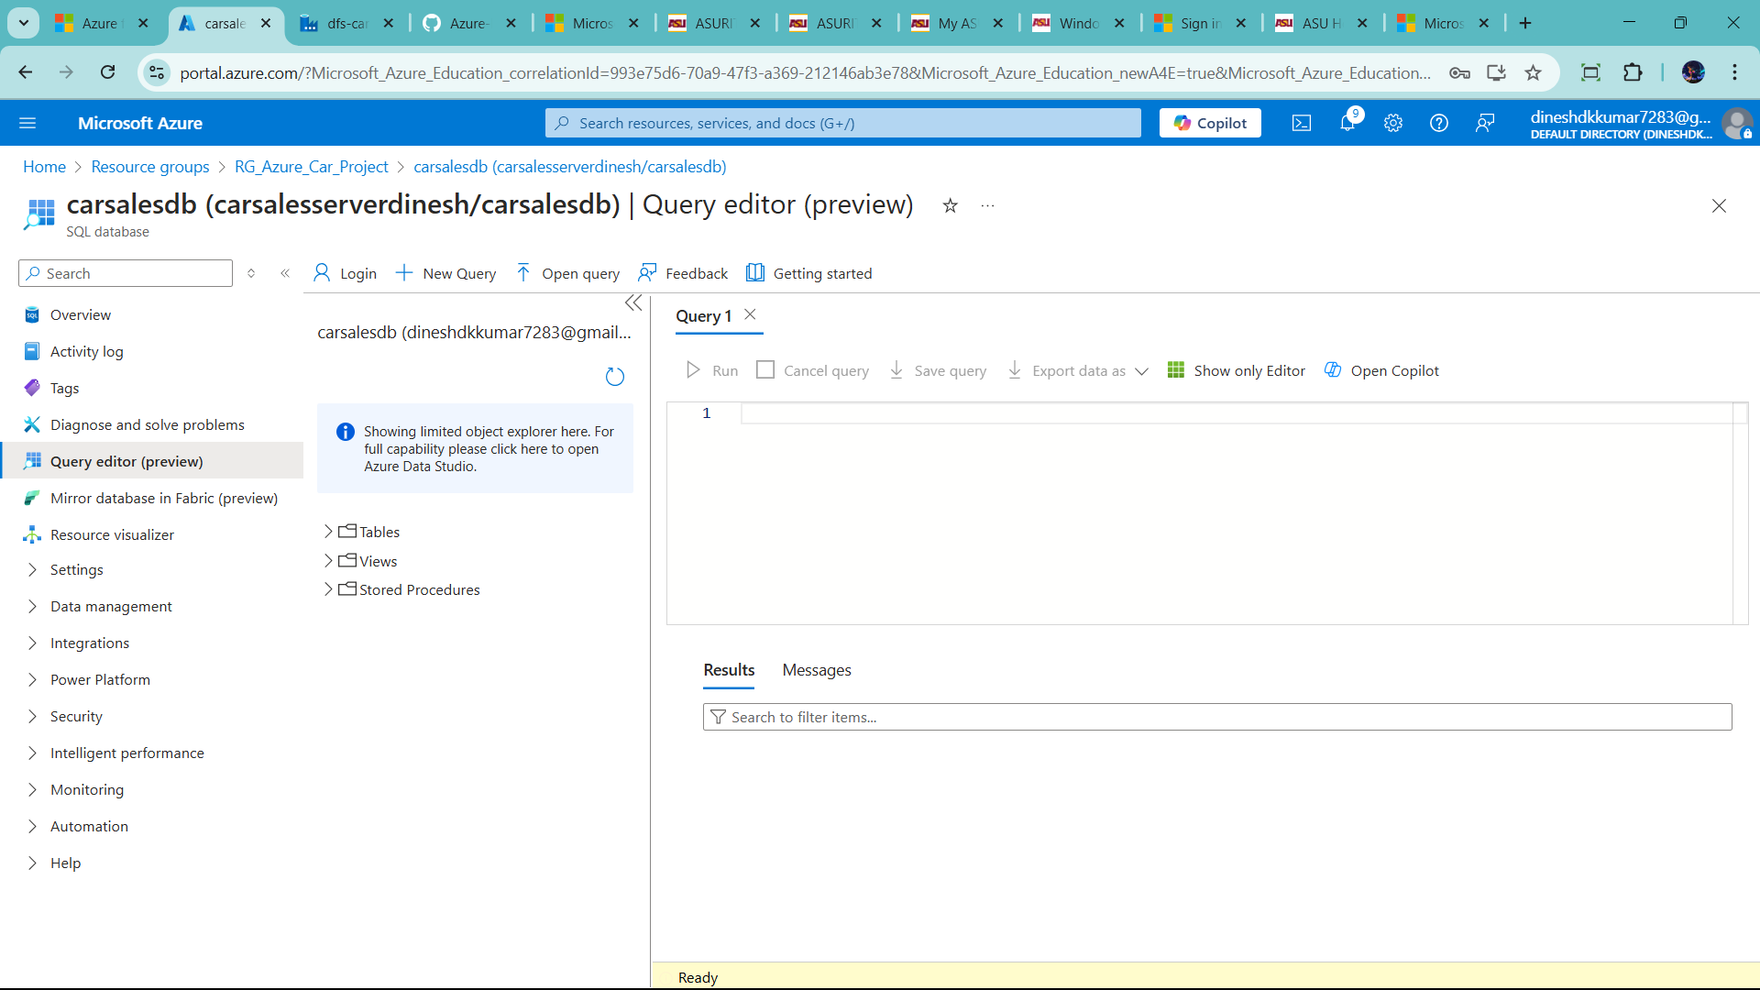

Create water mark table for store last datetime of excucte for store in this

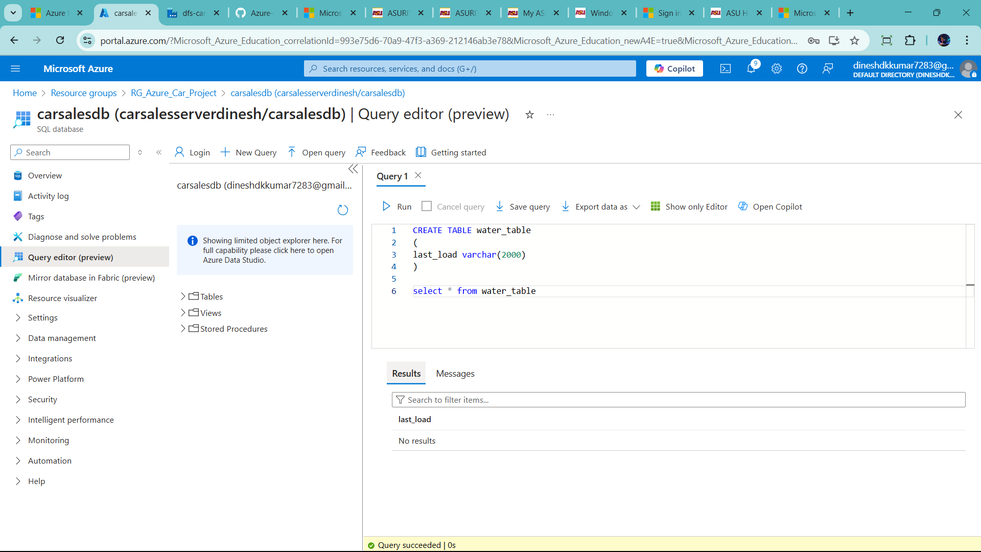

Let check min of date id in source sql table

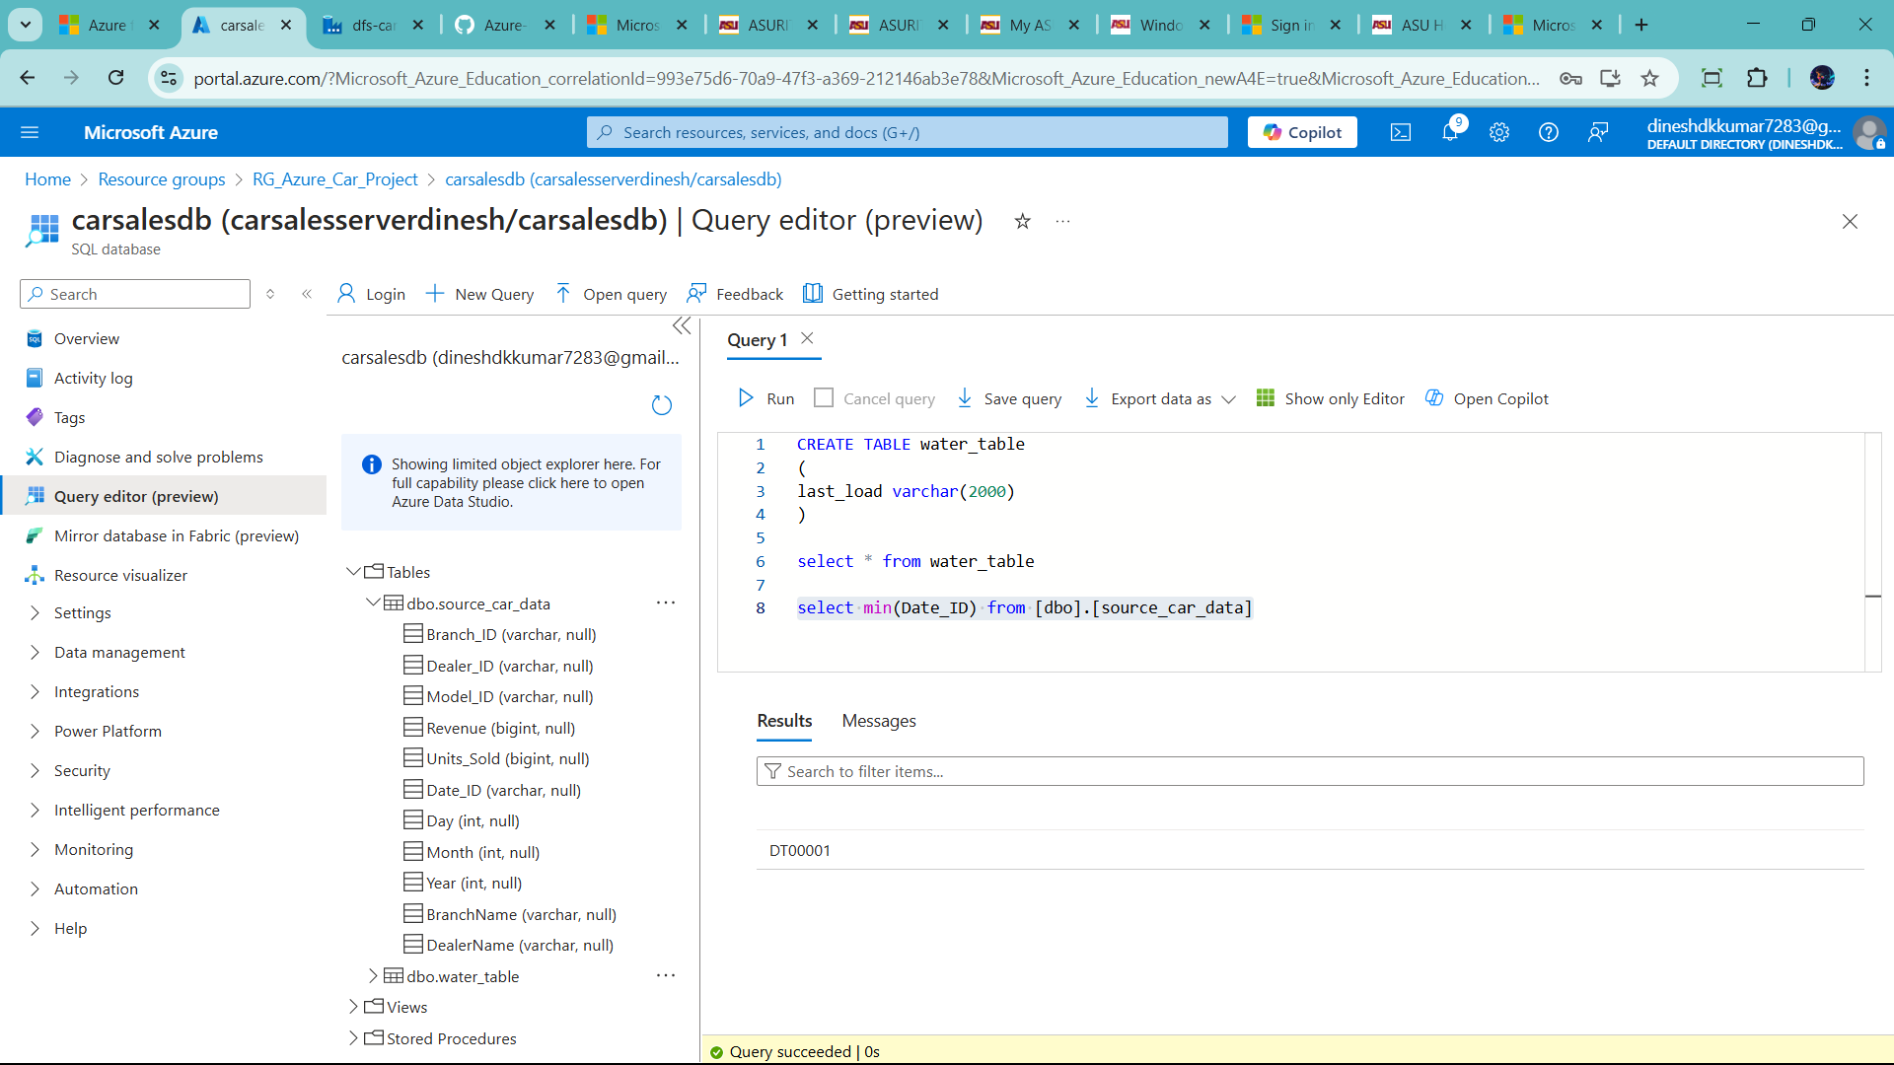

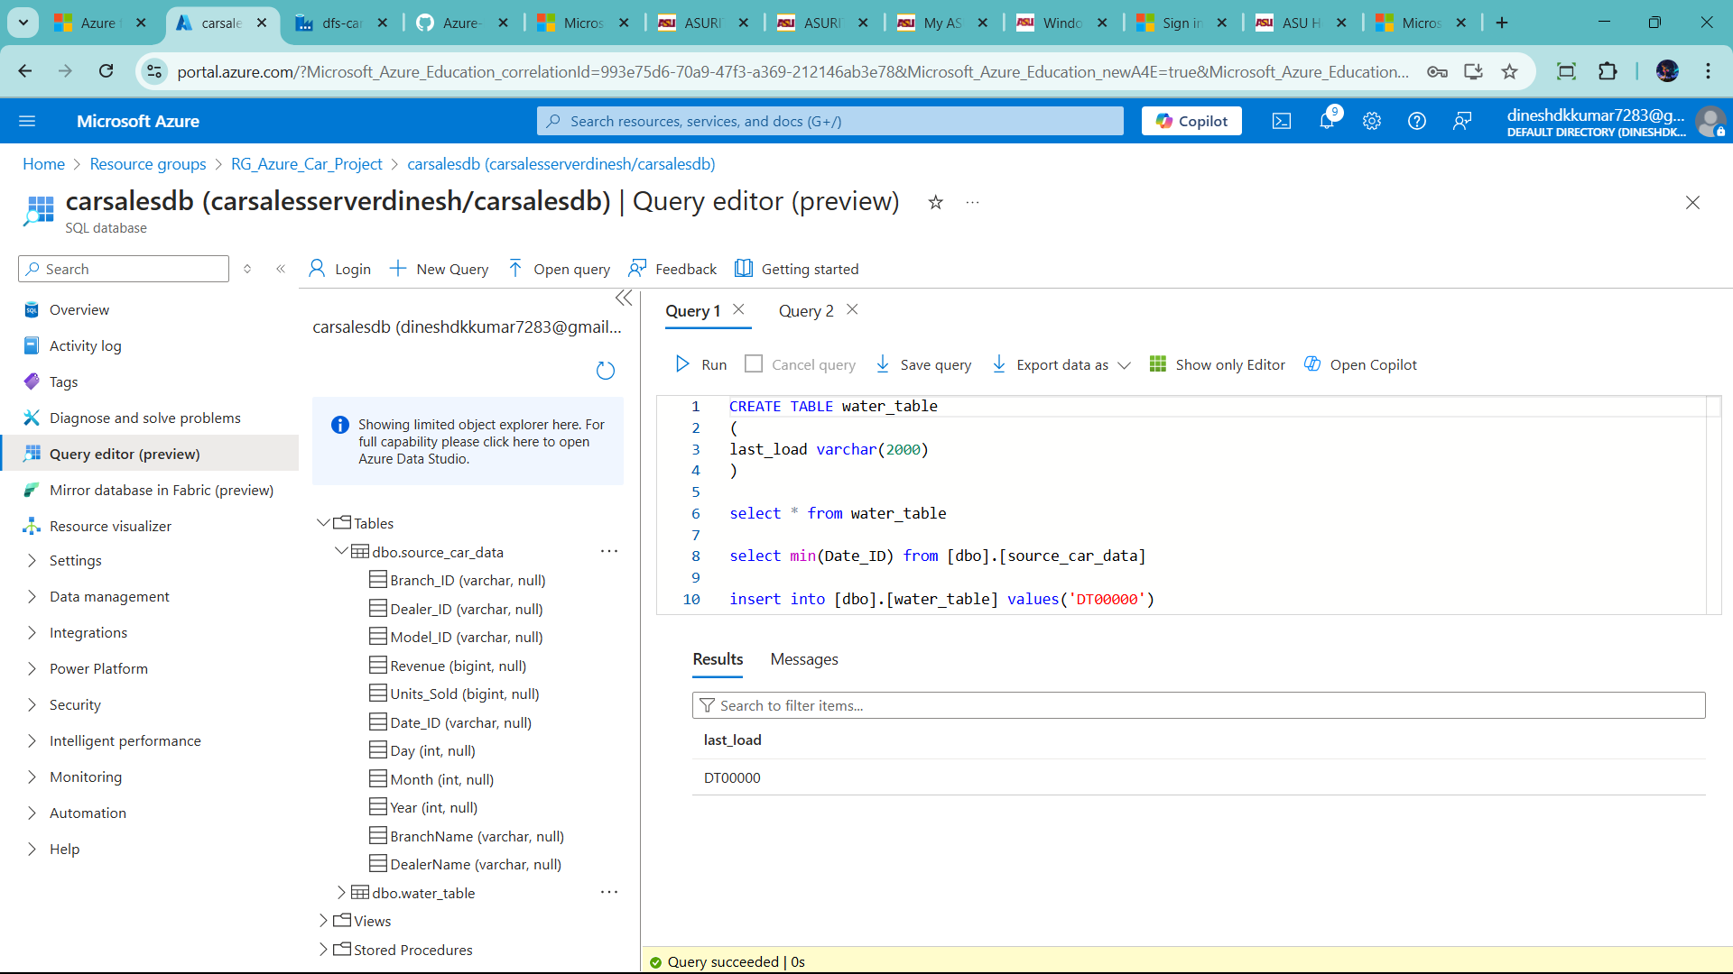

Create store procedure to add last date of data

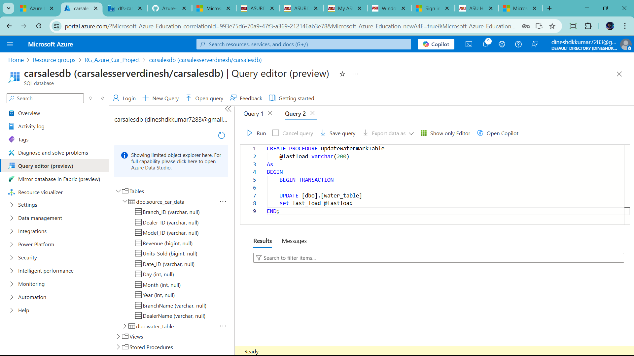

And runit

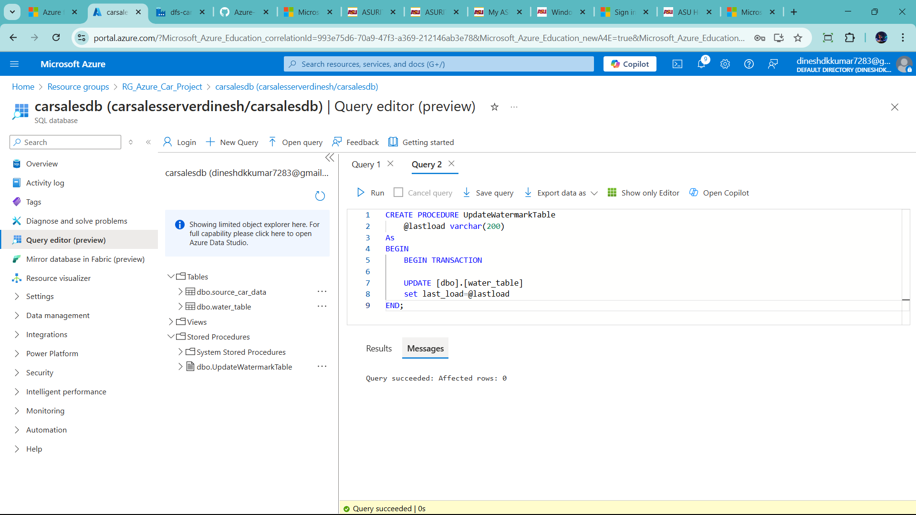

Go to data factory 🡪click increm_data_pipeline (when you create it) 🡪click activity use lookup

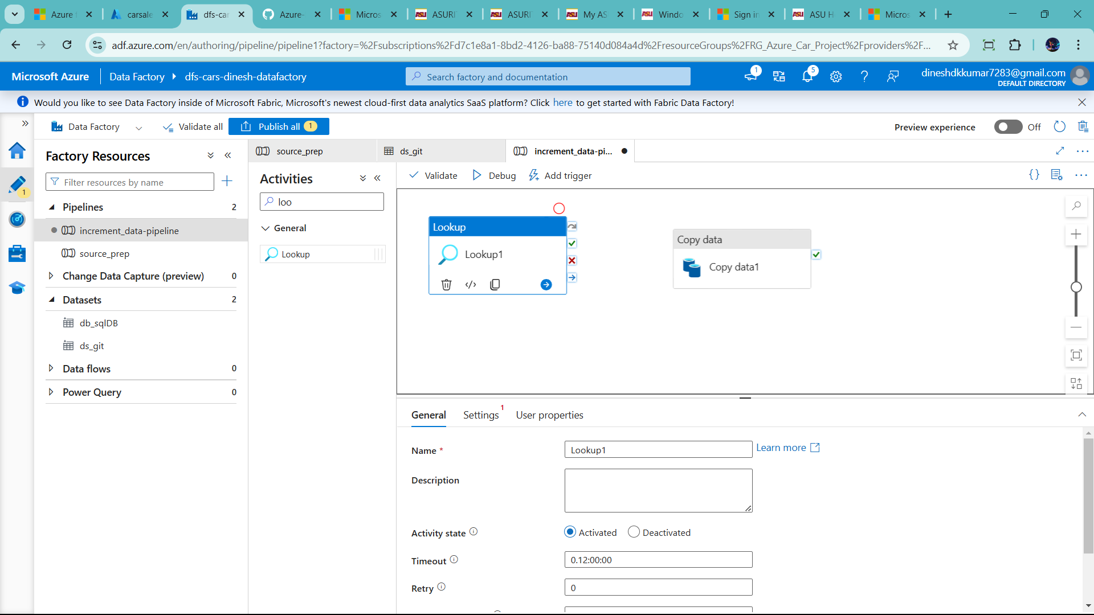

Use two lookup one is lastload and current load

Last_load 🡪use db_sqlDB 🡪 it is source dataset

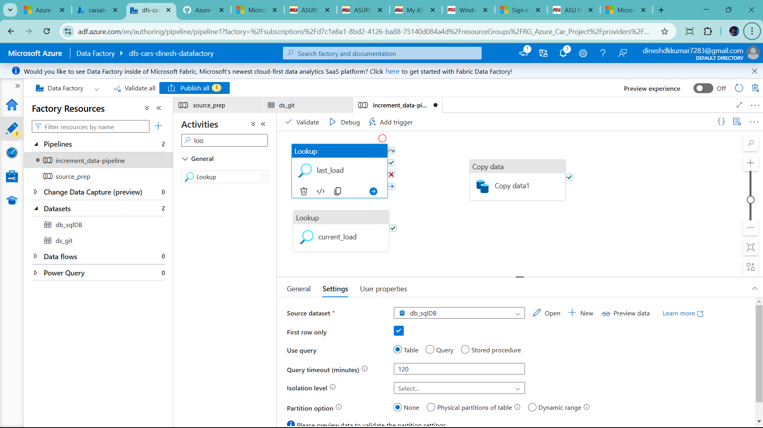

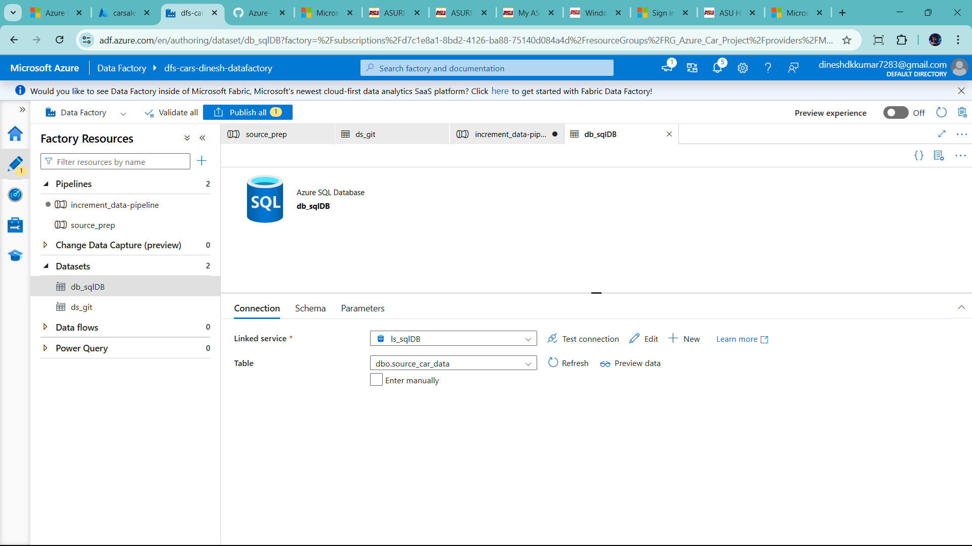

Go to parameter 🡪click new 🡪give name as table name

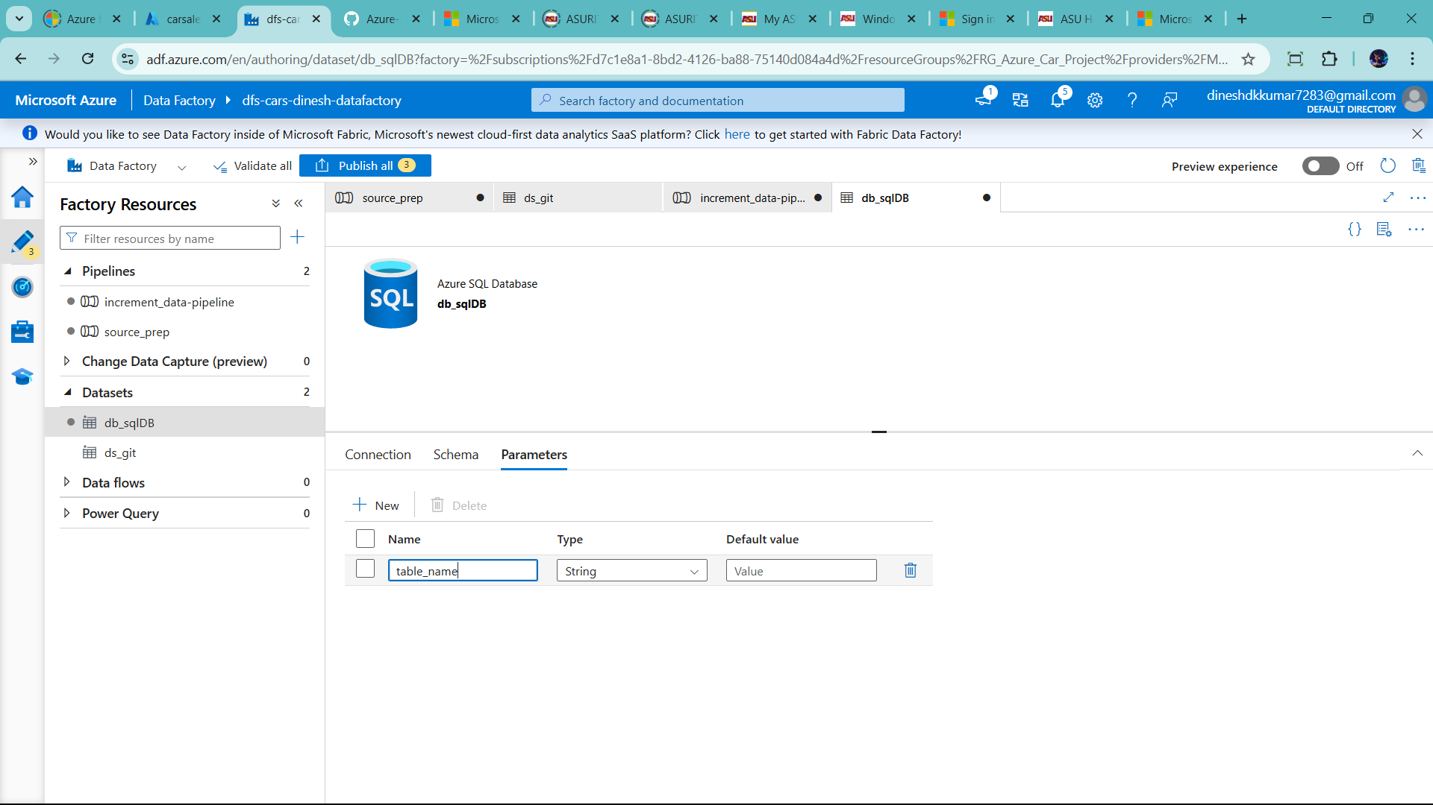

Go to connection

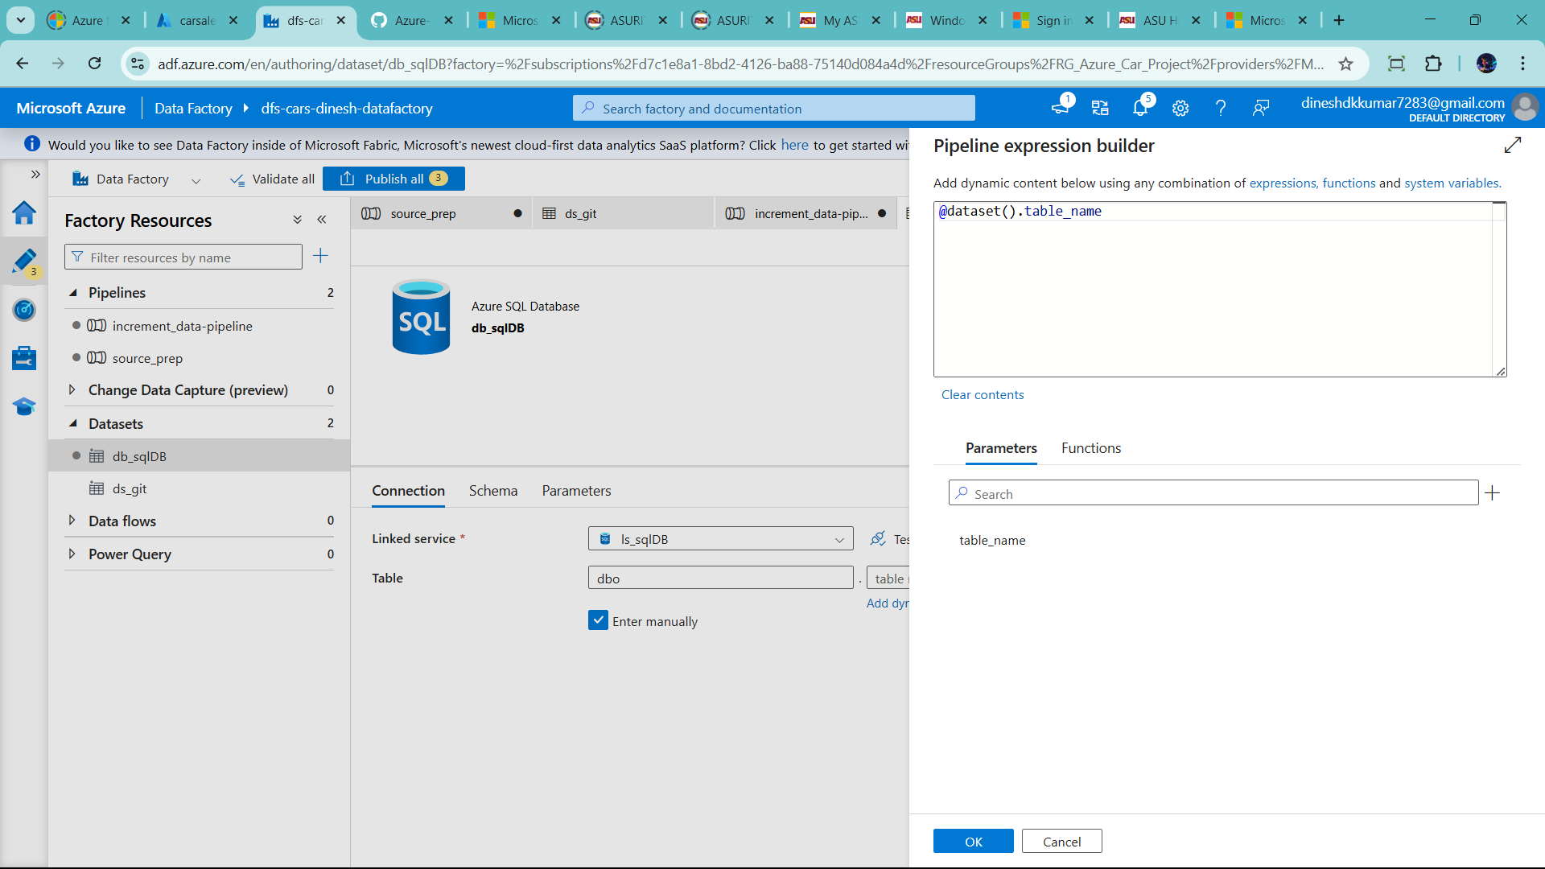

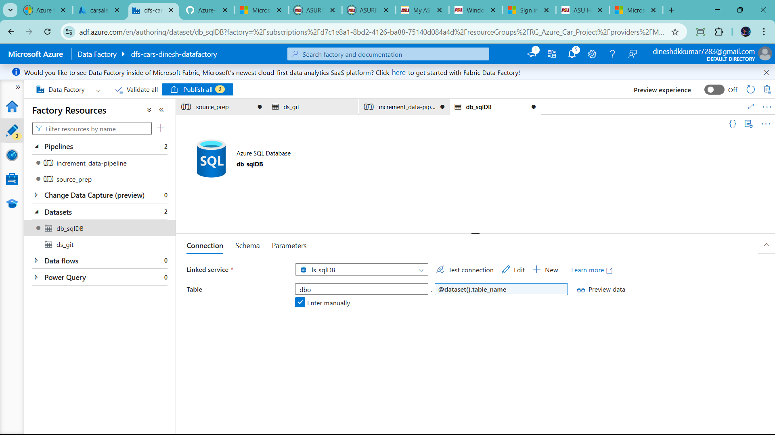

Now go to increment_data_load 🡪 click last load flow 🡪add table name water table

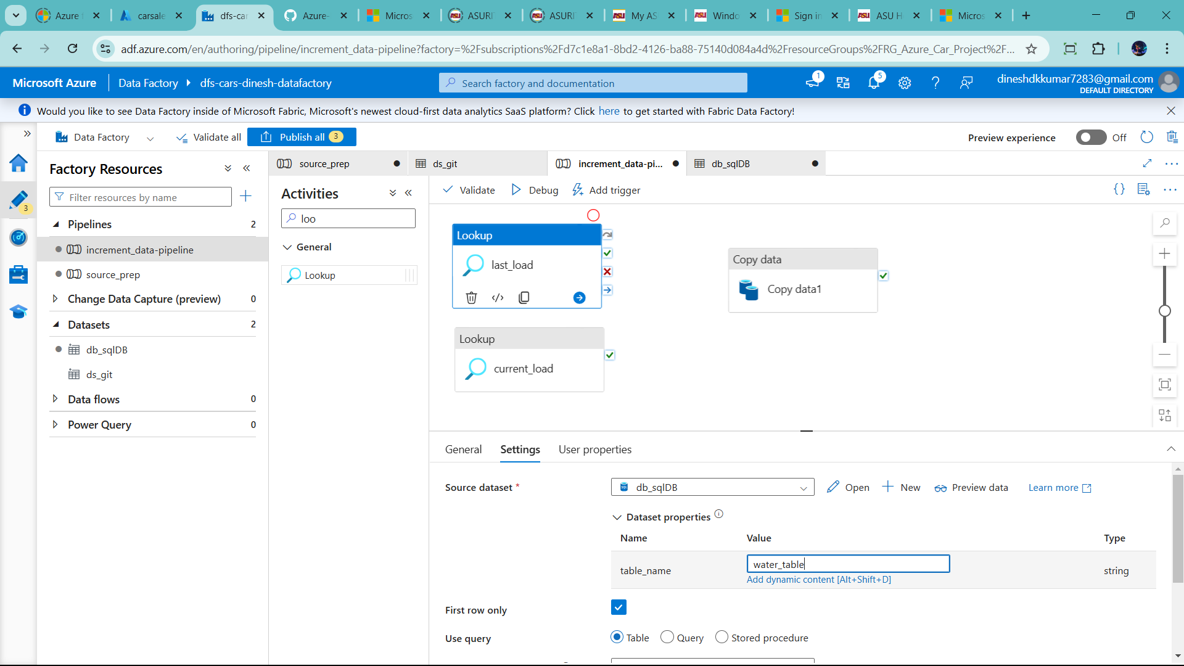

Uncheck first row only 🡪 click query 🡪select * from water_table

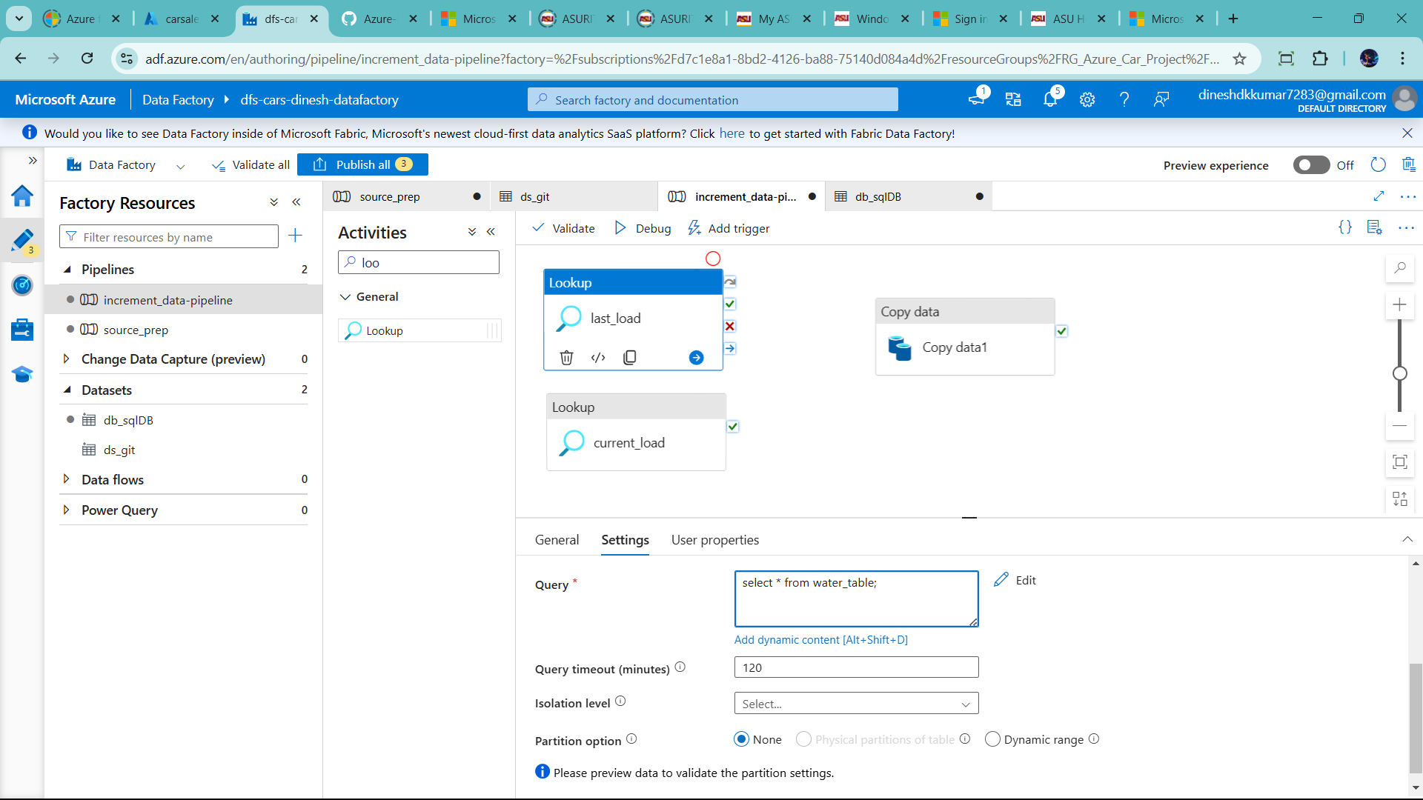

Deactive both the debug it

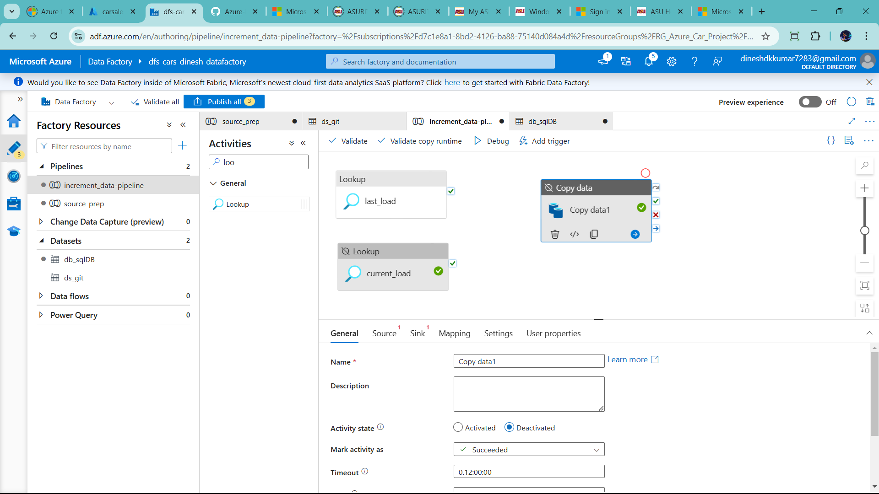

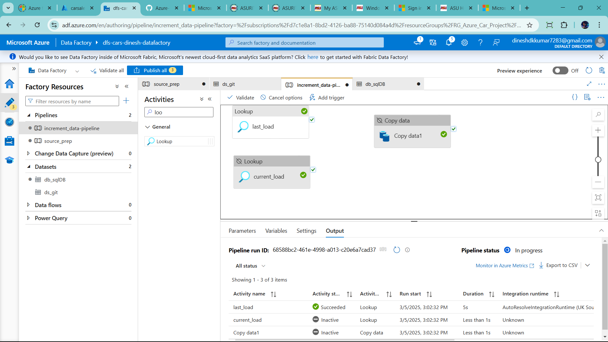

Click output for success

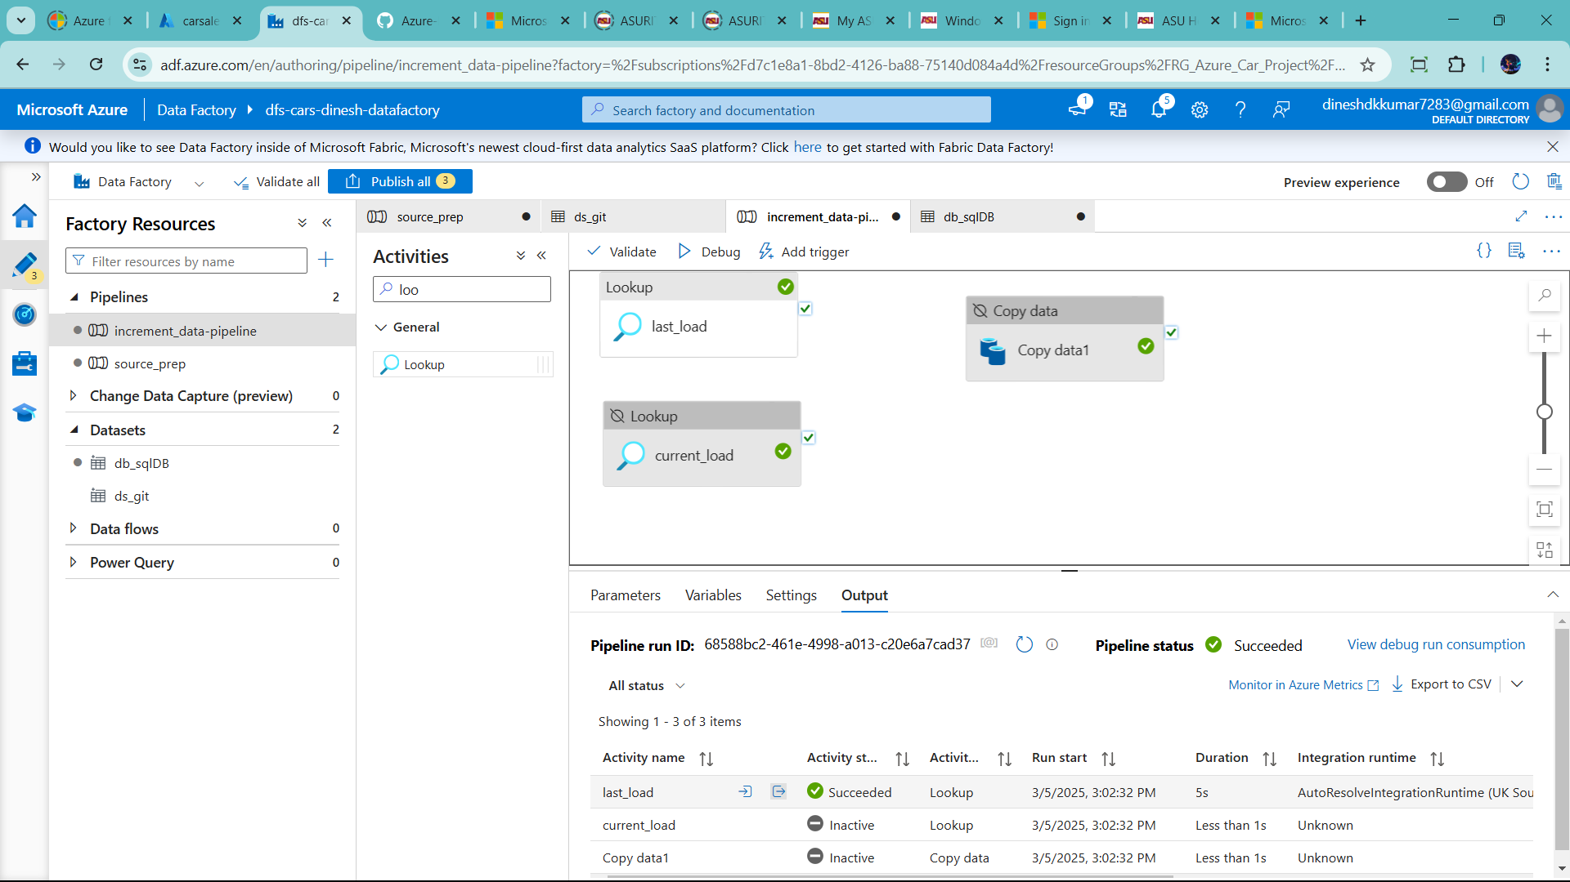

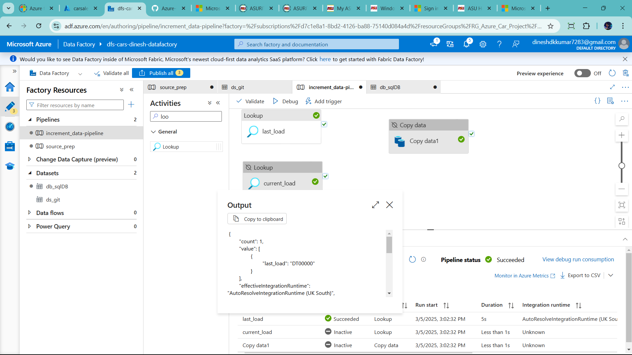

Now change the name loopup card for current load🡪 add parameter to pass name table name source_cars_data

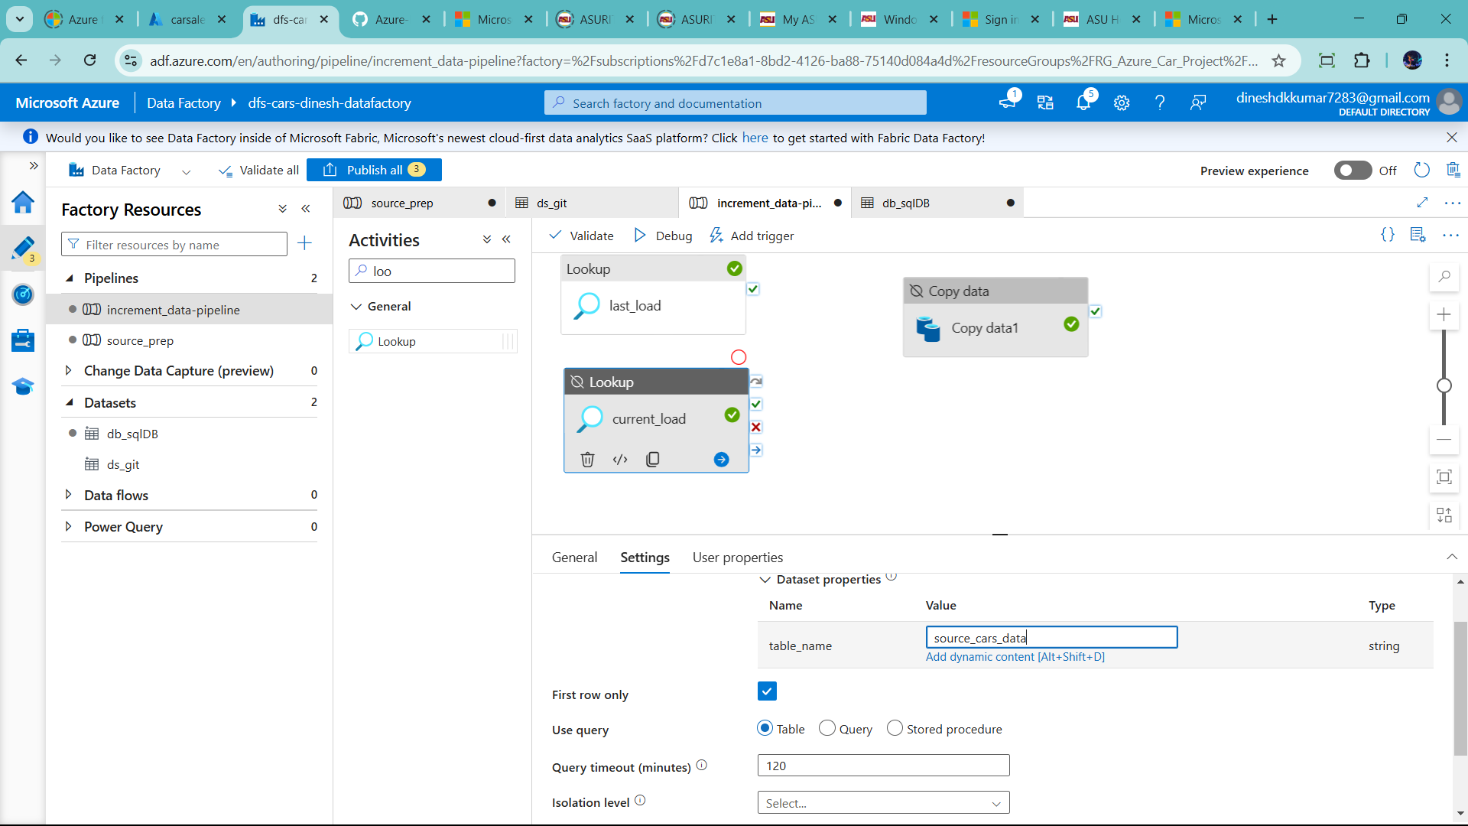

Uncheck first row only 🡪 use query -check Query

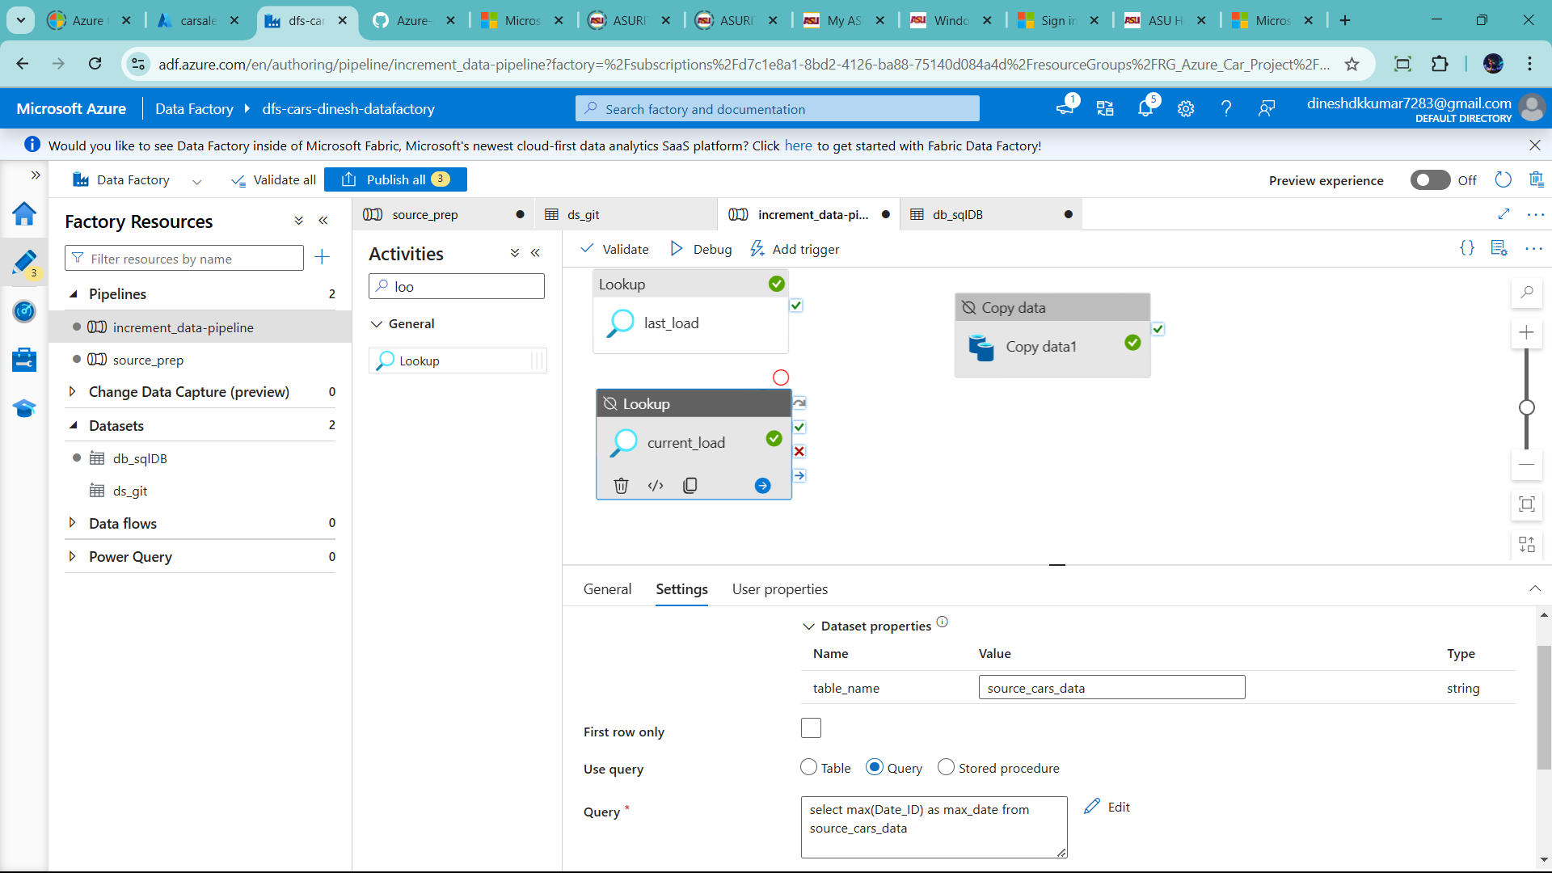

Final activate

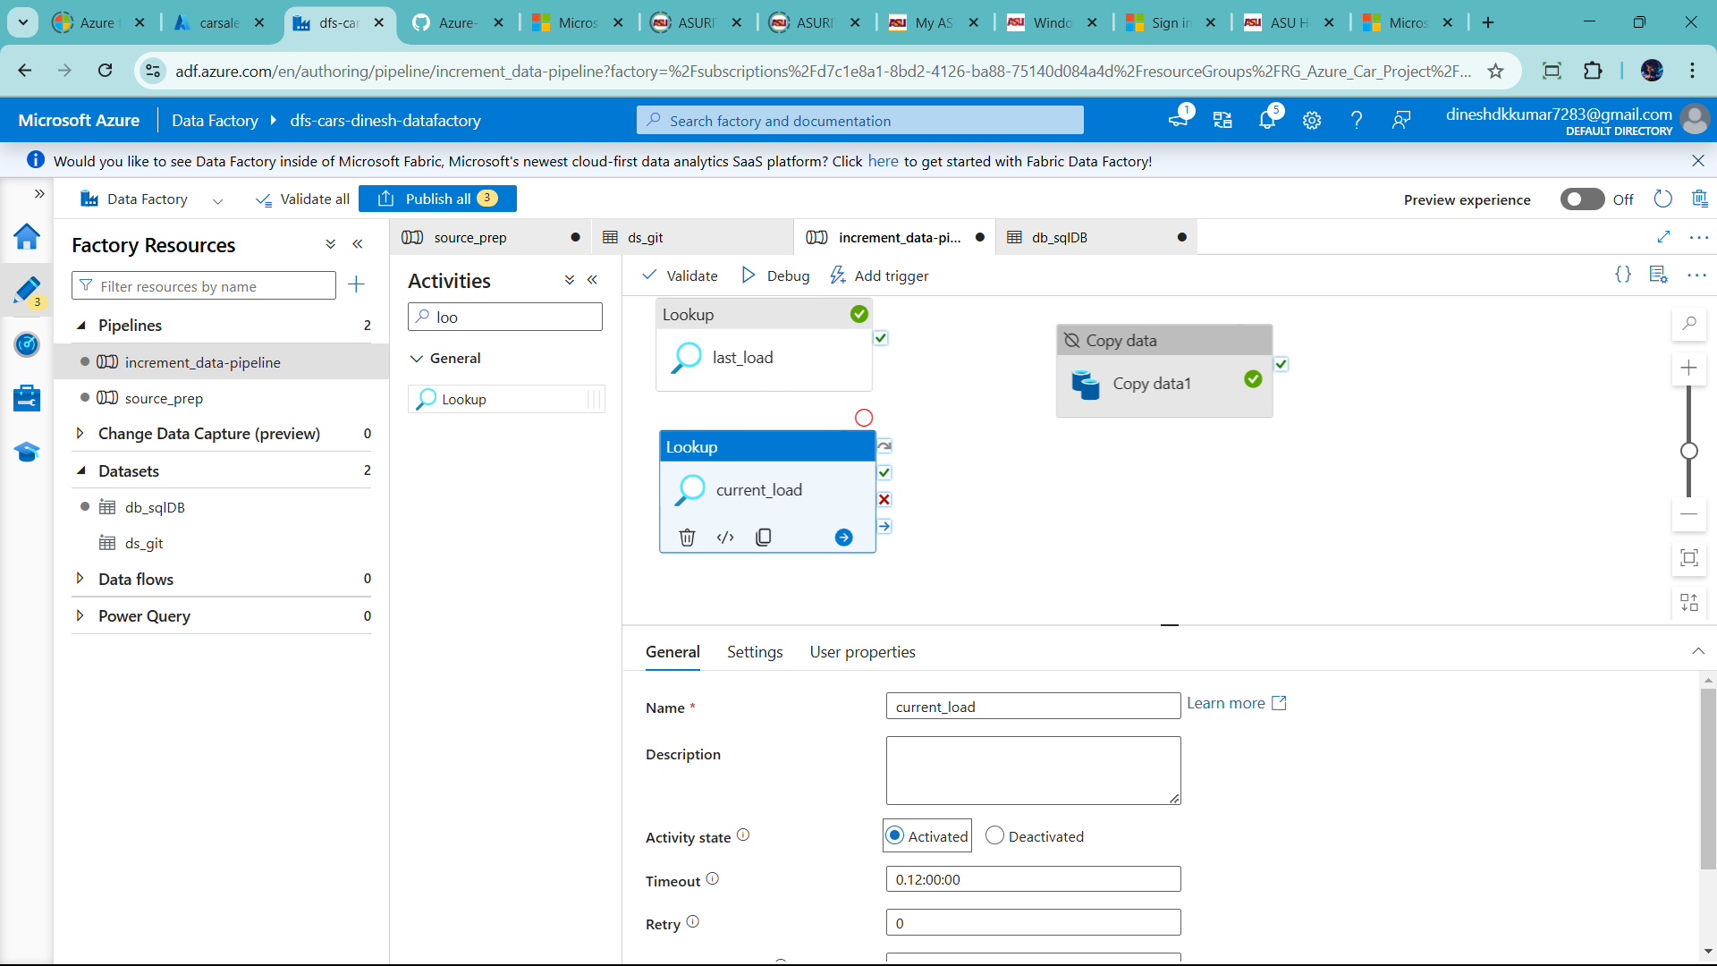

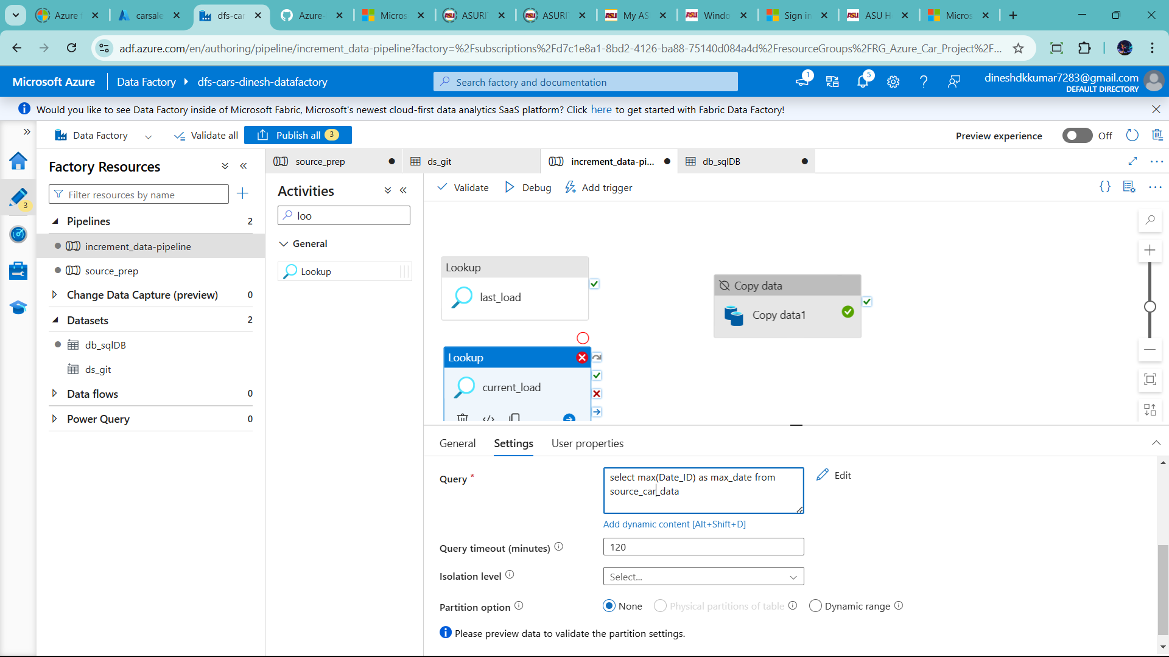

Not change as well Copy Data1 to rename 🡪Copy_Increm_Data🡪click source and dynamic name- : source_car_data 🡪 and click Query

🡪before write query 🡪connect with two lookup to copy data/ sql

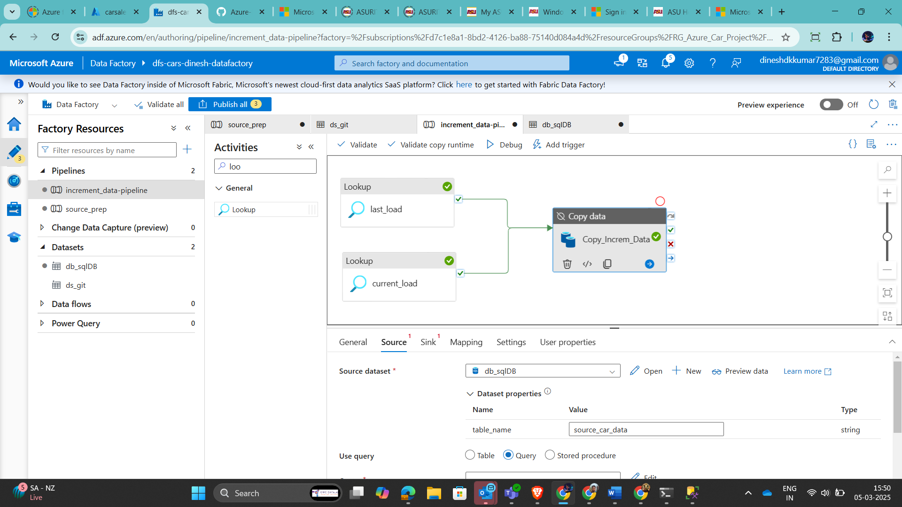

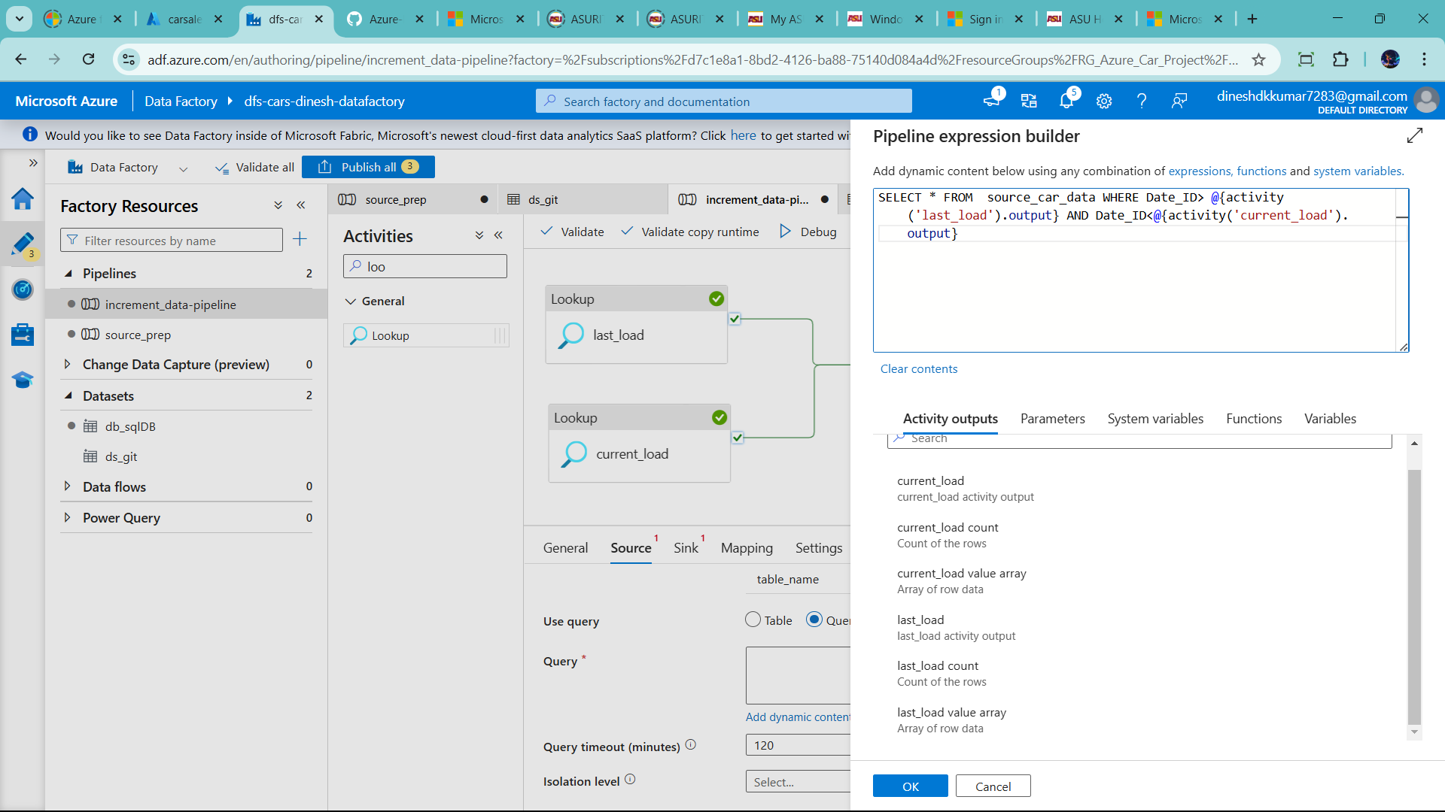

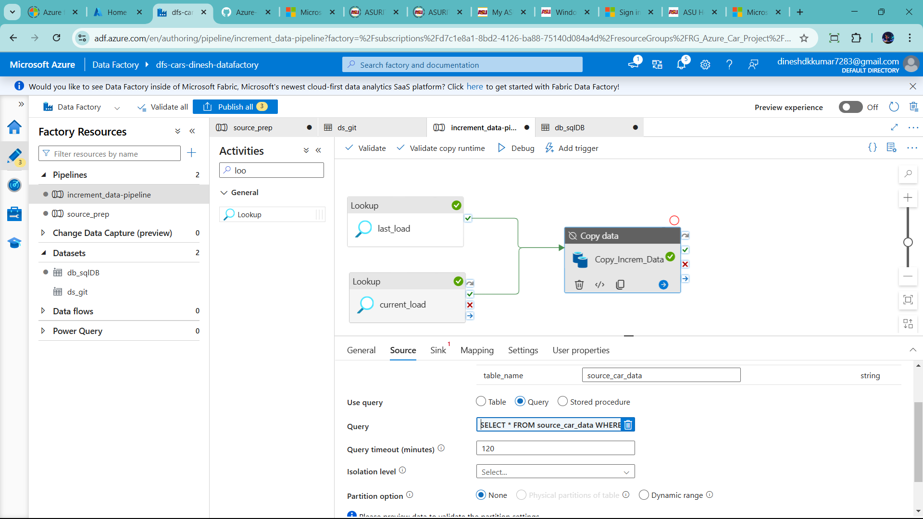

Let understood

SQL -🡪 Data Factory 🡪 Datalake (Brozen Container)

You can create data lake 🡪 based on sink /manager tap

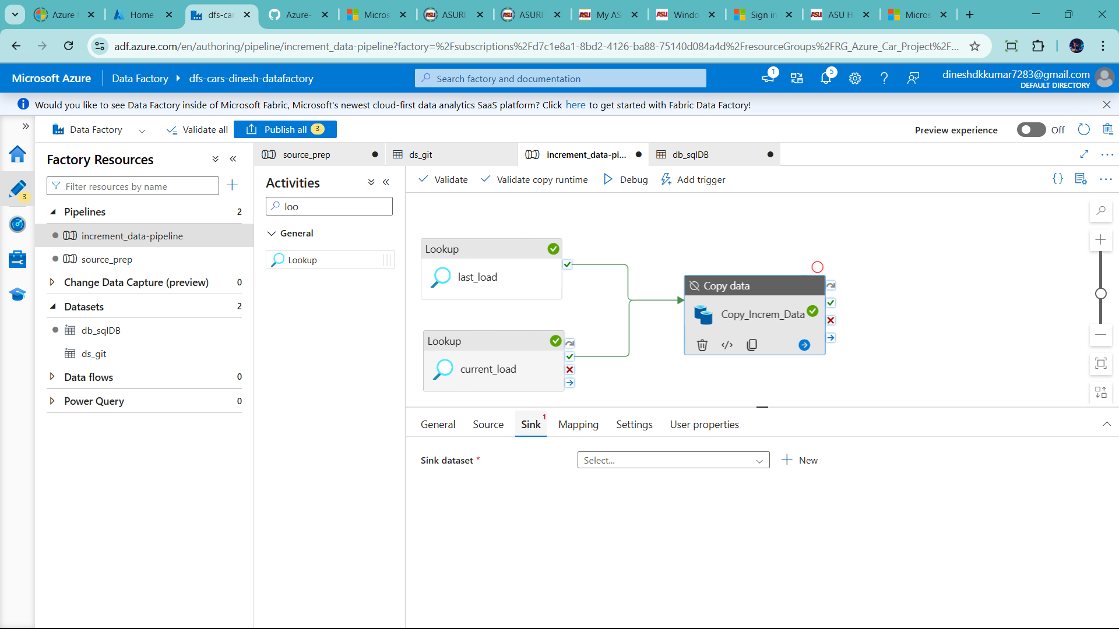

--in sink 🡪 click new 🡪azure data lake gen 2

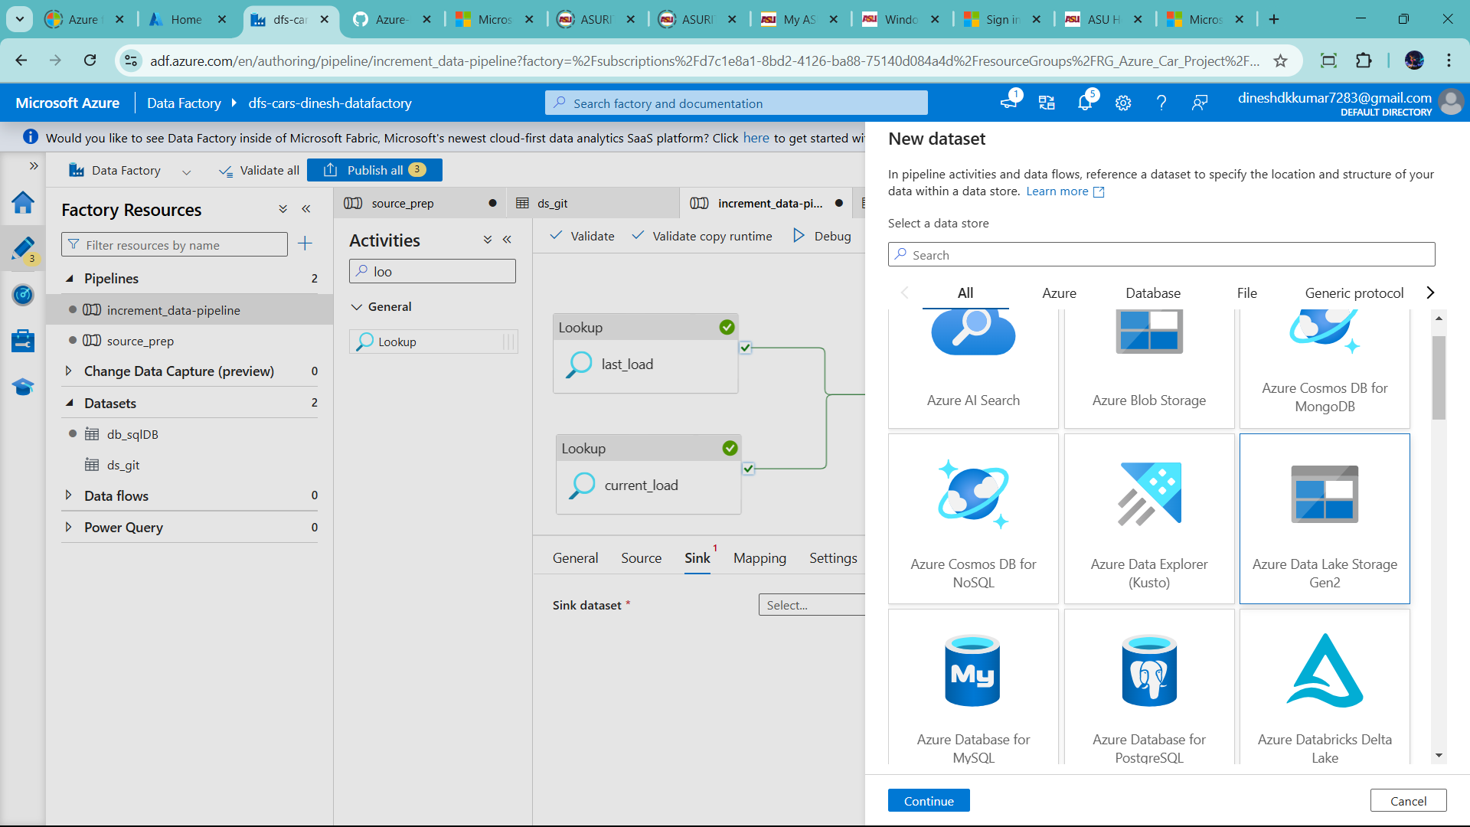

--click continue

🡪parquet formate to store data

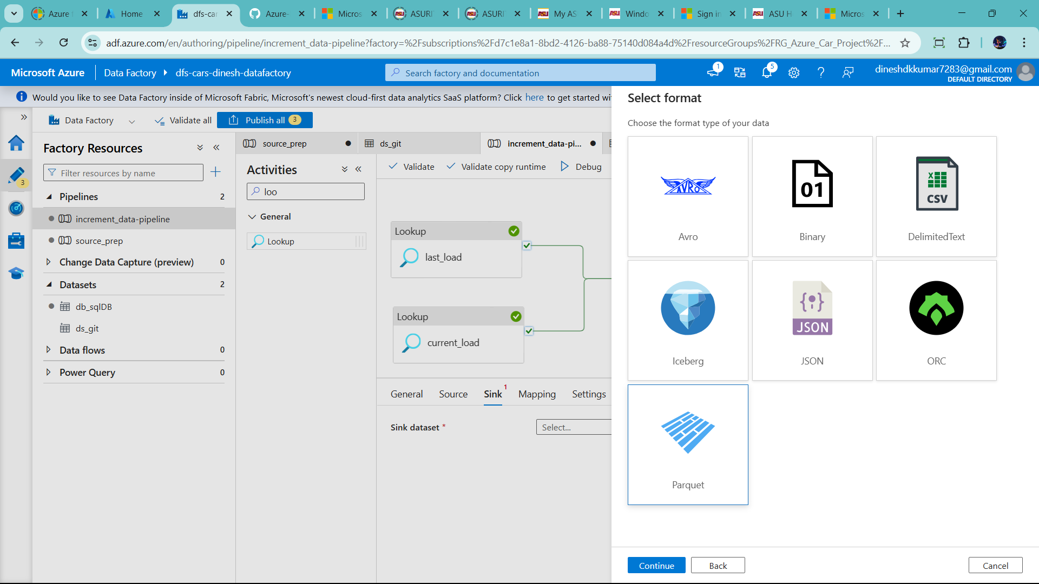

Click continue

🡪name as ds_brozen 🡪linked service to ls_datalake

🡪Azure subriscation chage to azure for student

🡪storage account name

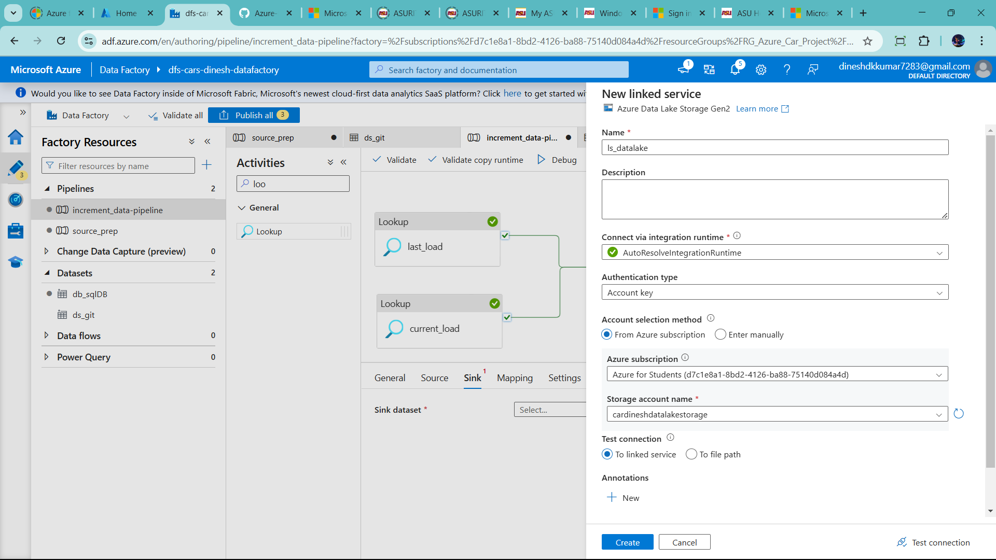

🡪click create

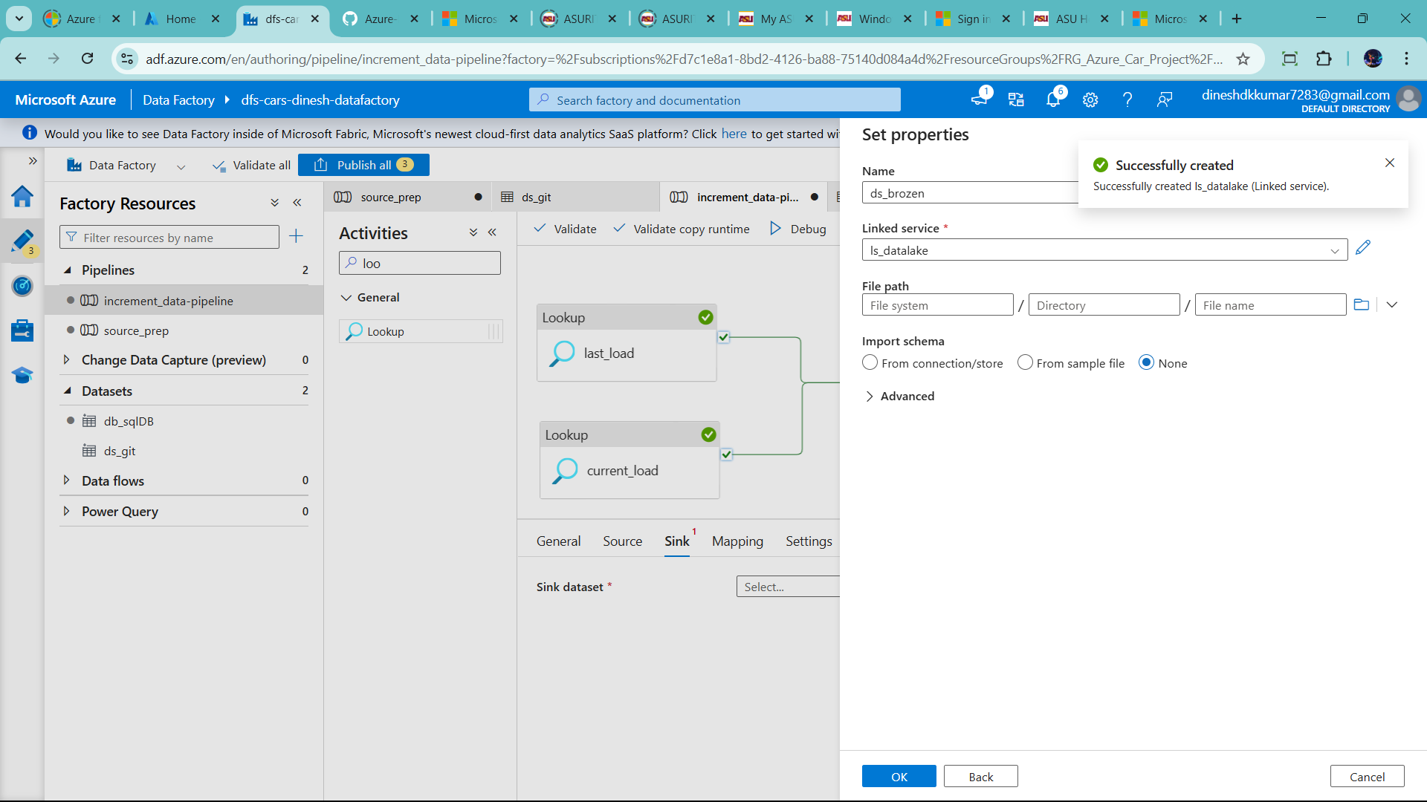

Click brozen file path 🡪click ok

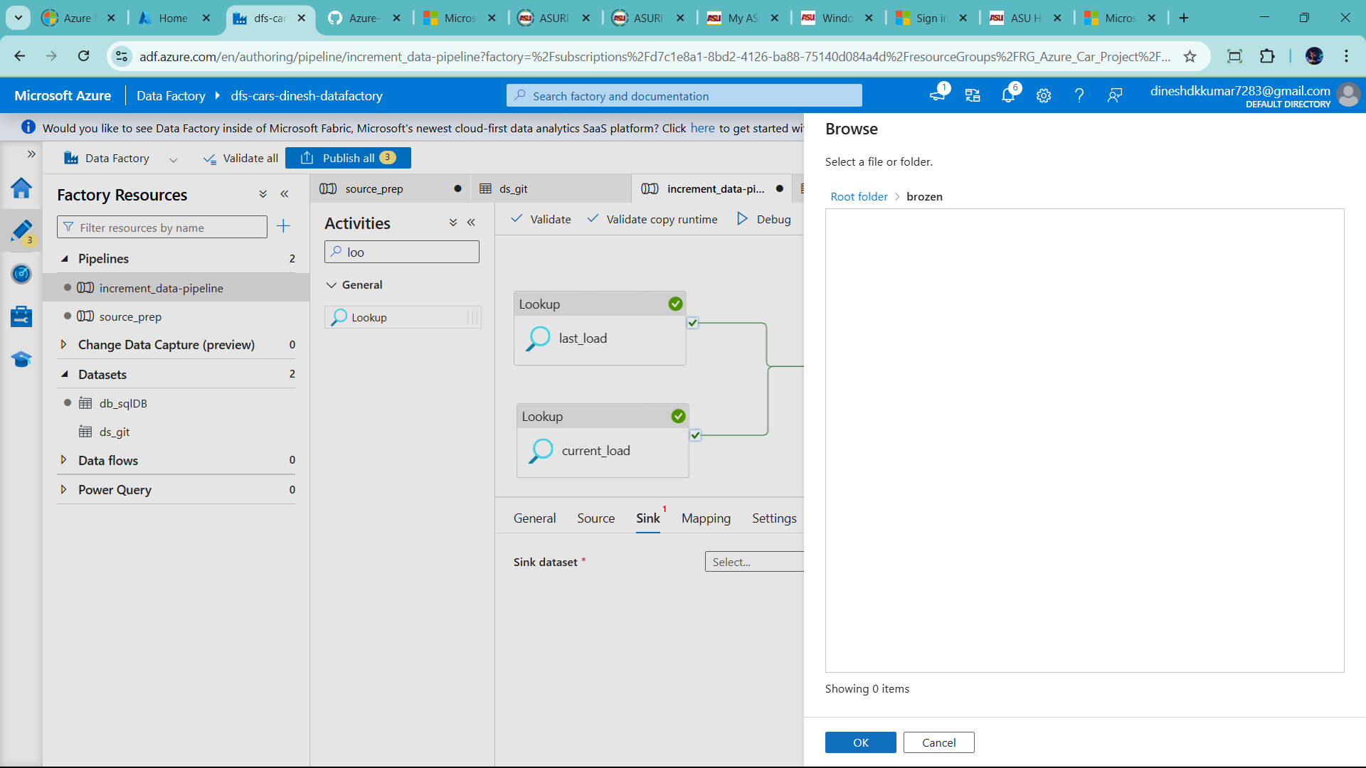

Add directory 🡪raw data

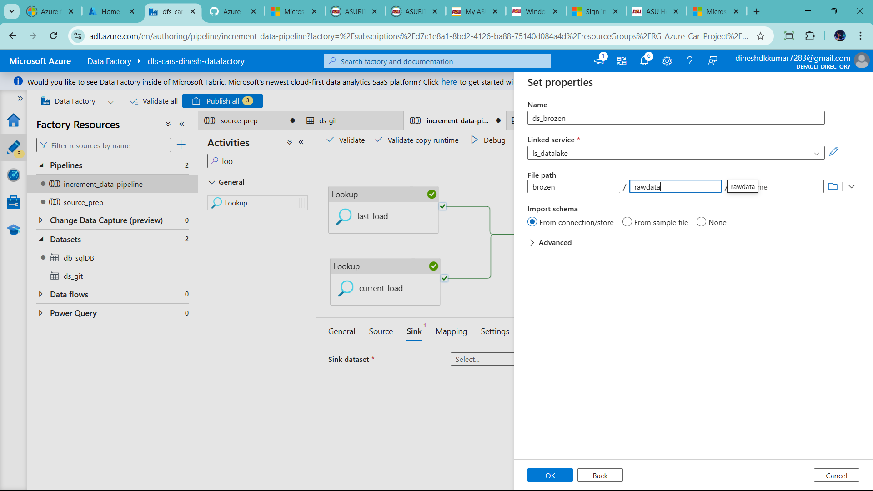

Click inport schema none

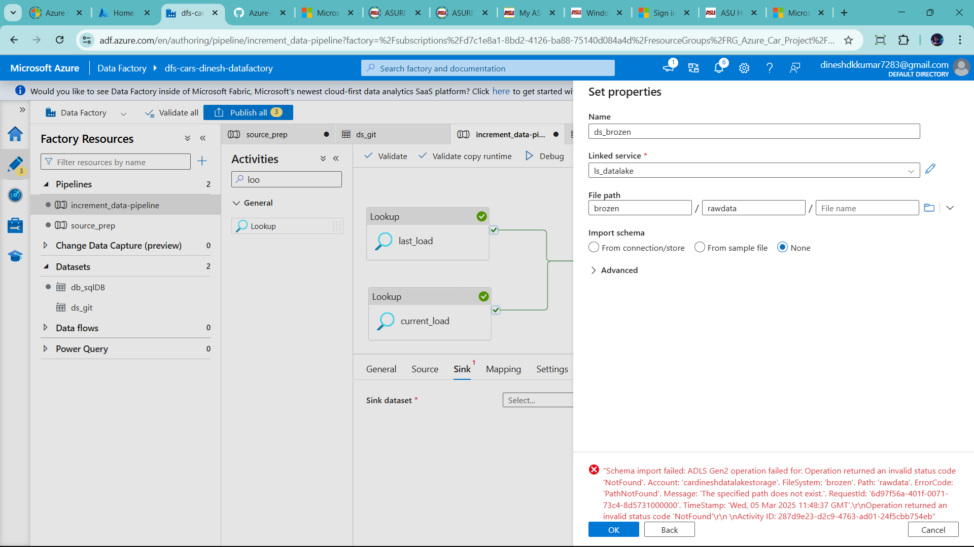

🡪now go mapping🡪 click import schemas 🡪add values based on query

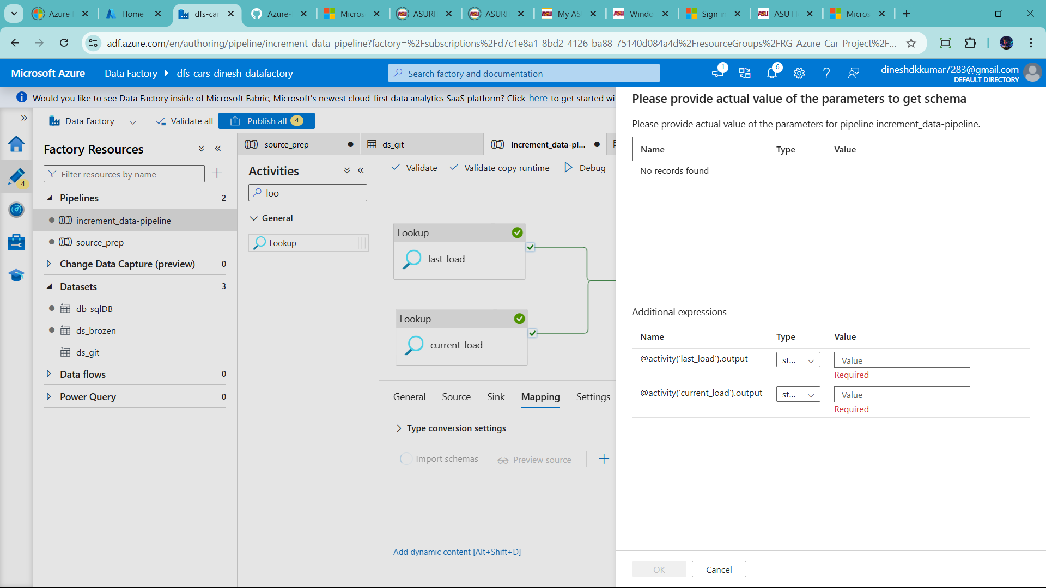

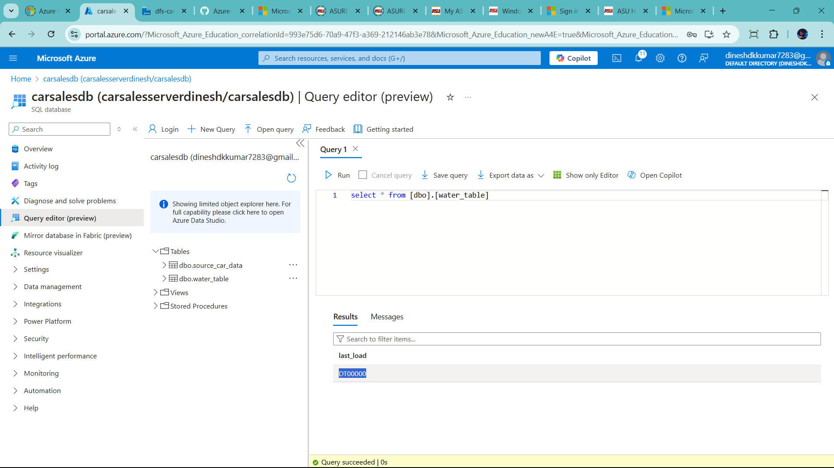

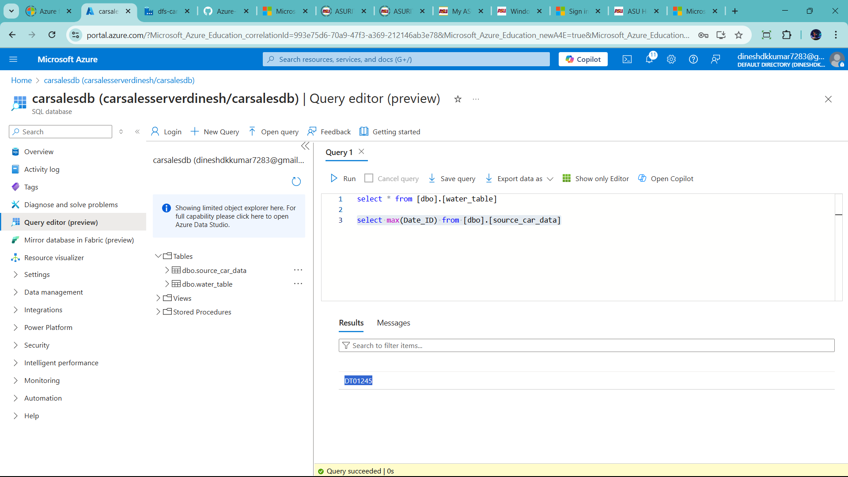

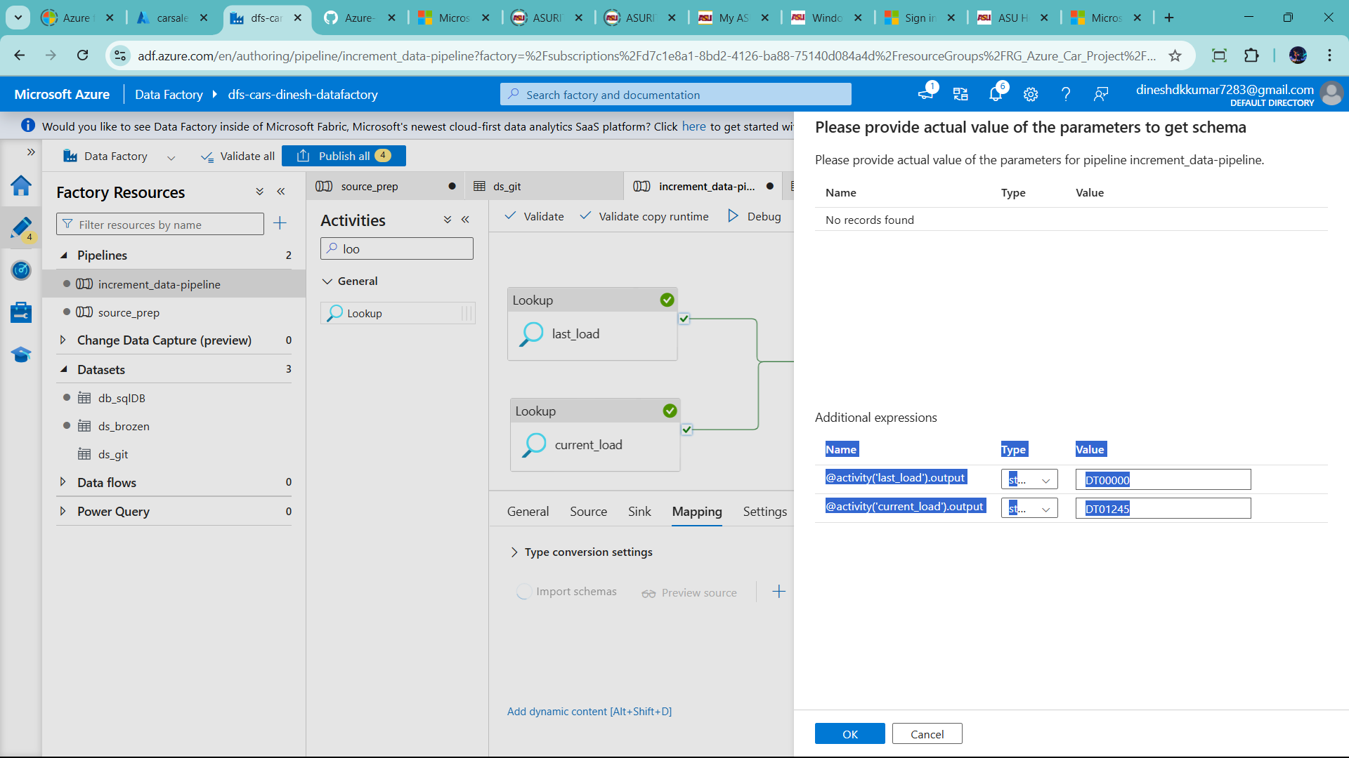

--click ok 🡪they show error change sql query

--chage query as per my respectivity

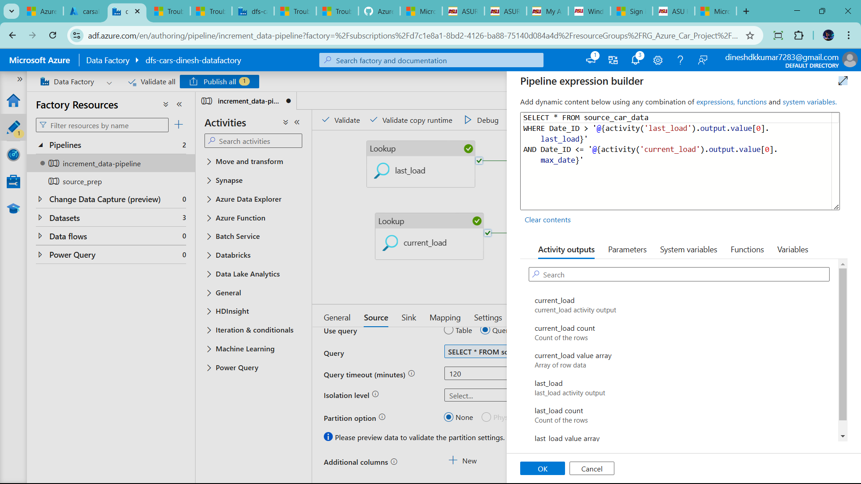

Debug it all activity

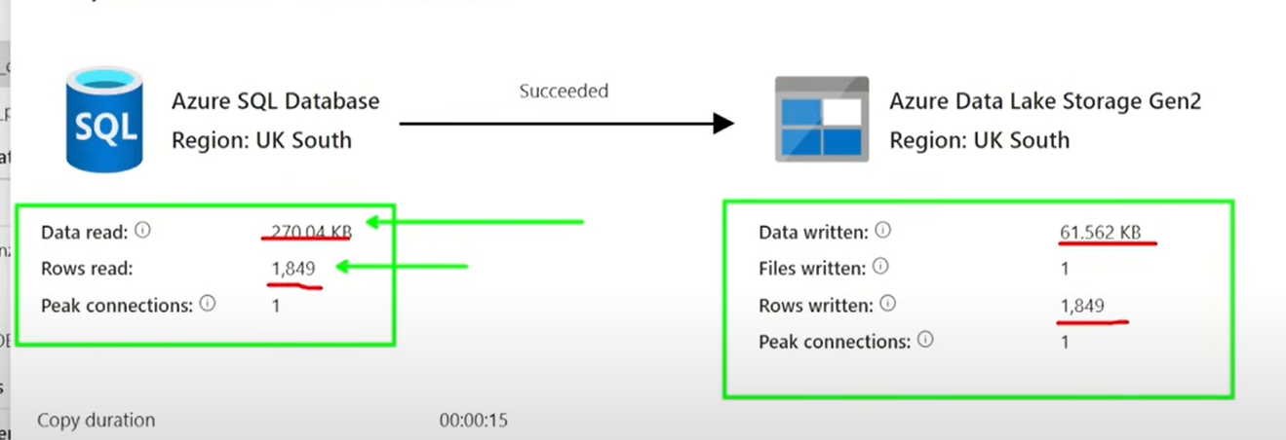

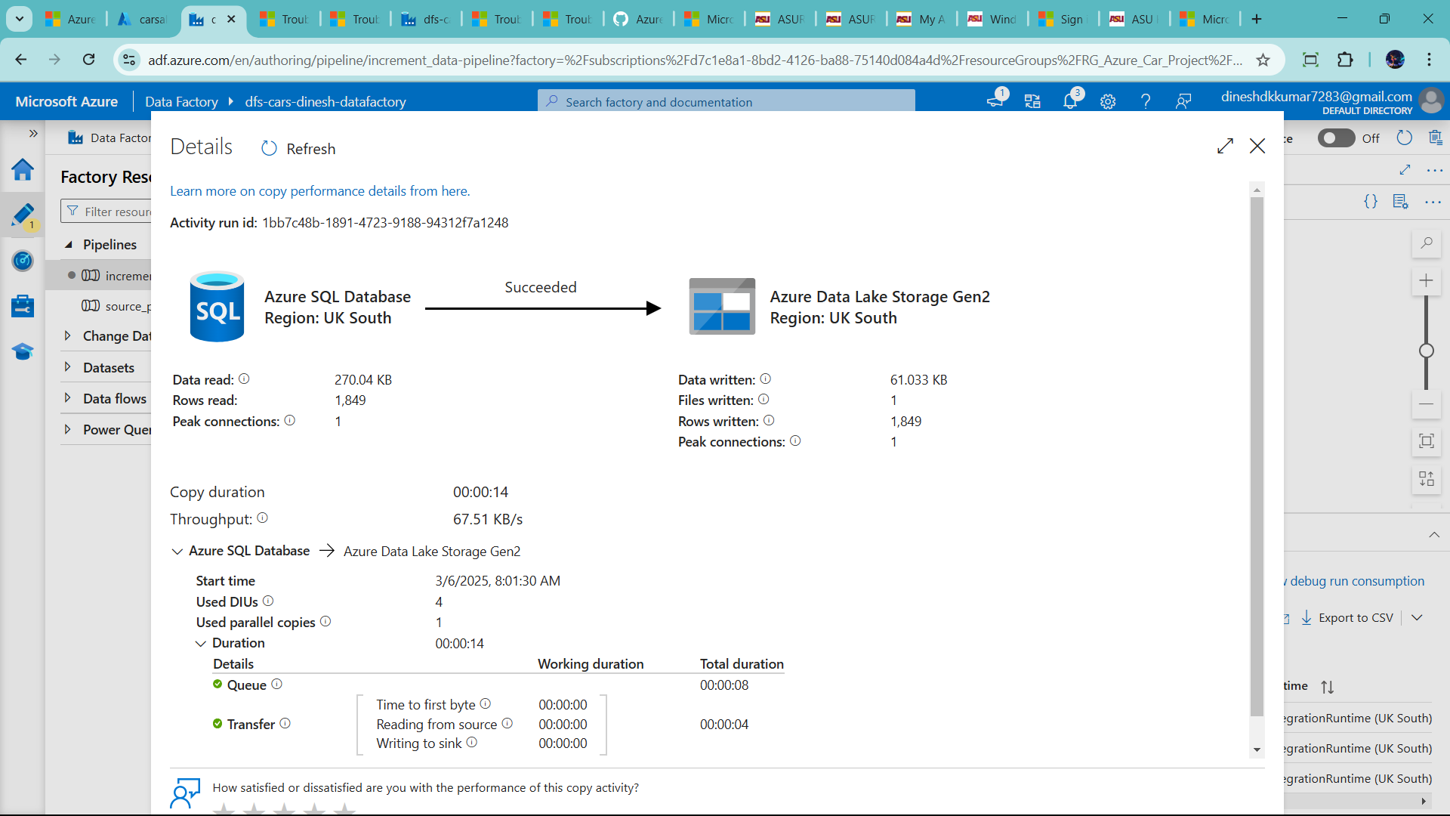

Add store procedure

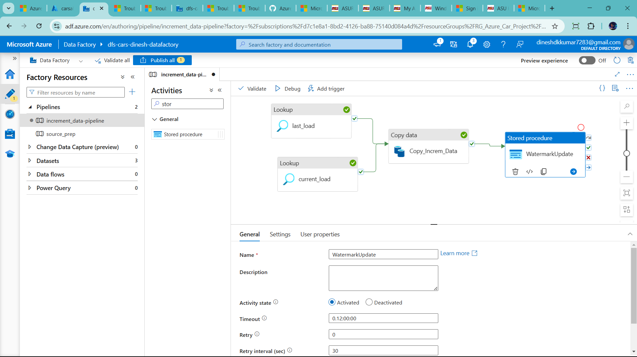

Add in setting section

Linked service, storeprocedure name, click import parameter

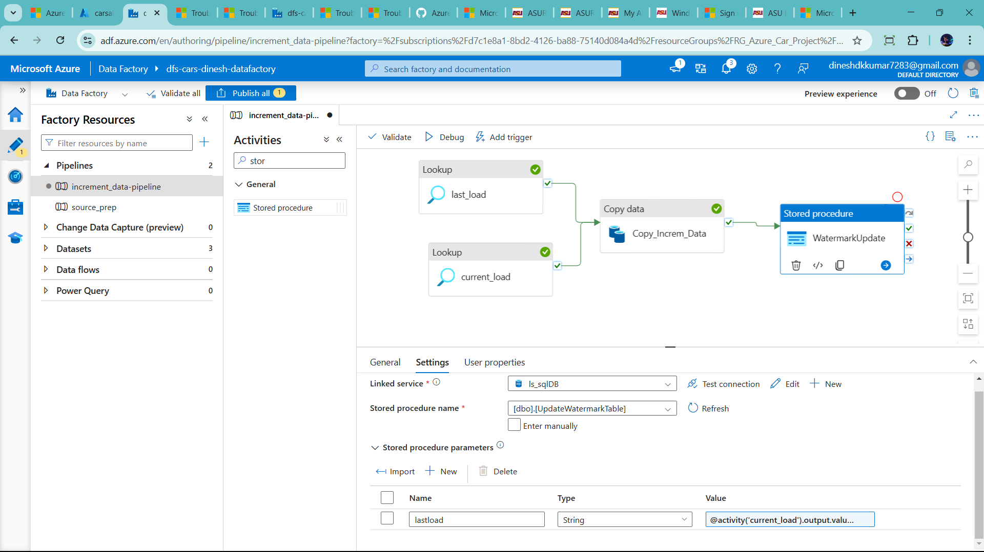

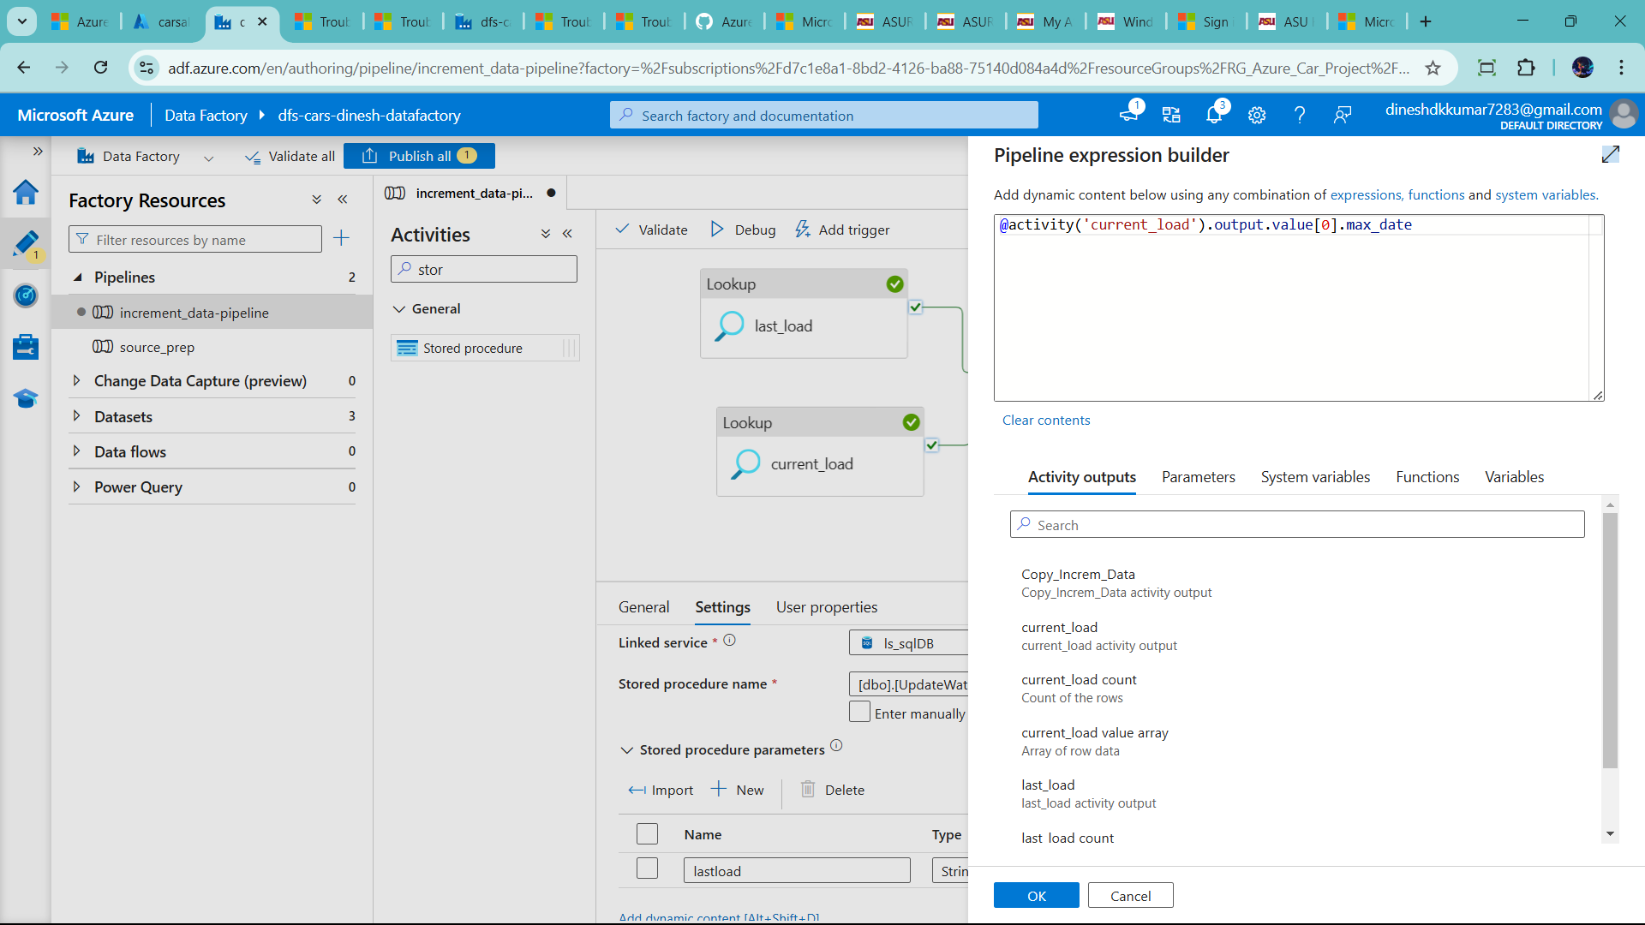

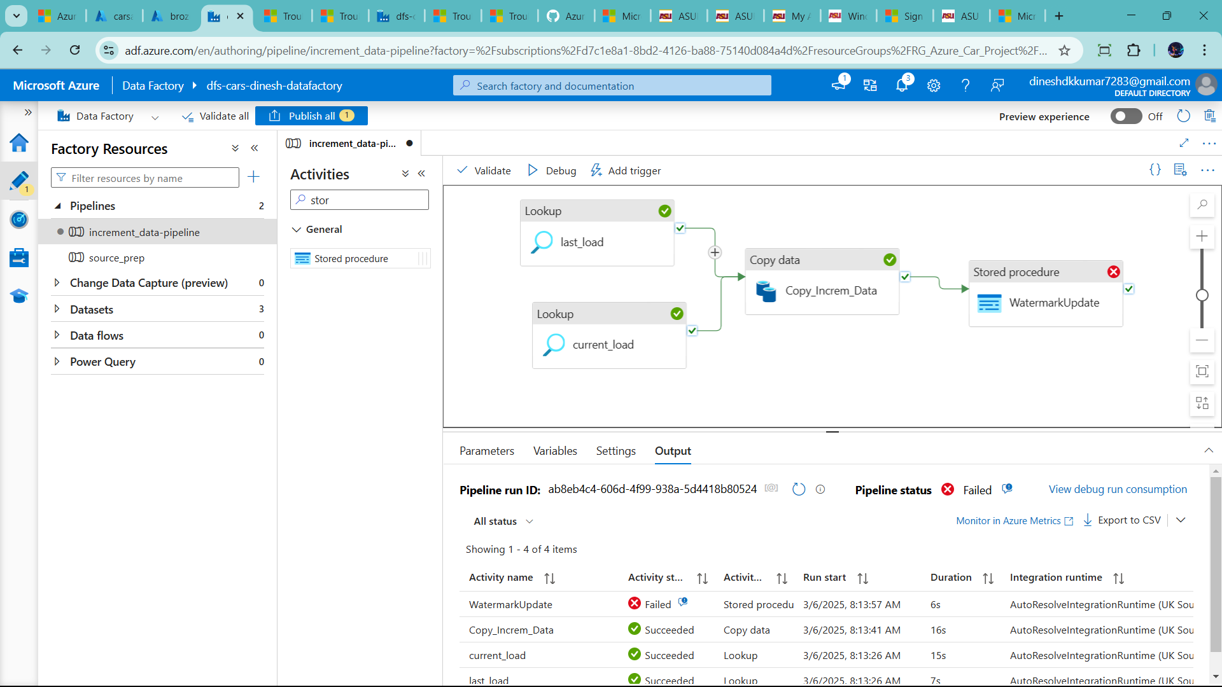

Handle this error

Go edit store procedure

DROP PROCEDURE AND RECREATE

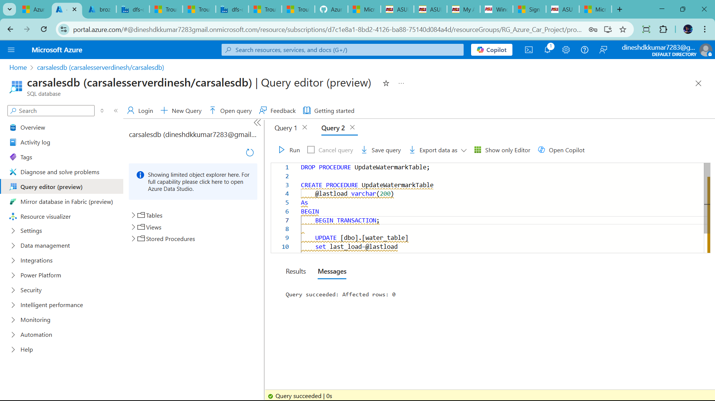

DROP PROCEDURE UpdateWatermarkTable;

CREATE PROCEDURE UpdateWatermarkTable

    @lastload varchar(200)

As

BEGIN

    BEGIN TRANSACTION;

    UPDATE [dbo].[water_table]

    set last_load=@lastload

    commit transaction;

END;

--delete data lake rawdata folder

And rerun pipeline

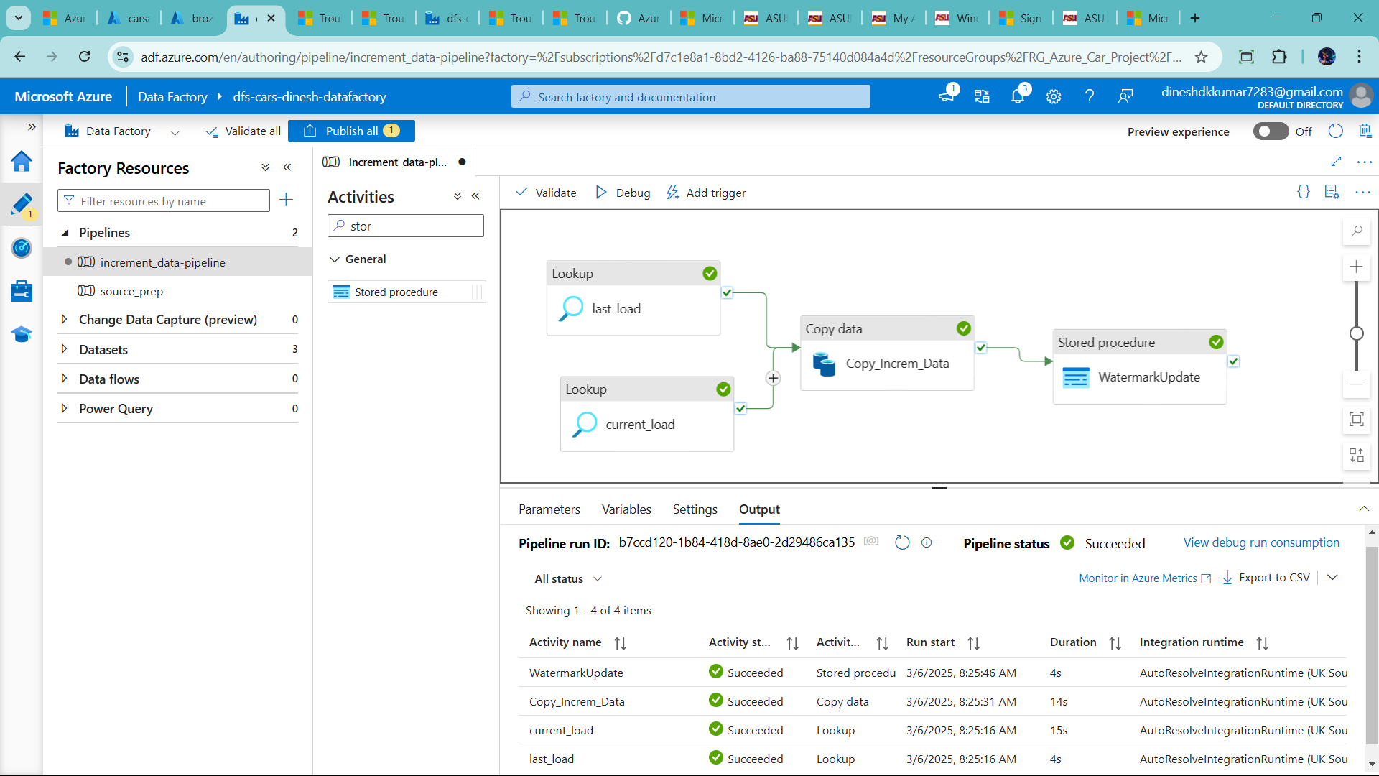

Successful updated watermark table

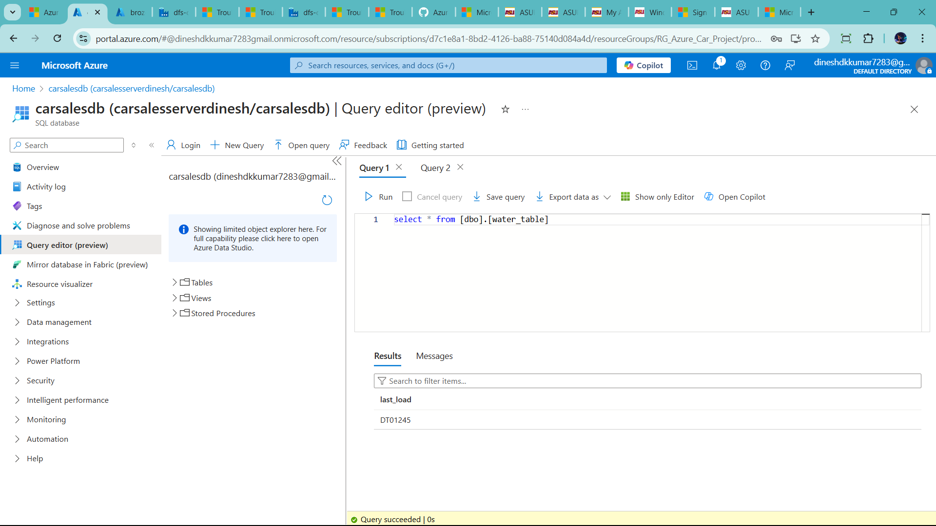

Now Success full Complete First part

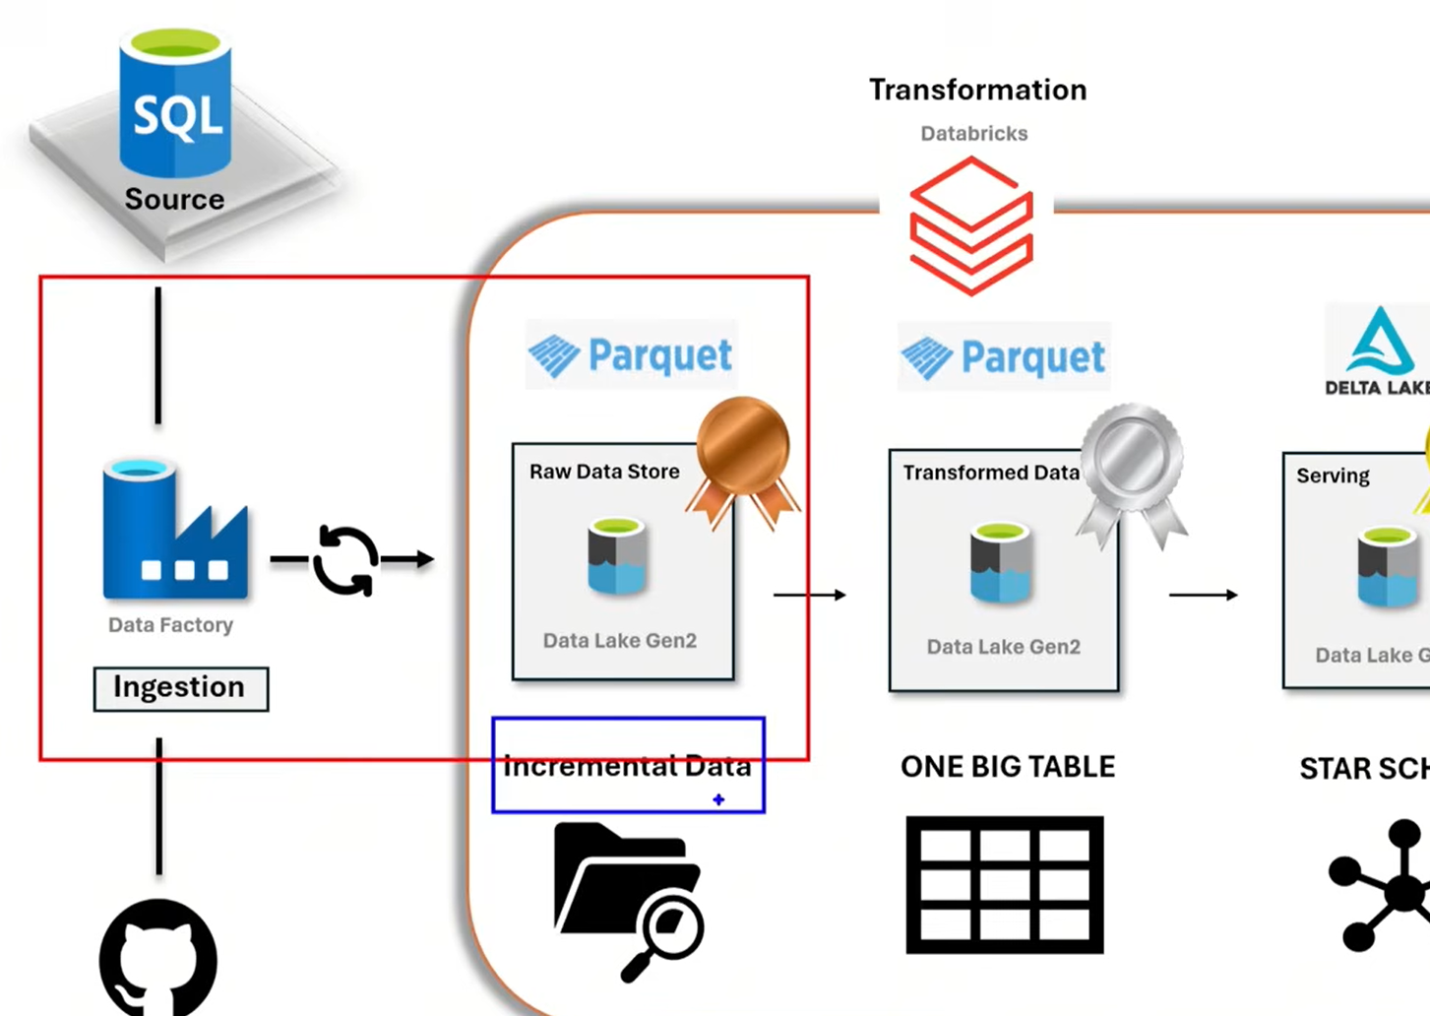

Let Start Create Databricks Resource

Go resource 🡪 click create

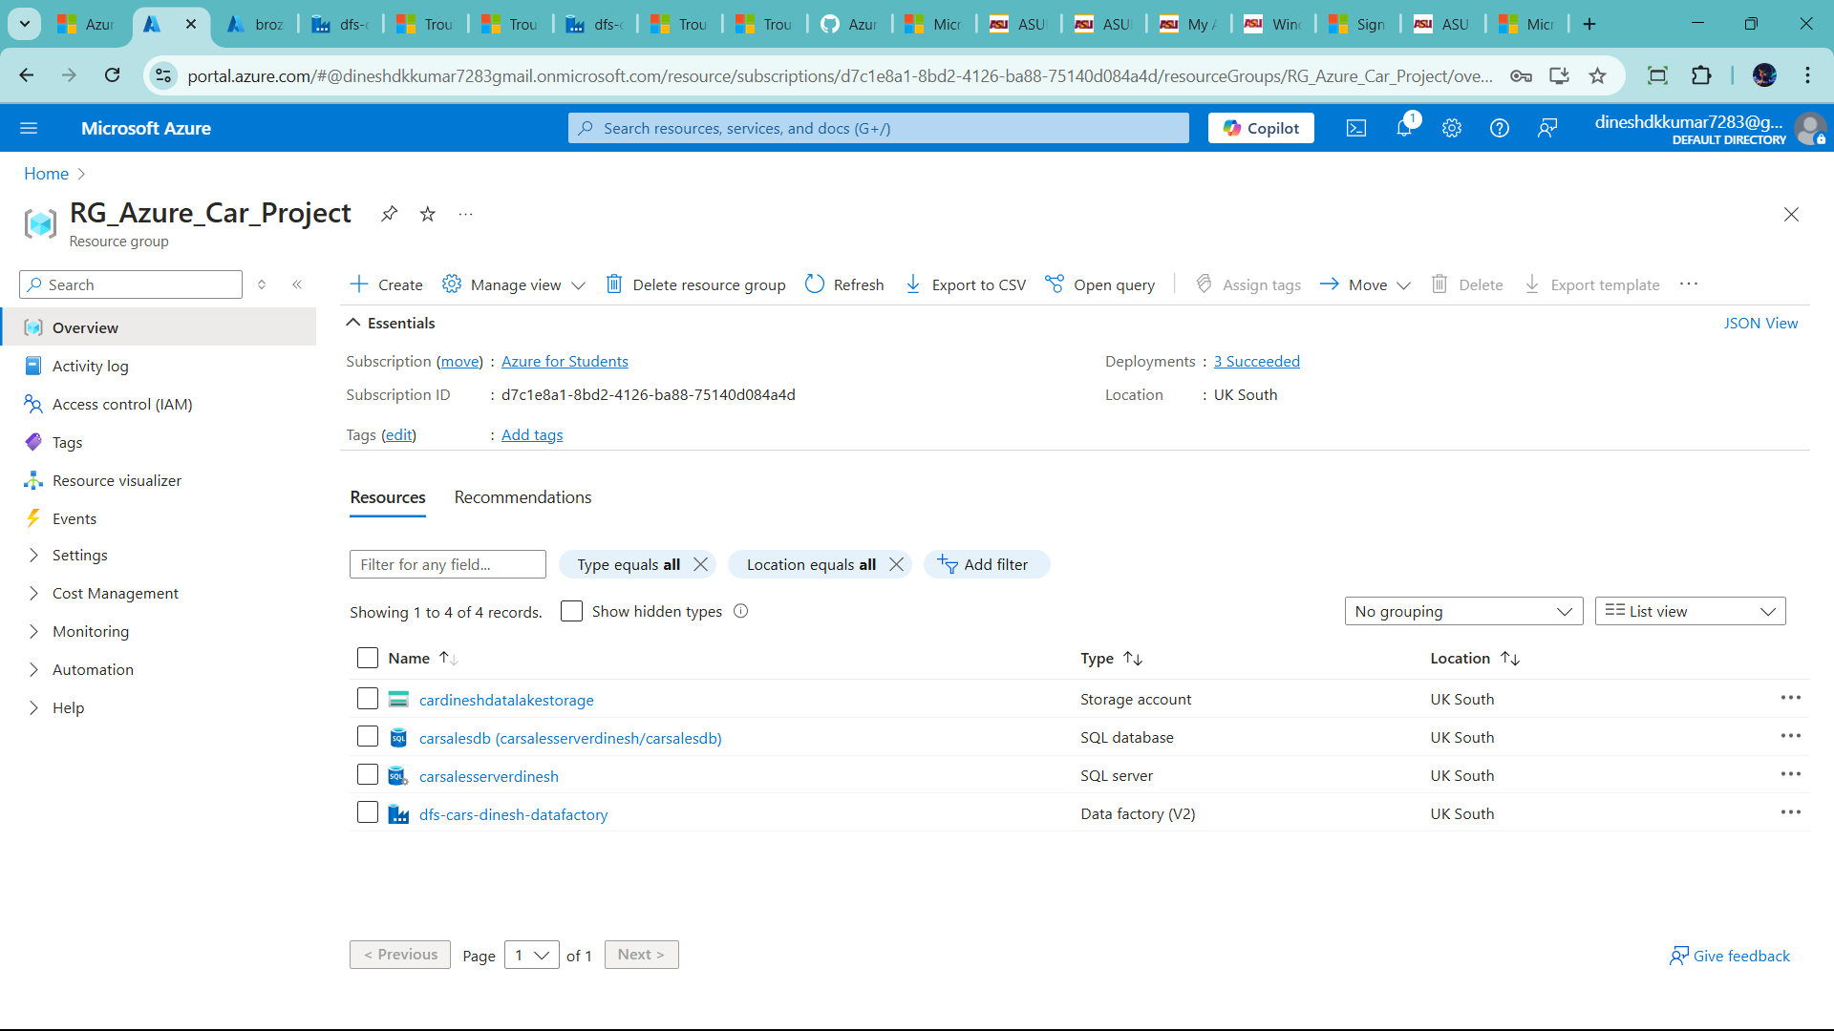

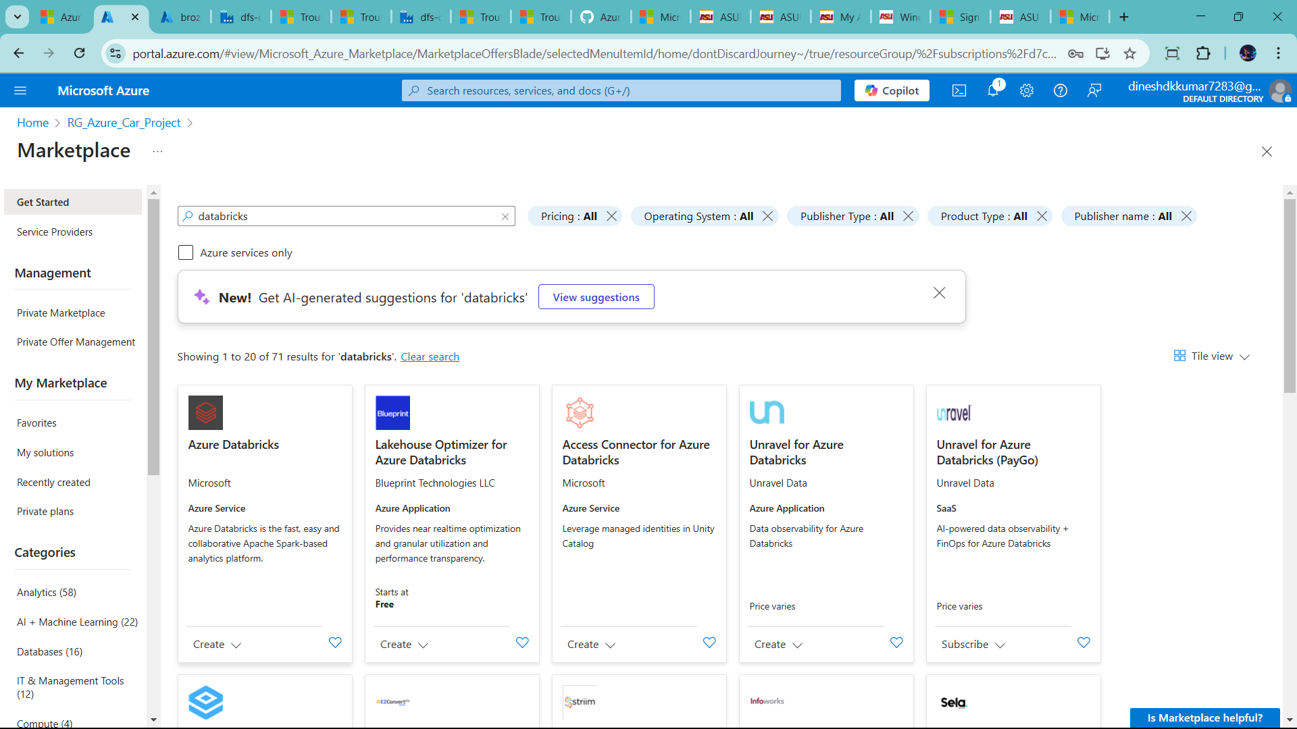

* Cars databricks

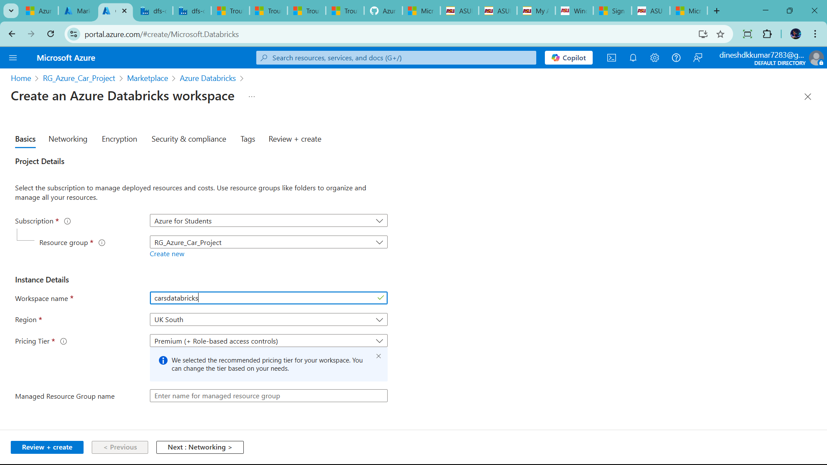

* Put workspace name
* Add change price Tier 🡪 trail 14 days
* Add manager resource group 🡪(use for catlog,etc)
* Click review+create

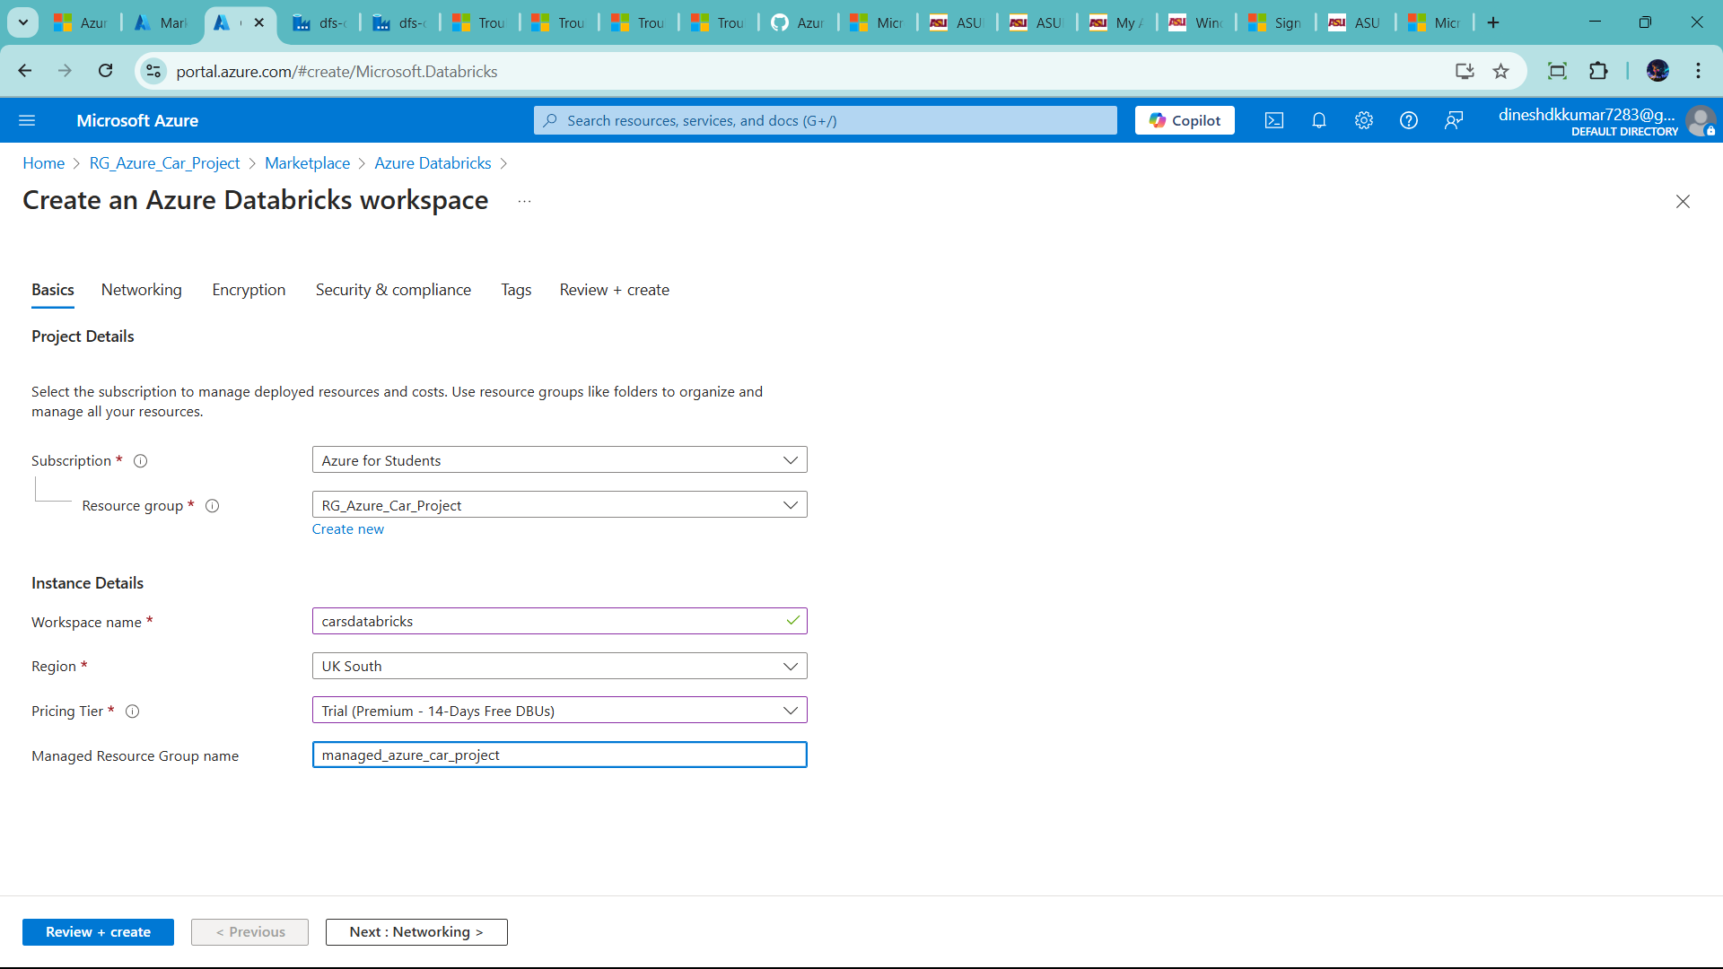

🡪click create and completed

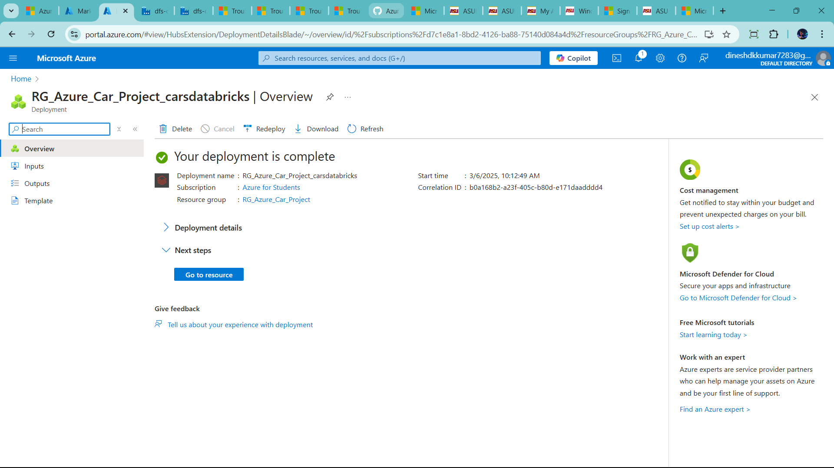

Click go to workspace

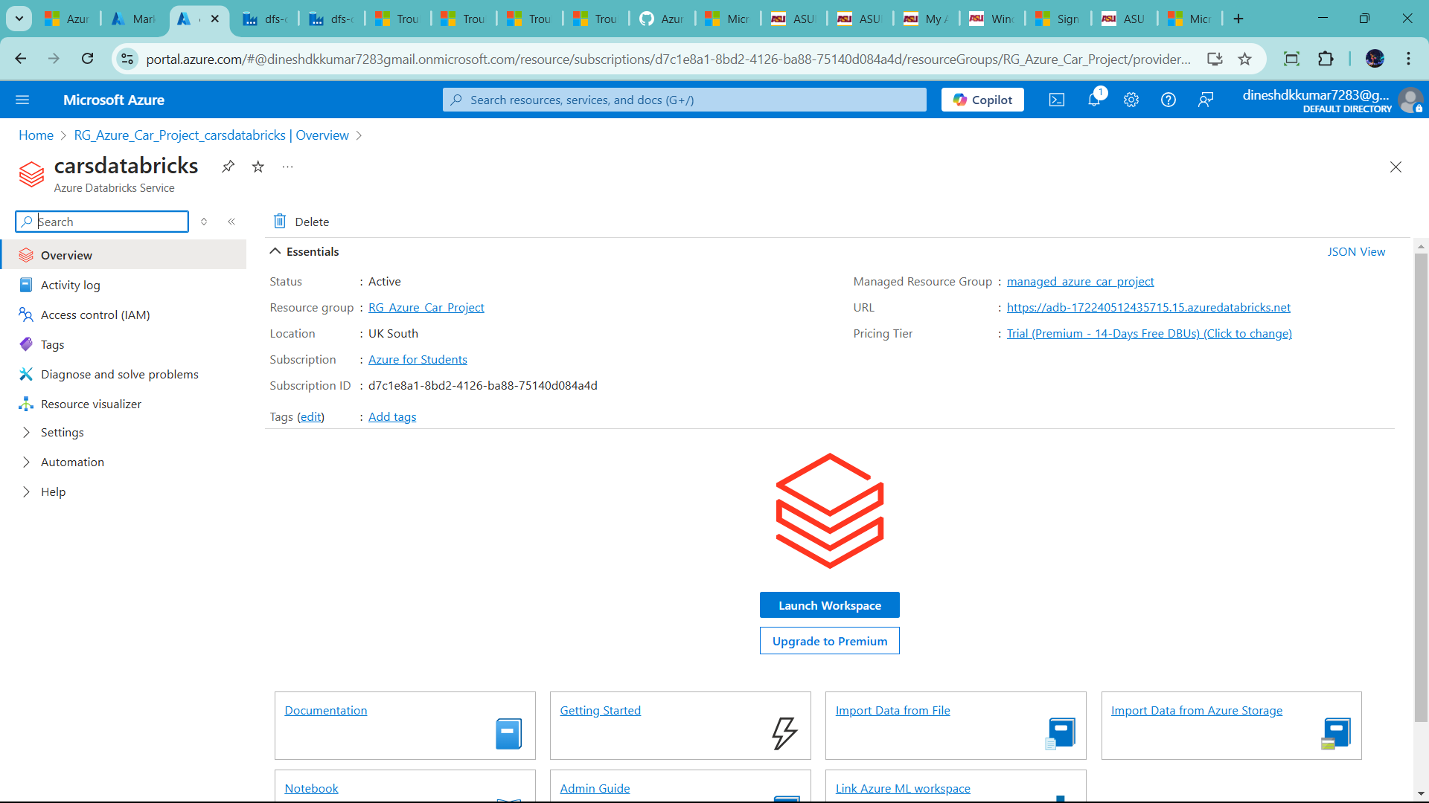

Click launch workspace

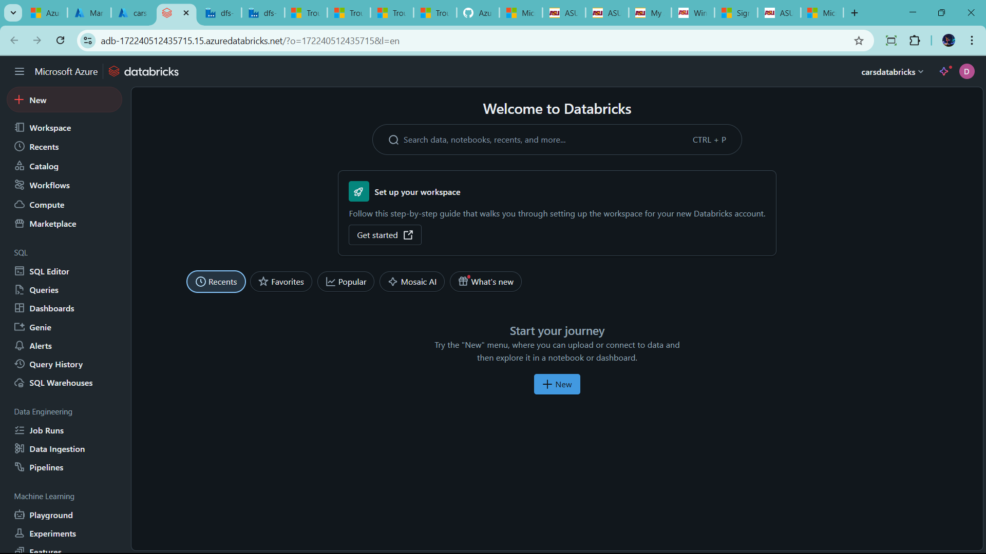

🡪workspace 🡪manage folder,notebook and maintain hierchery

🡪Recents 🡪 view all the recent items 🡪notebook,delta table,live table and more in recent tap

🡪Catalog 🡪 manage a Databases/ table,schema and volumn

🡪Workflows 🡪 it like ETL frameworks ,build pipeline low/no code,

🡪compute 🡪create a clusters

🡪SQL 🡪 it is section use for data analysis

🡪data engineering 🡪 have 3 frameworkd

* One is pipelines/Delta live tables 🡪it is ETL flow
* Machine learning🡪 build models
* Marketplace 🡪use service for 3rd party like azure,more

**First Create Unity Metastore**

**🡪but in databricks not able to create unity metastore**

**🡪 first change in Admin in databricks**

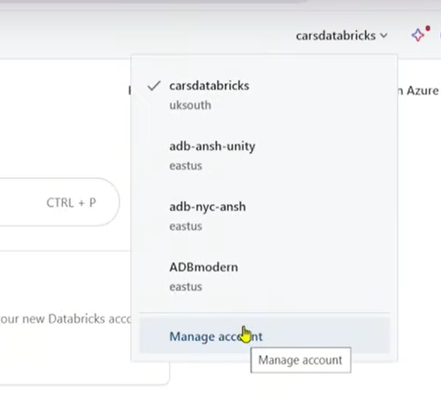

* **But over databricks not show manage account option**
* **Let how to enable**

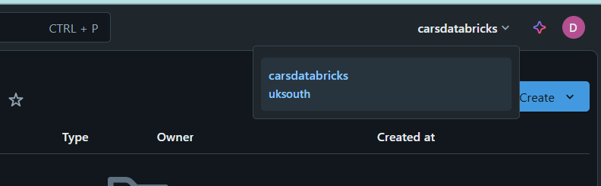

* First go to azure account 🡪 click Microsoft entra id
* 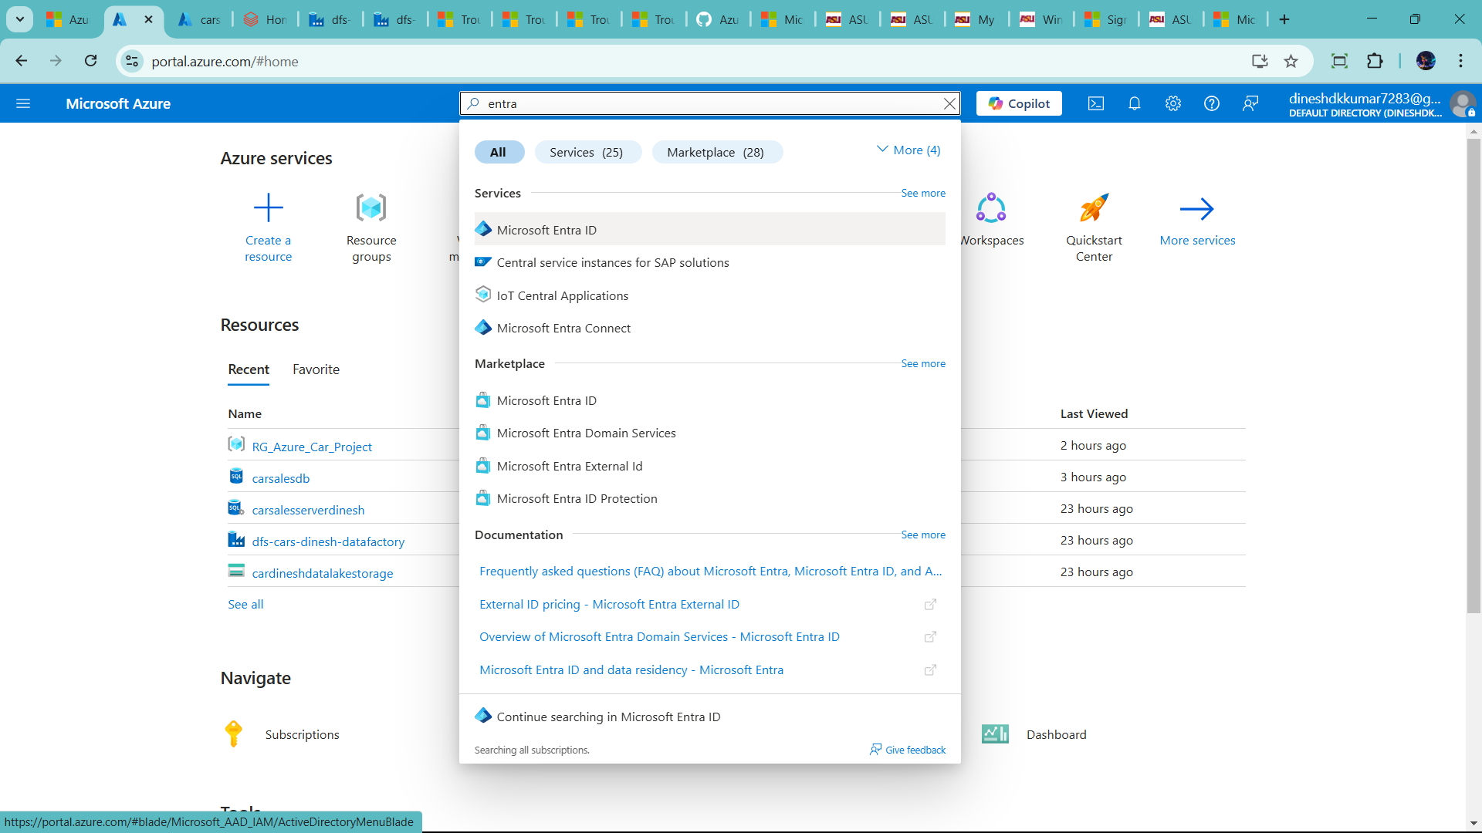

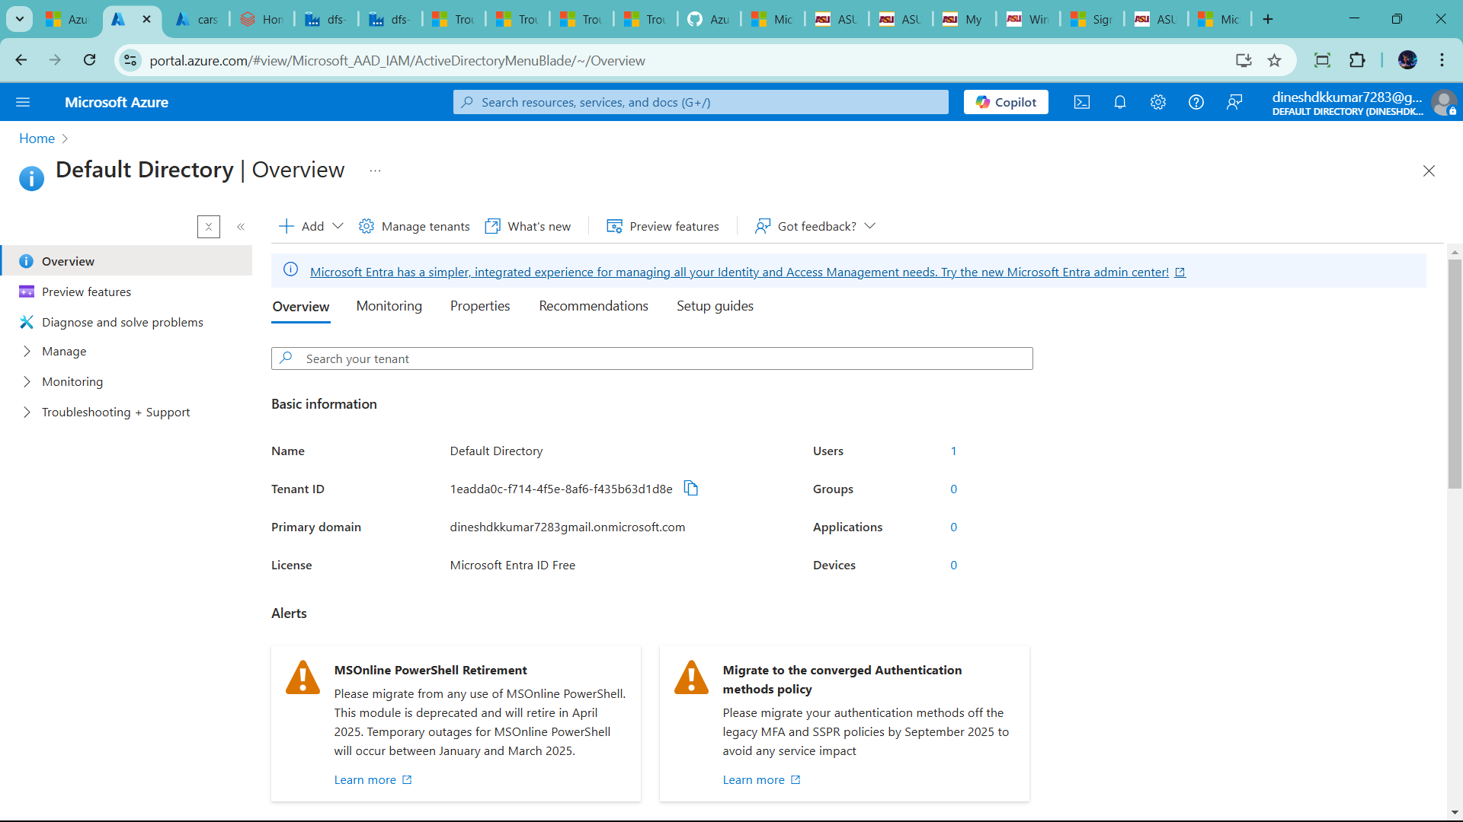

🡪go to manage 🡪user 🡪copy this user mail id with #tag

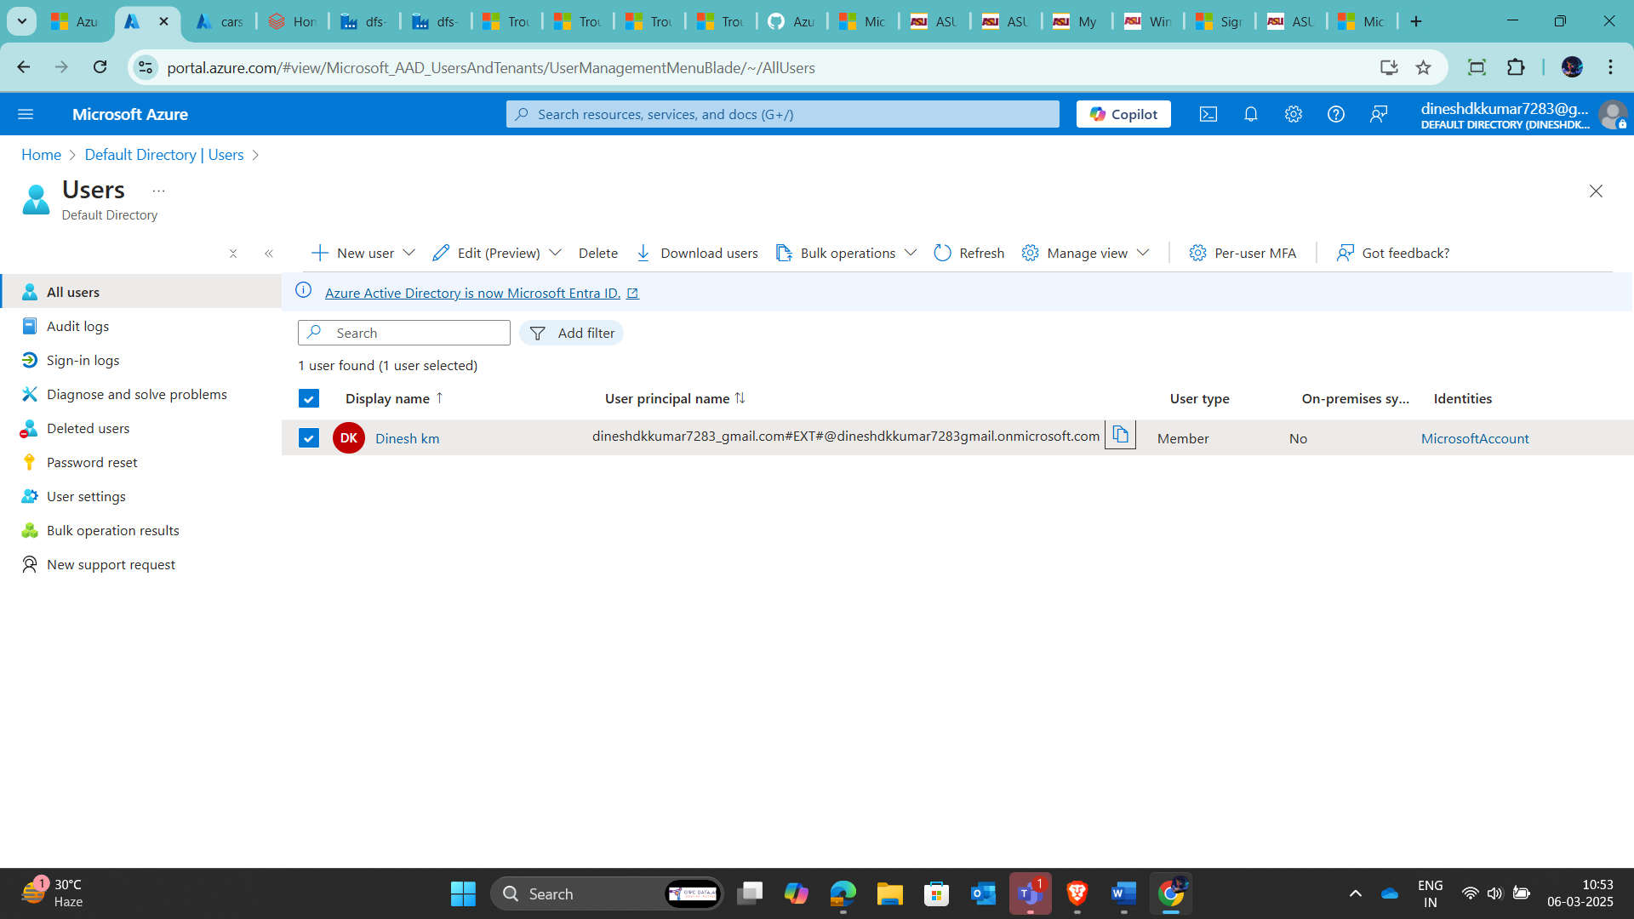

Login in another portal 🡪accounts.azuredatabricks.net

🡪first reset the password 🡪 now login in the #tag mail id

🡪success open Admin account

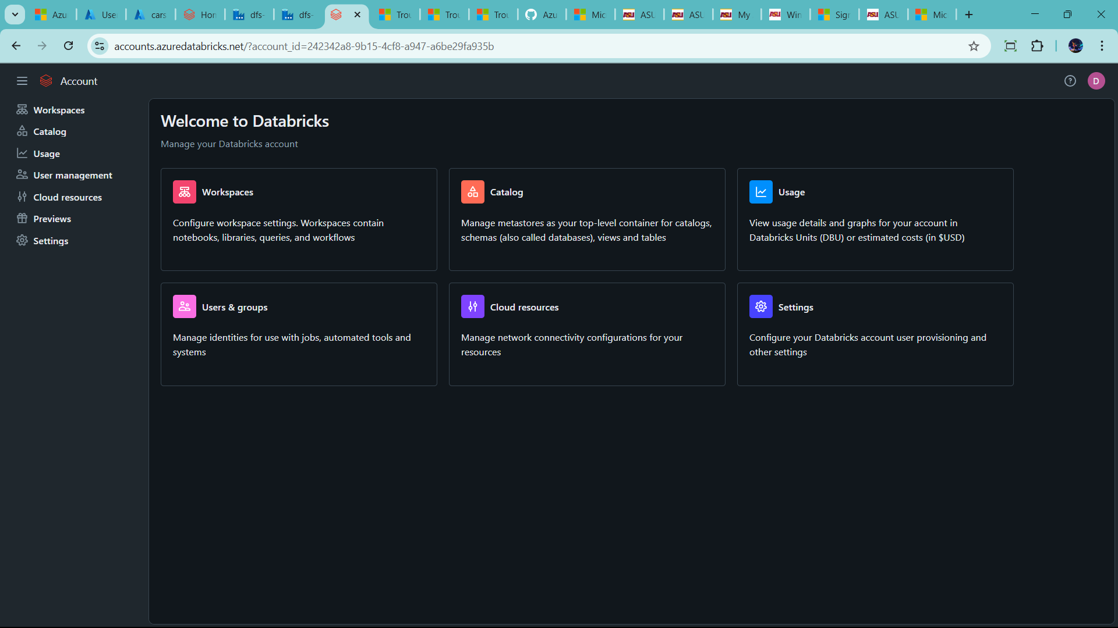

🡪go to user management section

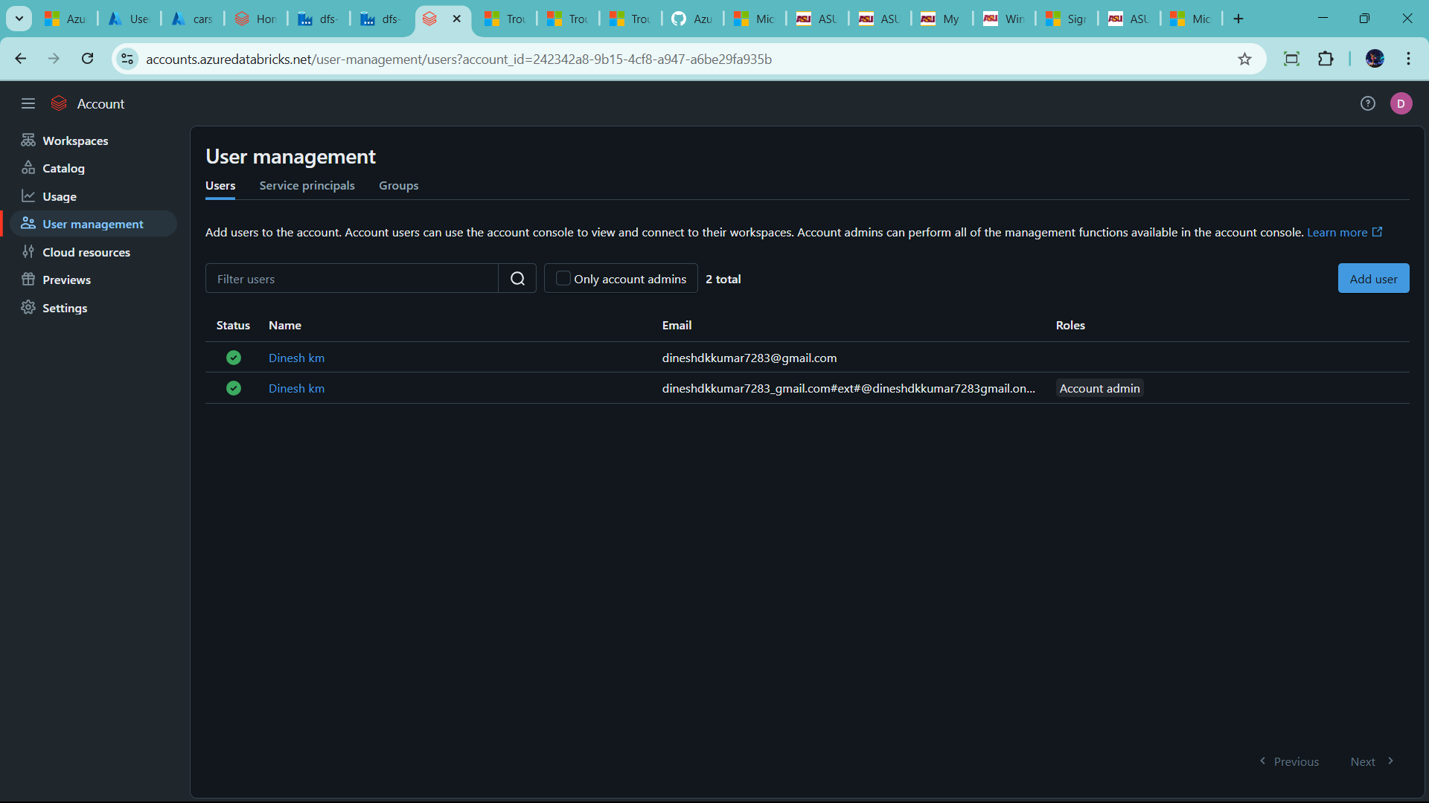

🡪add new user or already present 🡪 click the name

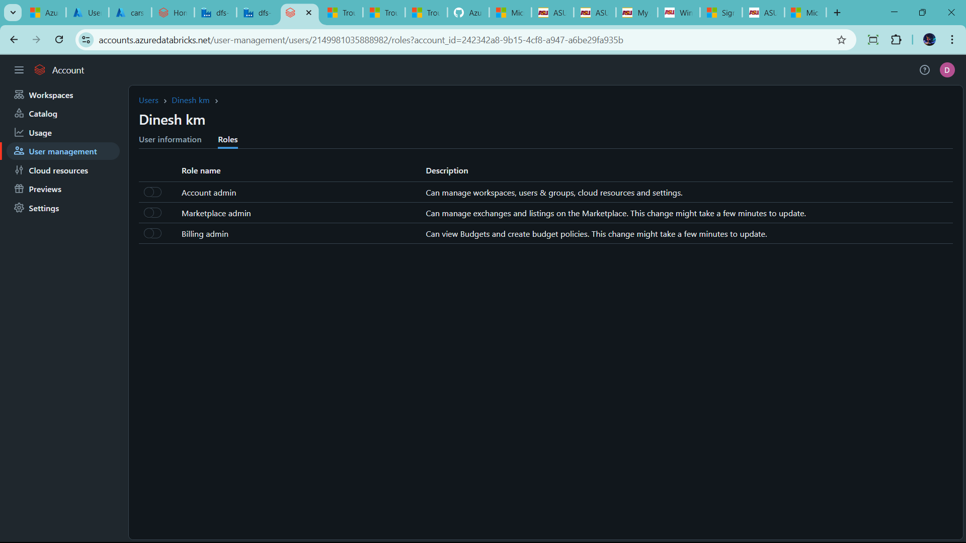

🡪click Admin account active

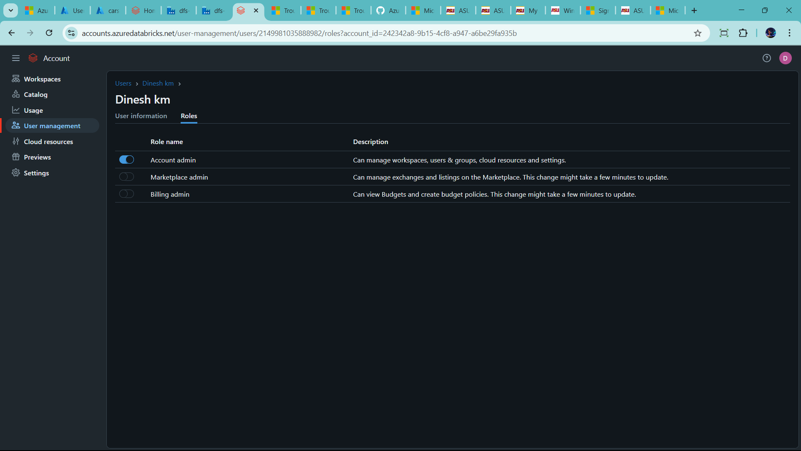

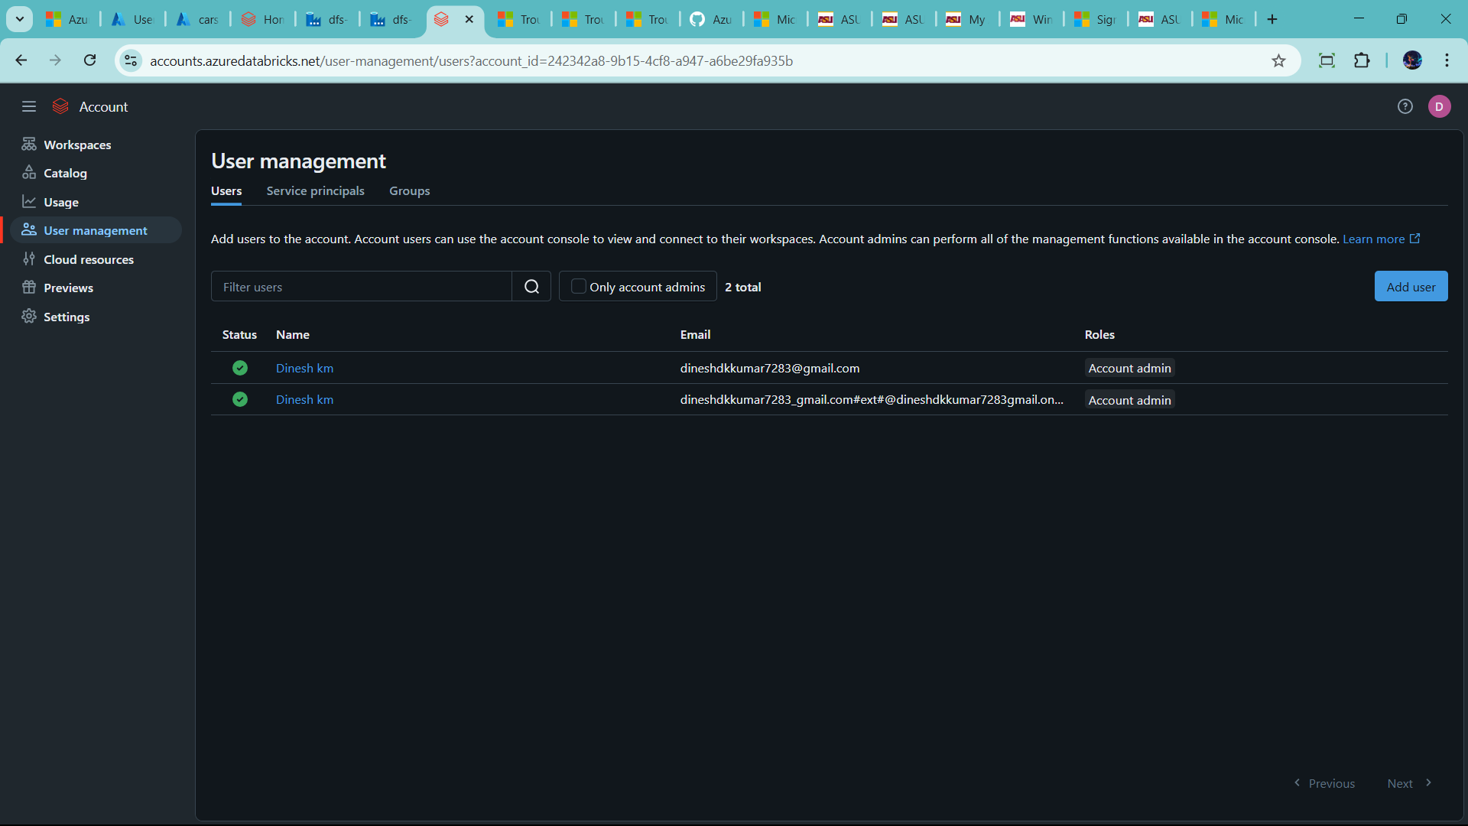

Now check catelog in admin console 🡪the already create unity catelog

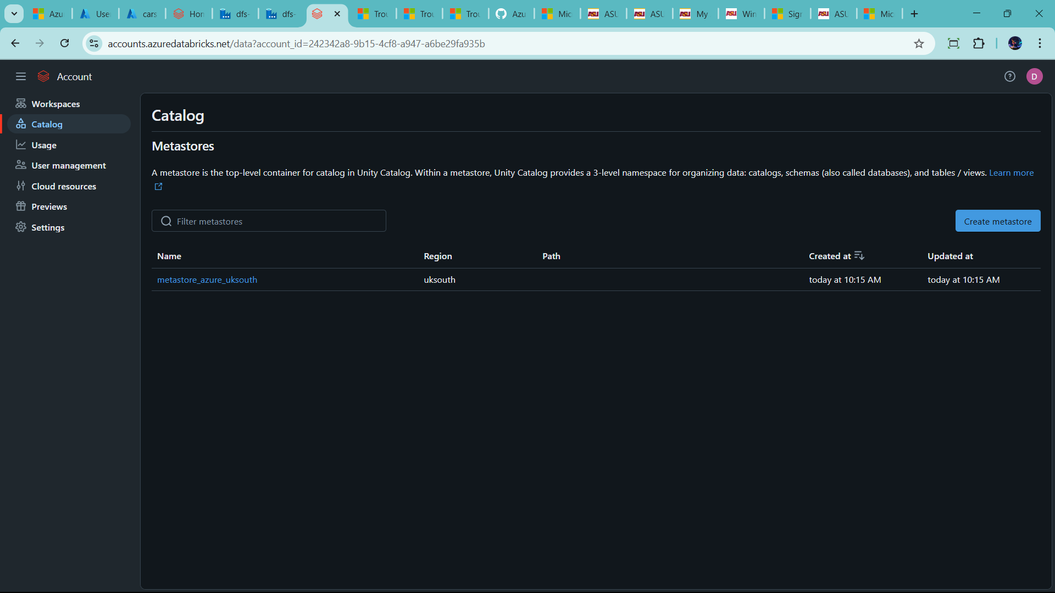

🡪now I deleted my unity catalog

-🡪only one region same unity catelog possible to create

🡪first click the name present in catalog

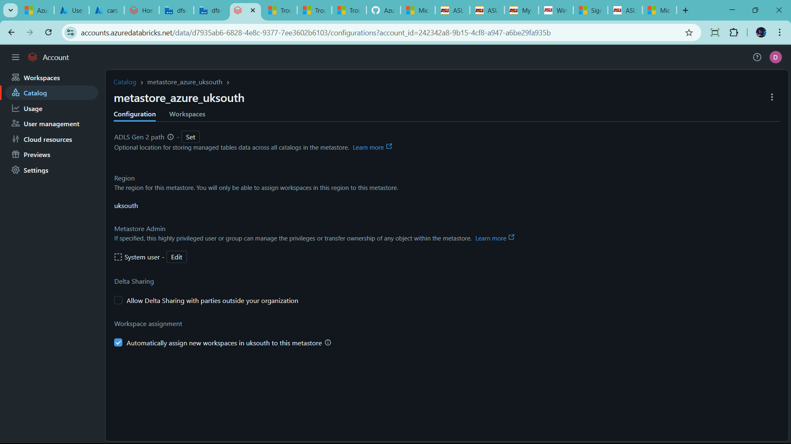

Click 3 dots 🡪 delete

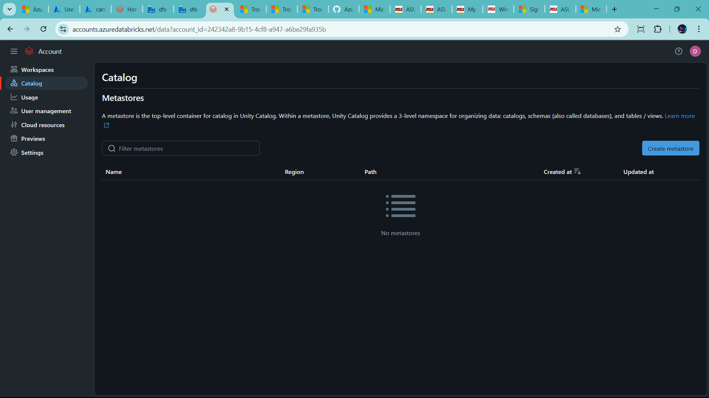

* Now create manually
* Click create metasote

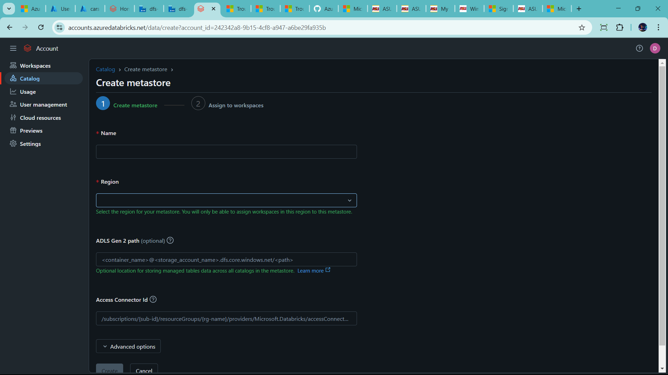

🡪fill it

🡪before databricks 🡪 connector 🡪 ADLS Gen 2

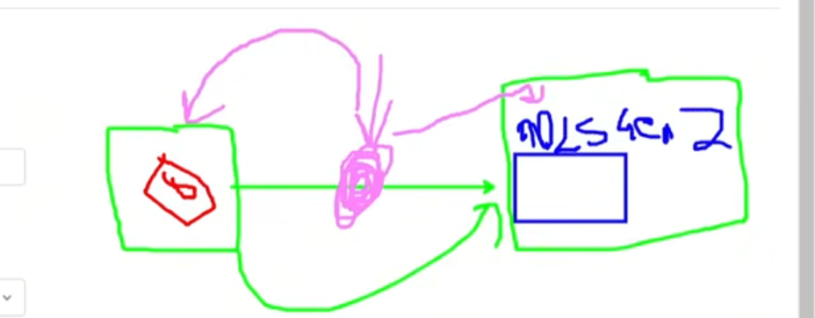

* Databricks have permission to use it datalake
* That use access connector id in account admin

🡪Let create Access connector in azure account

🡪go to azure resource group

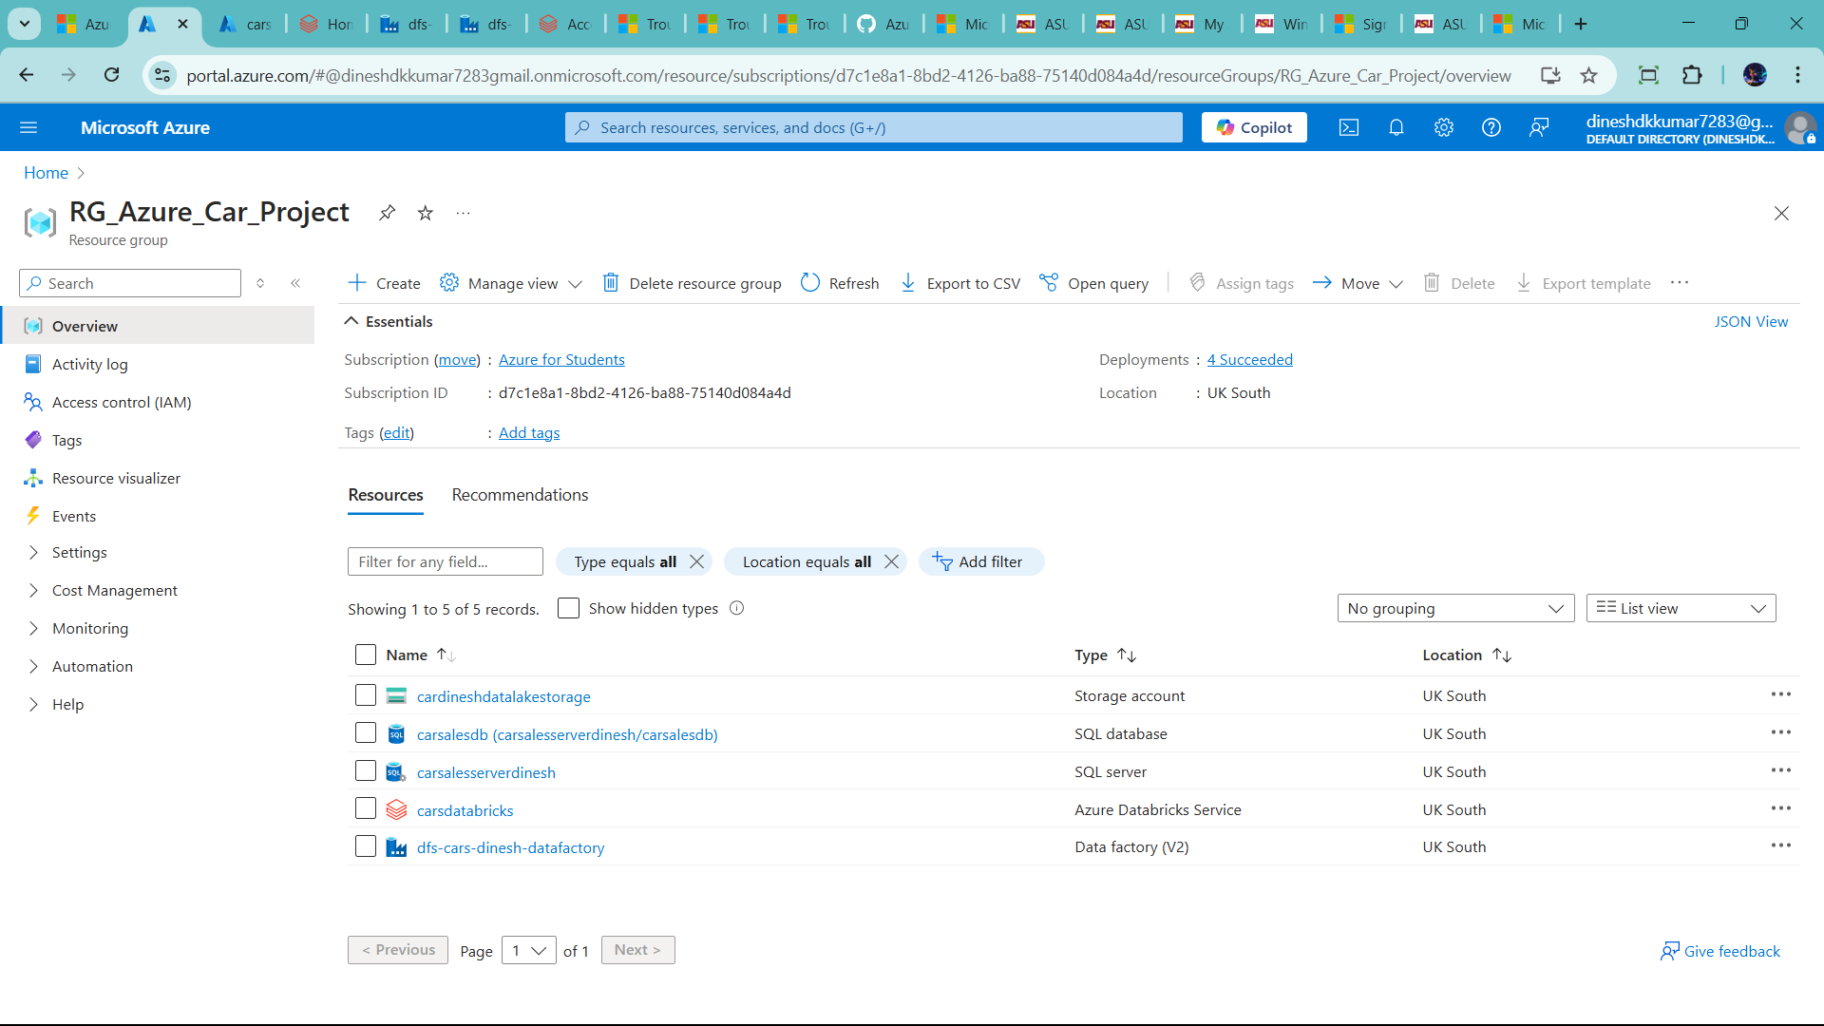

--click create 🡪search databricks 🡪 find access connector for azure databricks

🡪click create

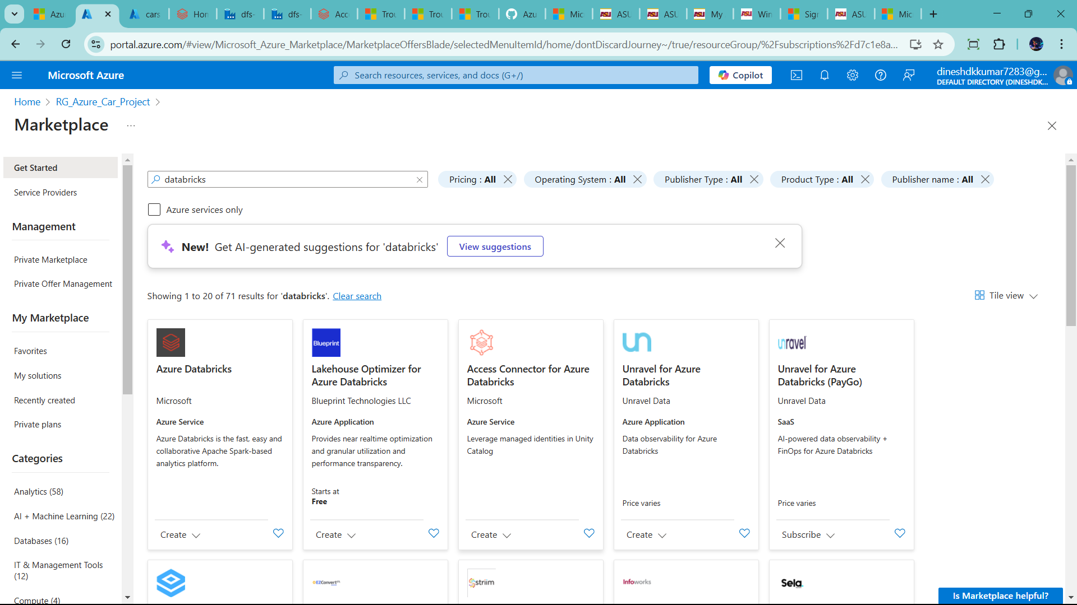

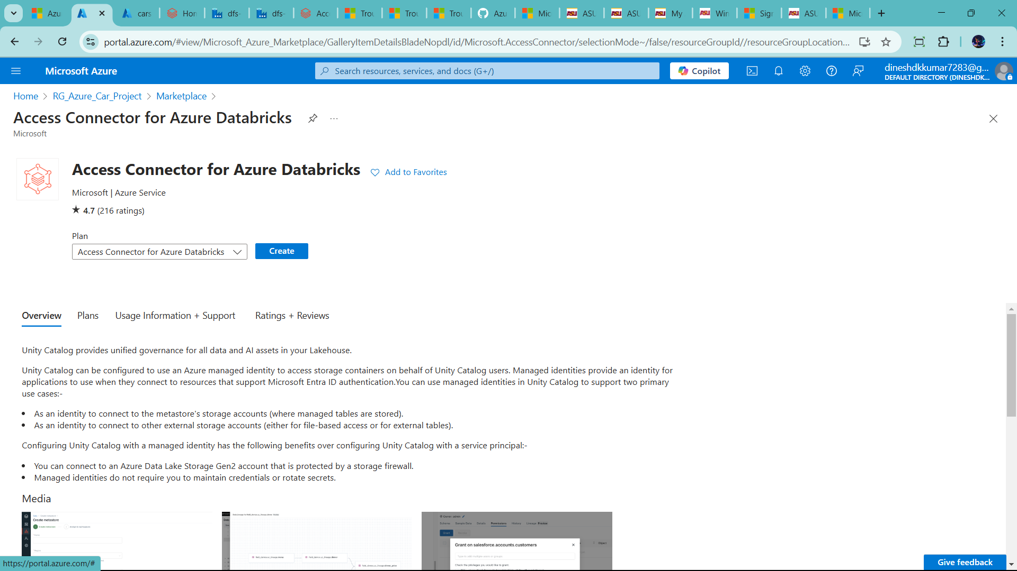

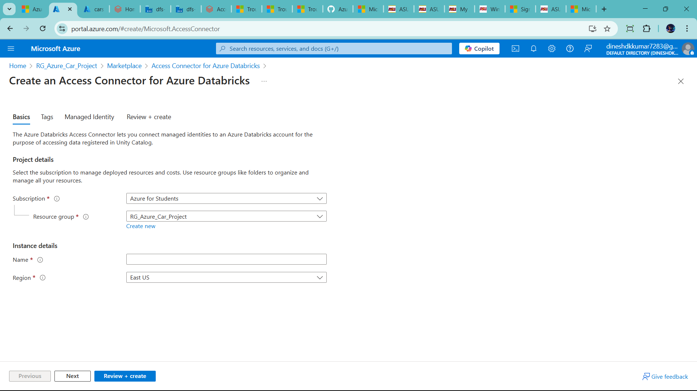

Fill it

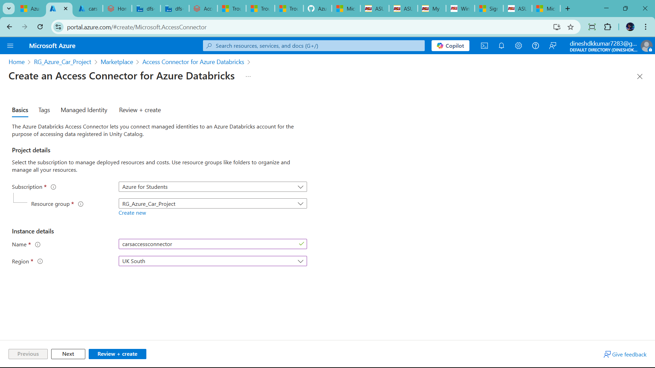

--review+create and click create

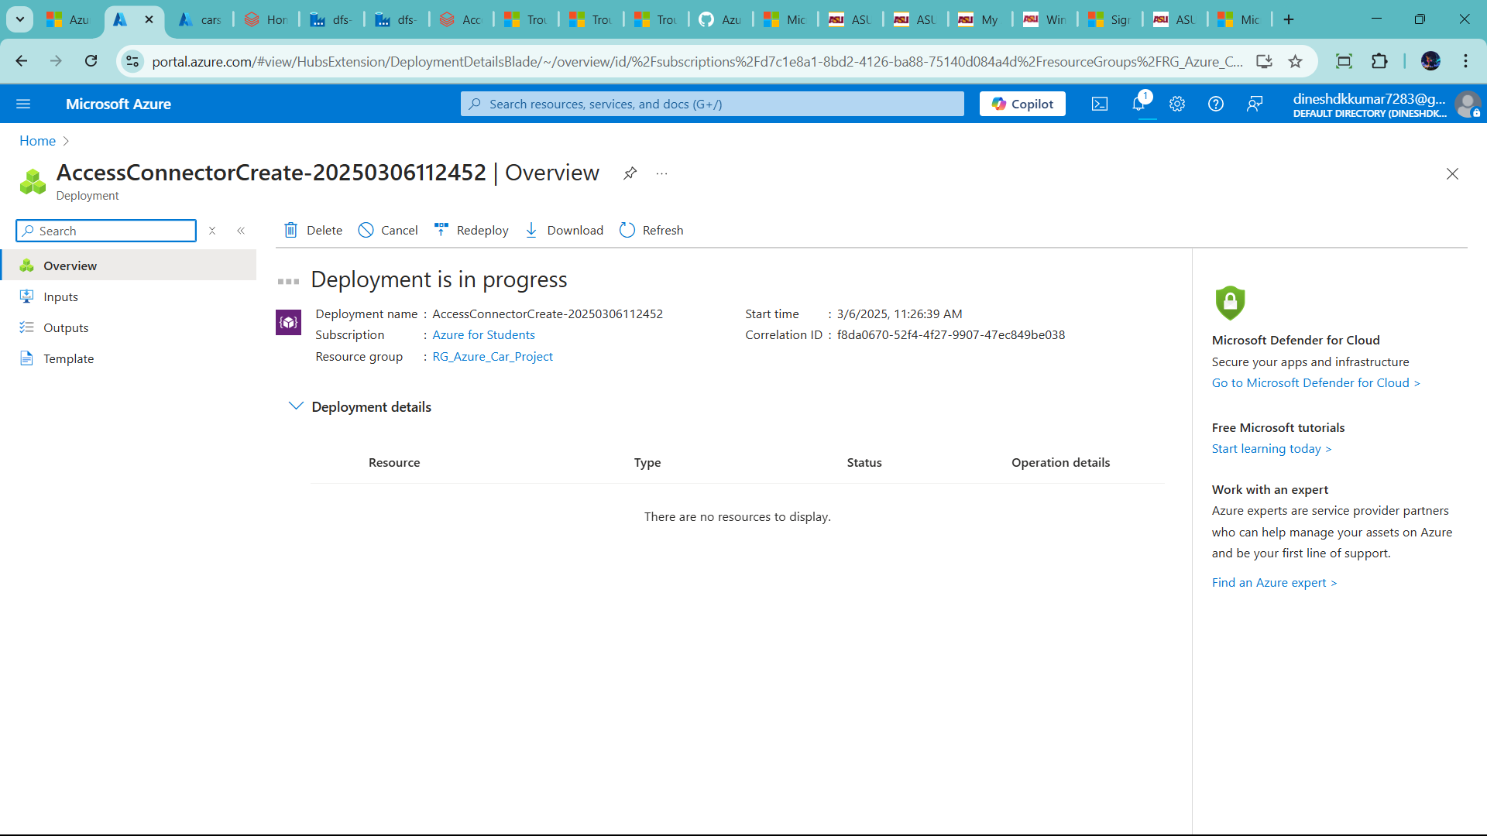

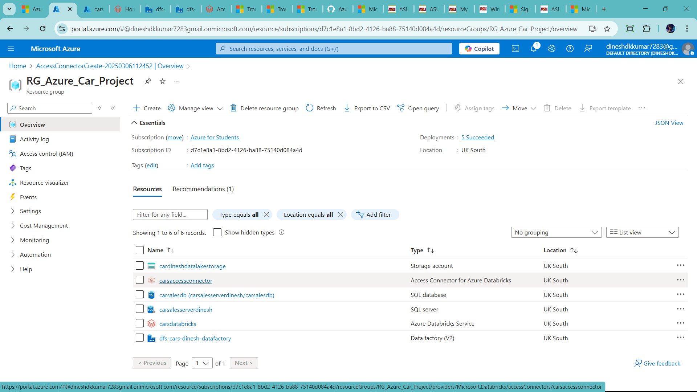

🡪access connect use to storage whole contributer 🡪 it means contribute to cardineshdatalakestorage

🡪it is indirect link and more data security

🡪lets go to datalake

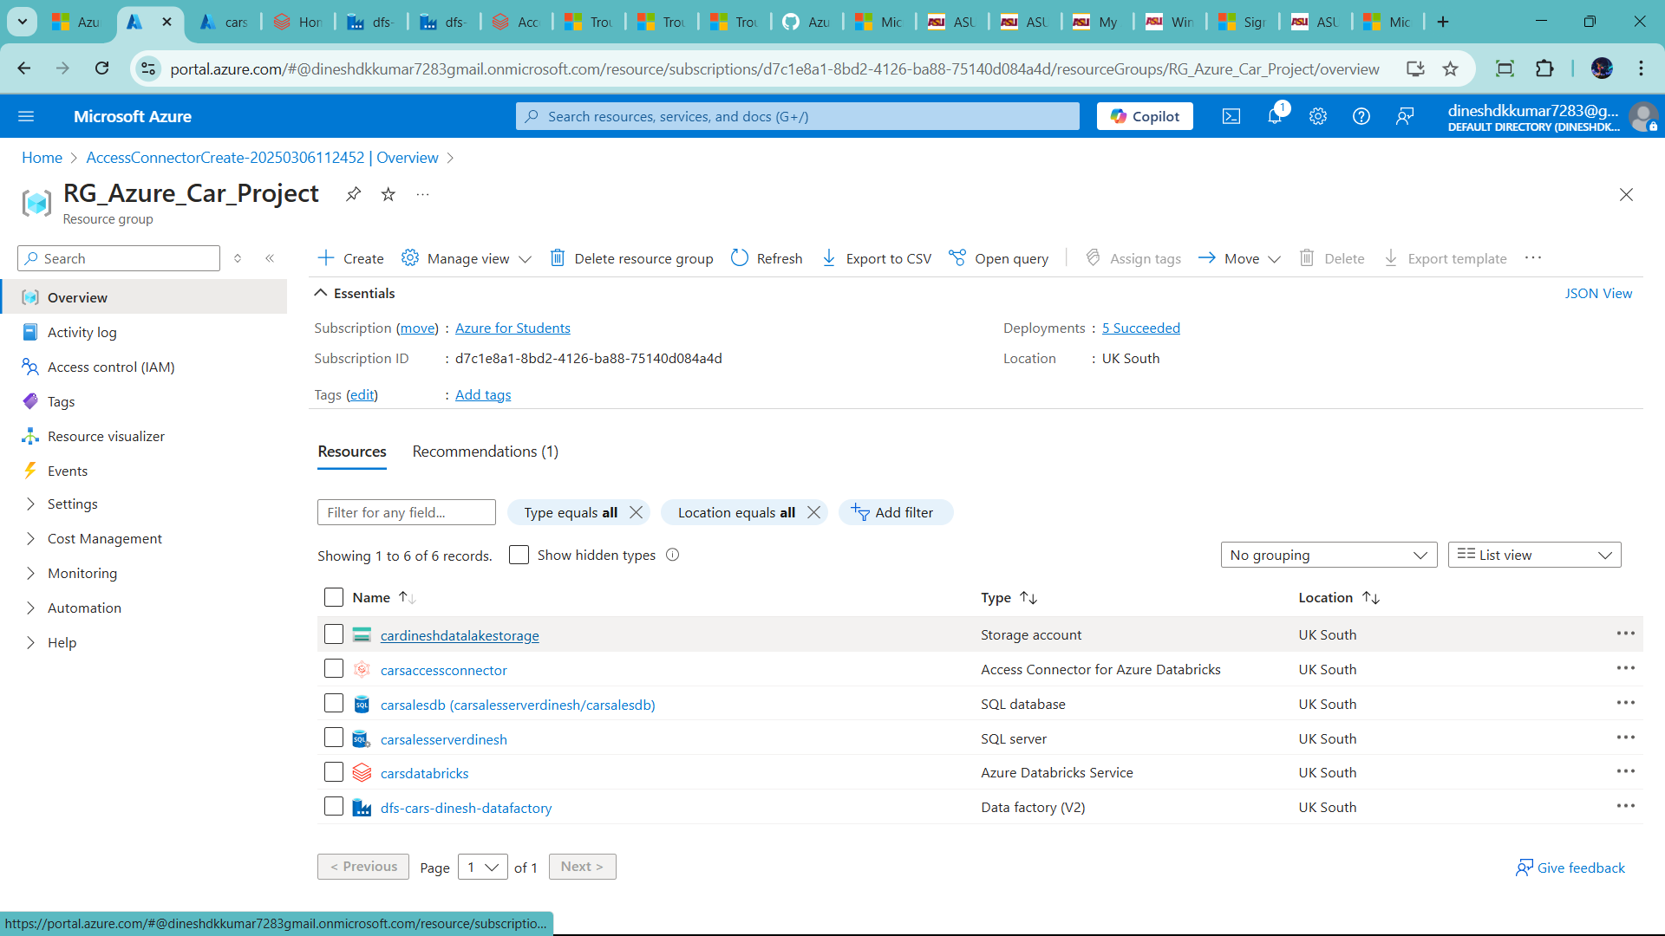

🡪go to acess control IAM

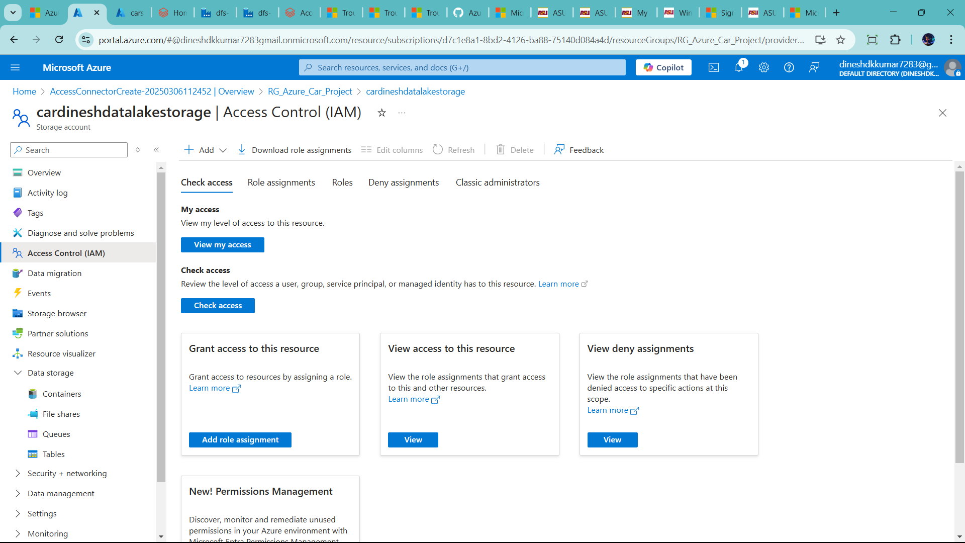

🡪click +Add 🡪Add role assignment

🡪search storage bolb data contributor🡪 click storage bolb data contributor 🡪click next

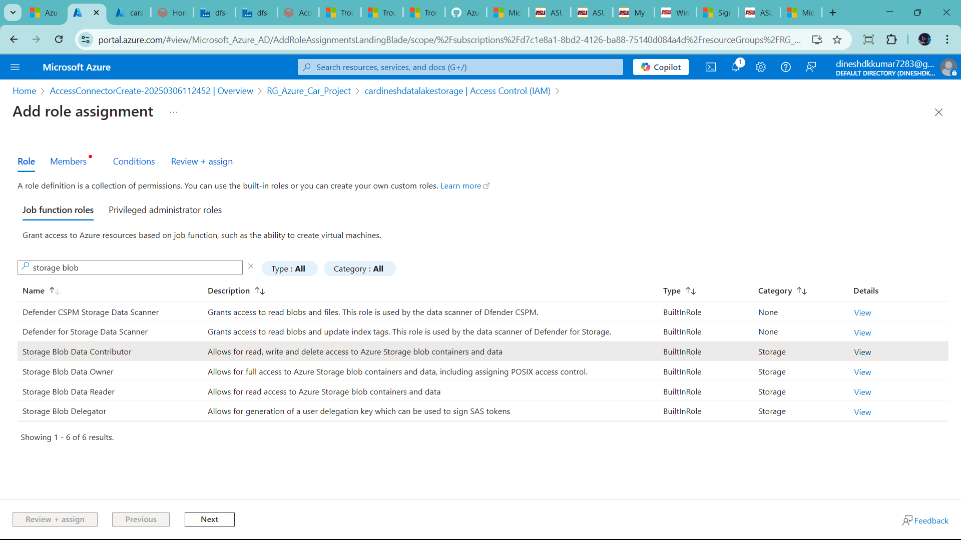

🡪click manage identity 🡪 now select members

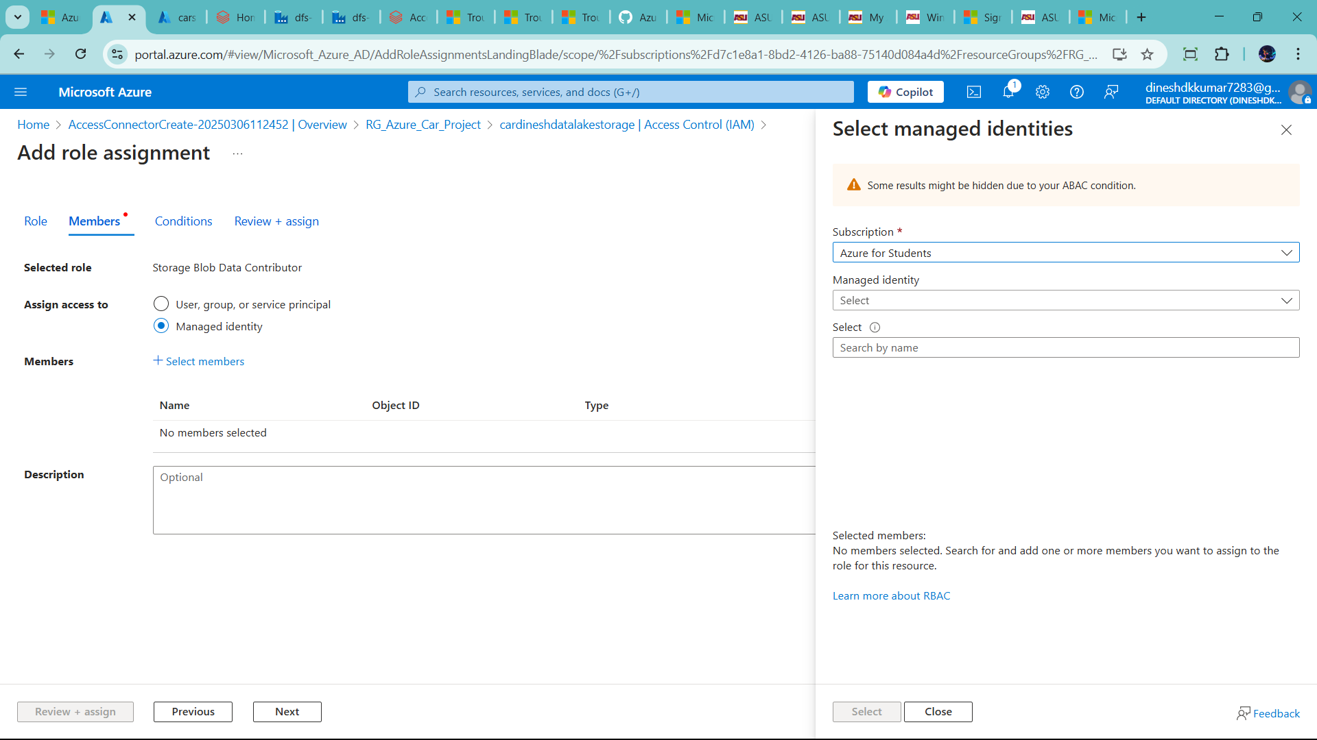

🡪add like this

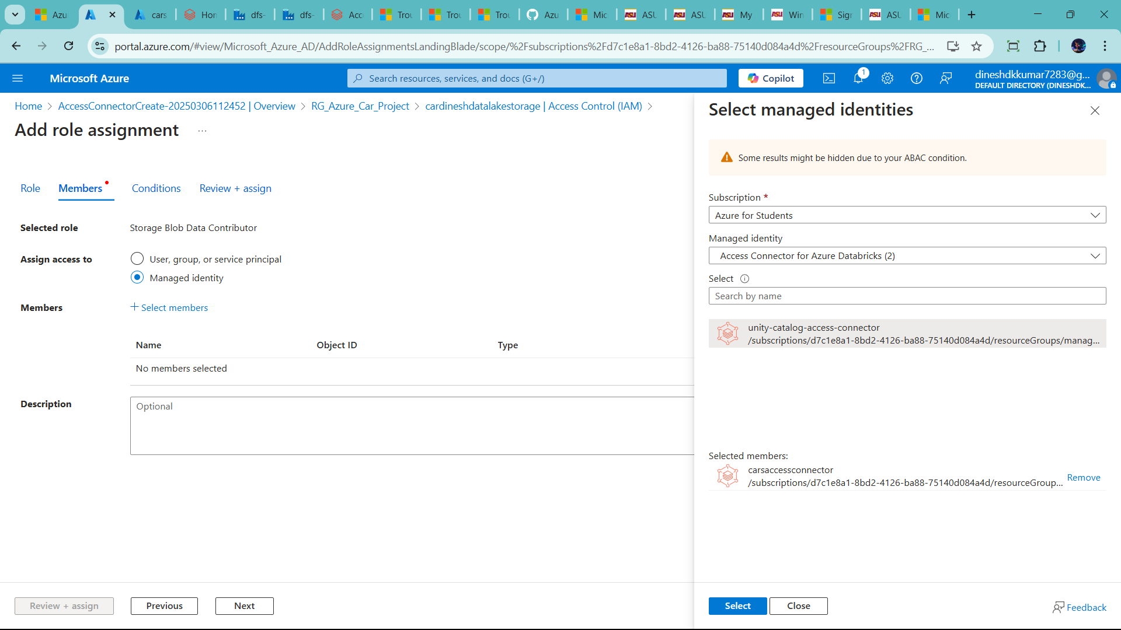

🡪click select

🡪review+assign

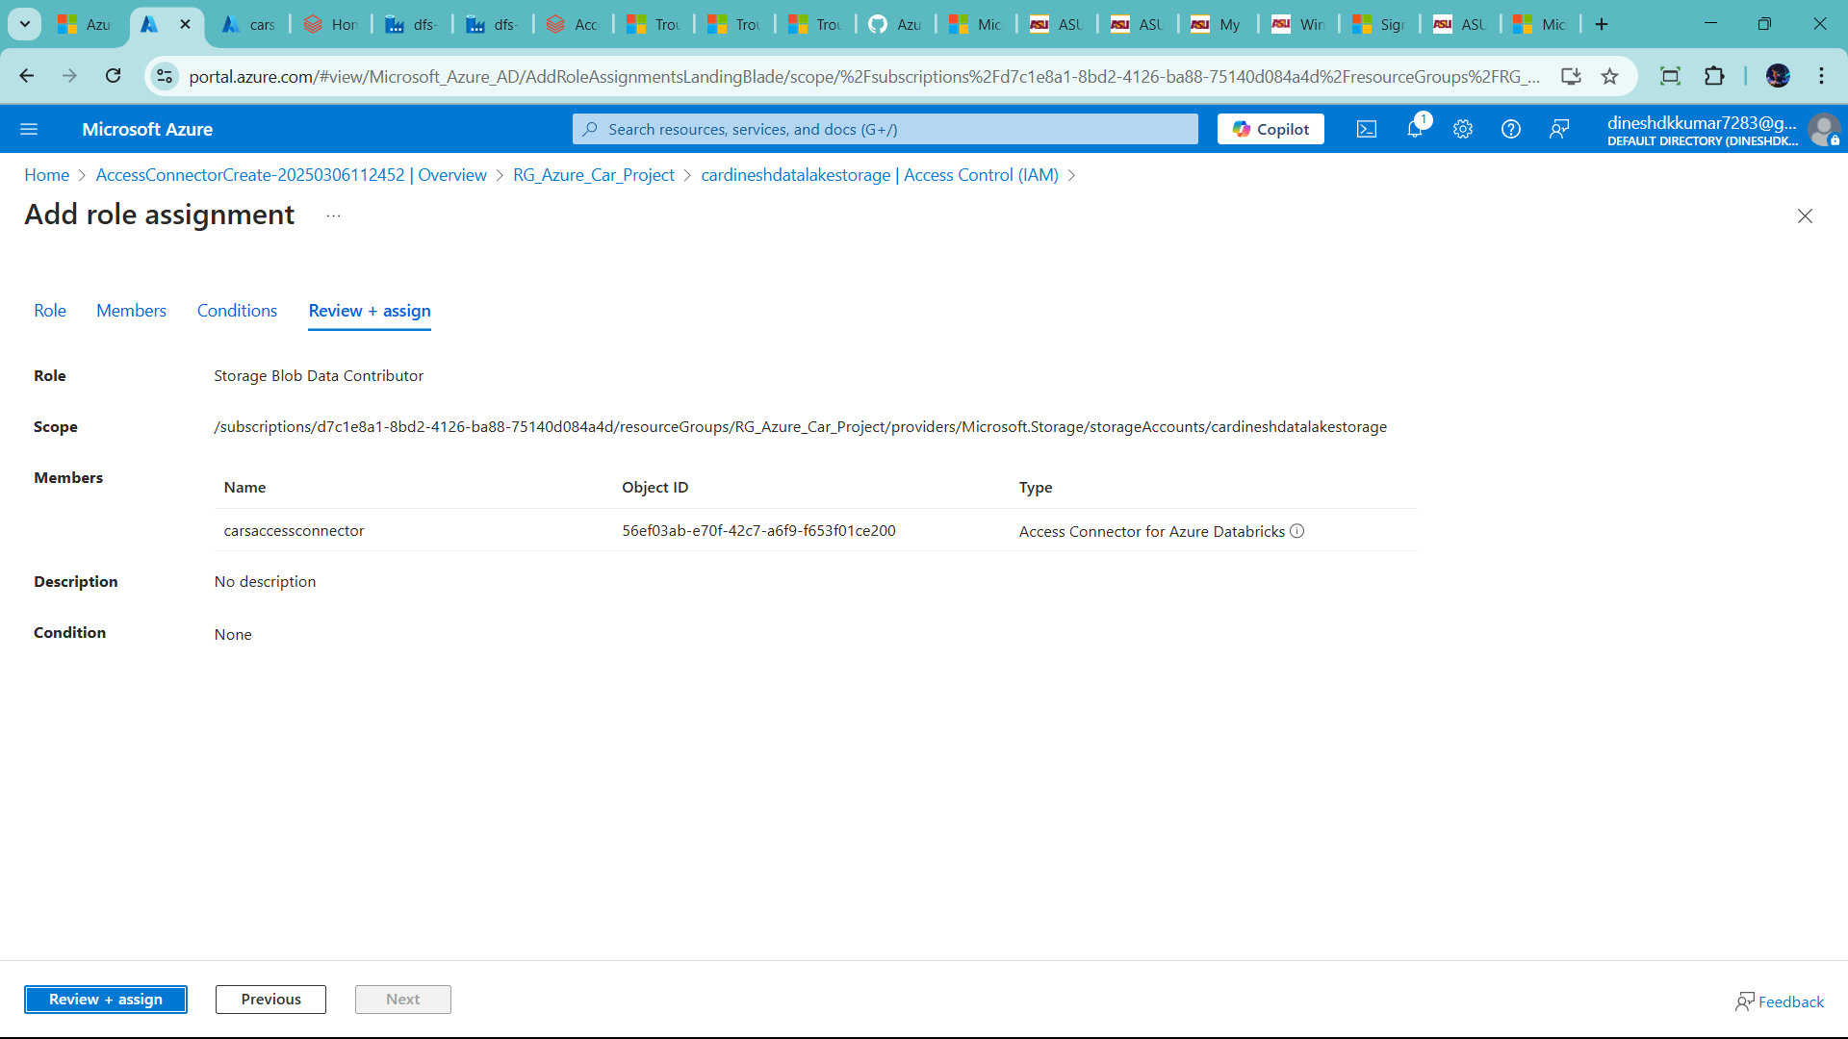

🡪click one more time 🡪add it

🡪one more step add container as well

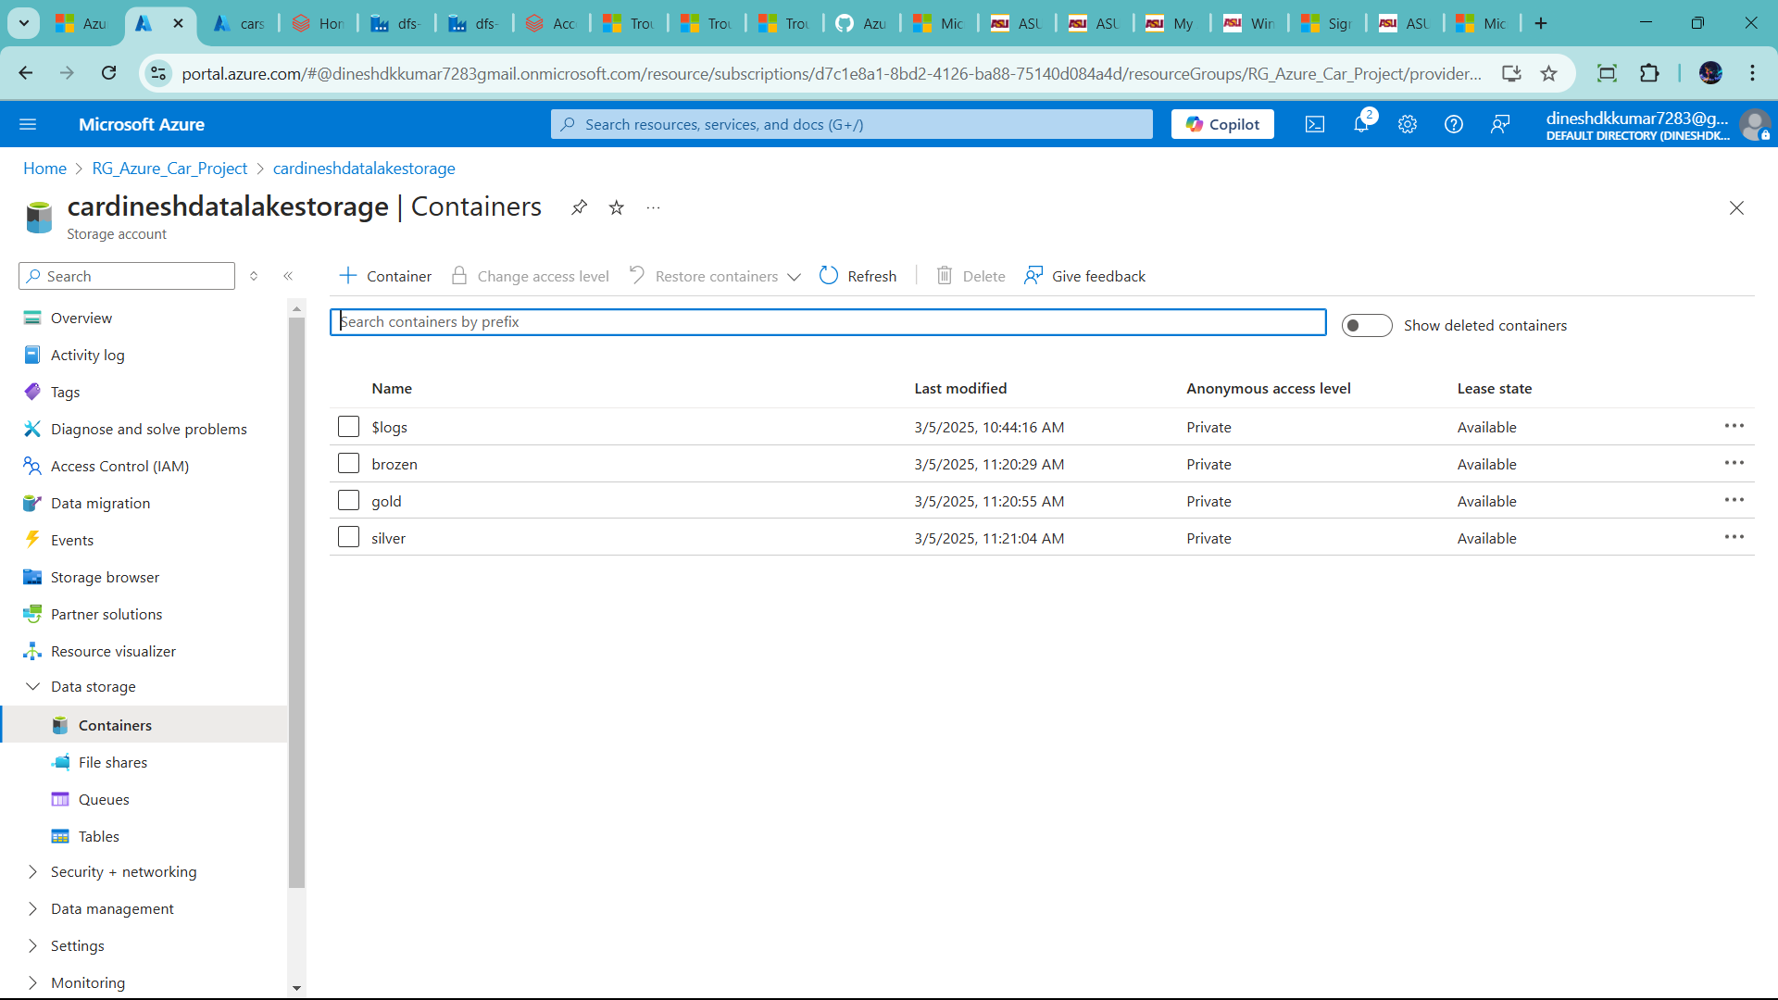

🡪click + container 🡪add name 🡪create

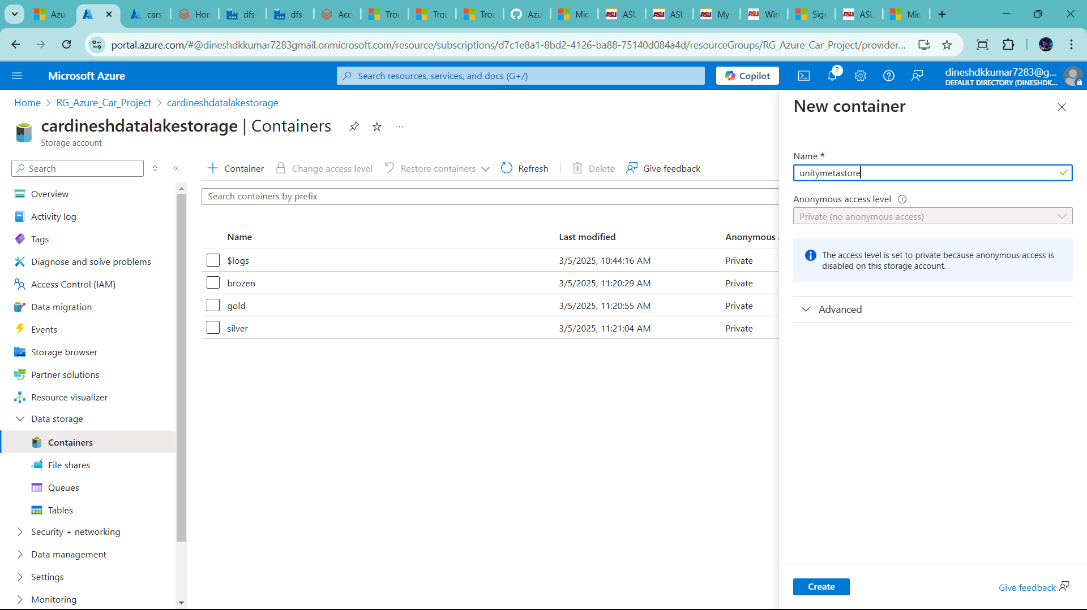

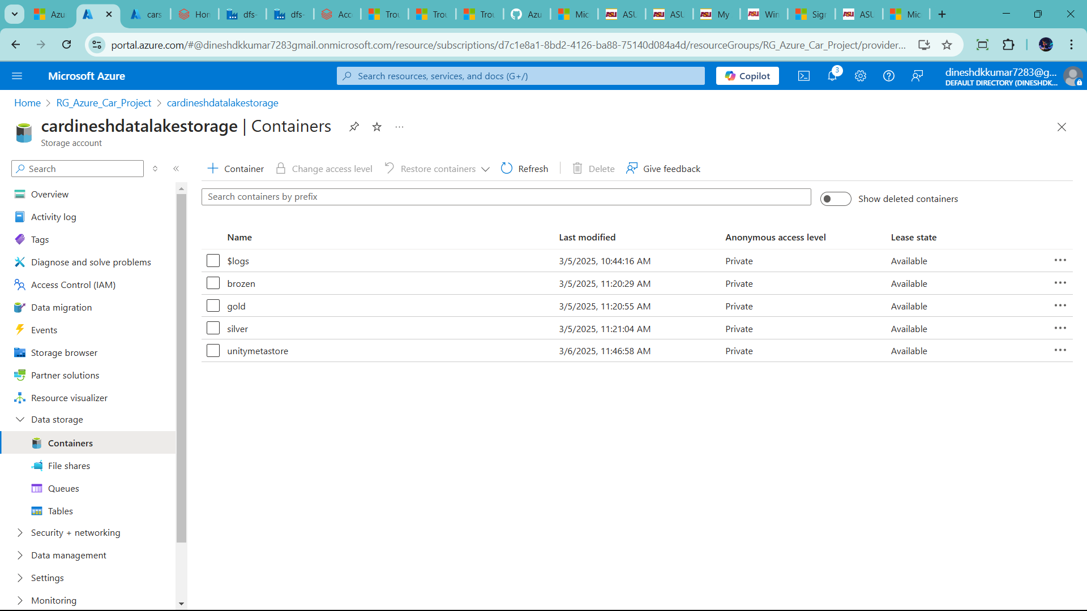

🡪go add Databricks Admin side

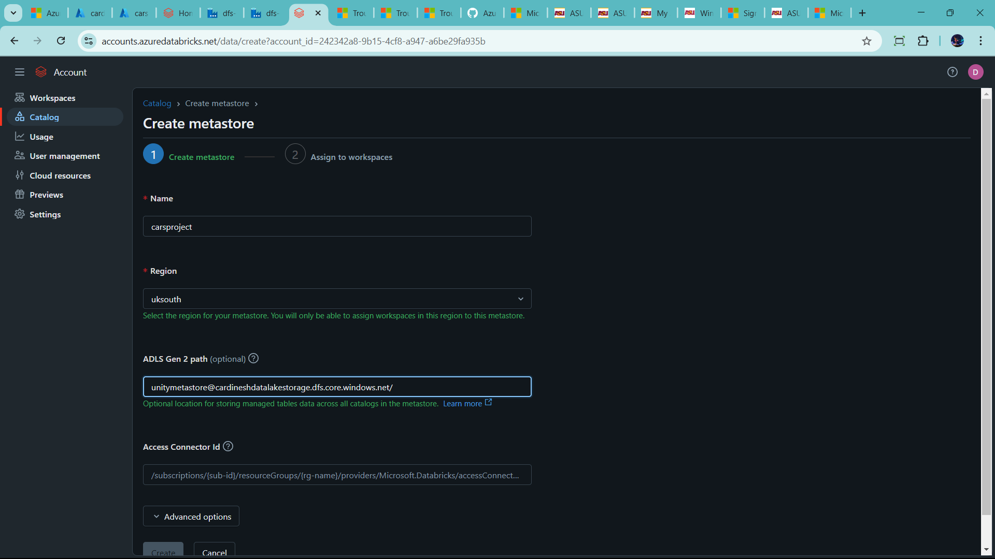

🡪acess connector id as well

🡪go to azure🡪resouce🡪

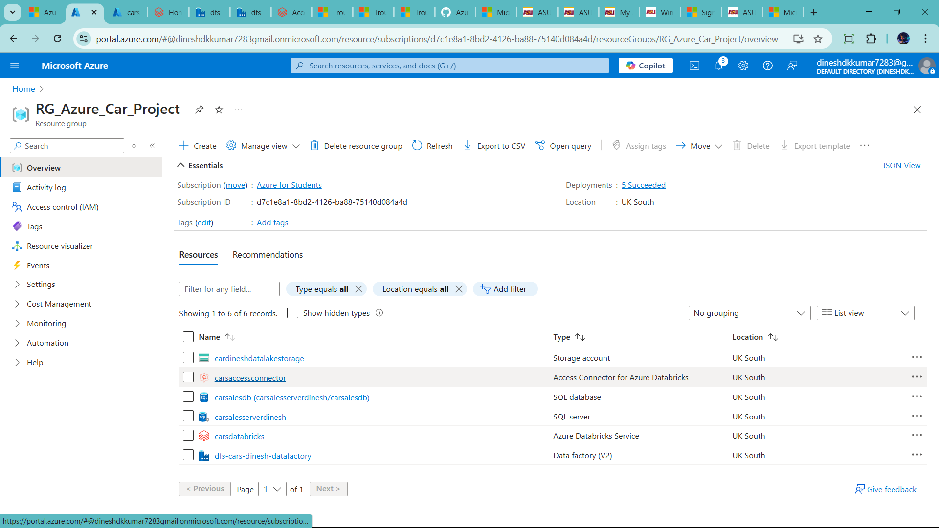

🡪copy the resource id

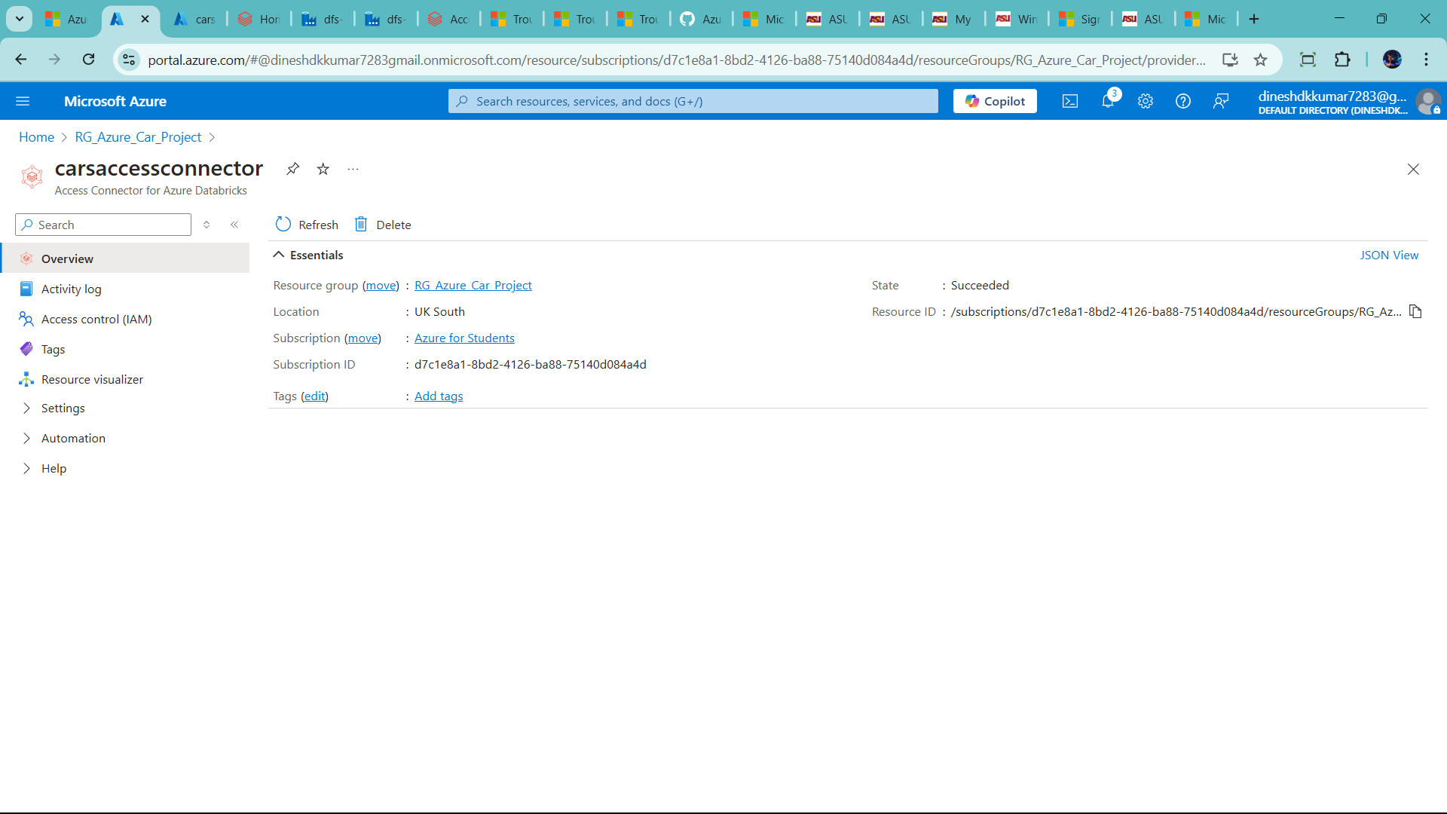🡪paste in databricks admin account

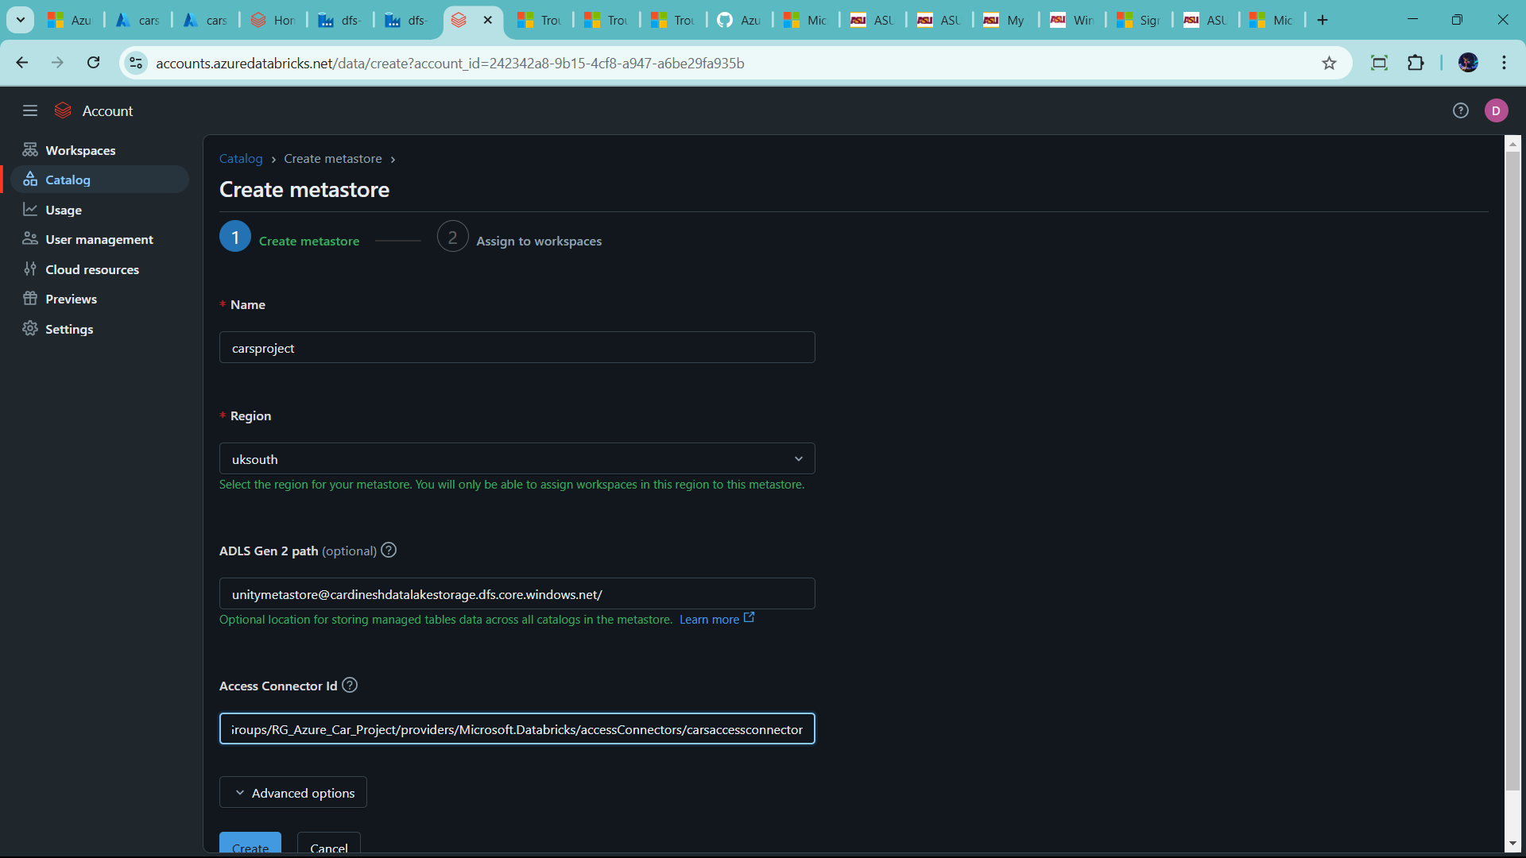

--Click create

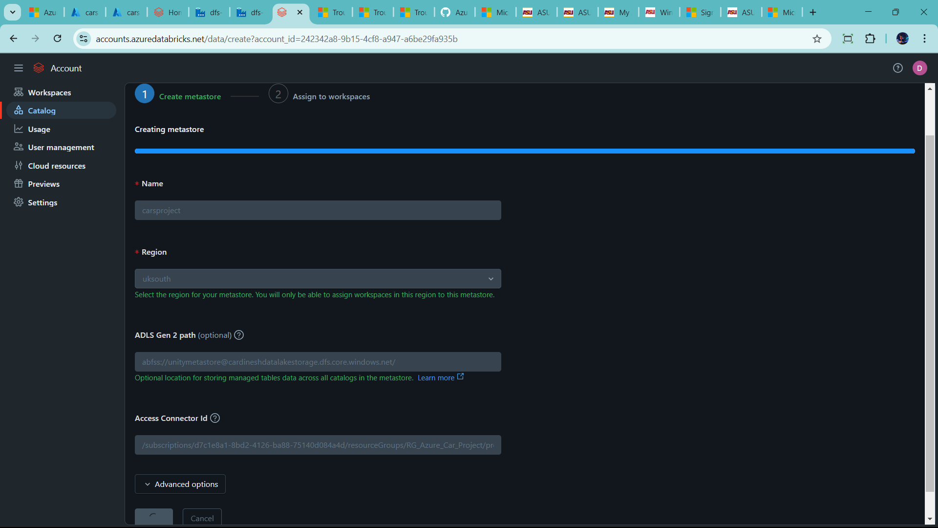

🡪go to workspaces

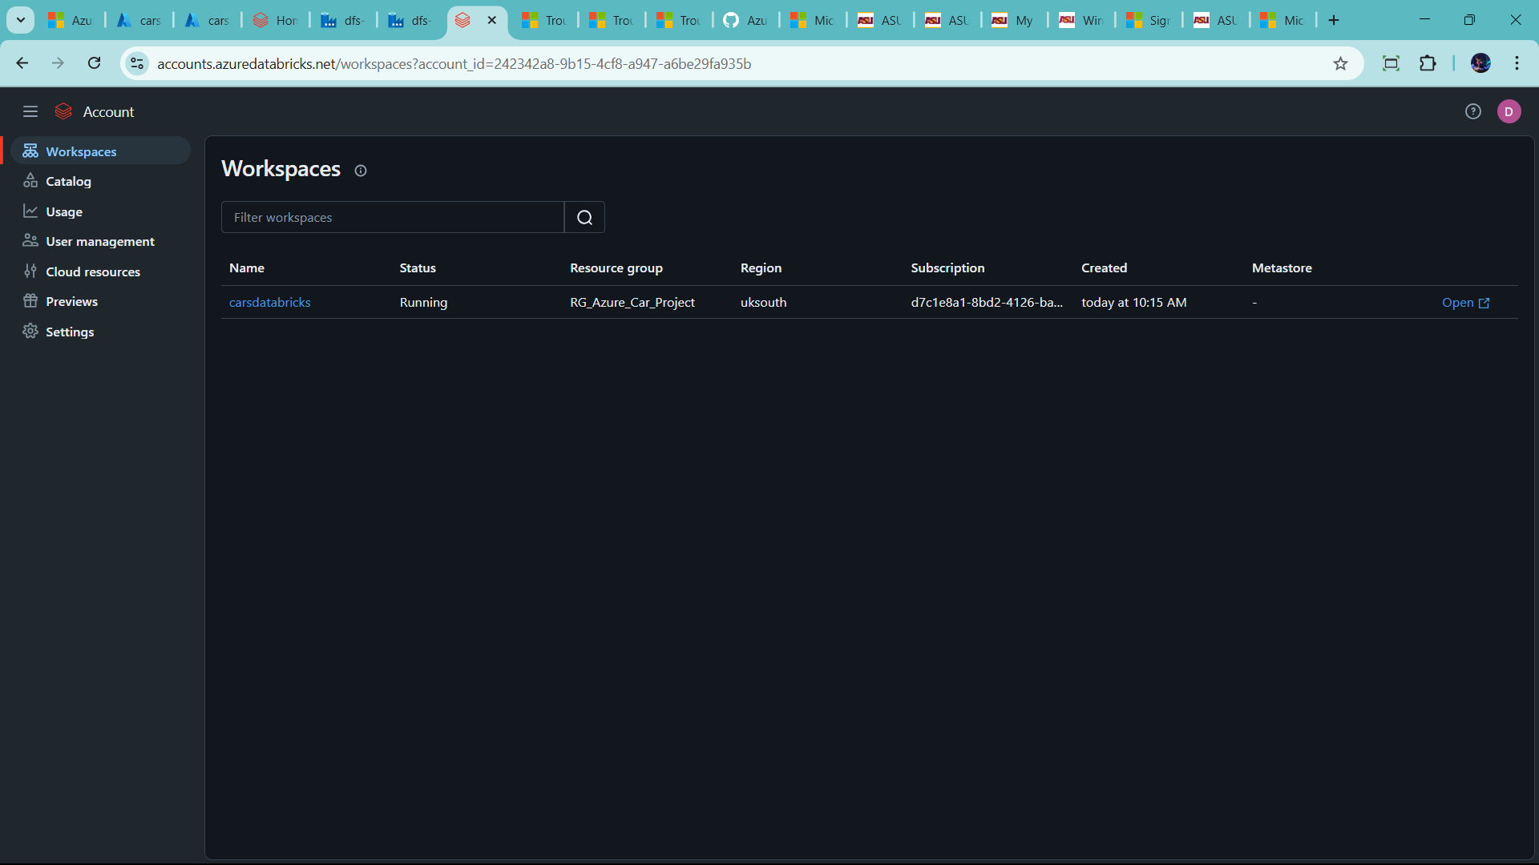

🡪click name

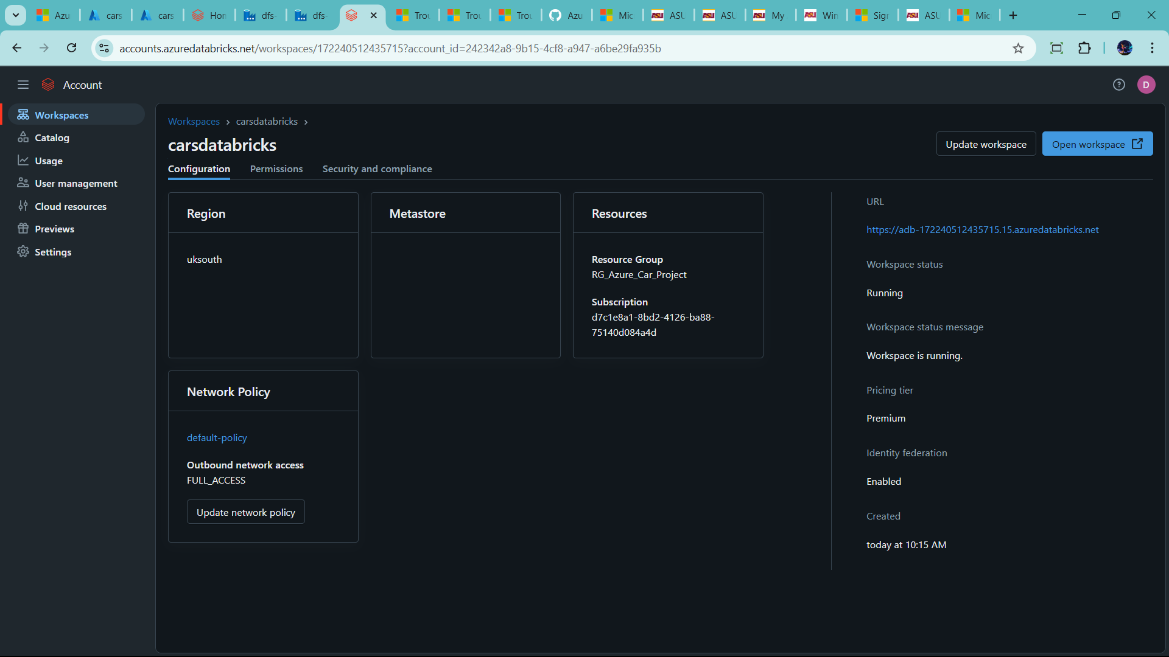

🡪now assign metastore

🡪go to catalog 🡪click name 🡪

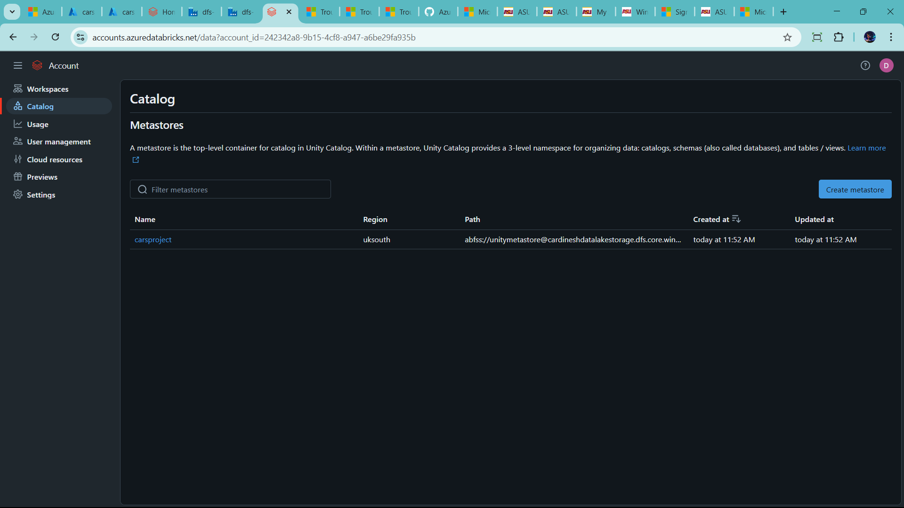

🡪go to workspaces in catalog 🡪 assign workspace

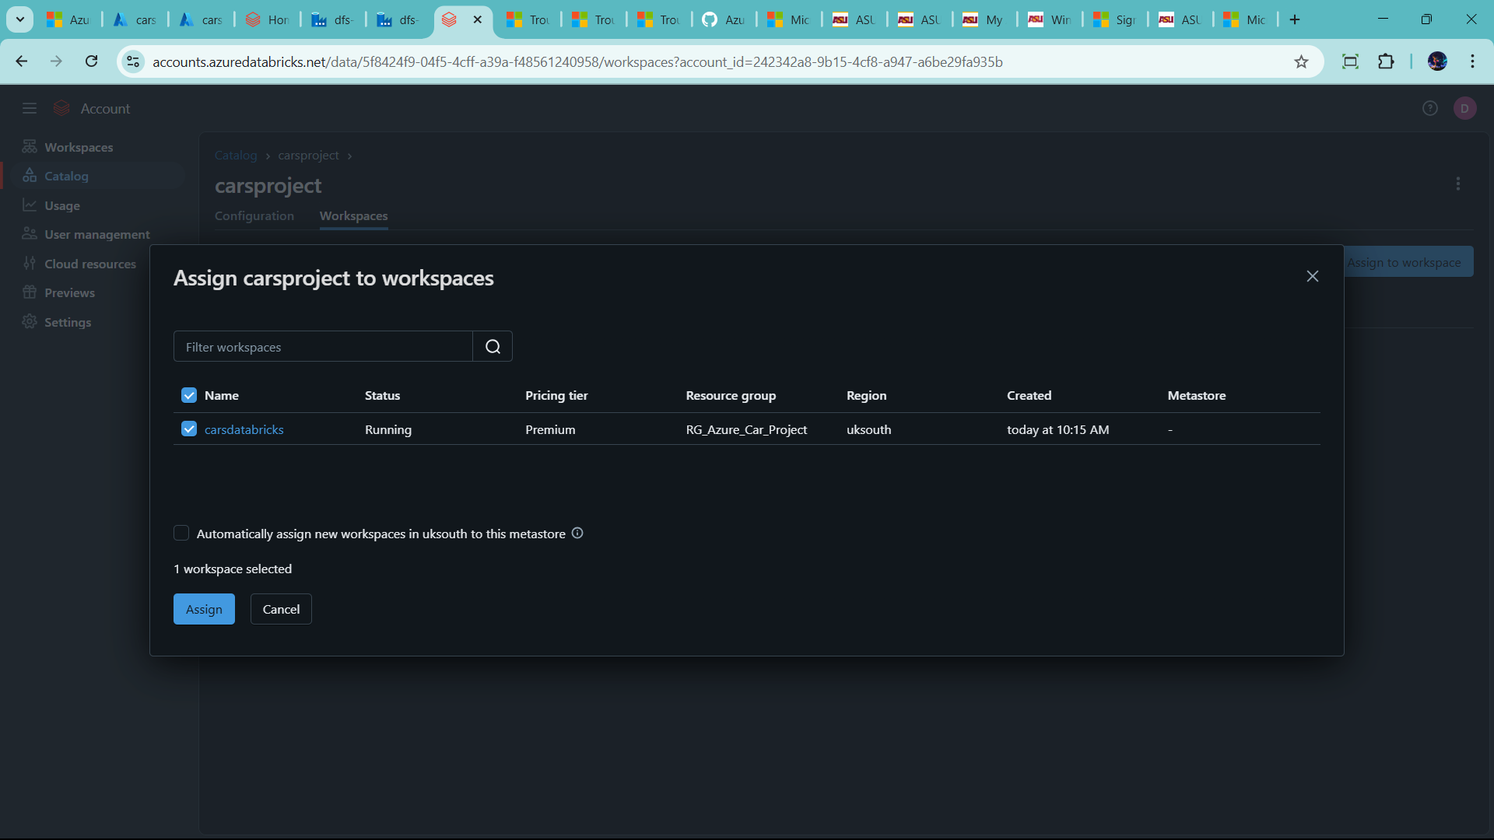

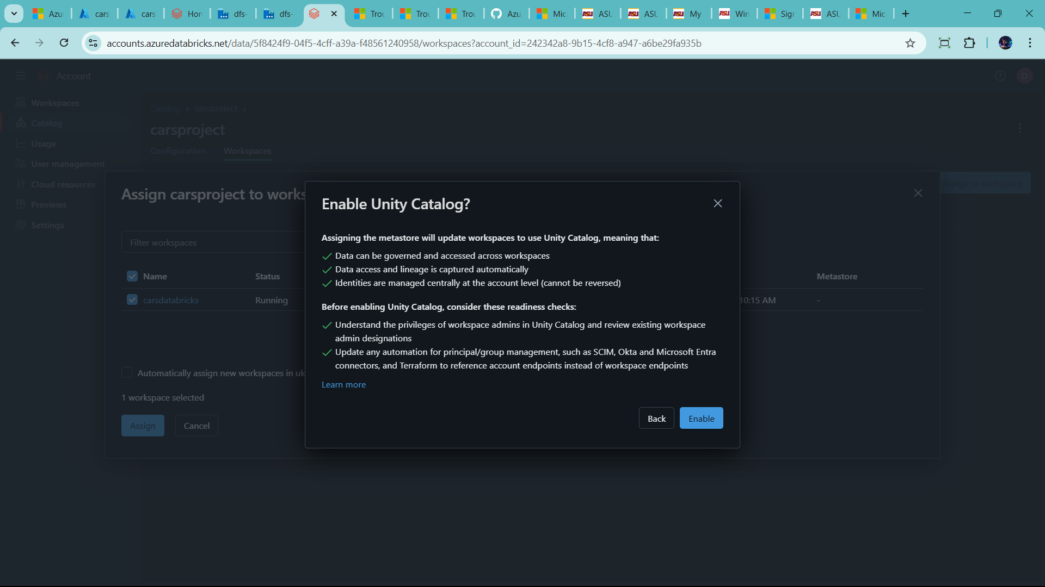

🡪unity catalog only use this workspace only in databricks

🡪click enable

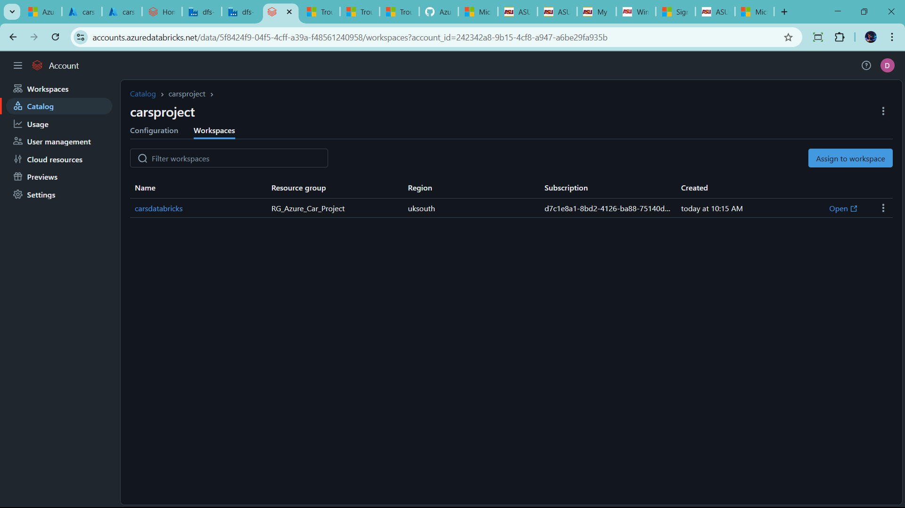

🡪Now move forward azure databricks and refresh 🡪check it is enable it

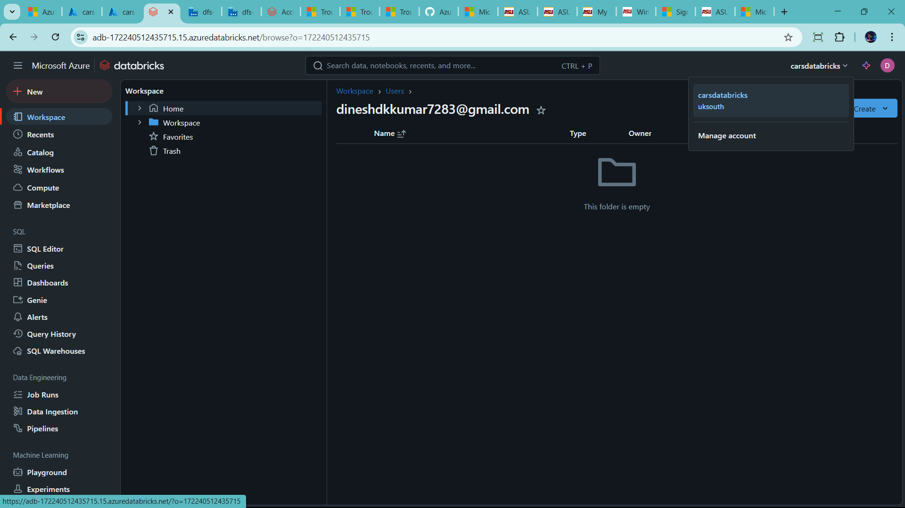

🡪now click compute 🡪create compute

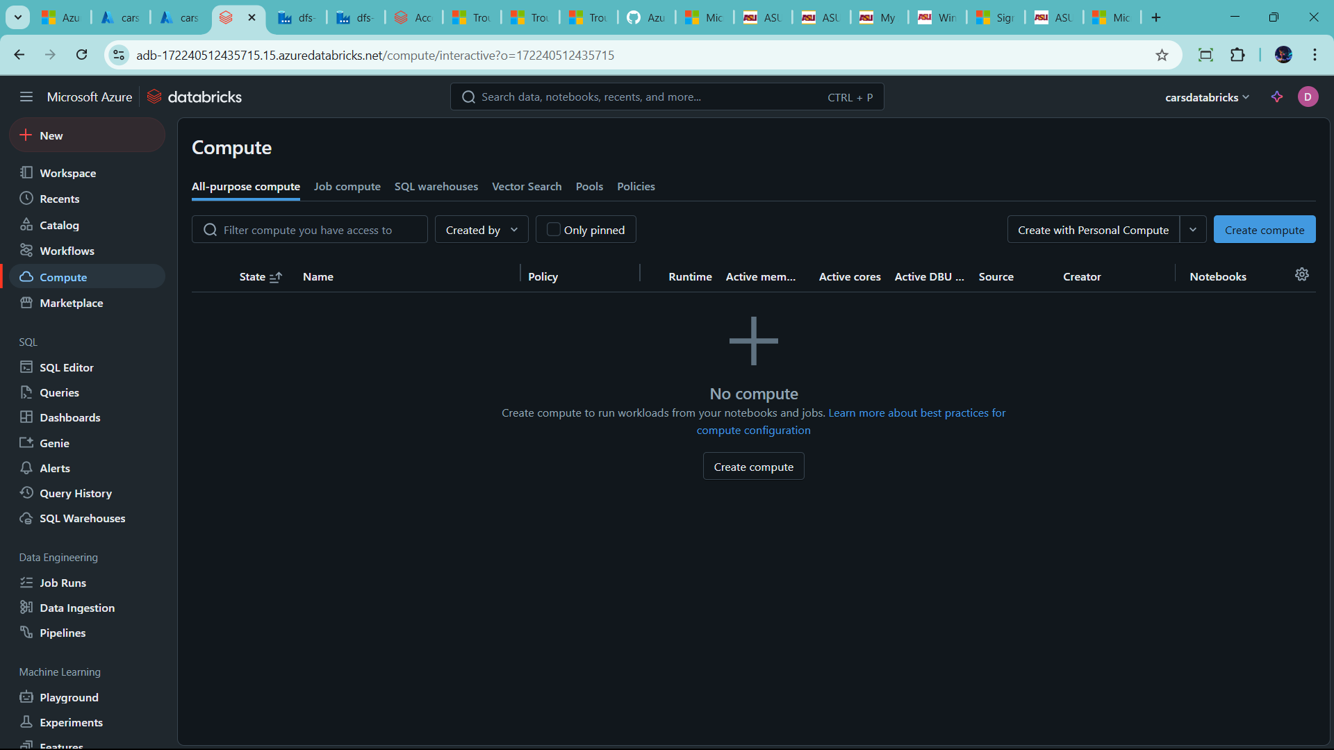

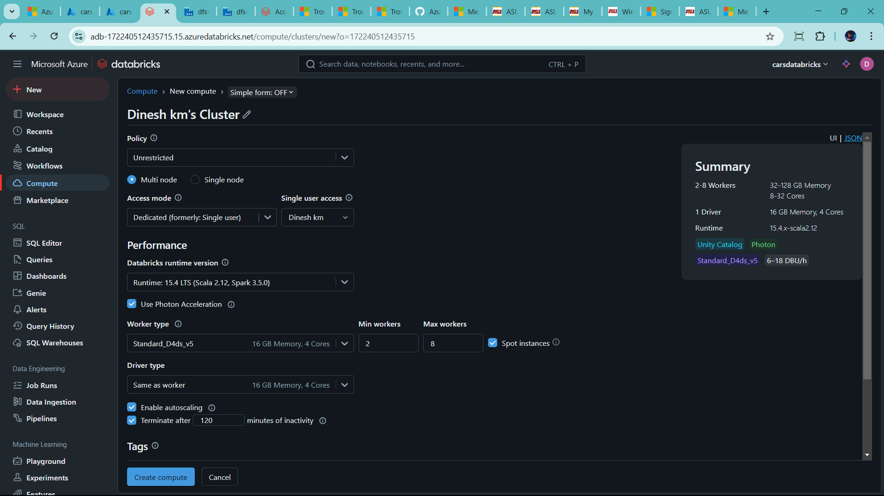

🡪change it as your preference

🡪first policy 🡪change to personal computer 🡪it is single node

🡪change runtime version

🡪change termiter time

🡪go to advance option 🡪no cange

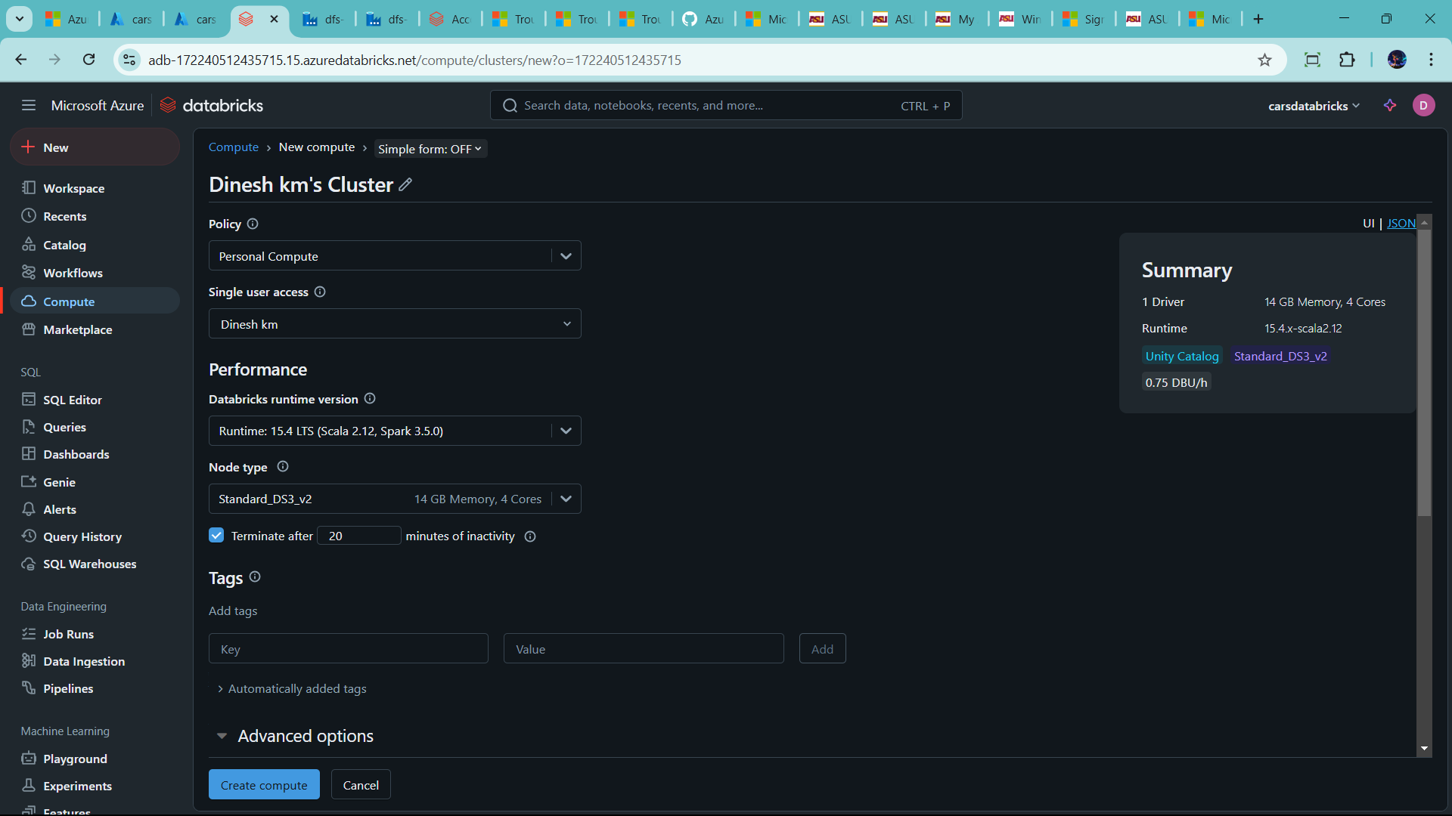

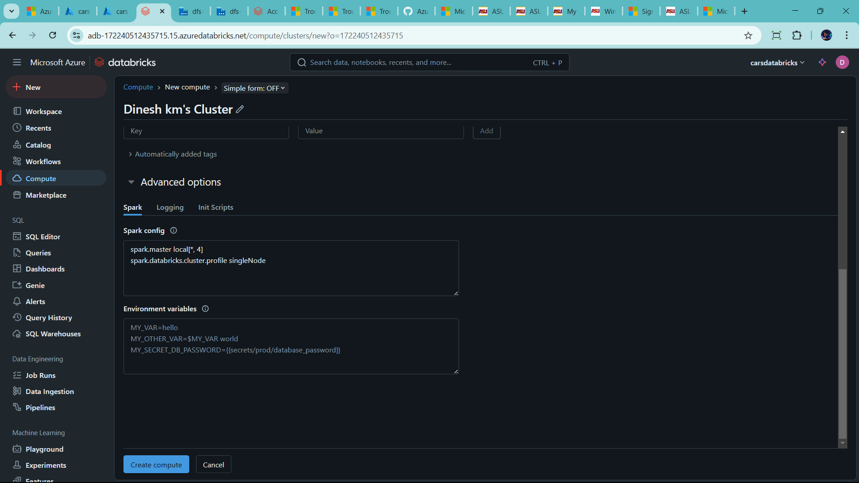

🡪click create compute

🡪why use create compute? 🡪 it act as a virtual machine

🡪how to connect databricks and data lake container (brozen,silver,gold folder)

Ans) it is storage credential 🡪it use access connector . to have access permission. To read the data at any container

🡪lets go databicks 🡪click catalog 🡪click extranal data

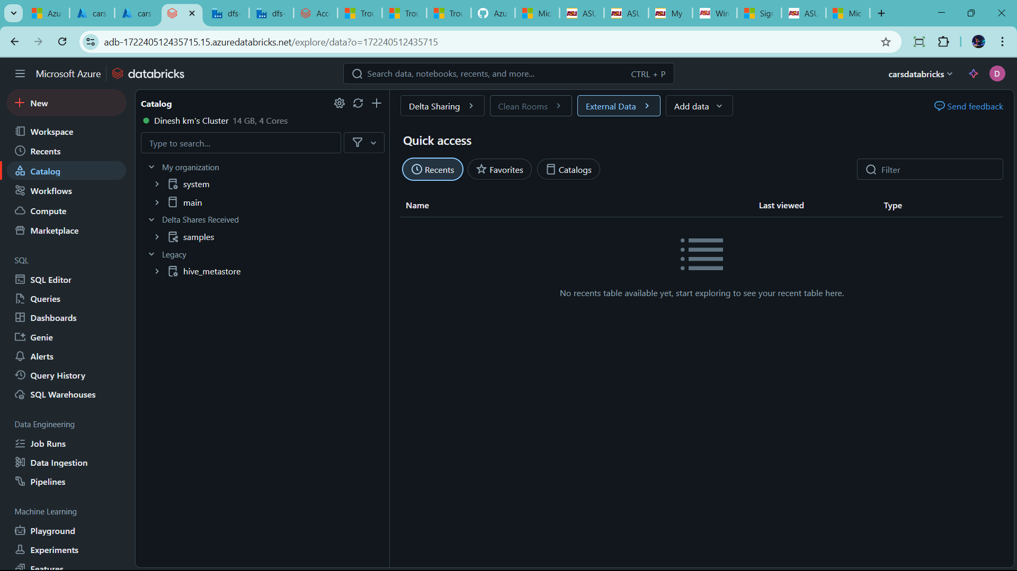

🡪two ways create External location

1) UI

2) Notebooks

🡪perfer UI

🡪click on credentials 🡪create credentials

🡪add name

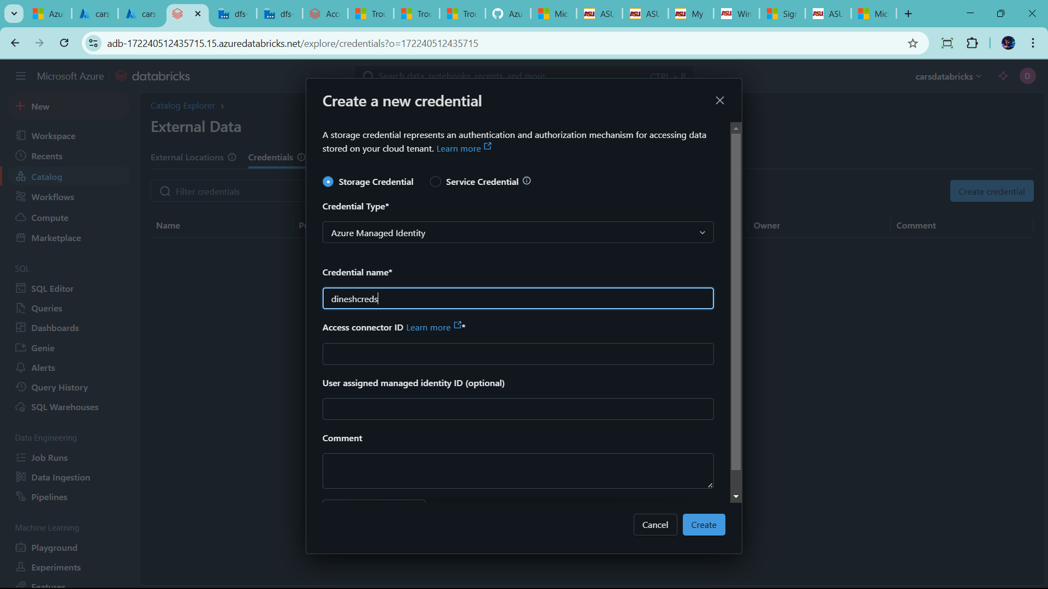

🡪add Access Connector ID 🡪 id present in Azure connector

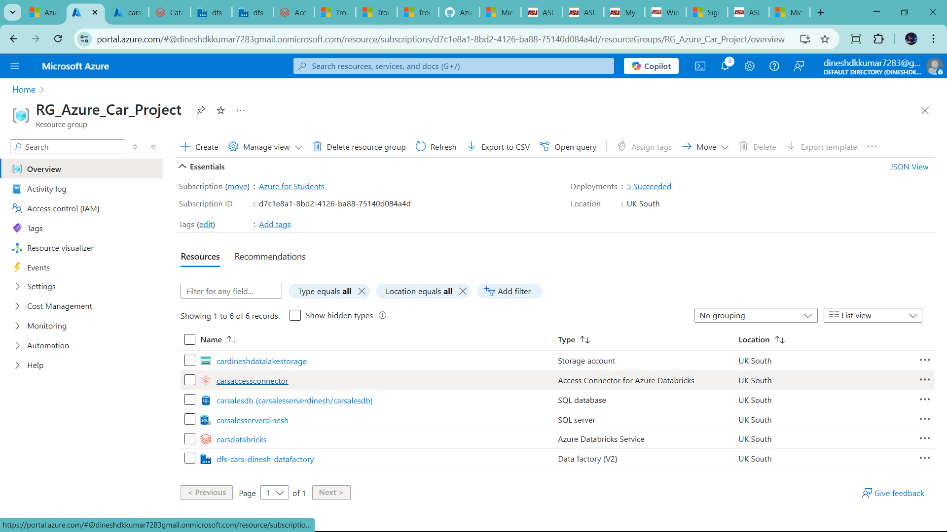

🡪copy the Resouce id

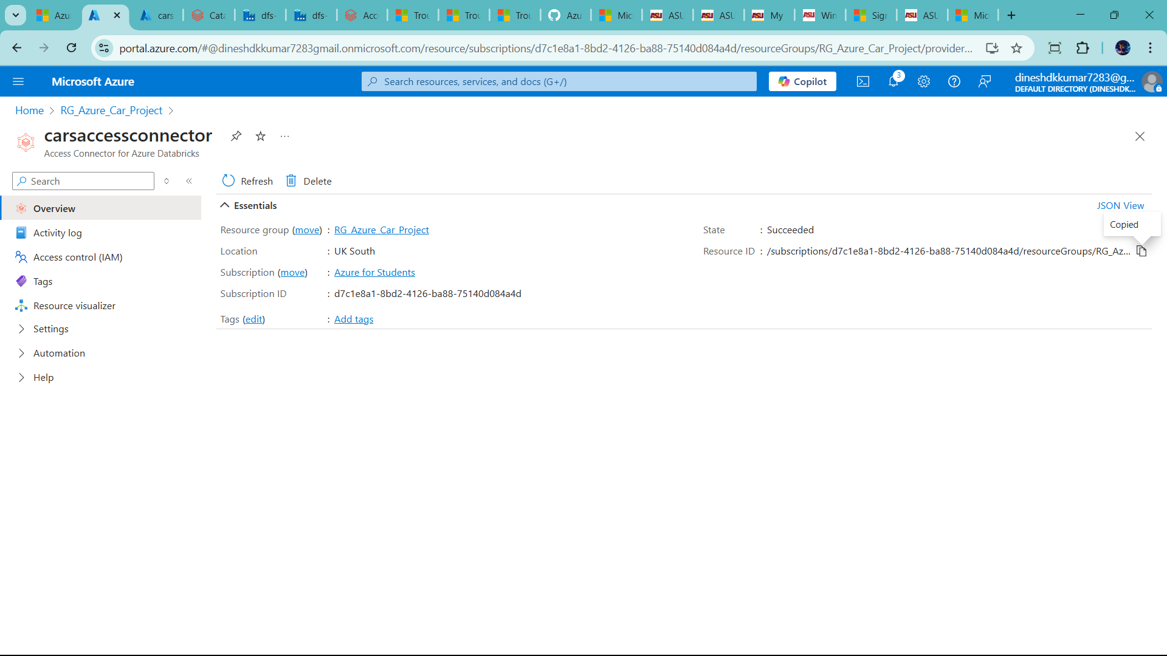

🡪past in databricks create new credential 🡪 access connecter id

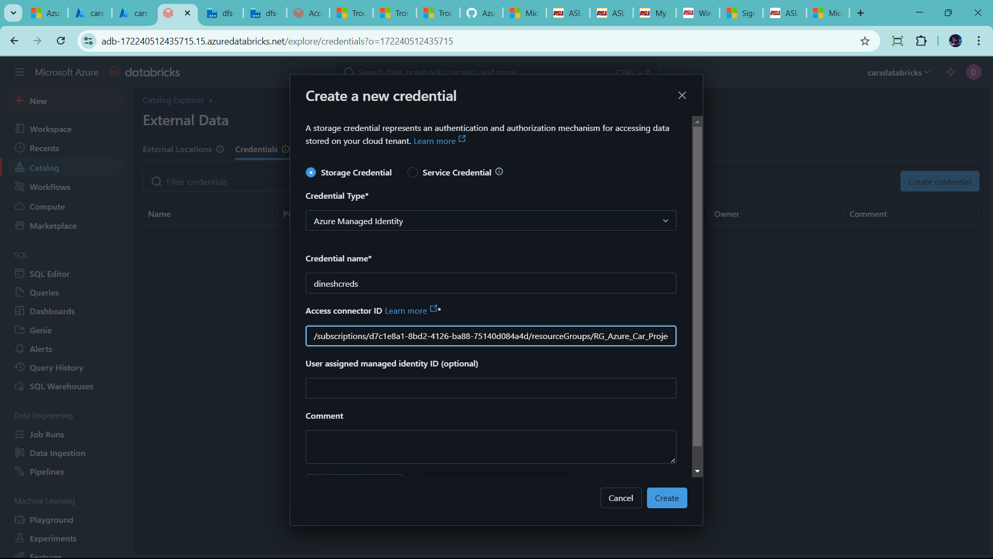

* Click create

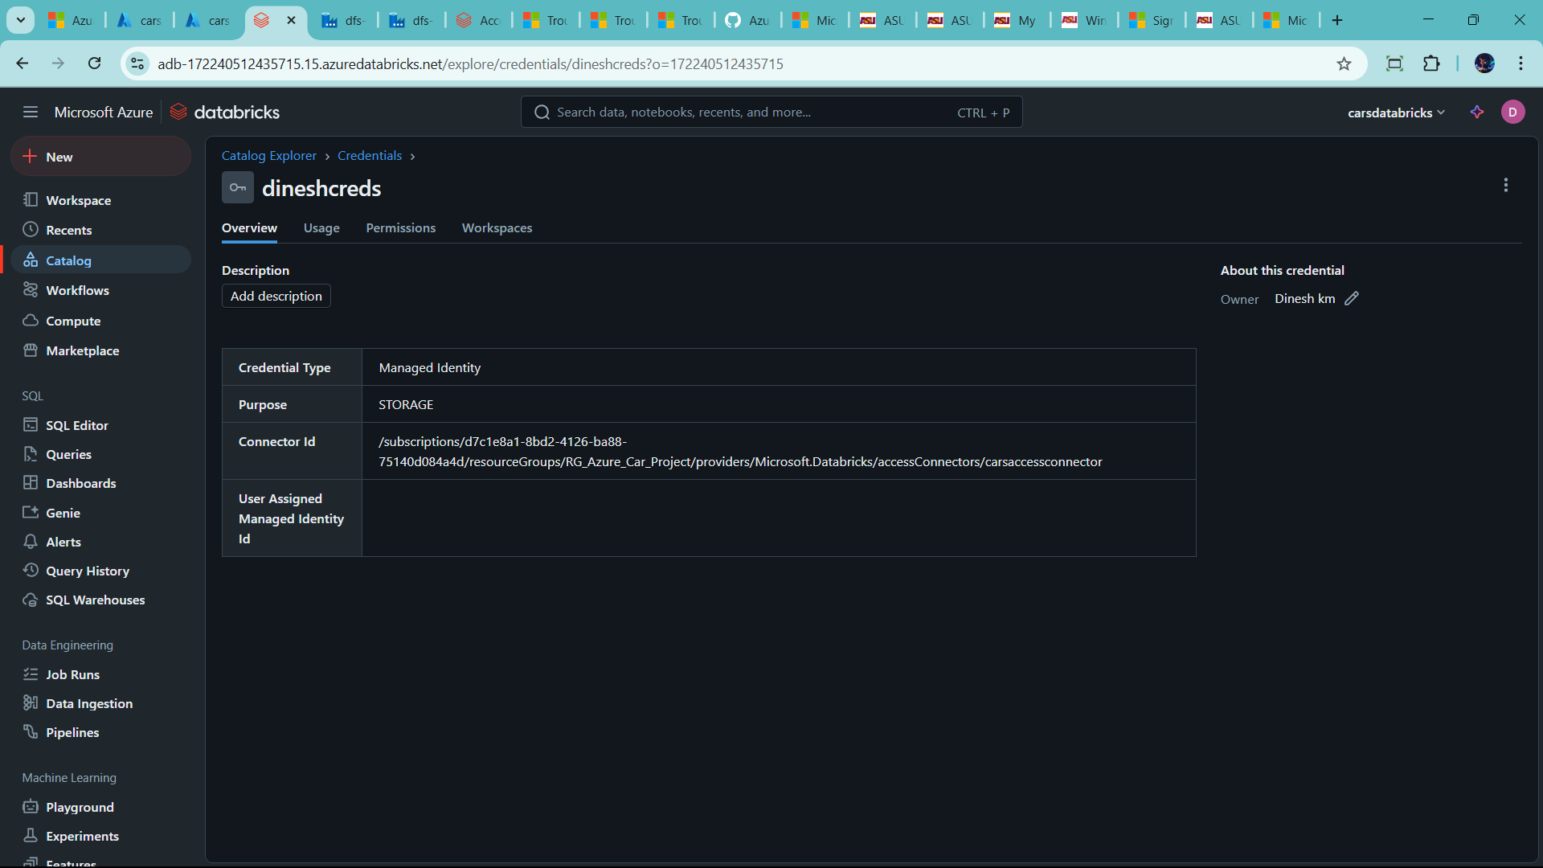

🡪Now create same UI external creditals

🡪go catalog 🡪click external data 🡪

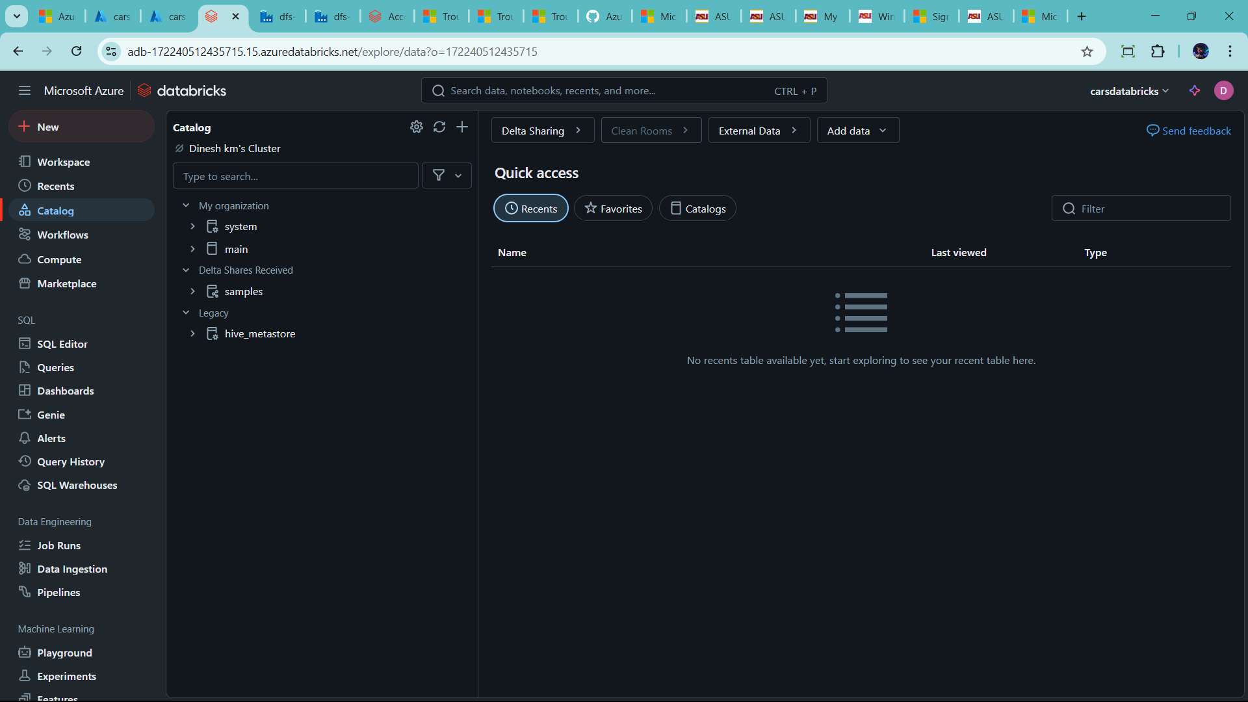

🡪create external location

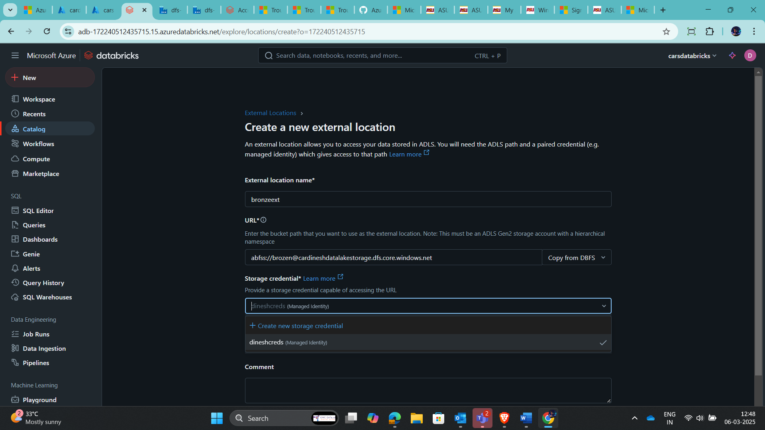

--handle error 🡪#tag account to normal account 🡪save it

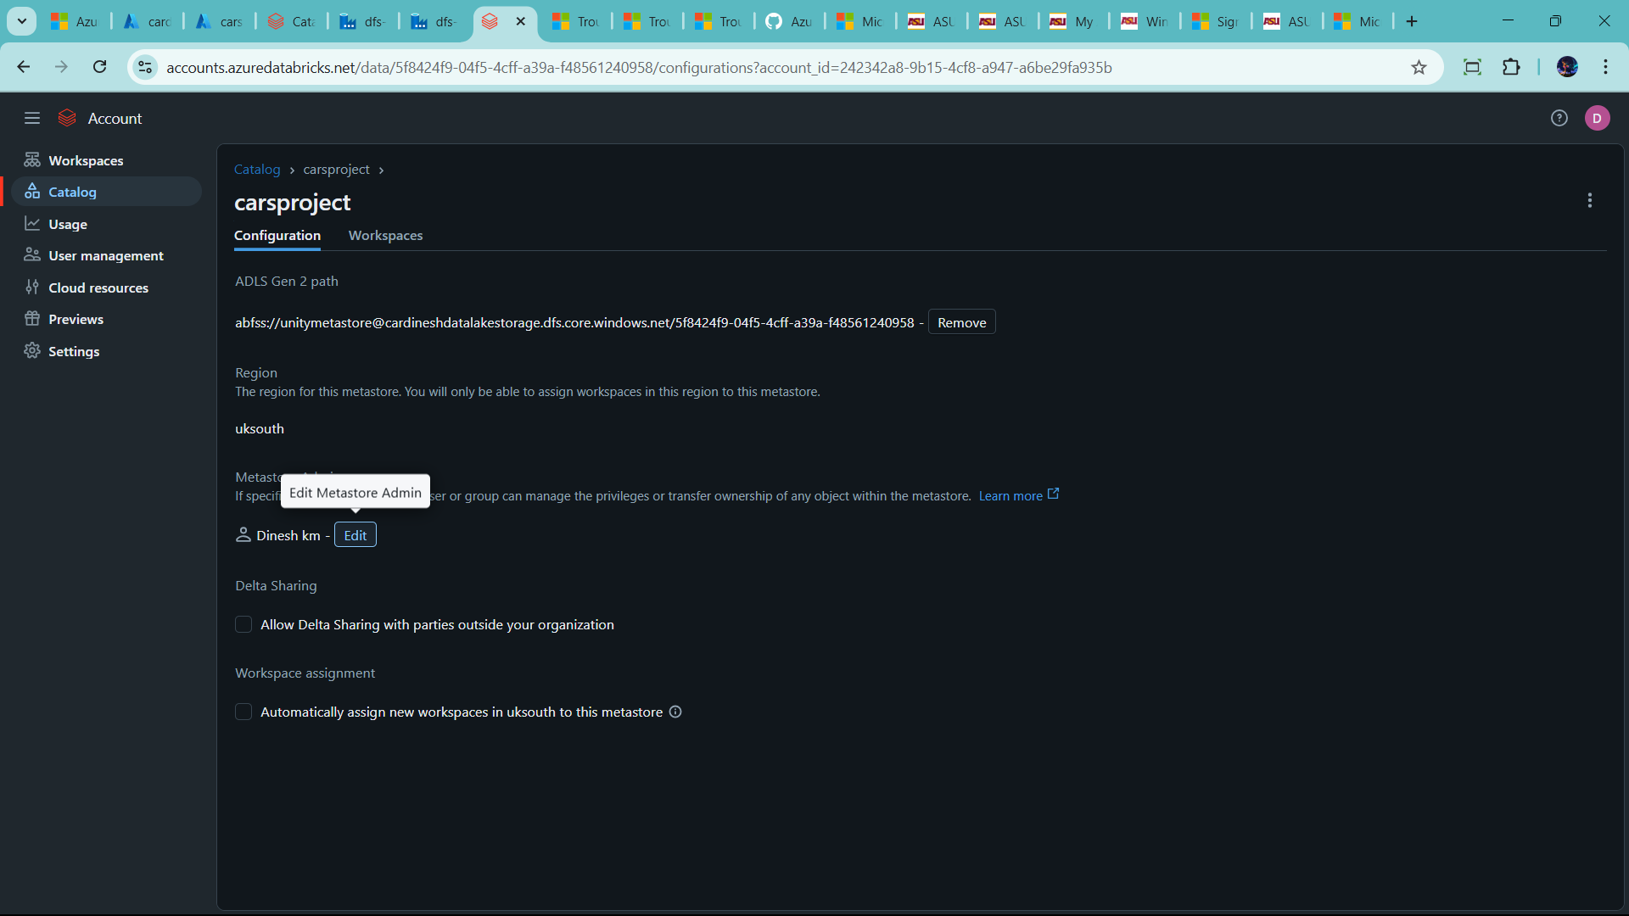

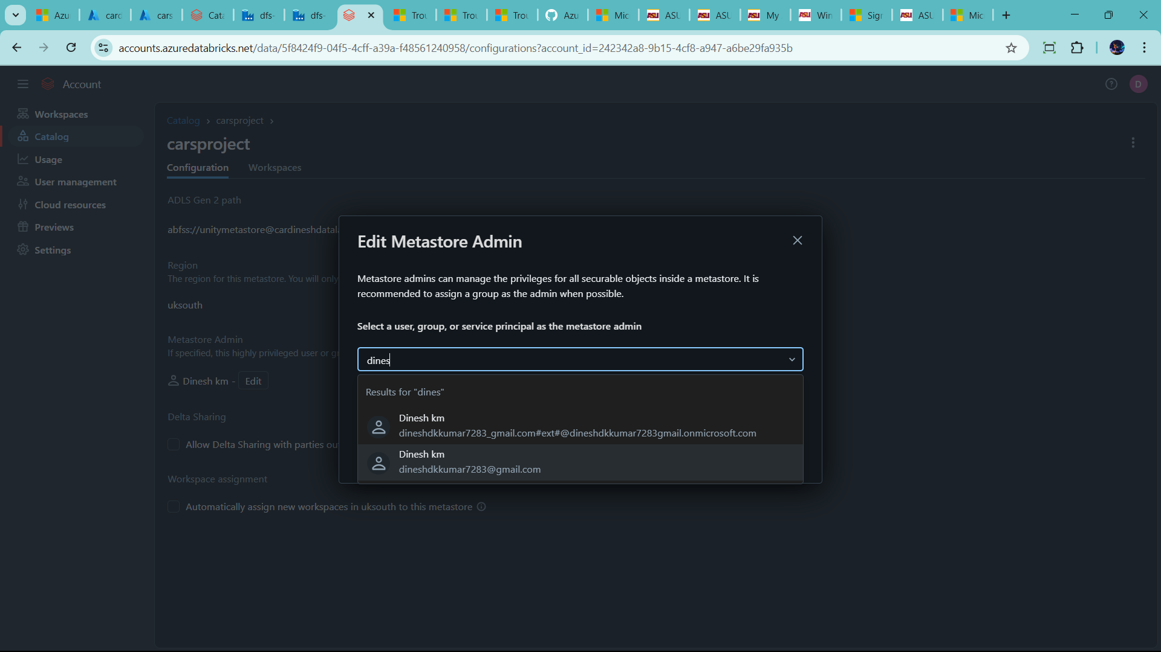

🡪now create

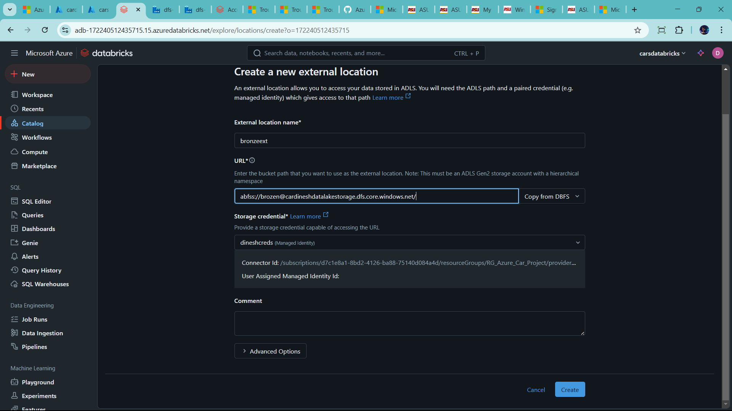

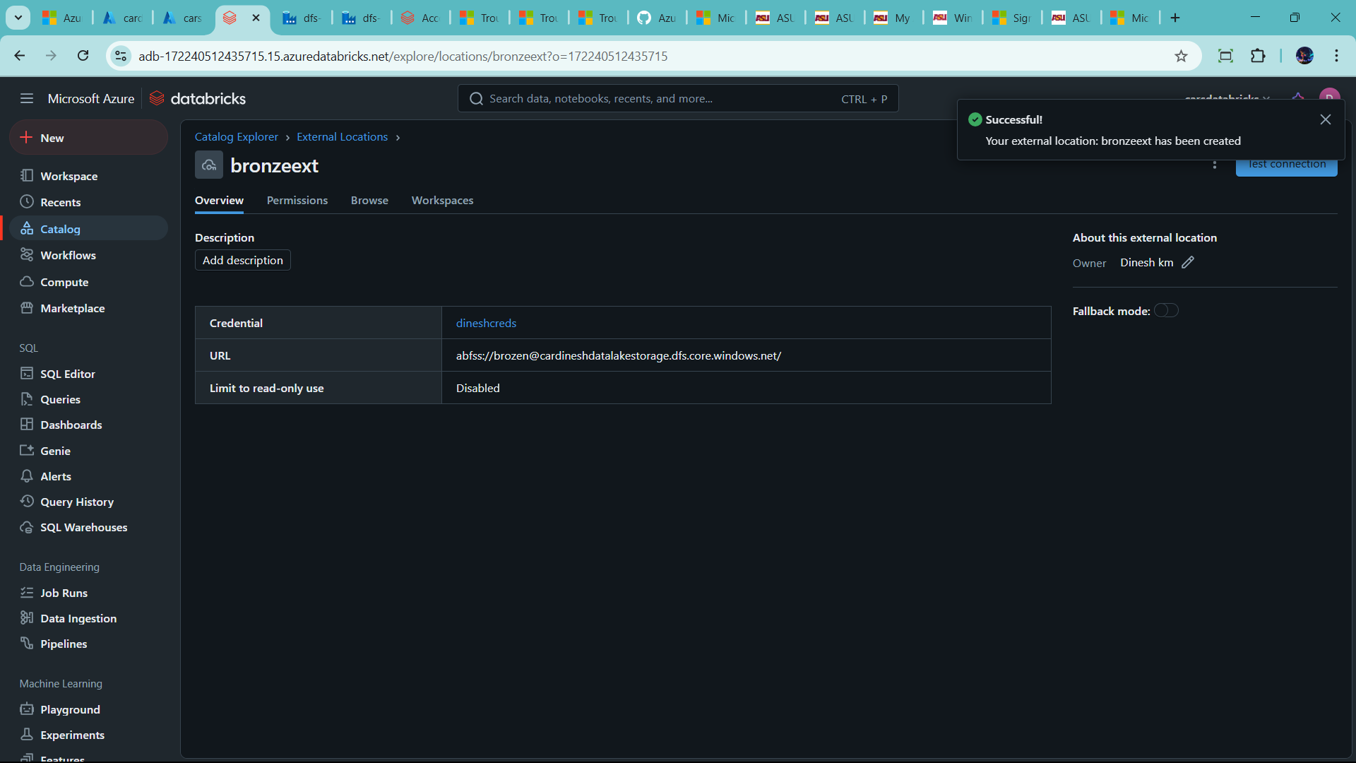

Test the connection

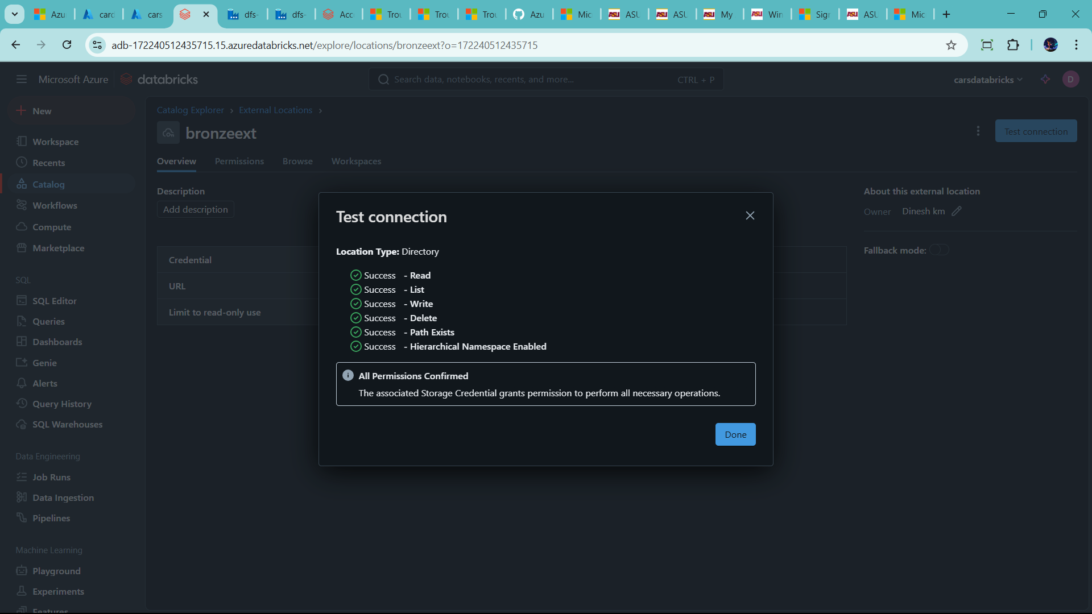

Create same like silver and gold

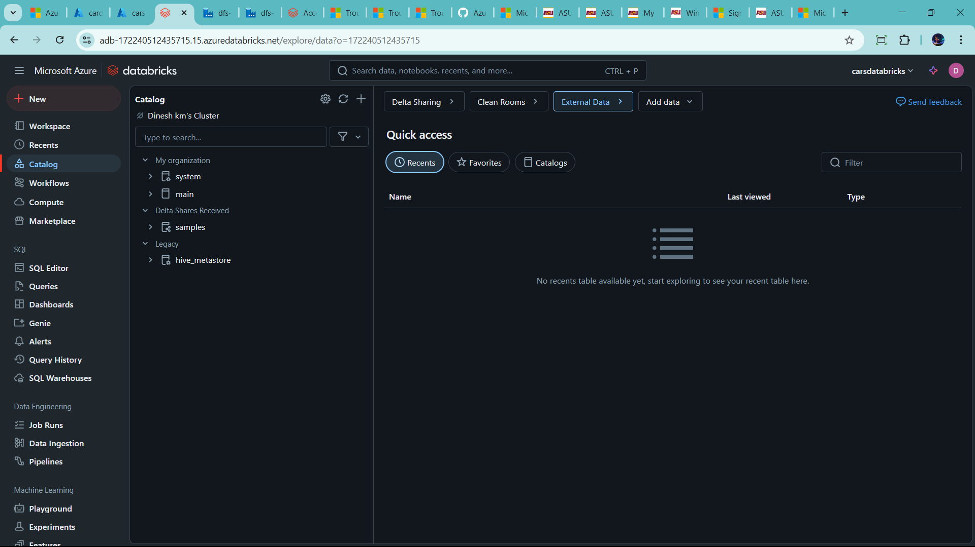

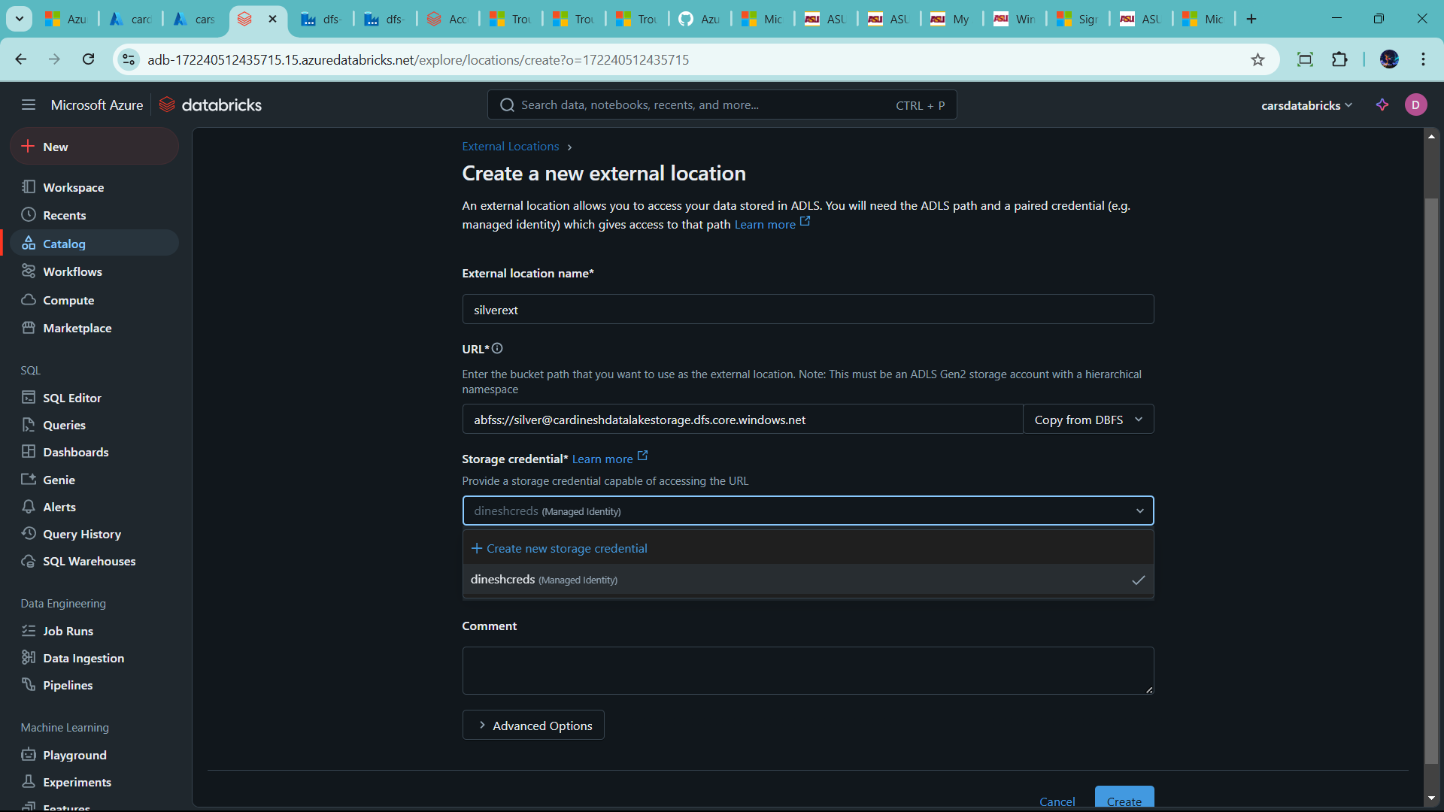

🡪click create

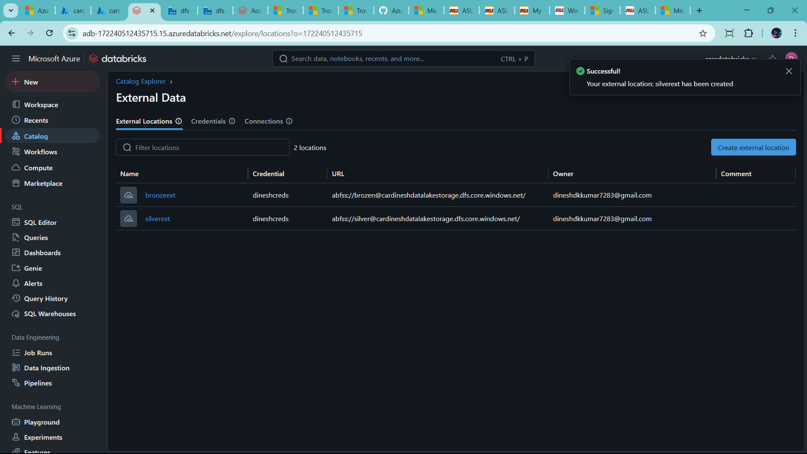

🡪same as gold

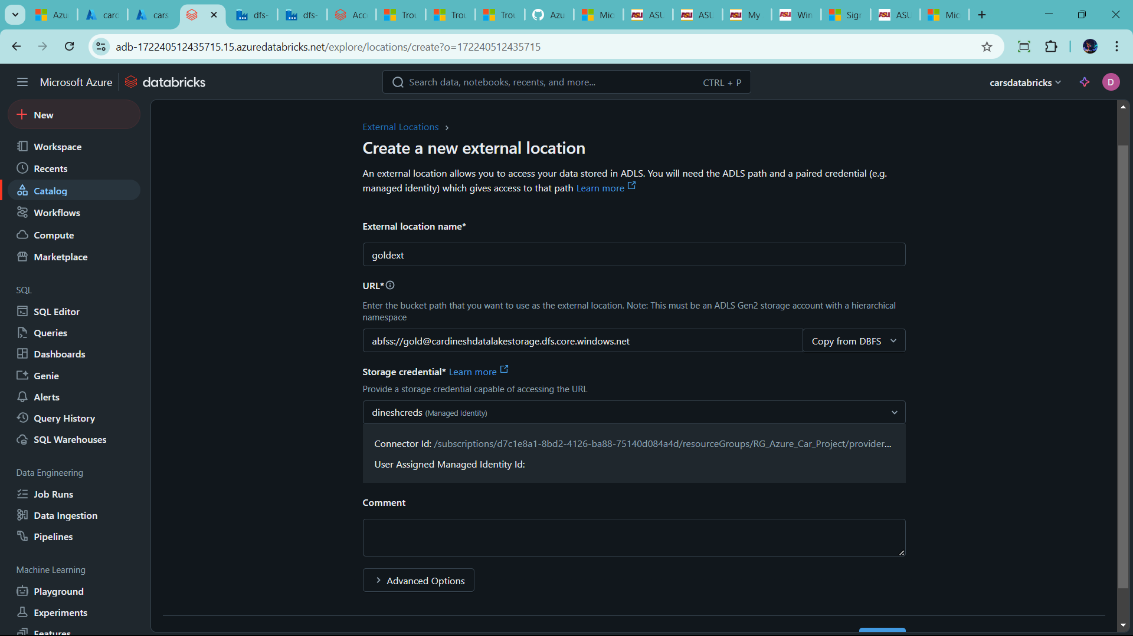

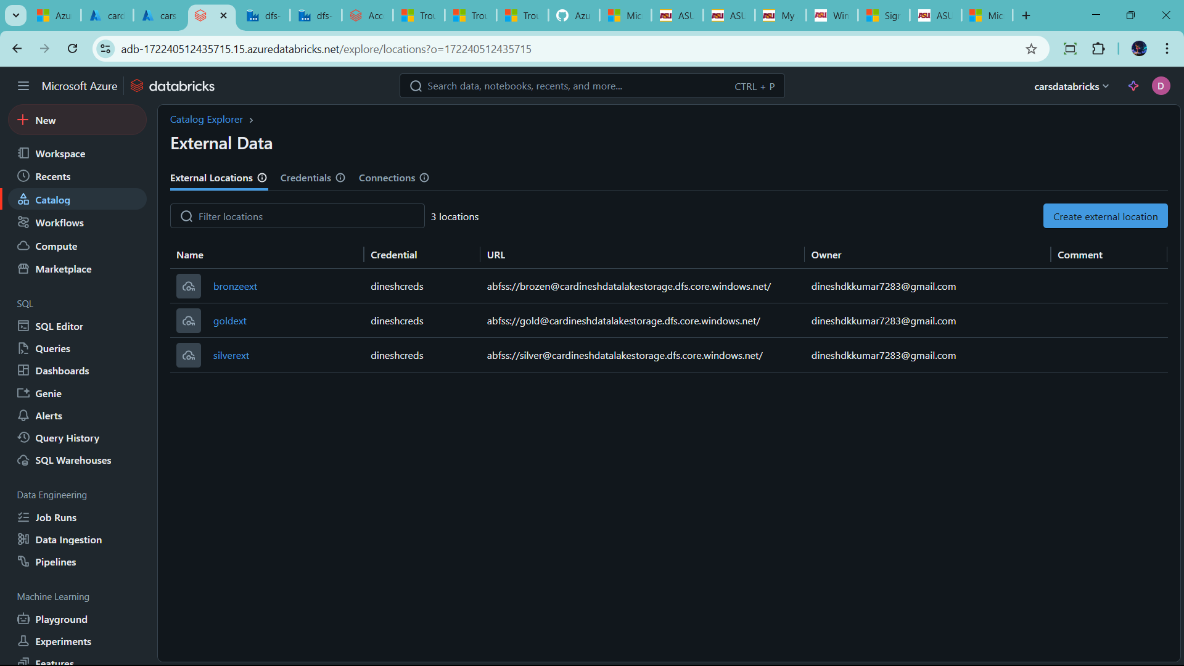

Now Start Create WorkSpaces

🡪click workspaces 🡪add folder name

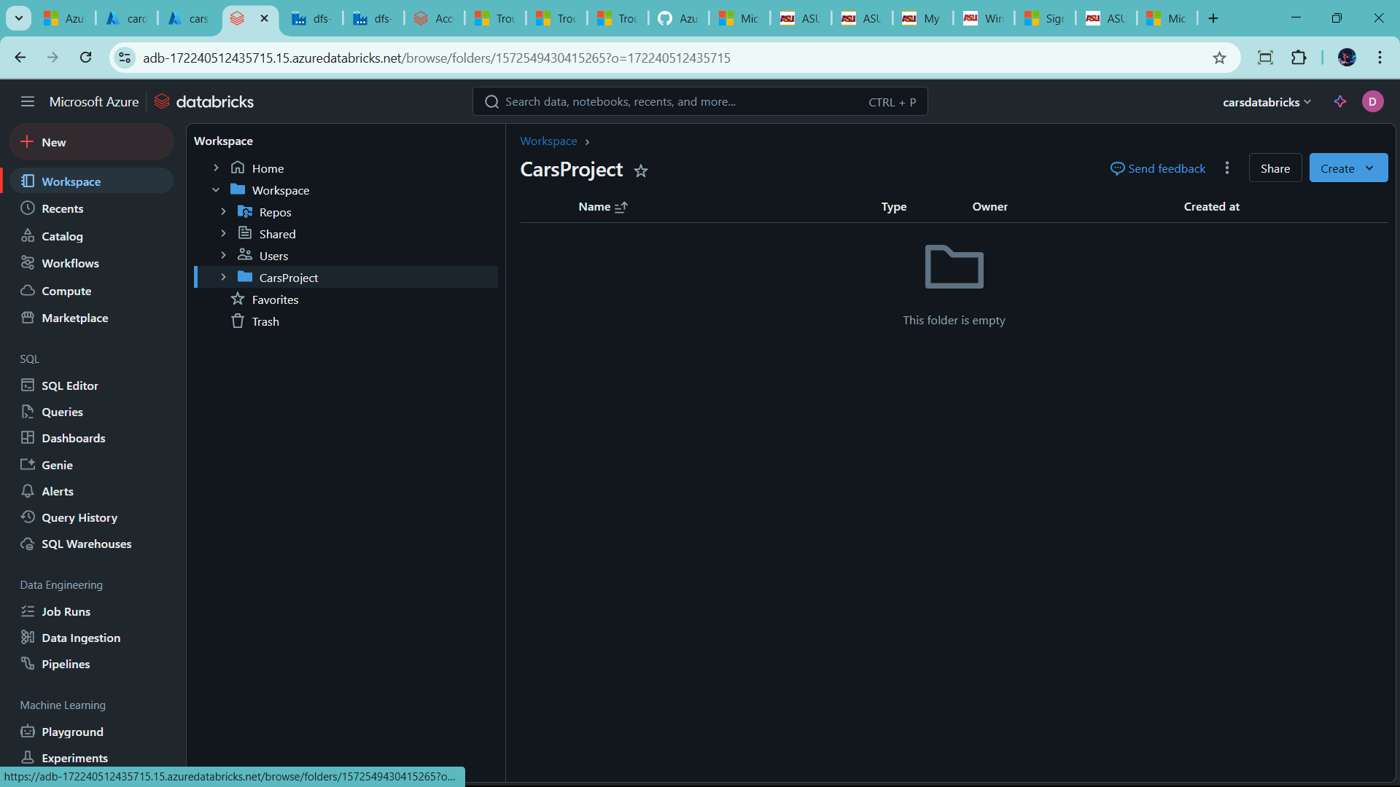

🡪click Carsproject 🡪 now create notebook

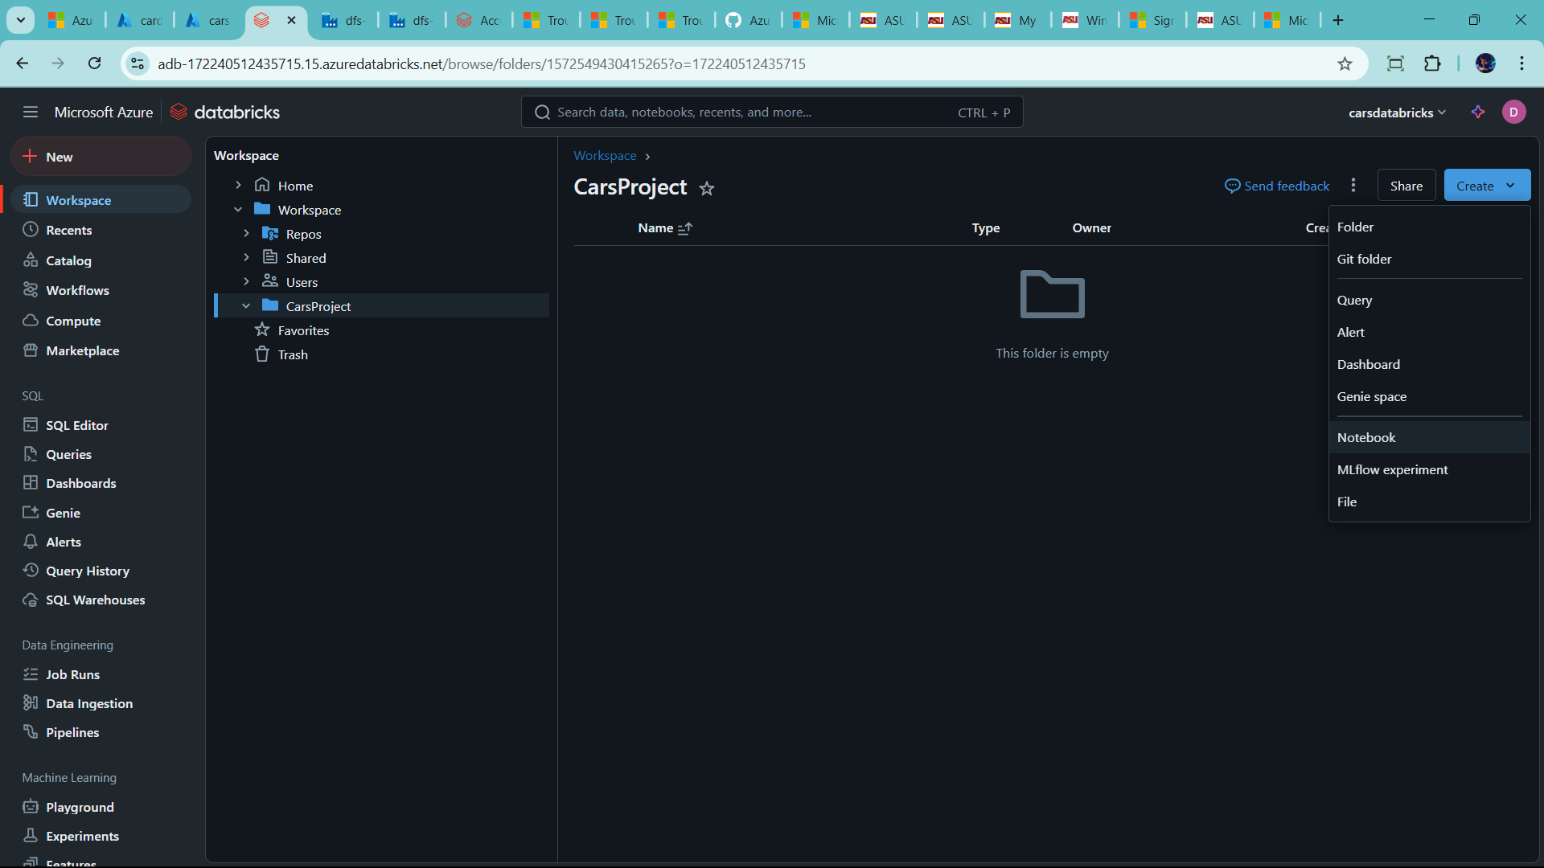

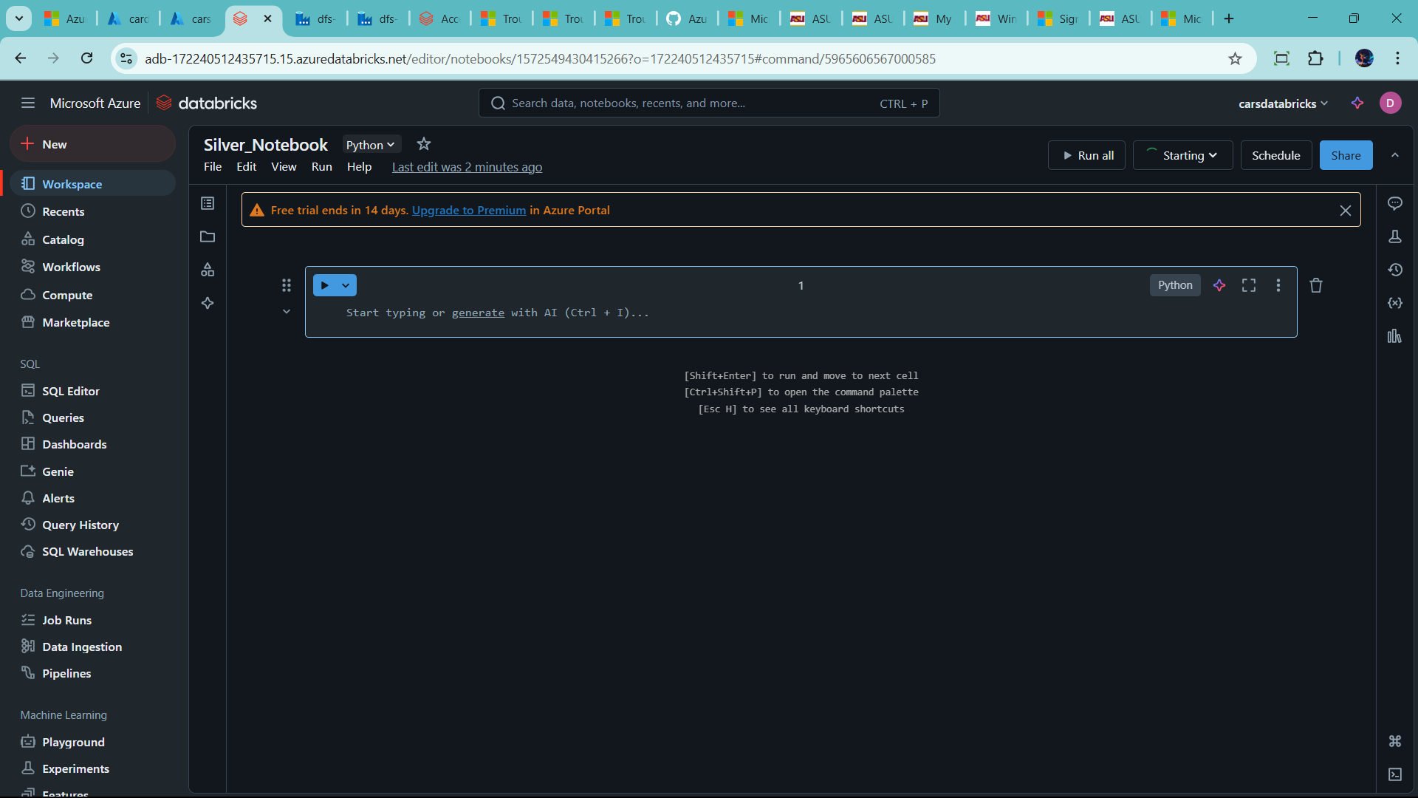

🡪rename db_Notebook

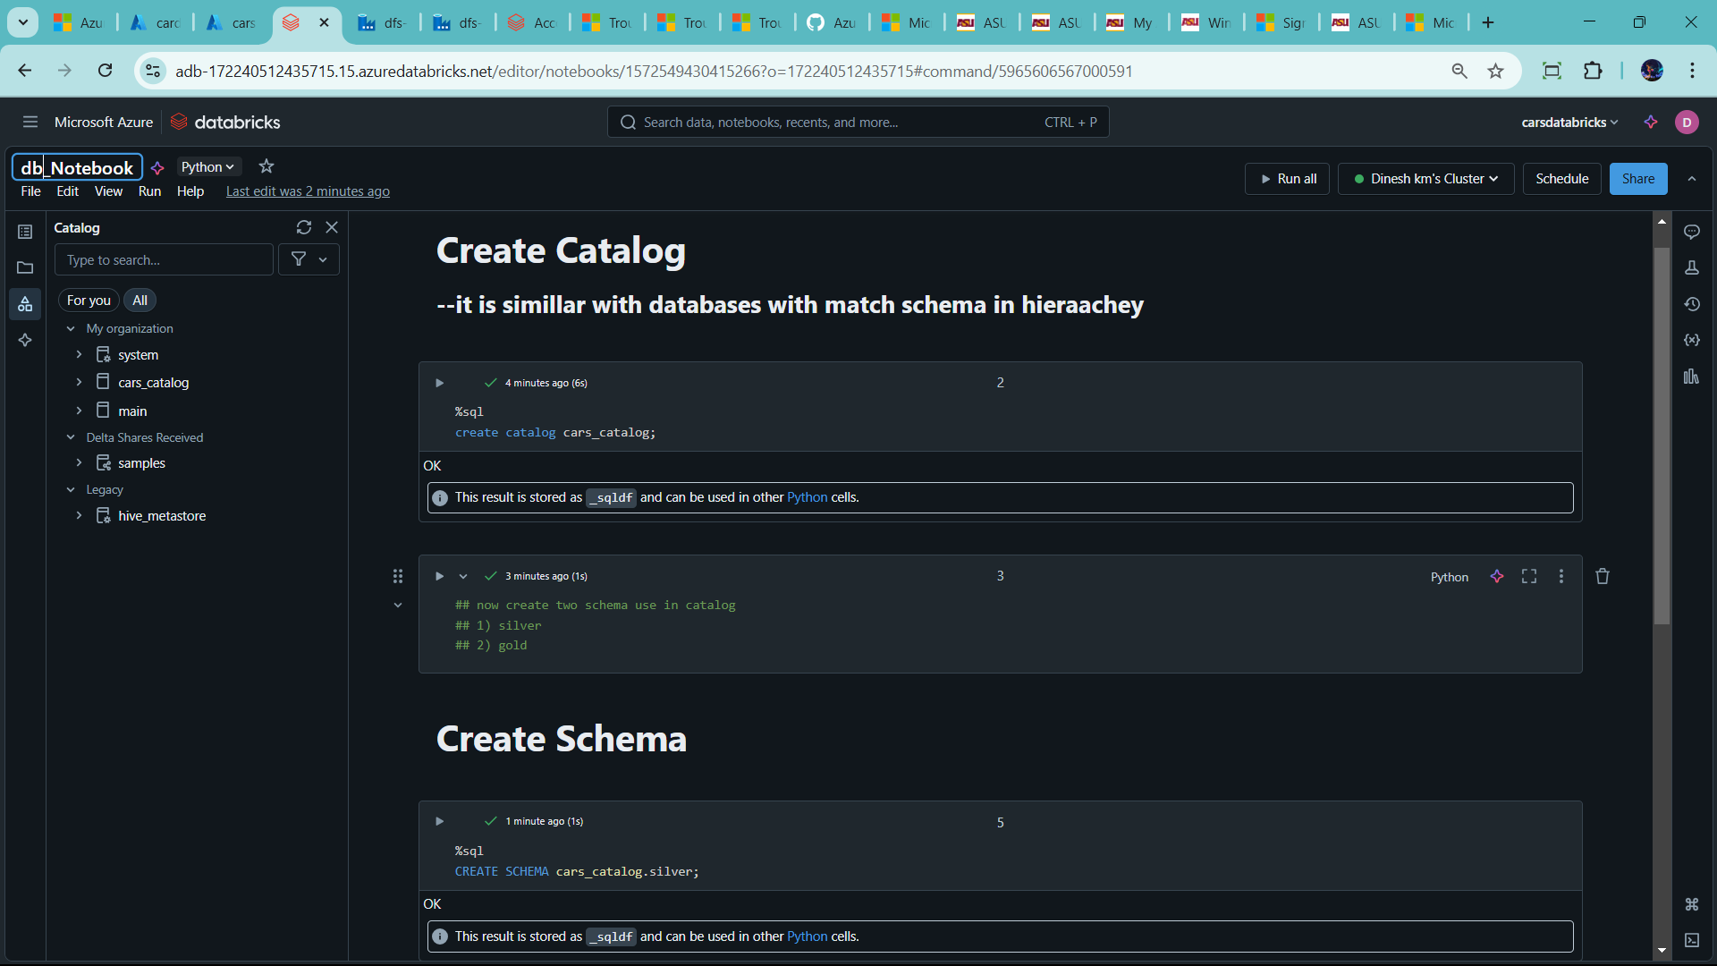

🡪create another notebook for reading data

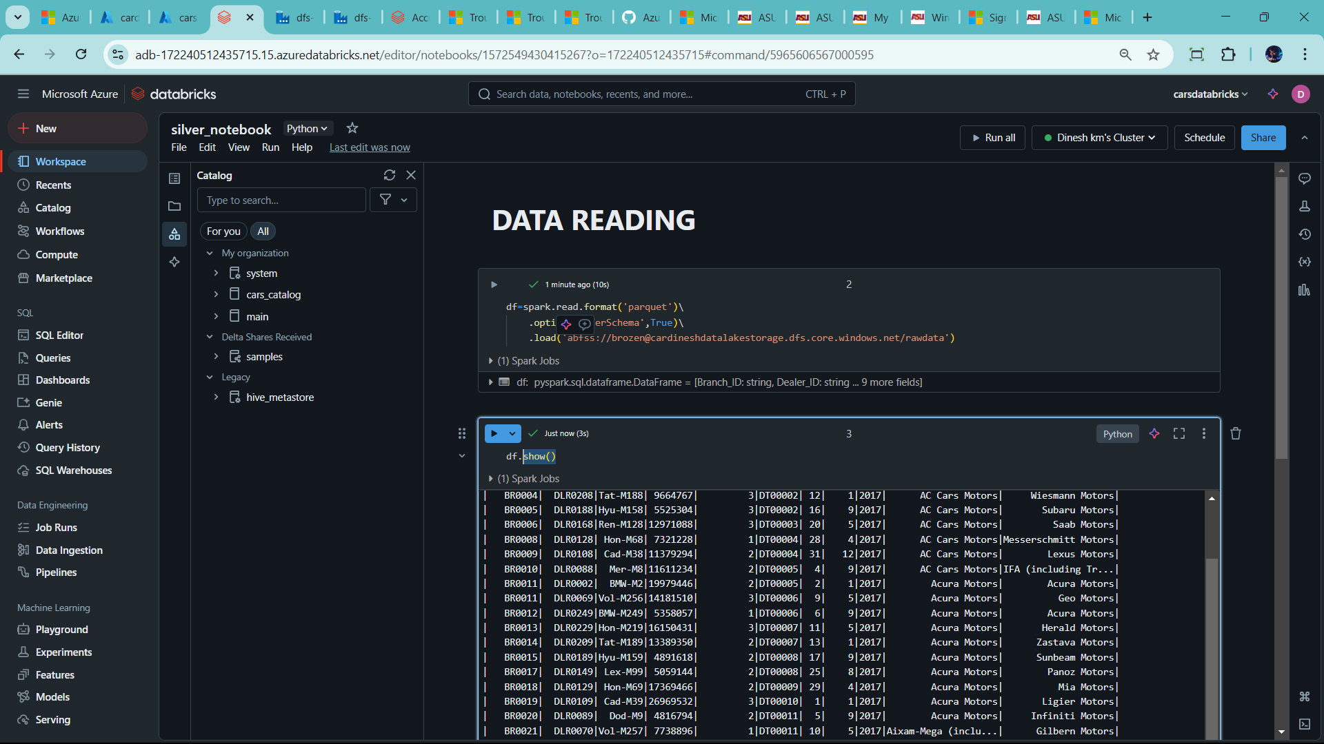

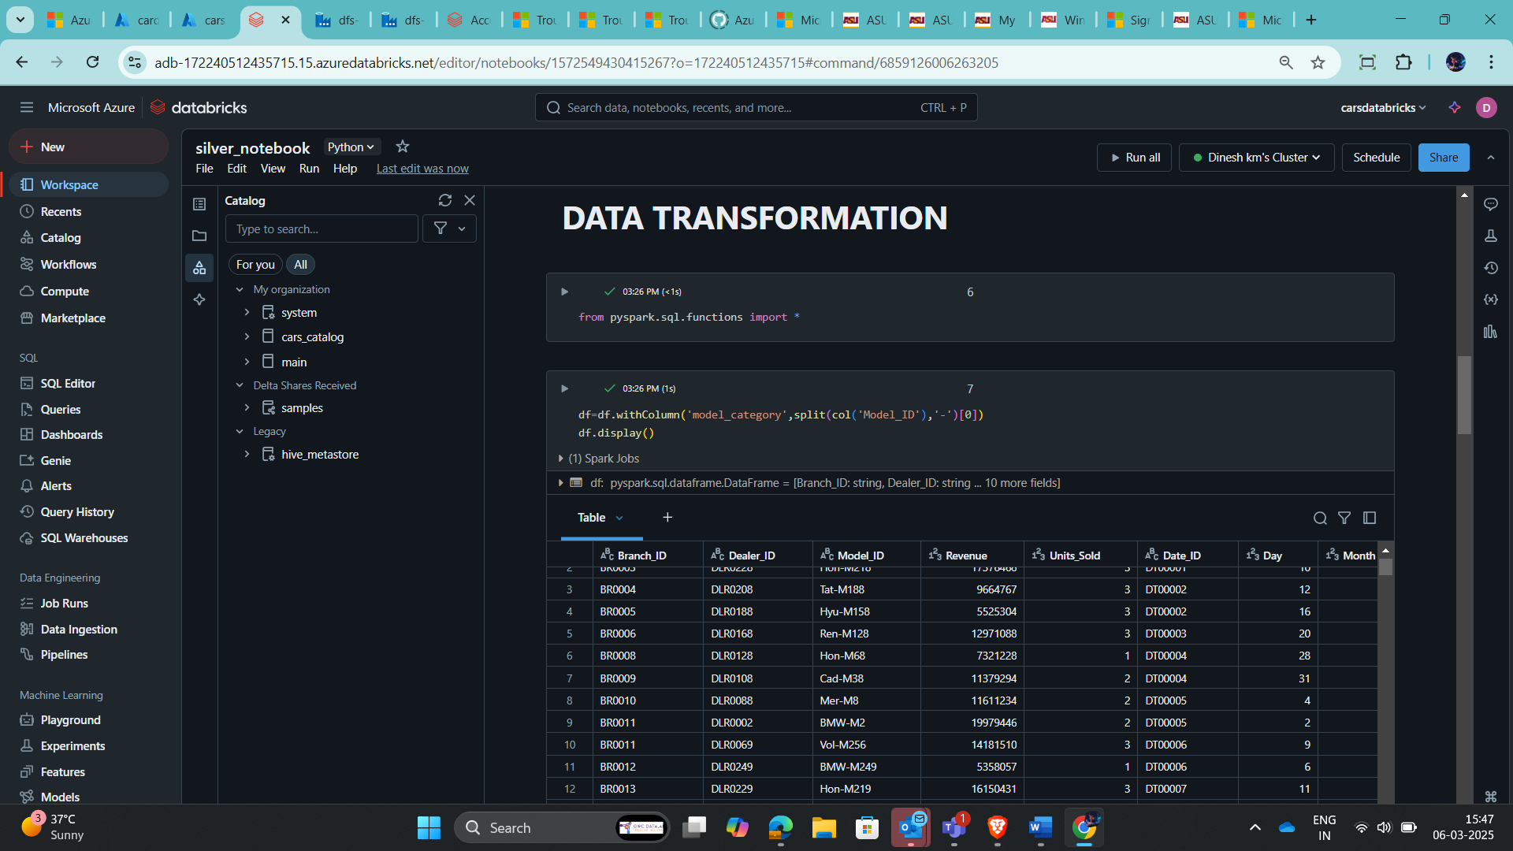

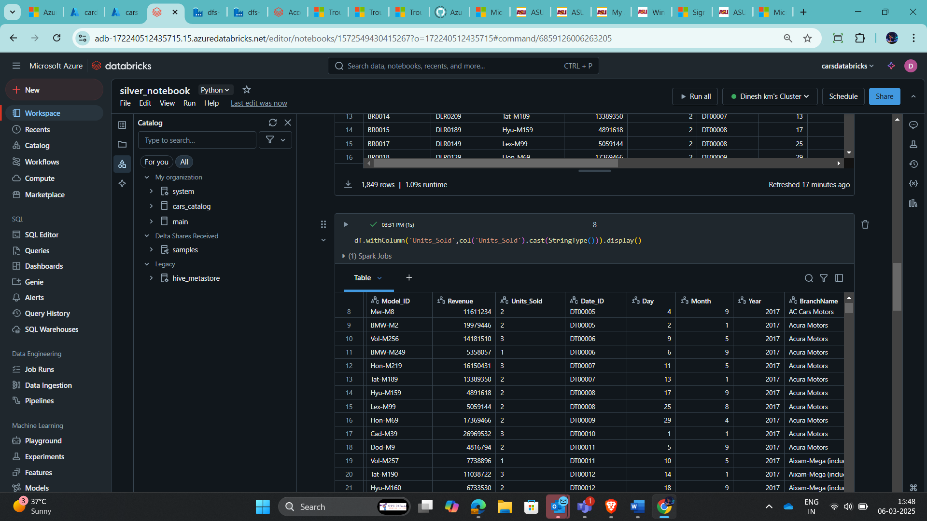

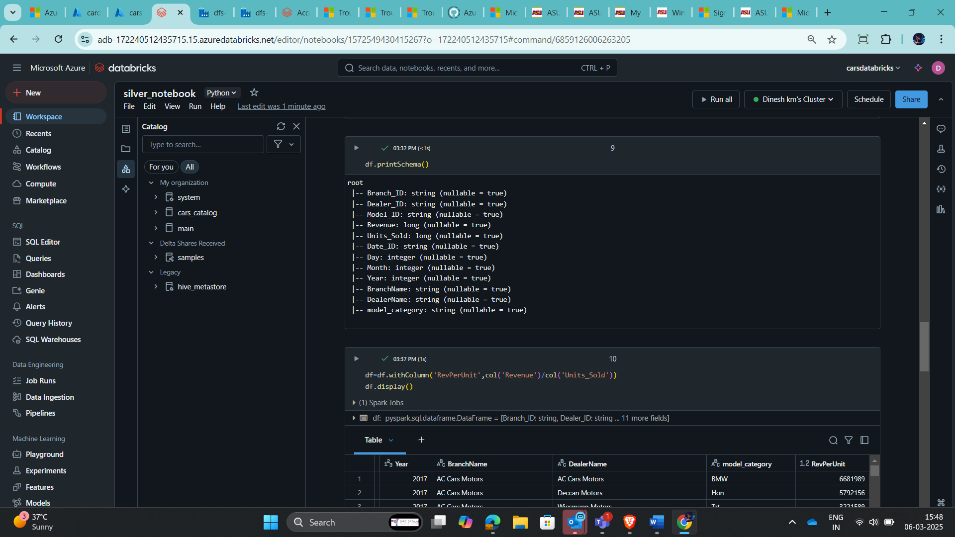

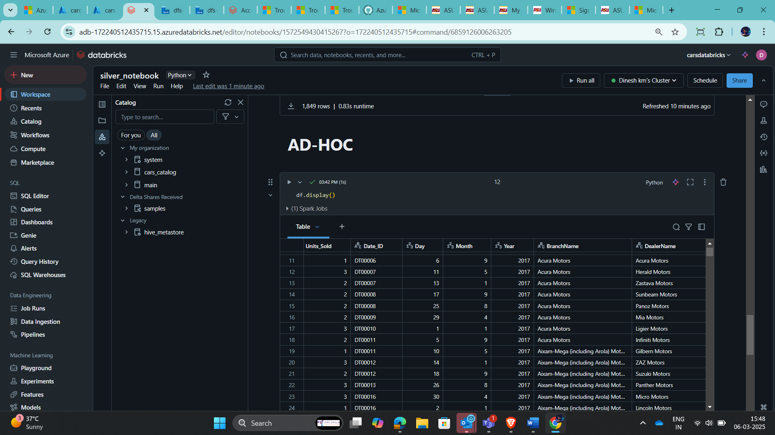

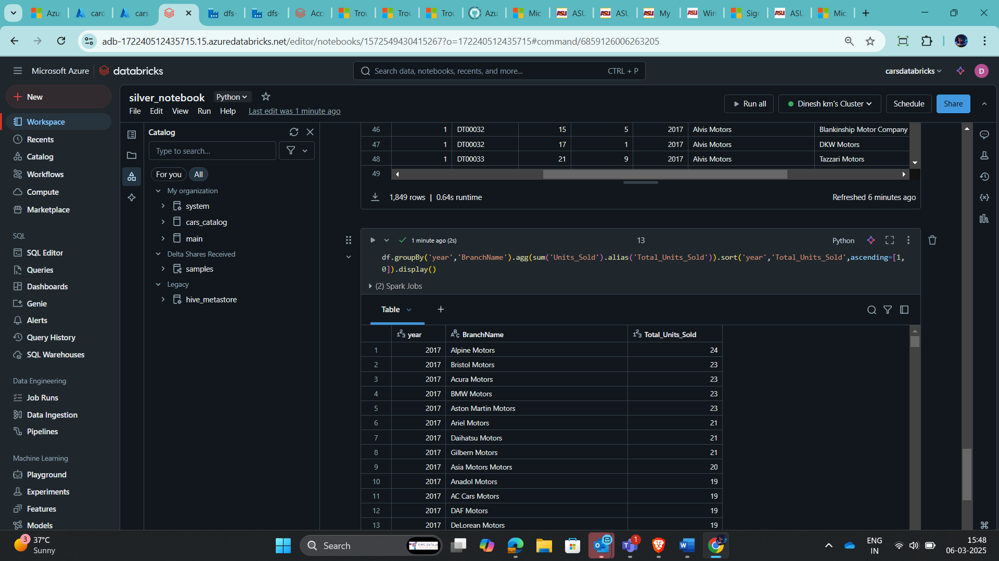

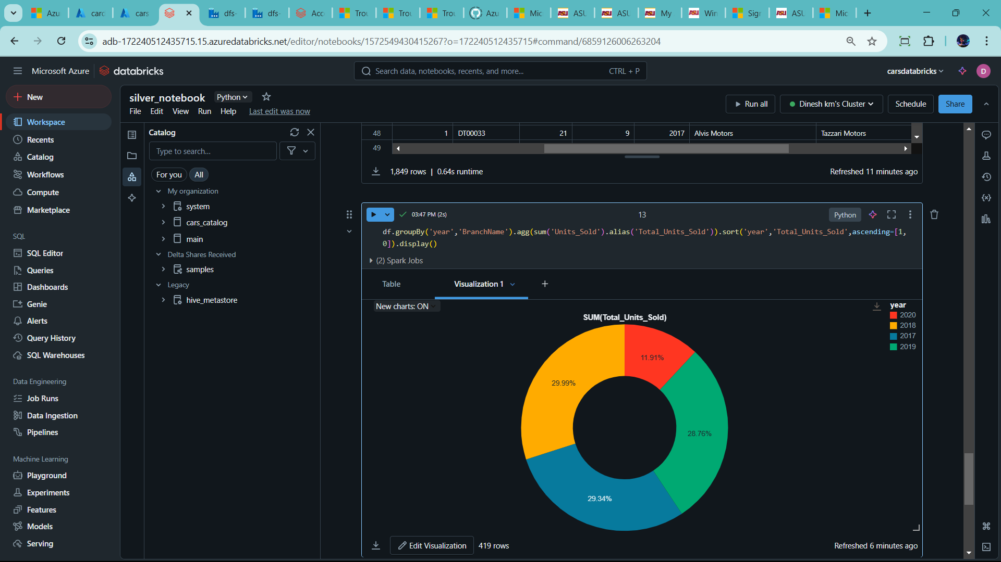

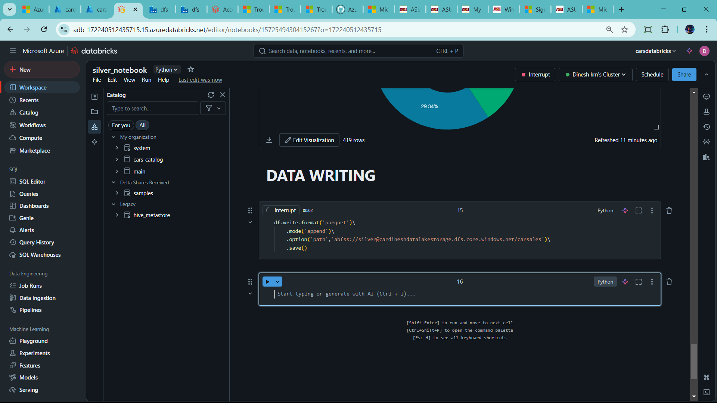

Folder and file success added

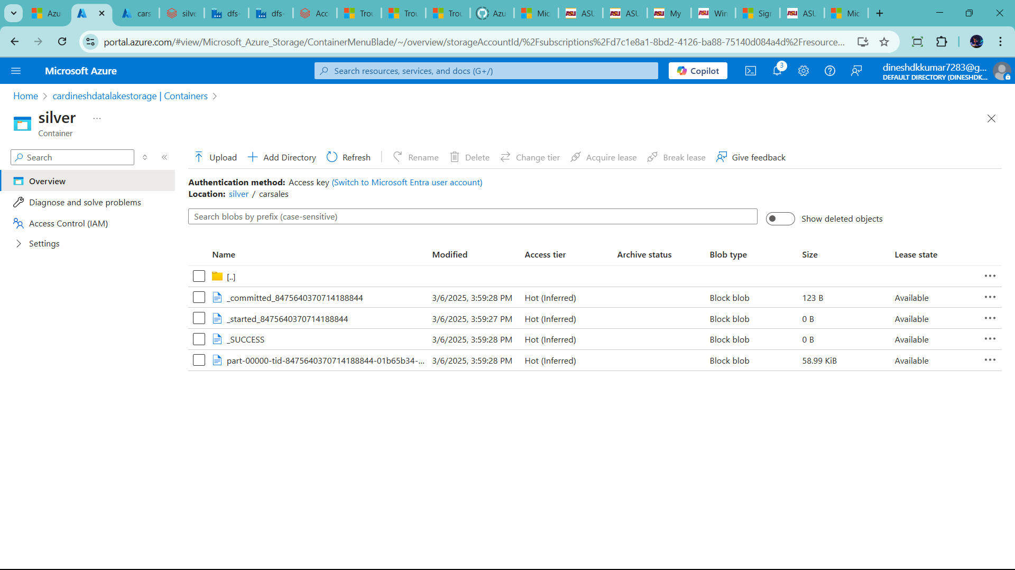

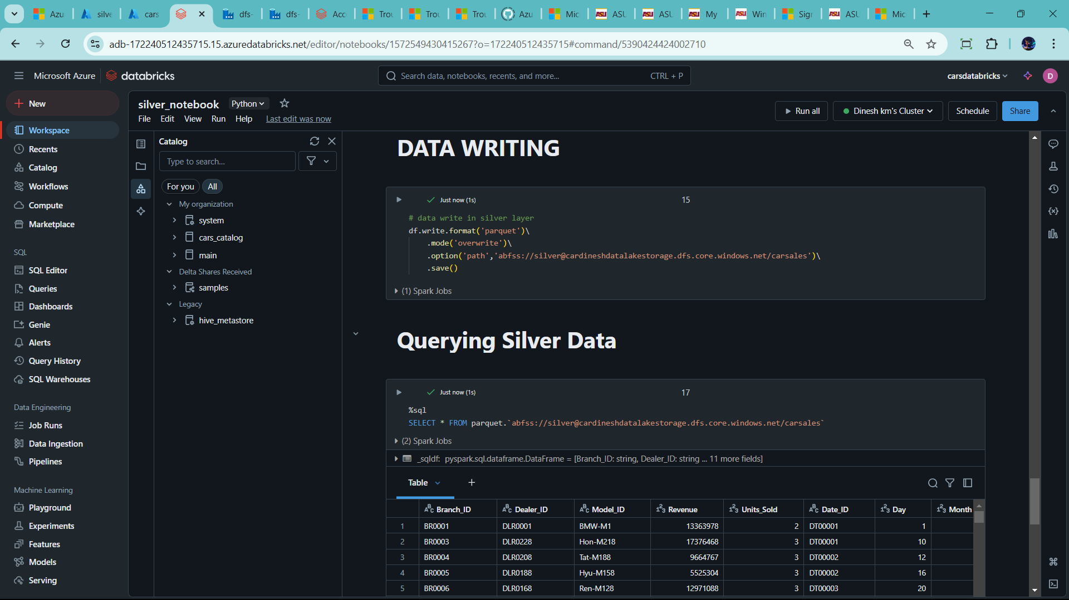

-🡪 Now Create Data Modelling

🡪Star Schema 🡪so Create New Notebook 🡪 for gold Layer

🡪slow change dimension

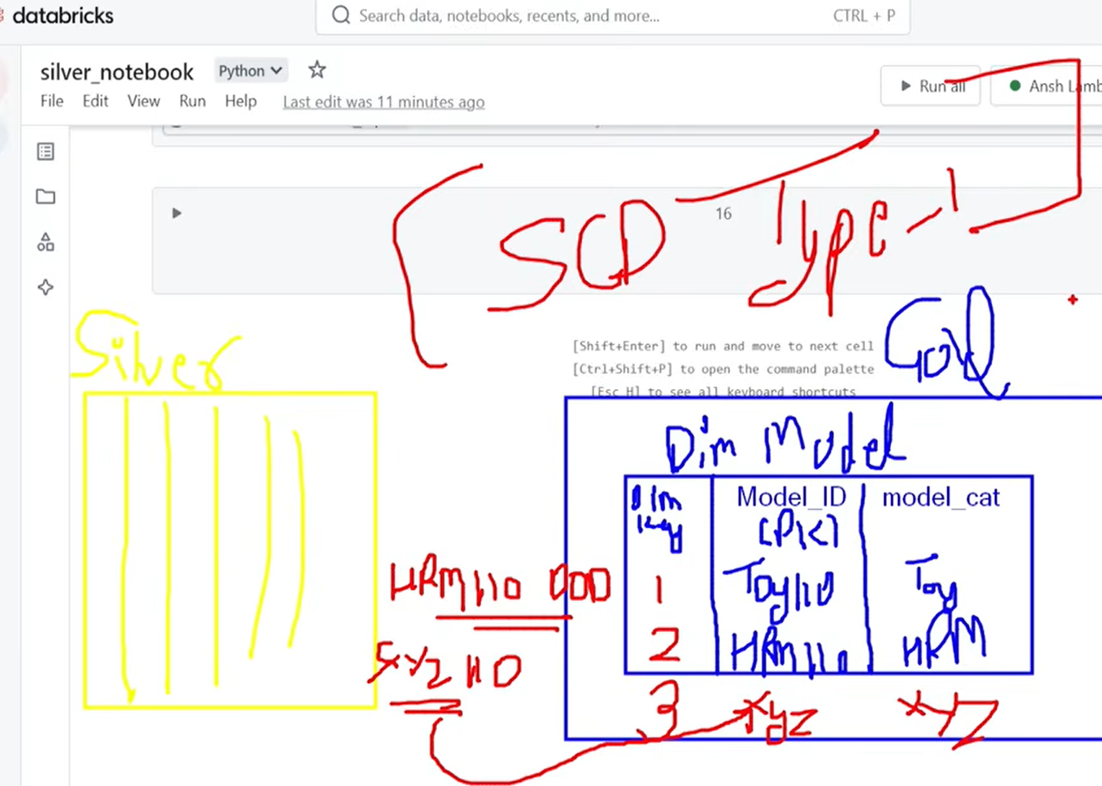

🡪gold table have dim id, id,name

🡪the silver table have new data 🡪let check gold id but dim id, because dim id not present in silver table

* Then id of gold table join with silver table. If left join both table new records in silver but not in gold table🡪 it means dim id return null to inform insert new records present

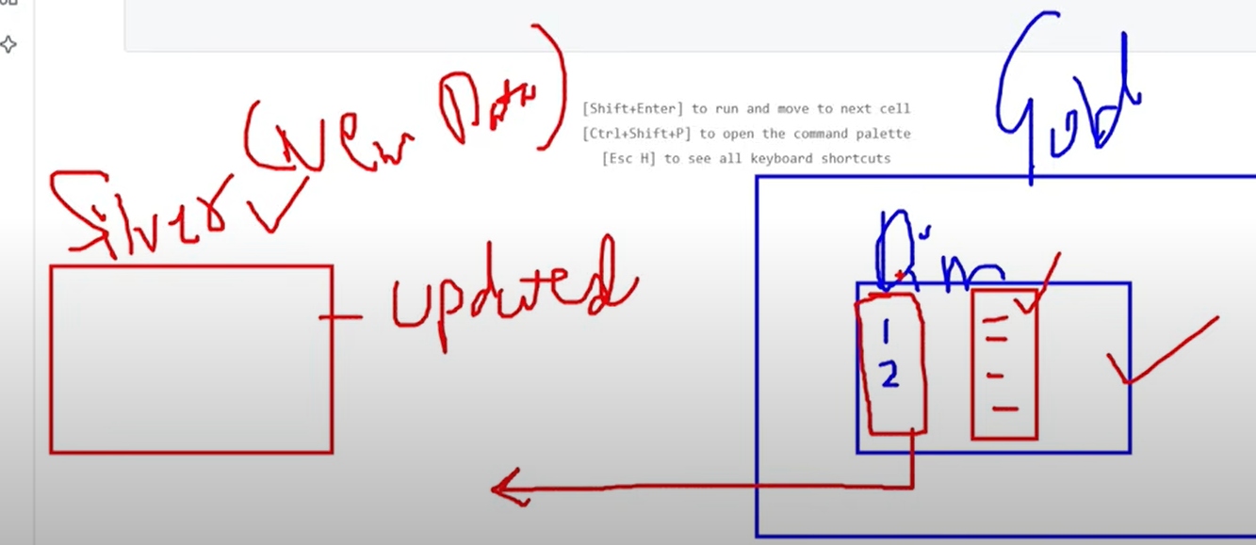

🡪dim id is surrogate key

* 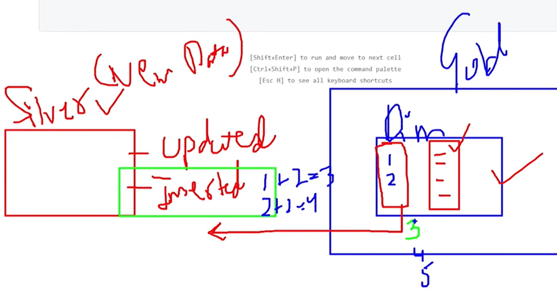

🡪 first time run gold table use left join because gold layer not available table

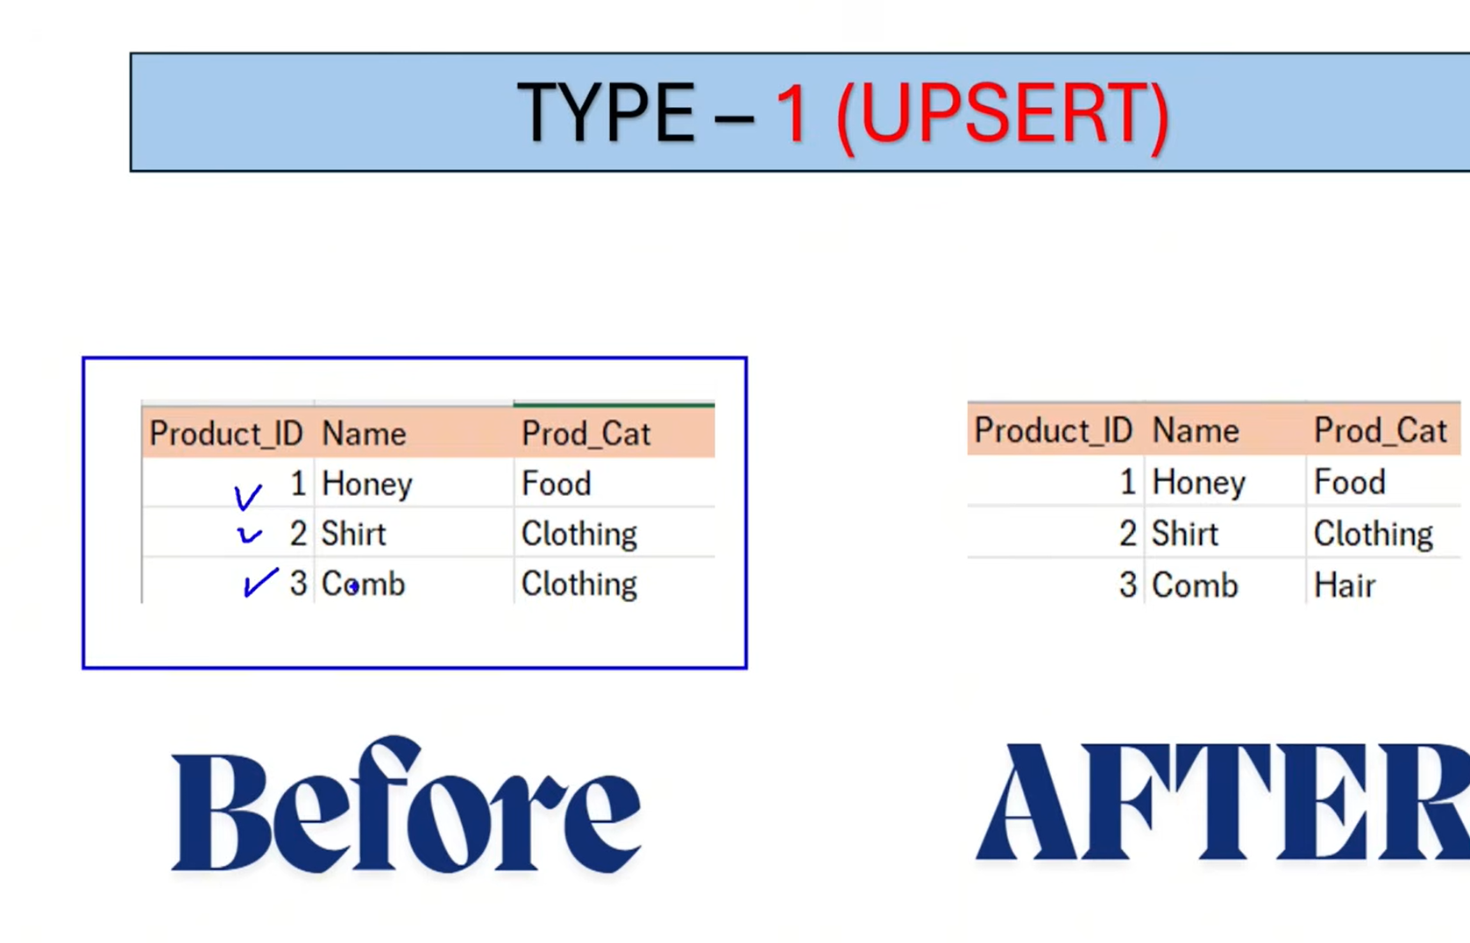

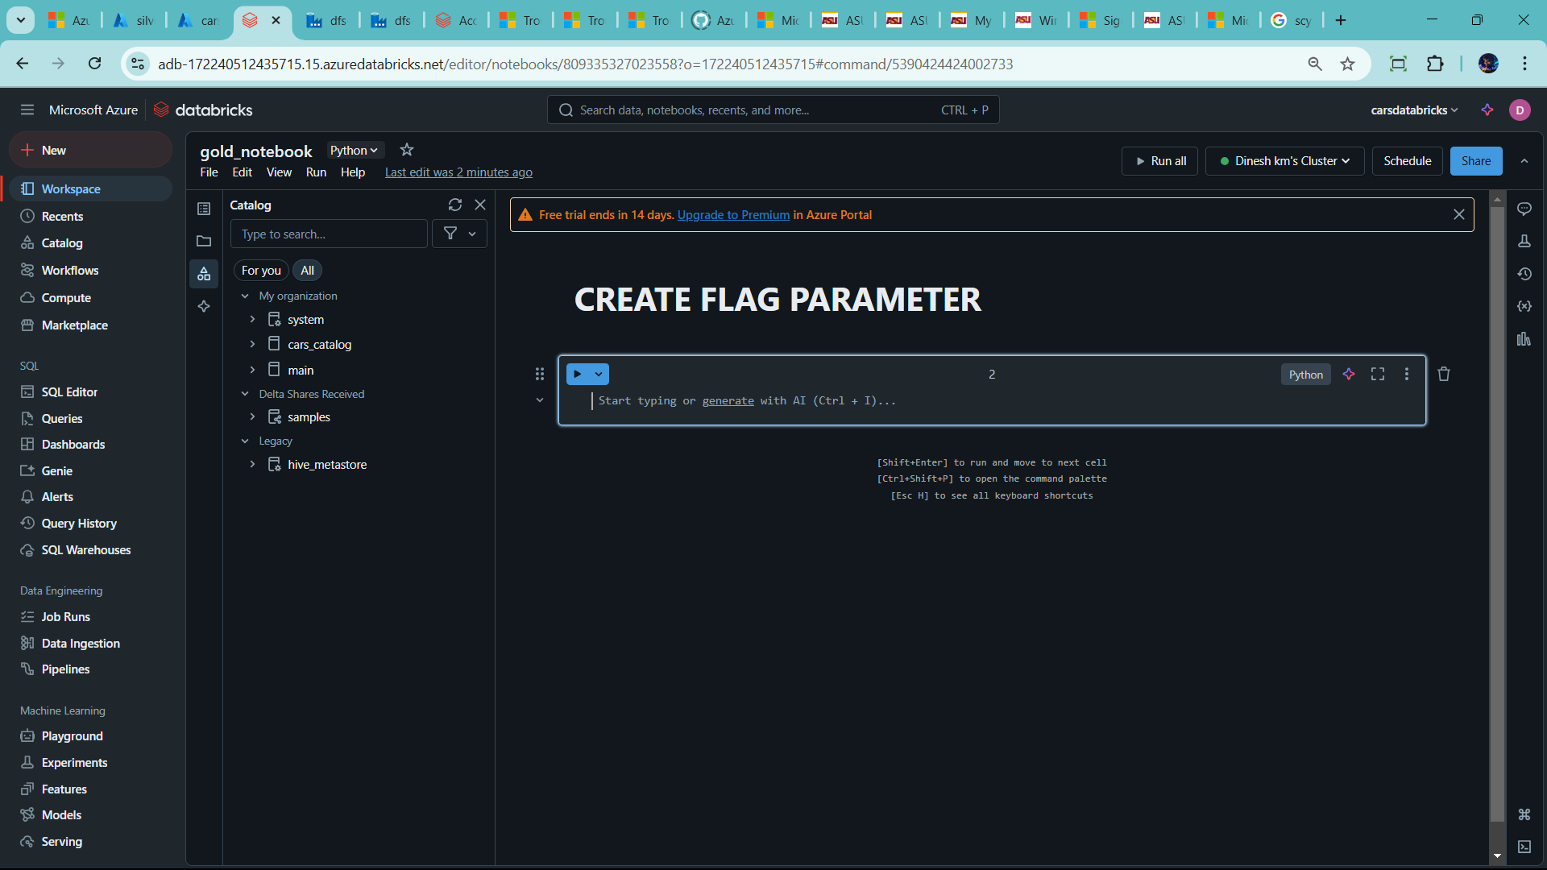

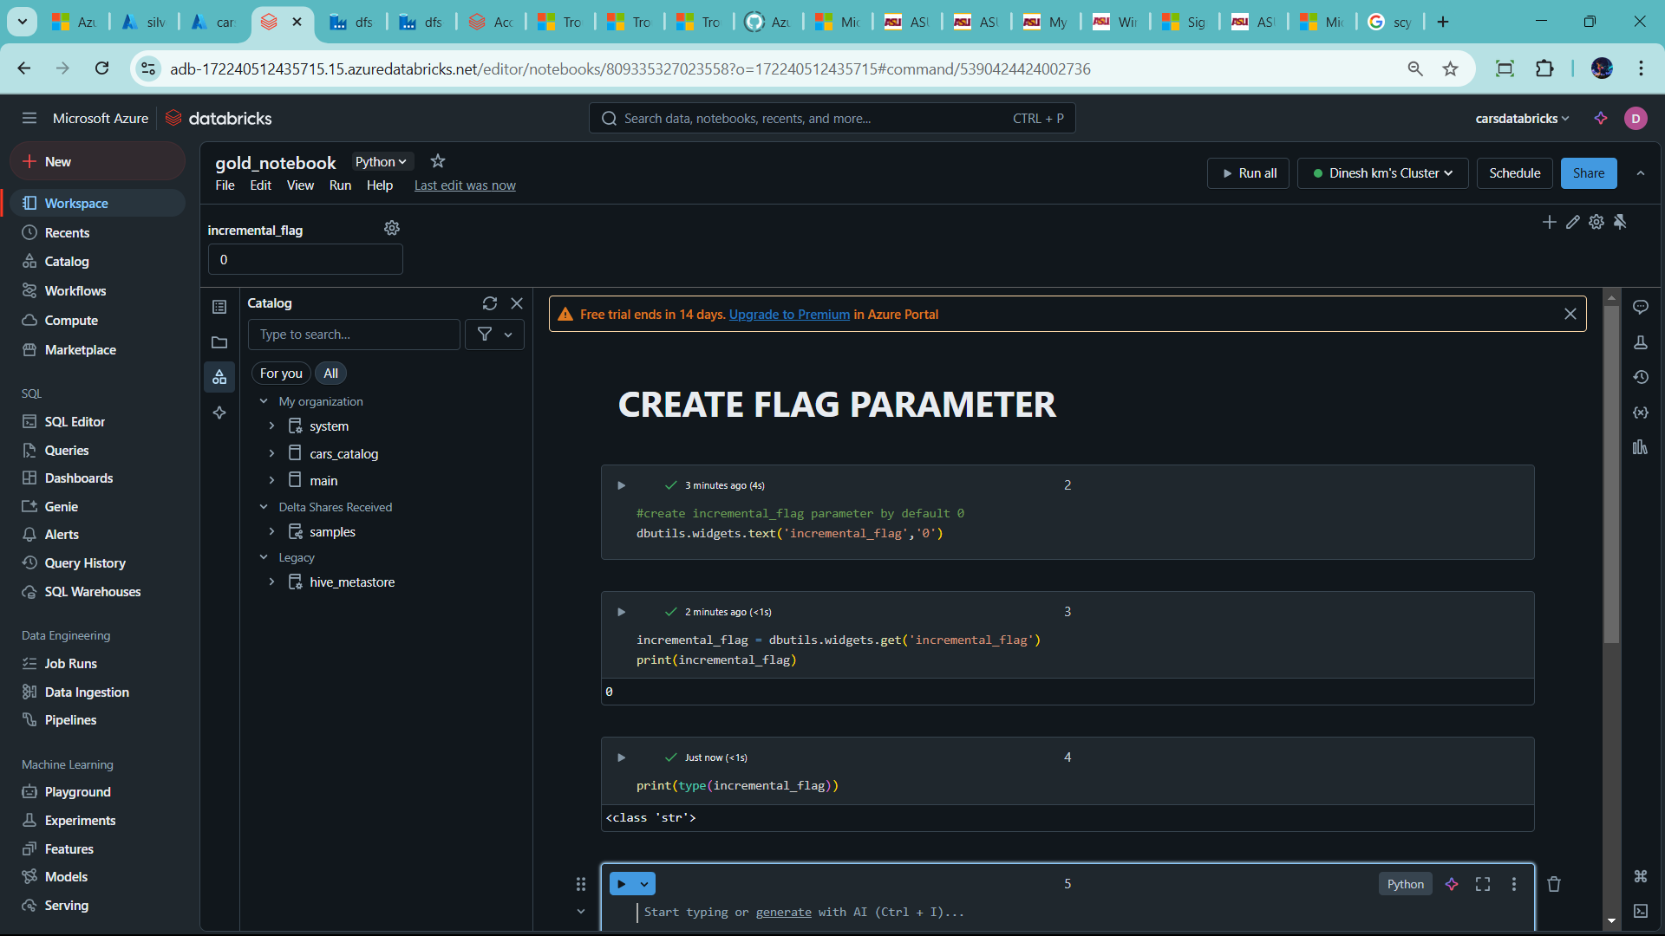

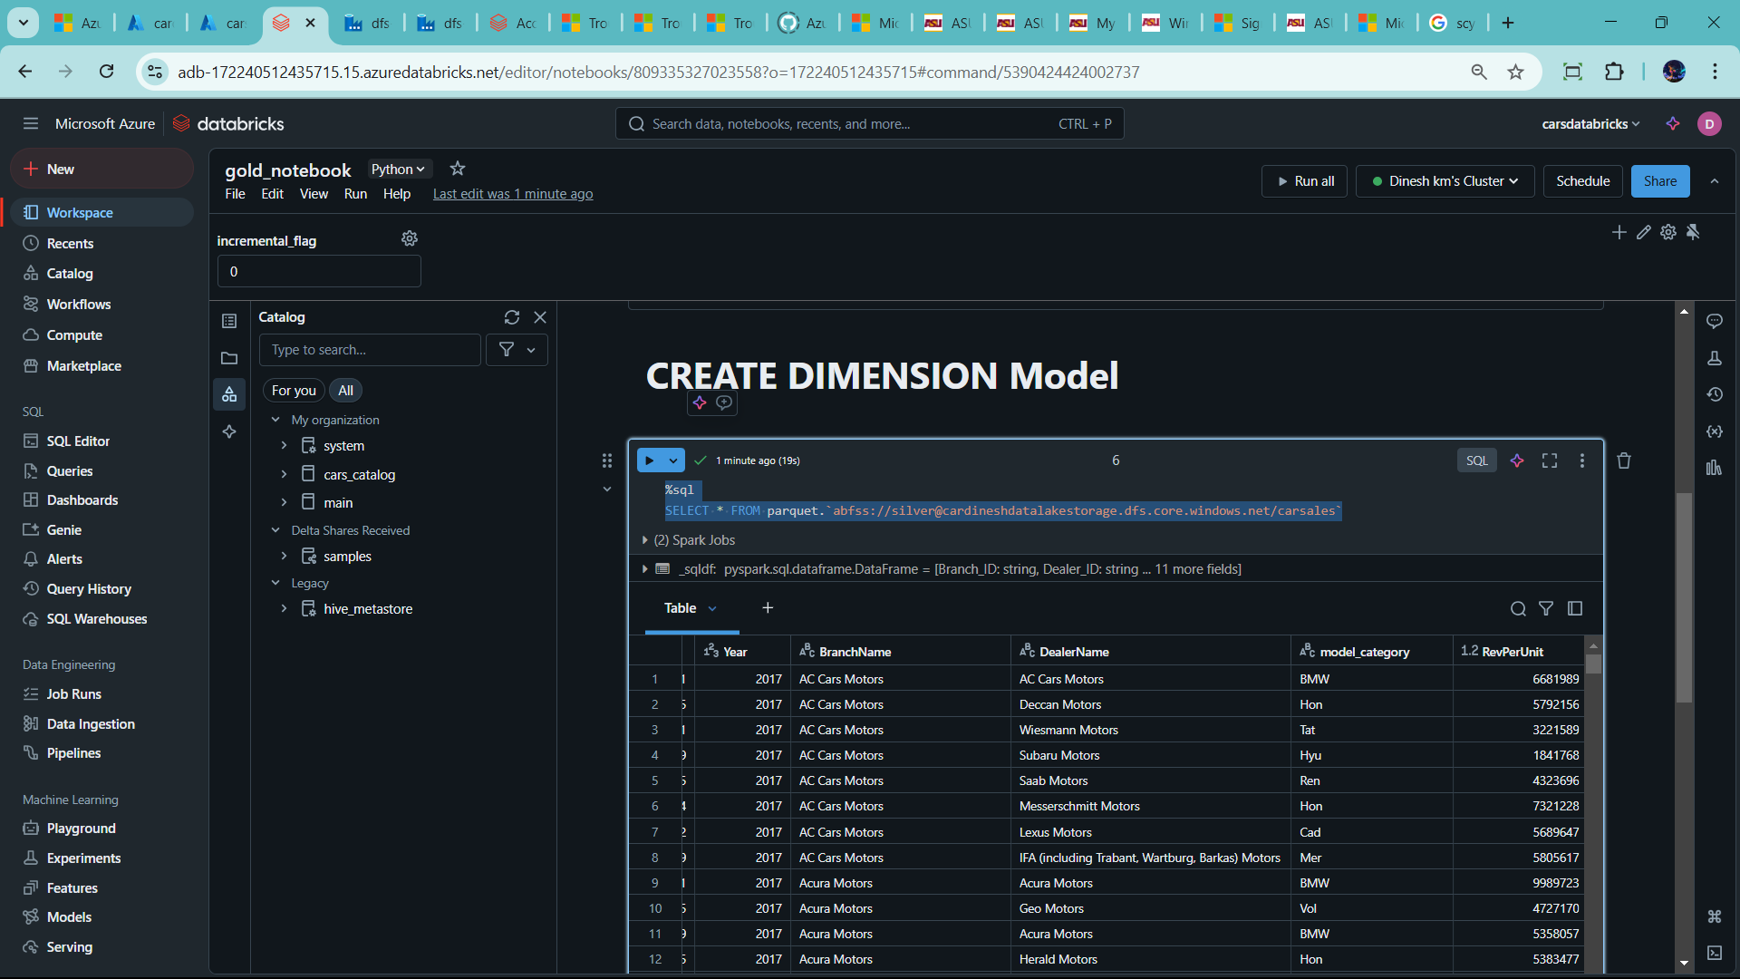

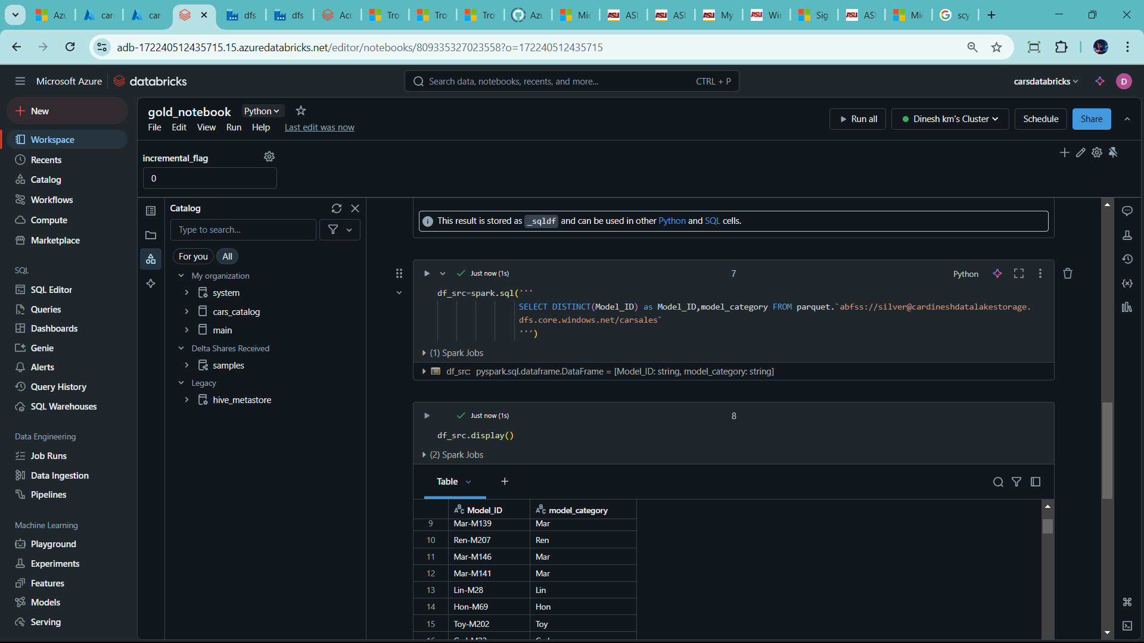

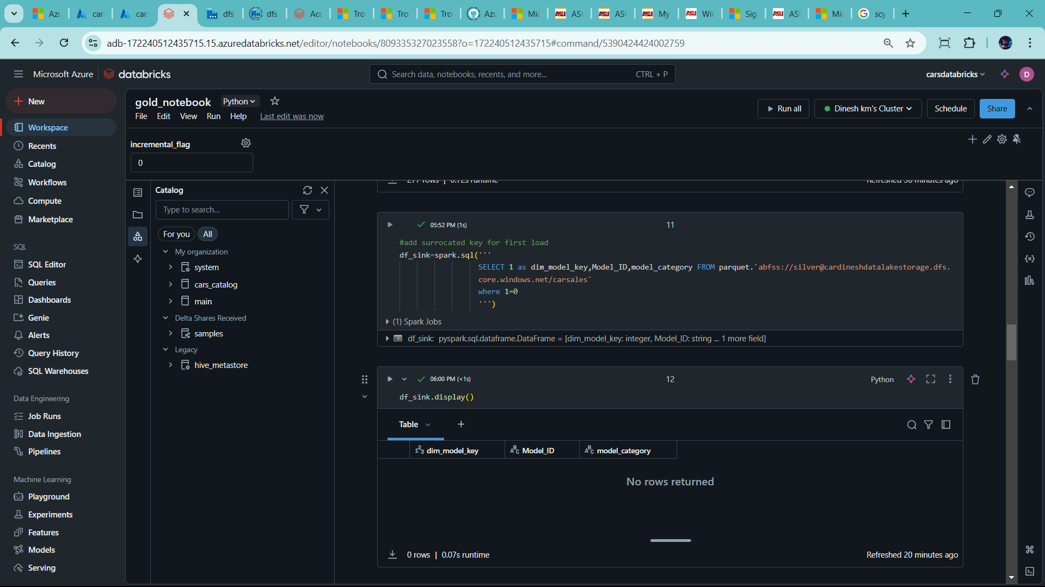

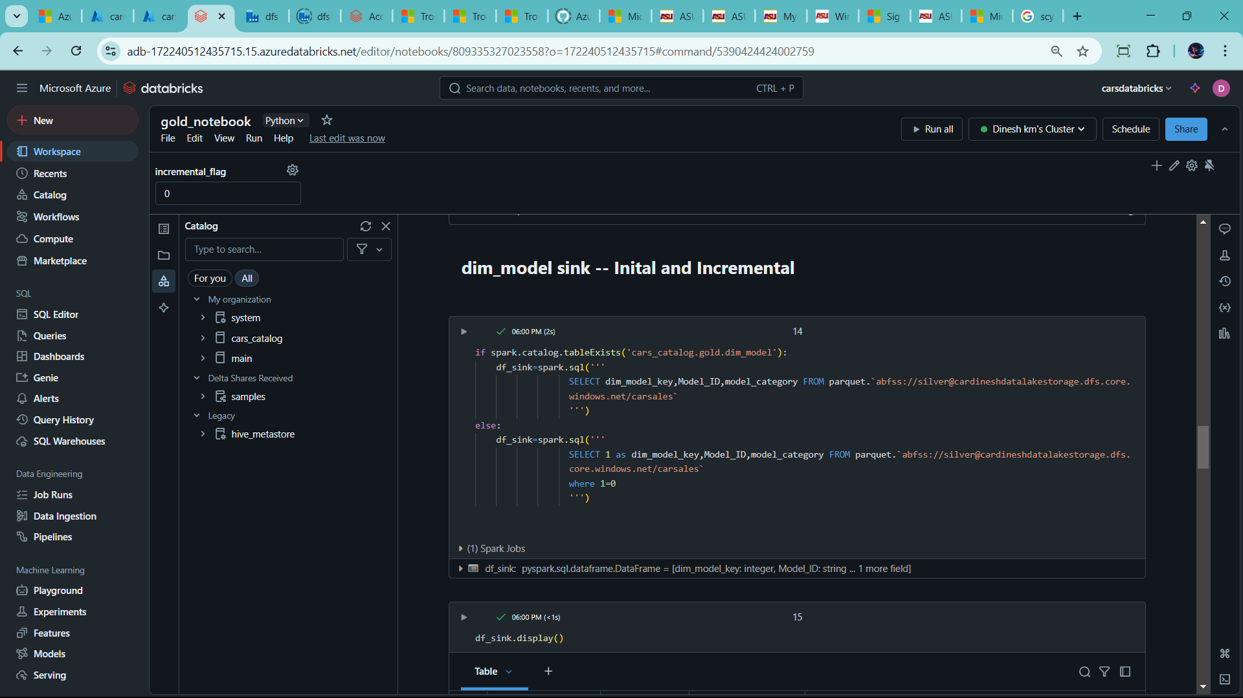

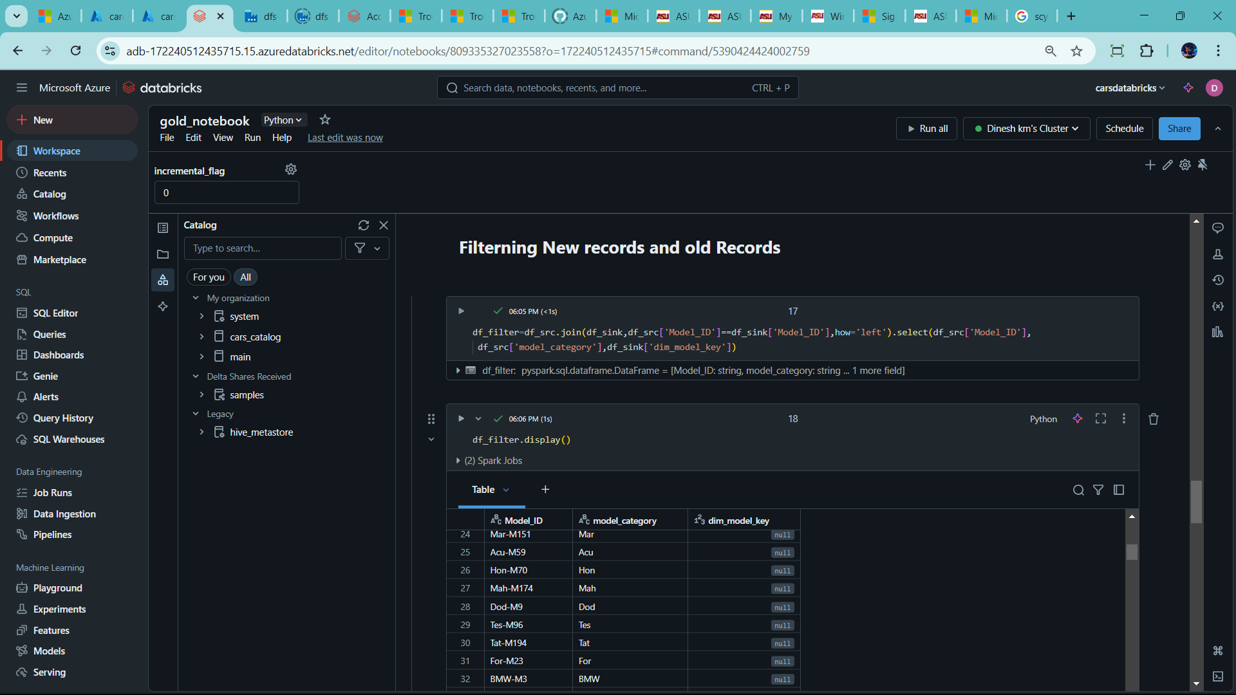

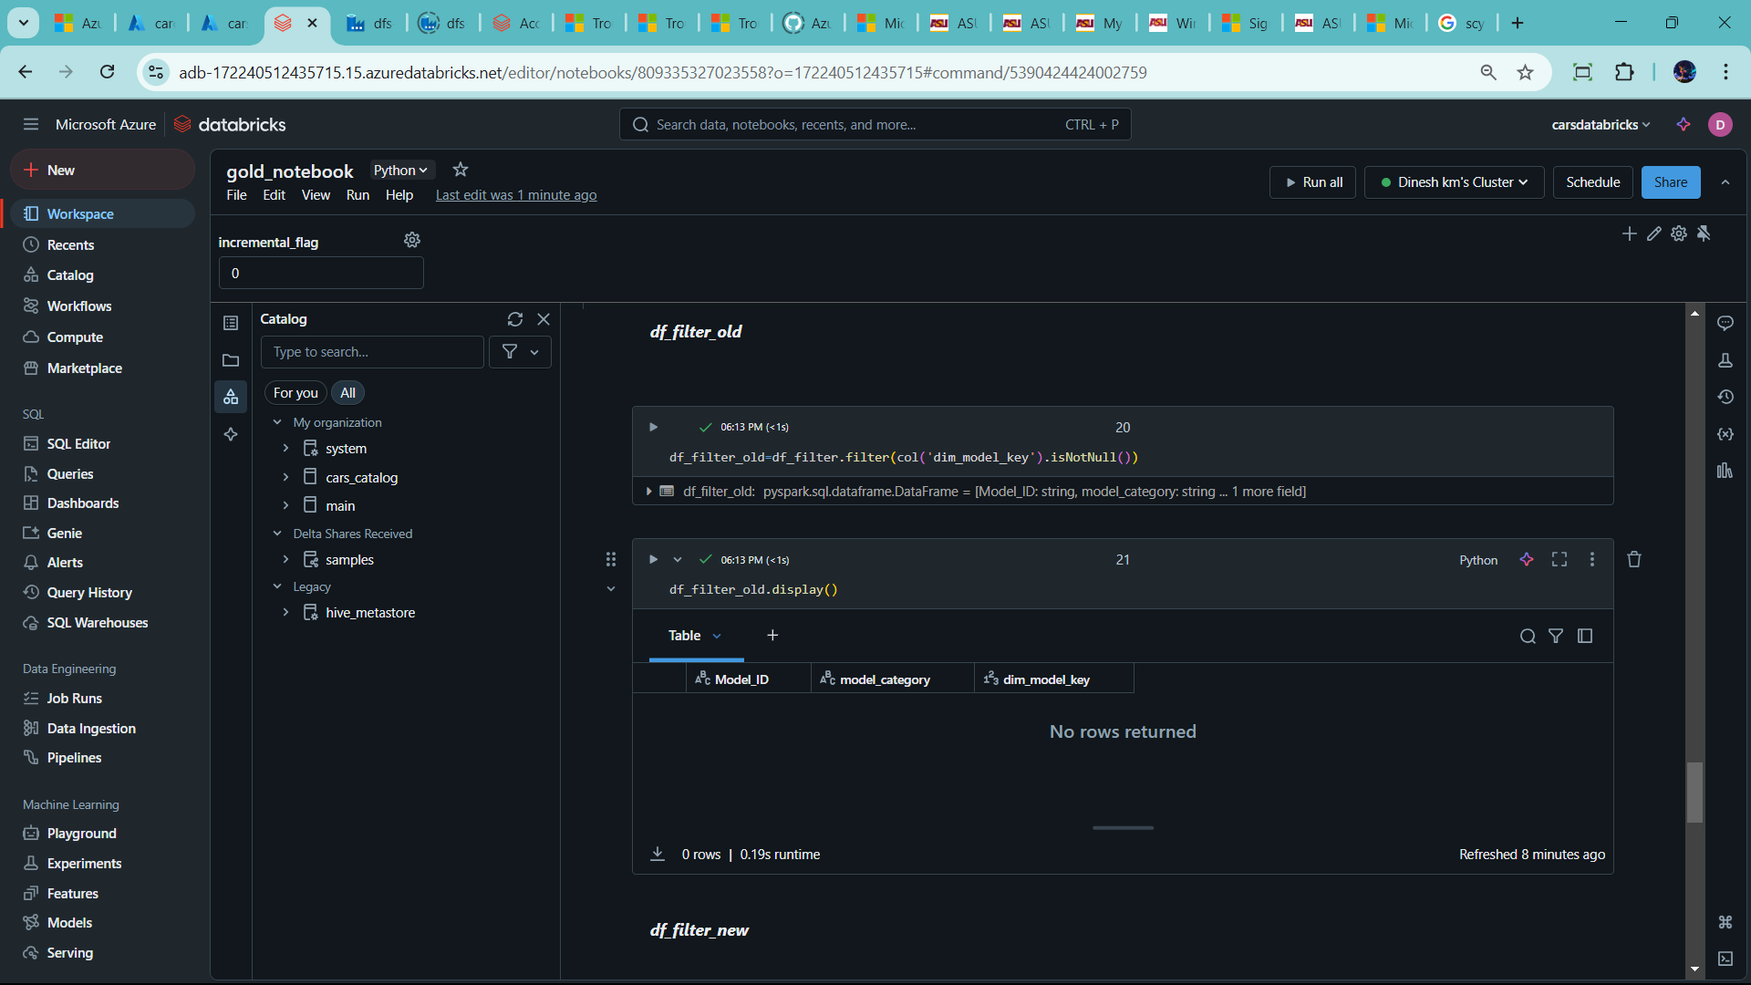

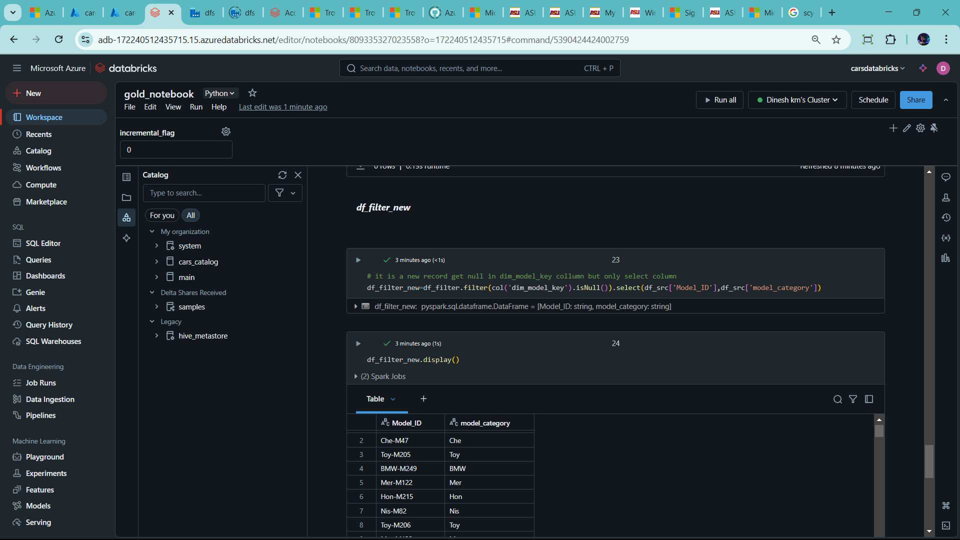

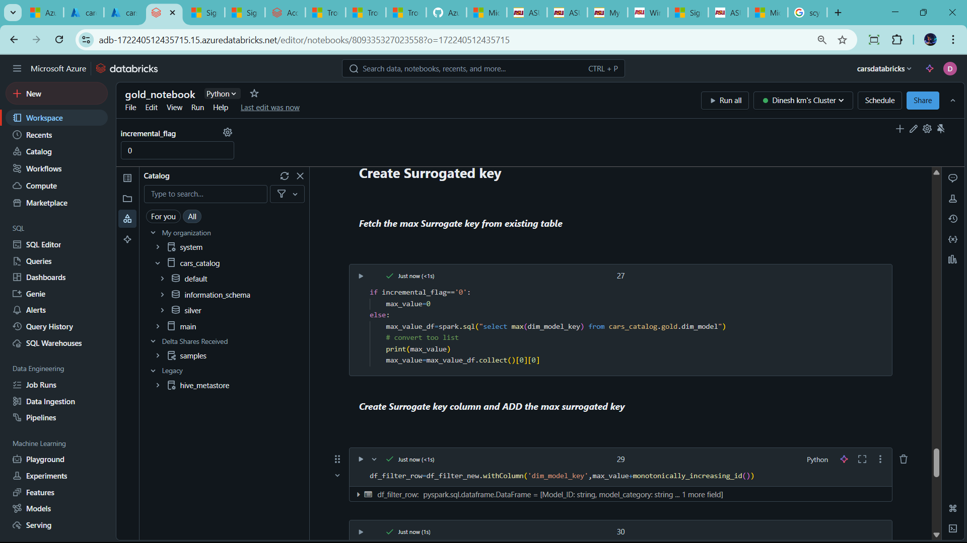

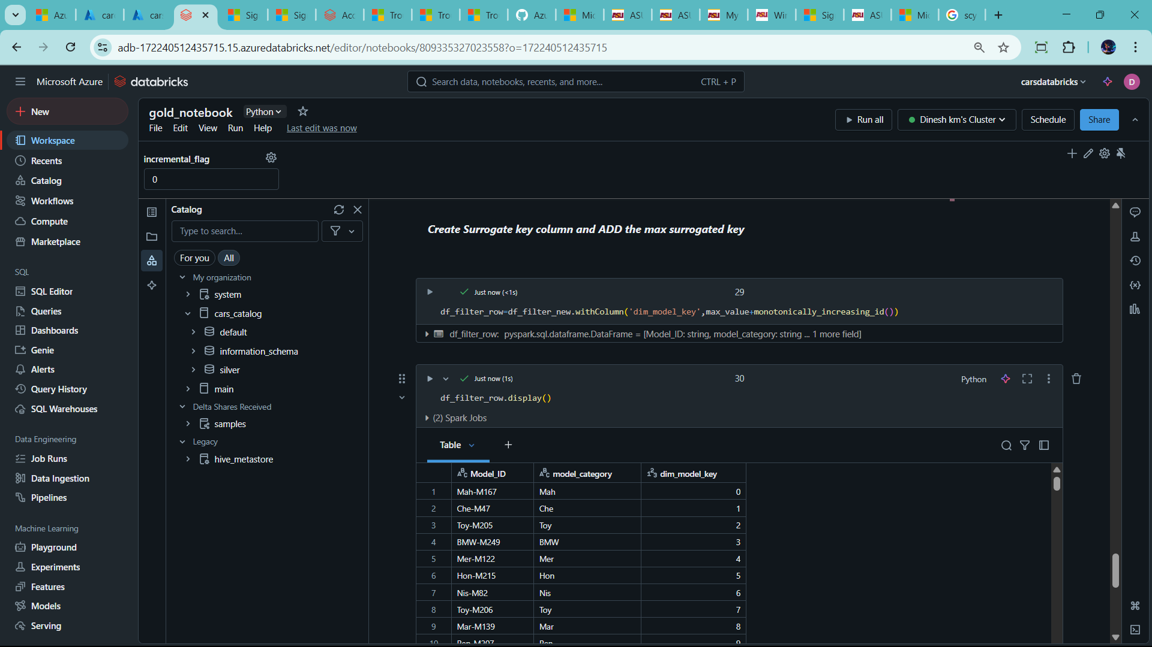

--change to max_value= 1 because surrogate key start 0

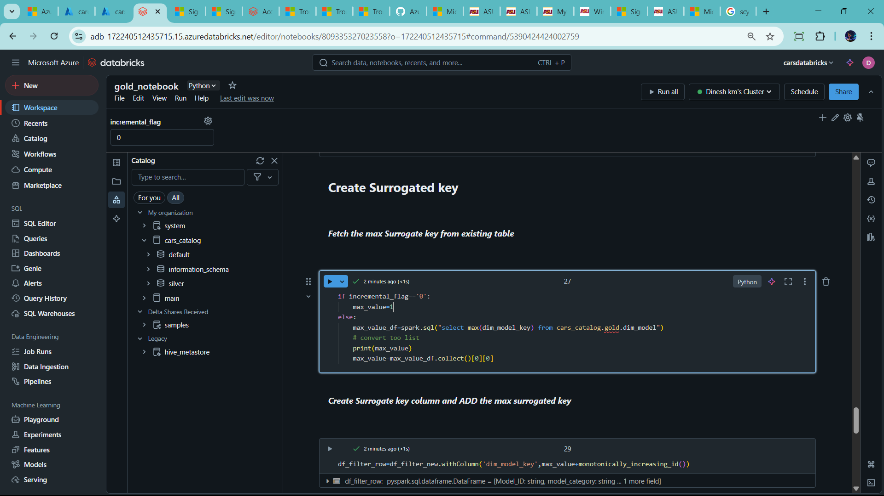

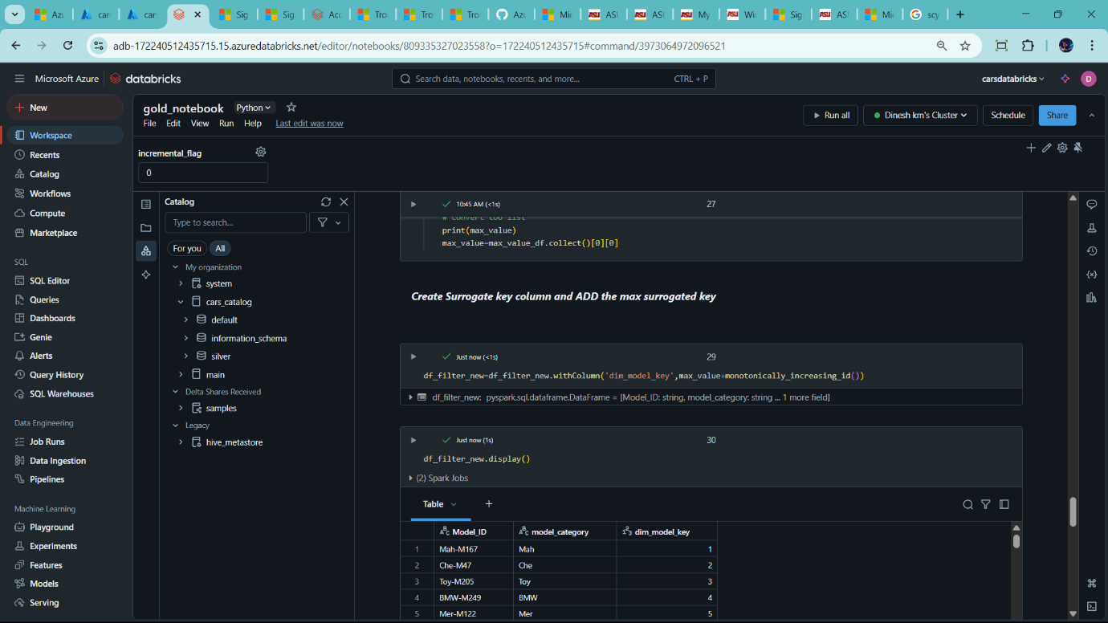

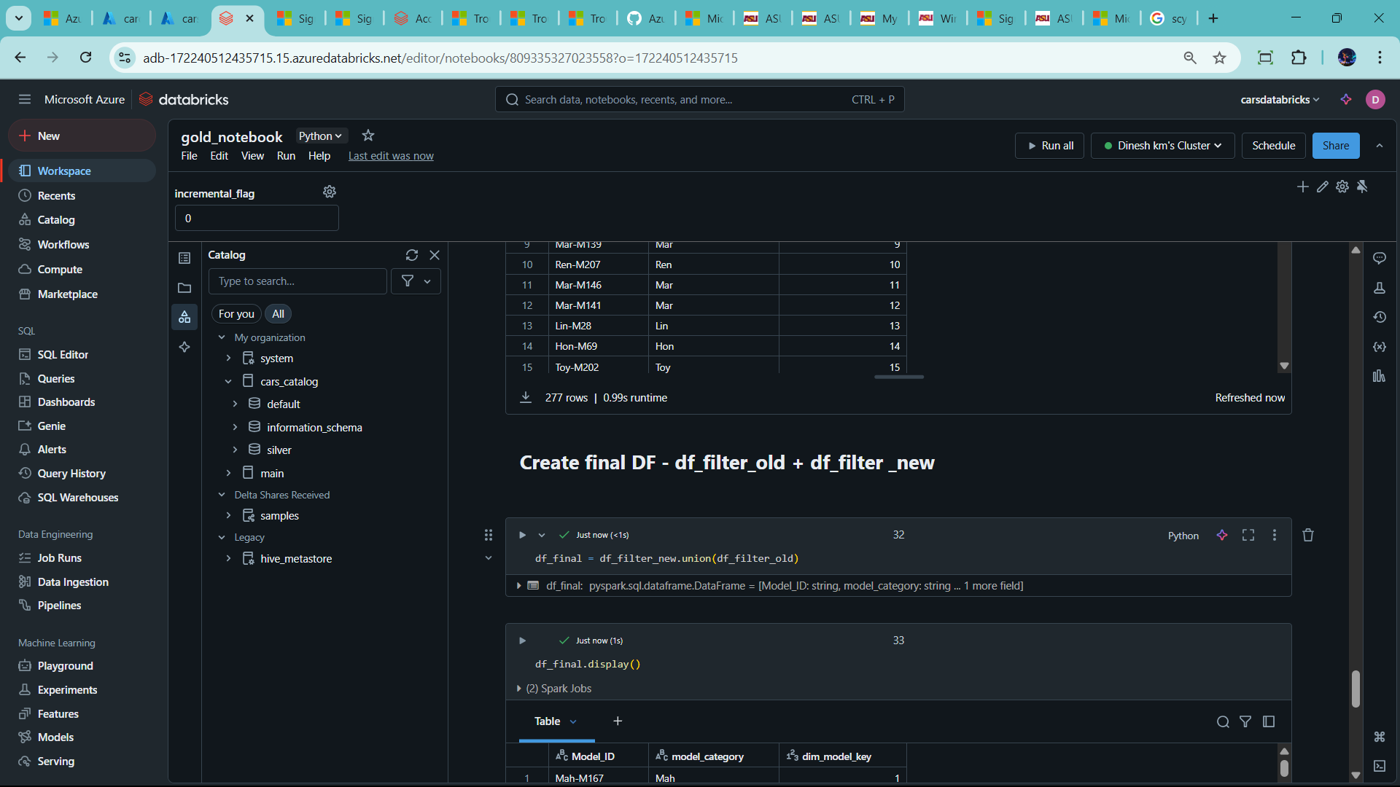

Old records –so Update

Destination

Source

New Record – INSERT

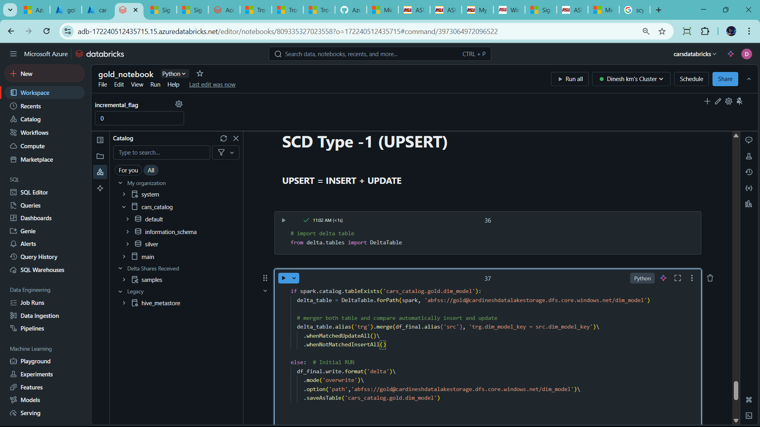

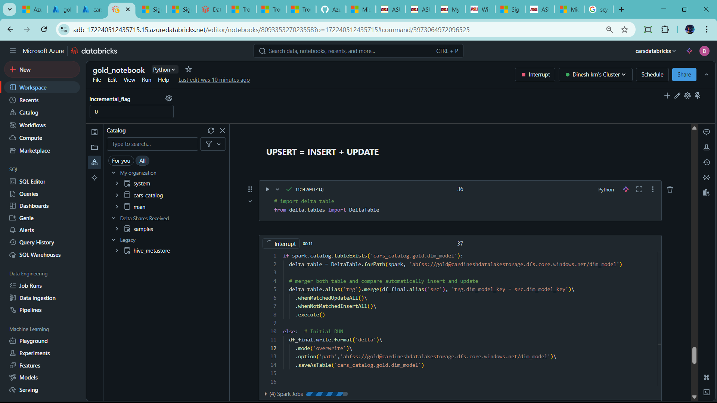

--change name gold_dim_model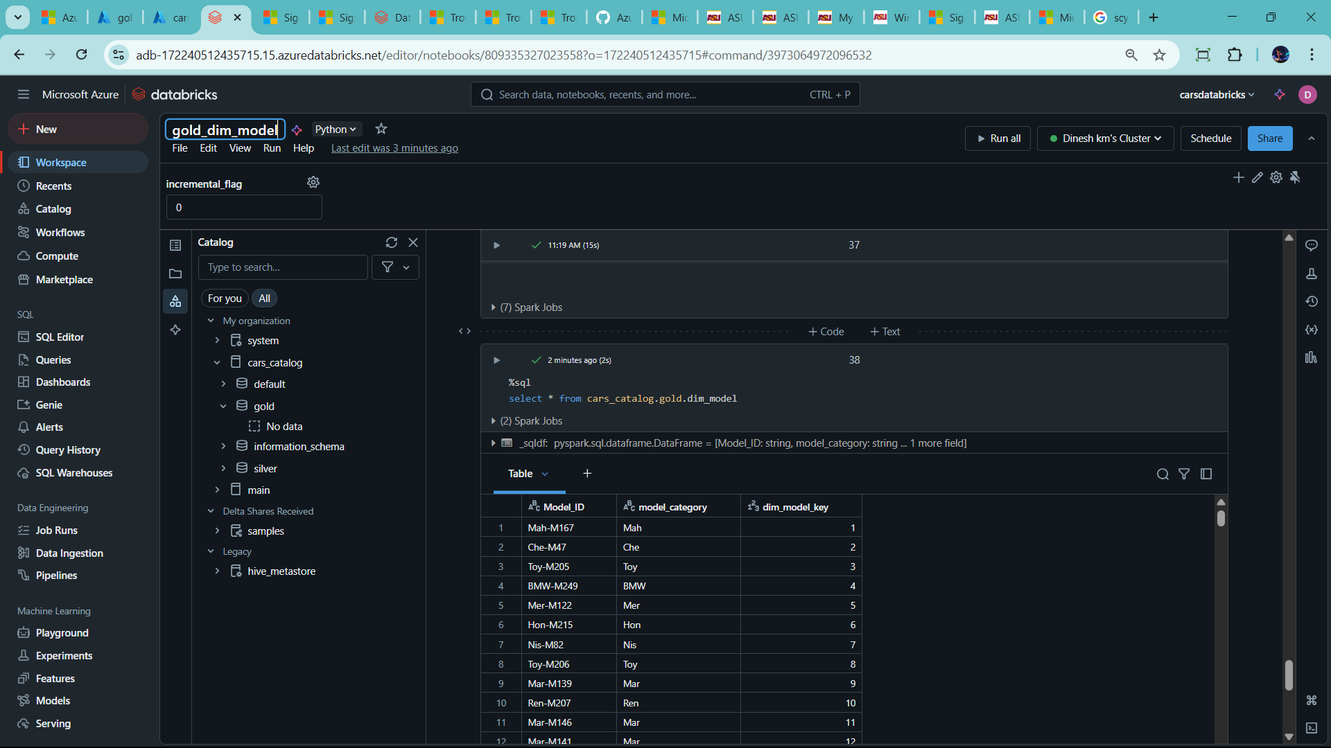

-🡪 copy this gold_dim_model to gold_dim_branch in clone method

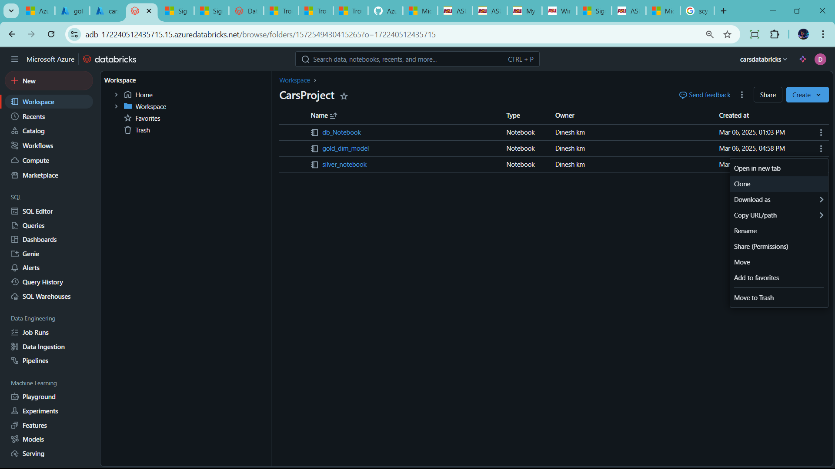

🡪

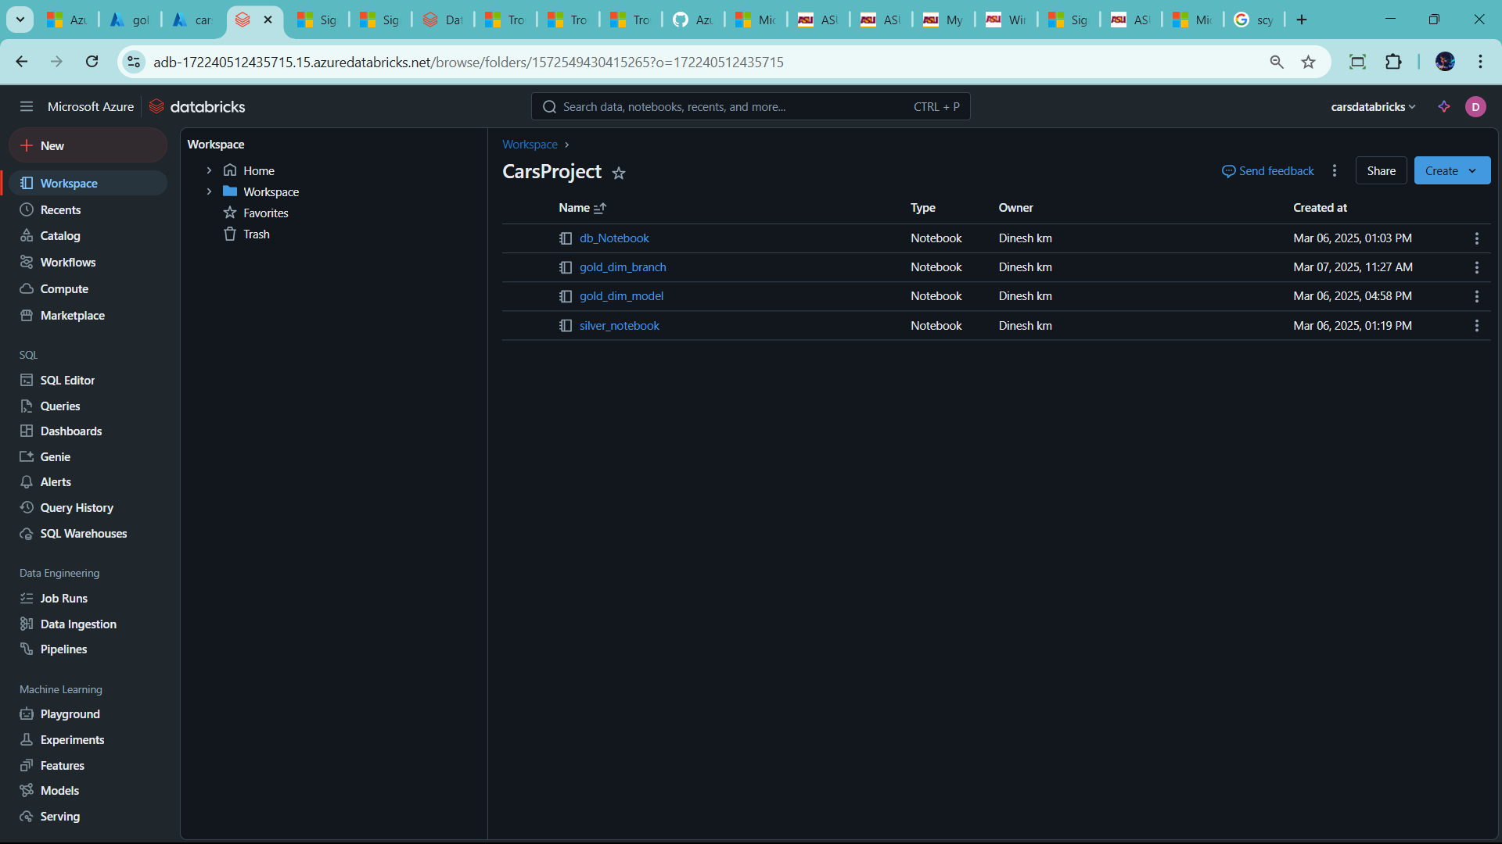

🡪change accouding

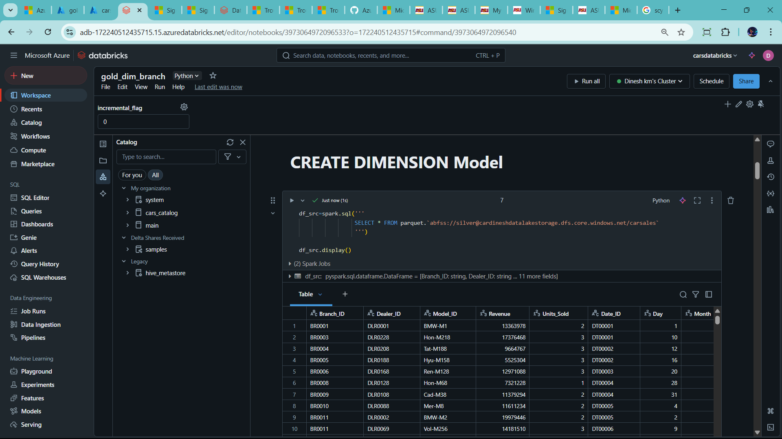

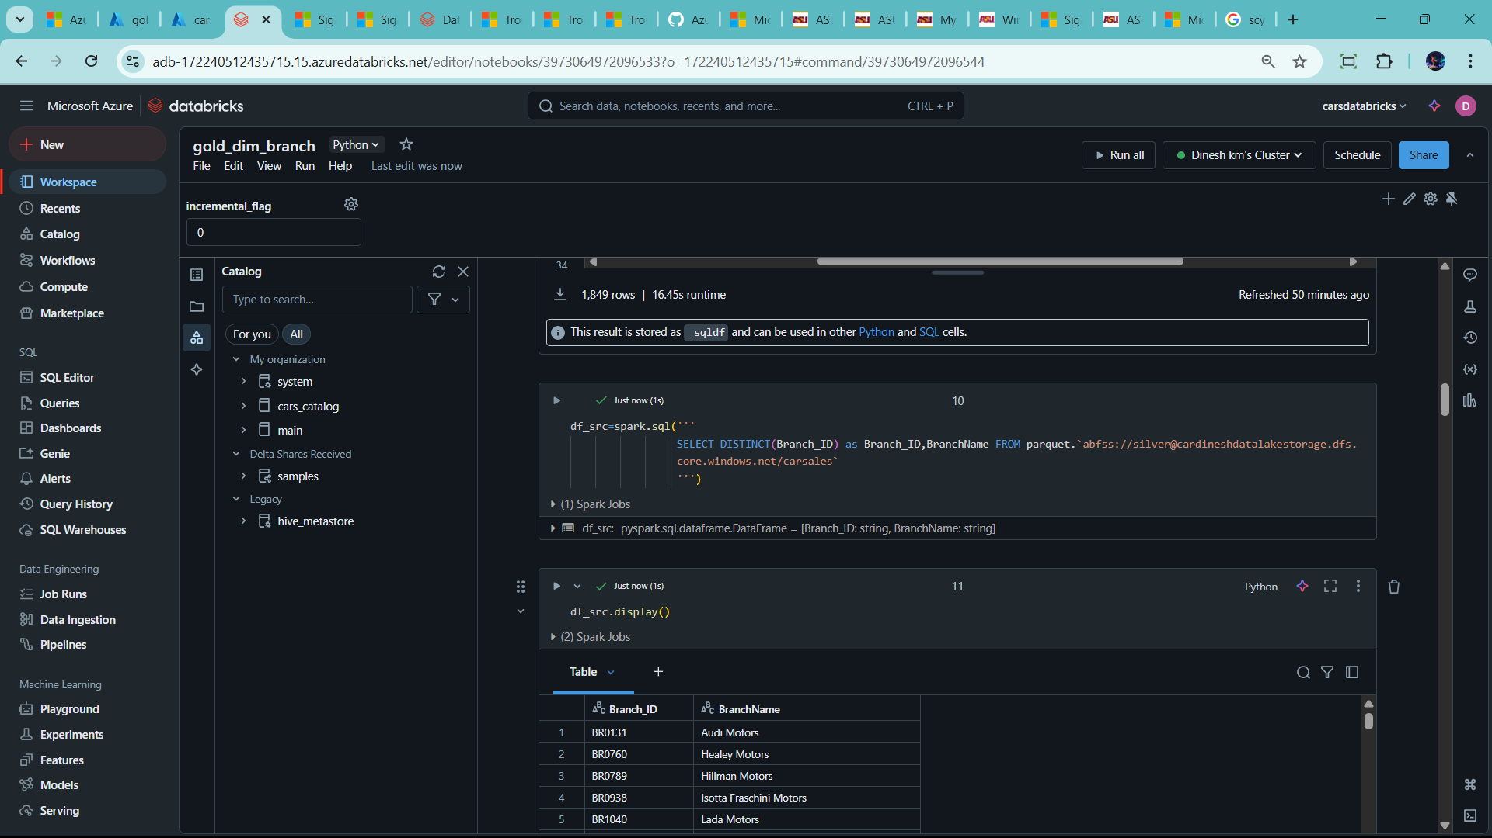

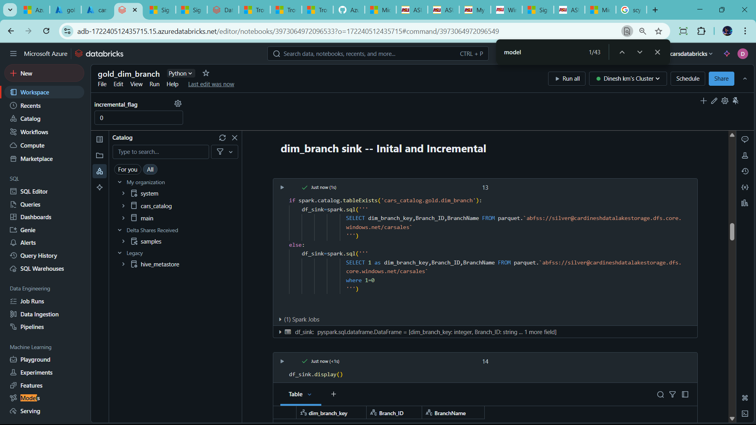

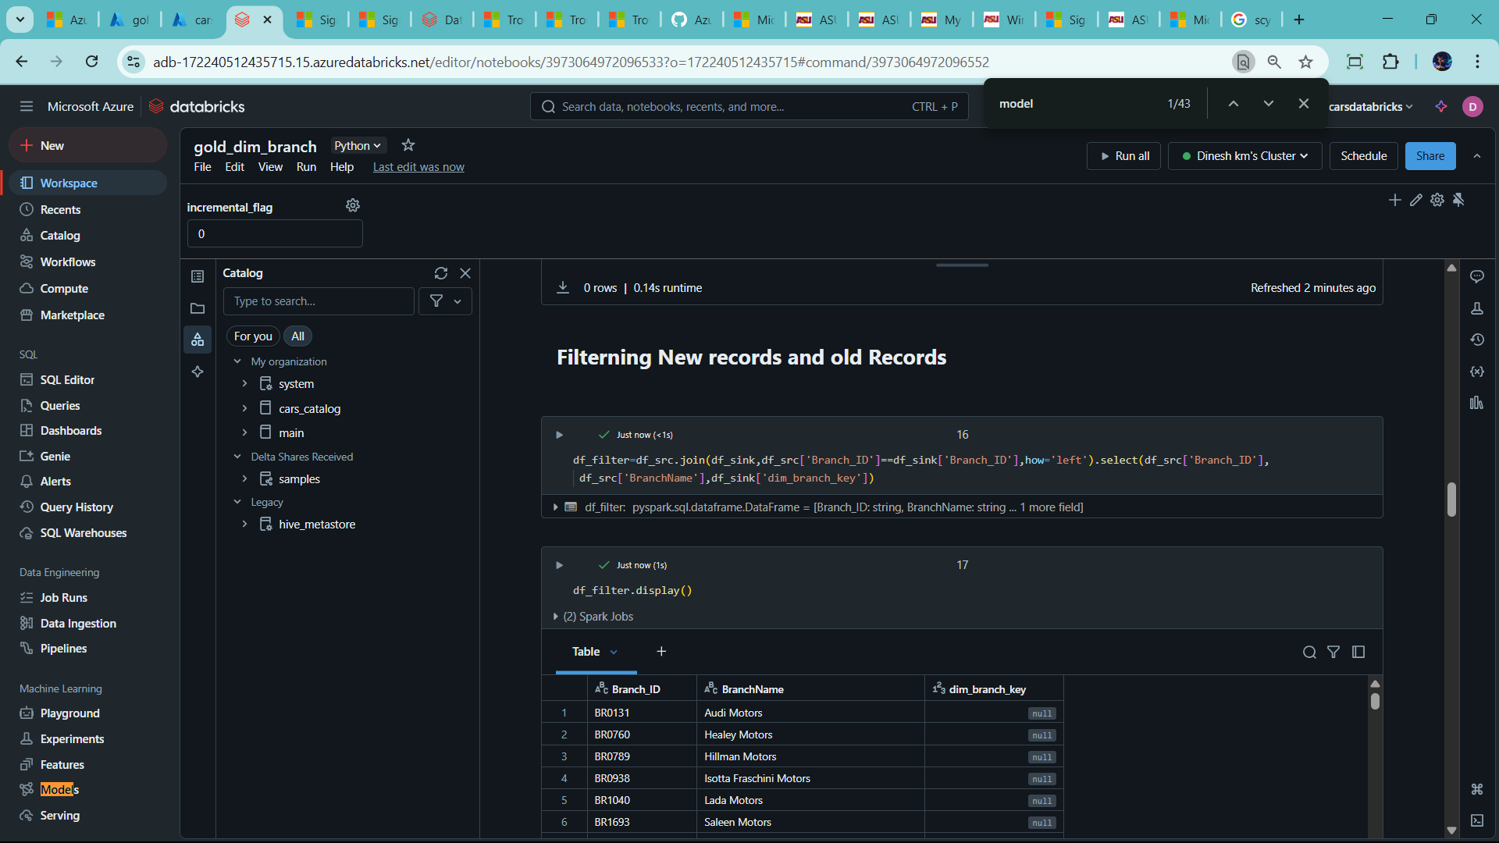

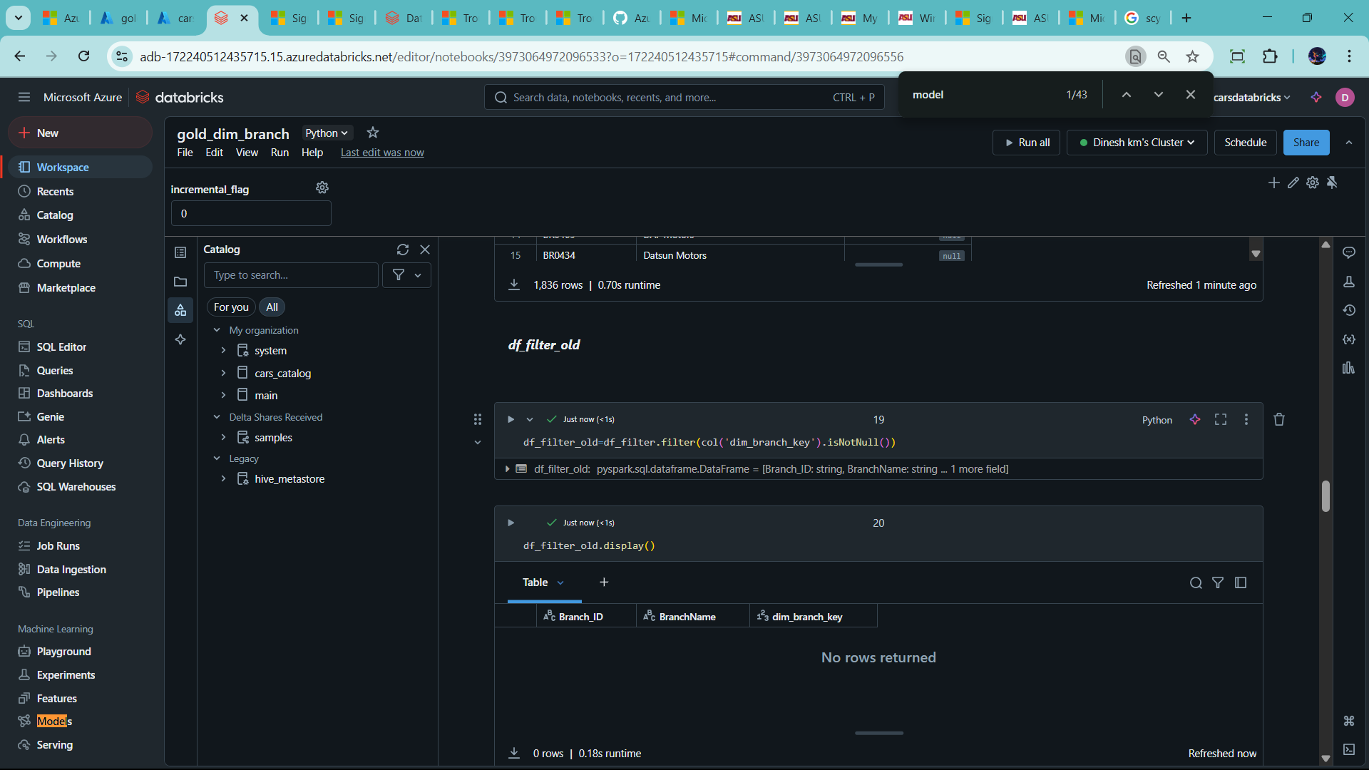

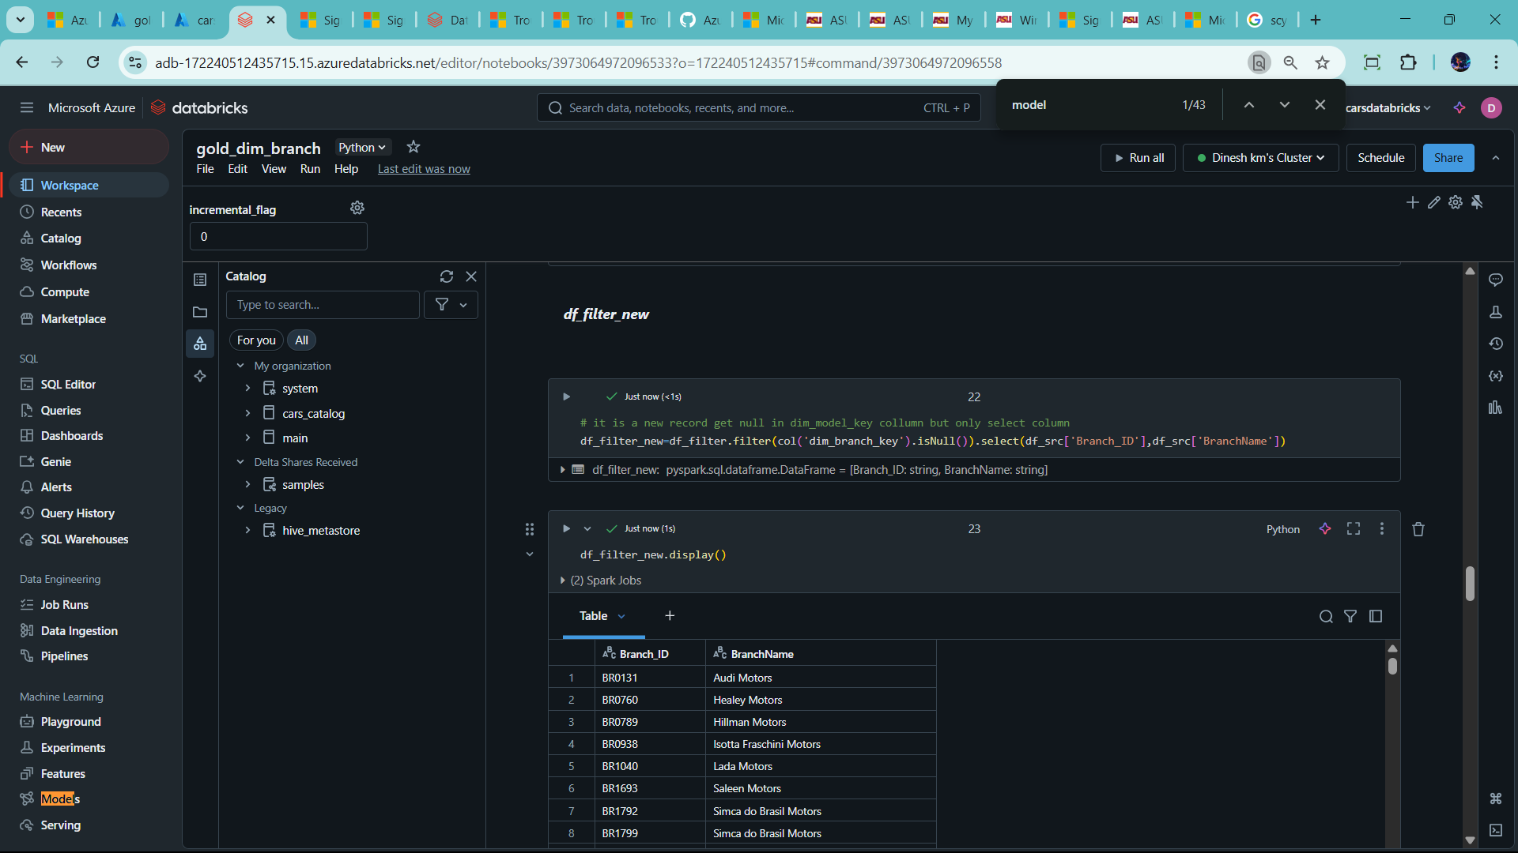

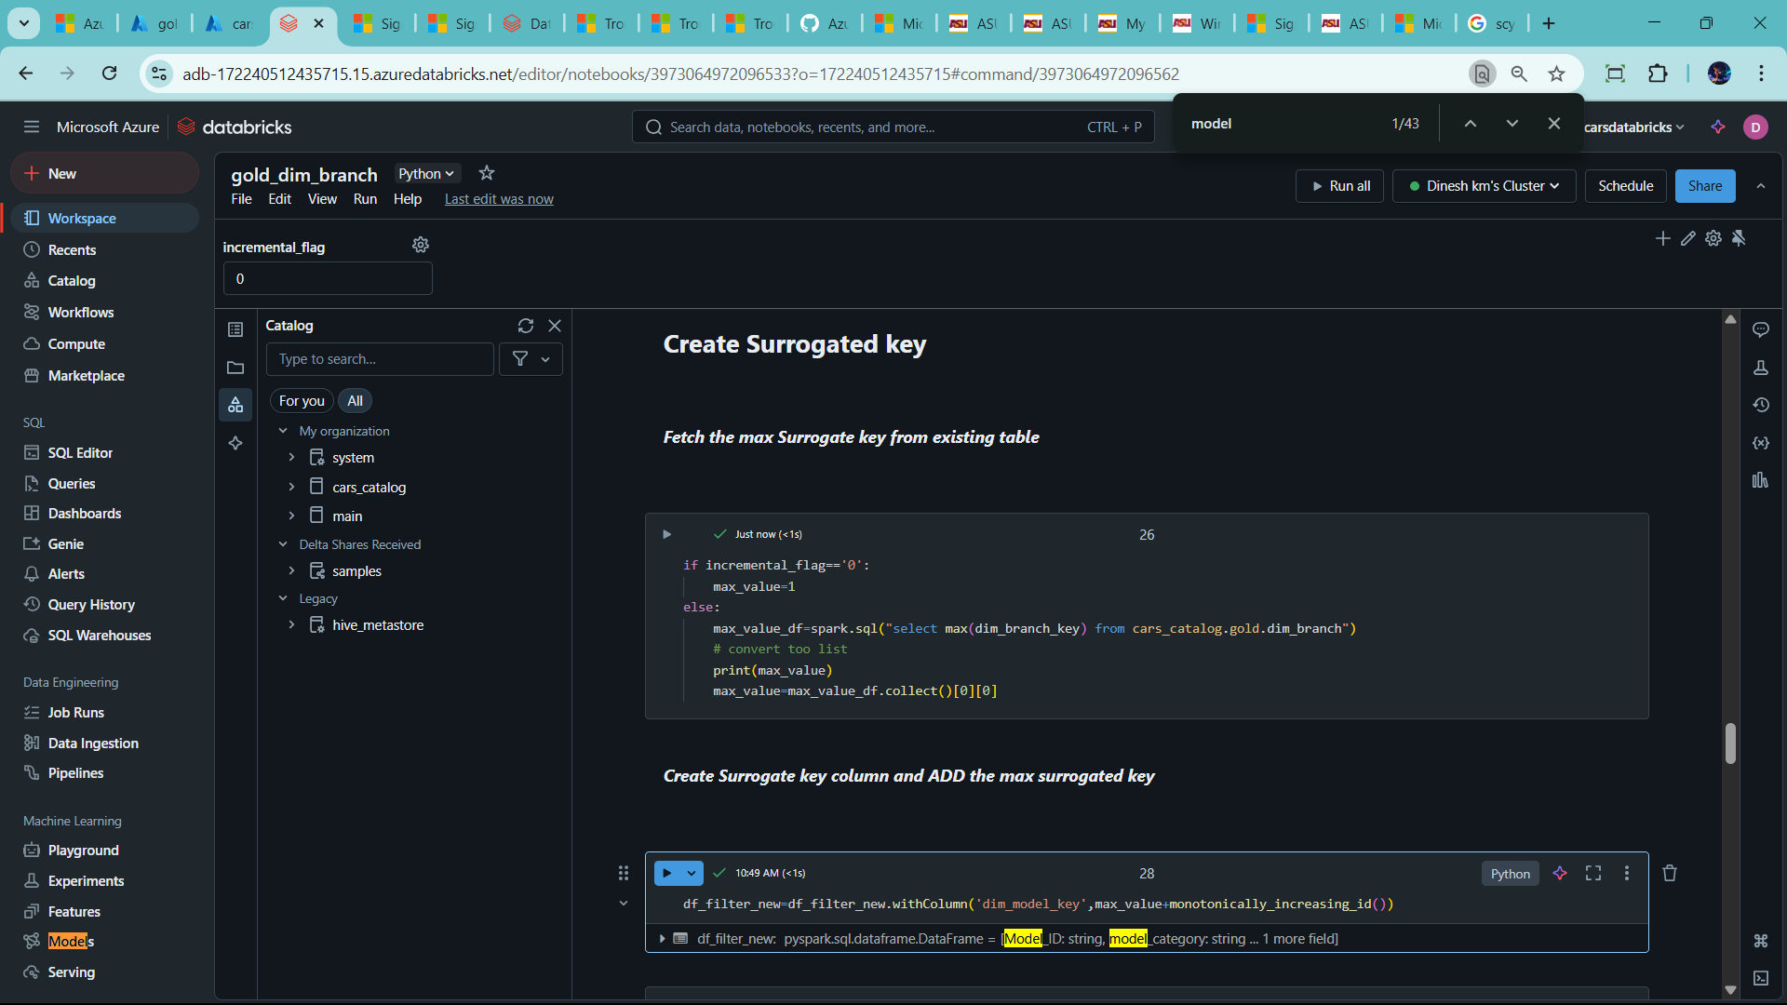

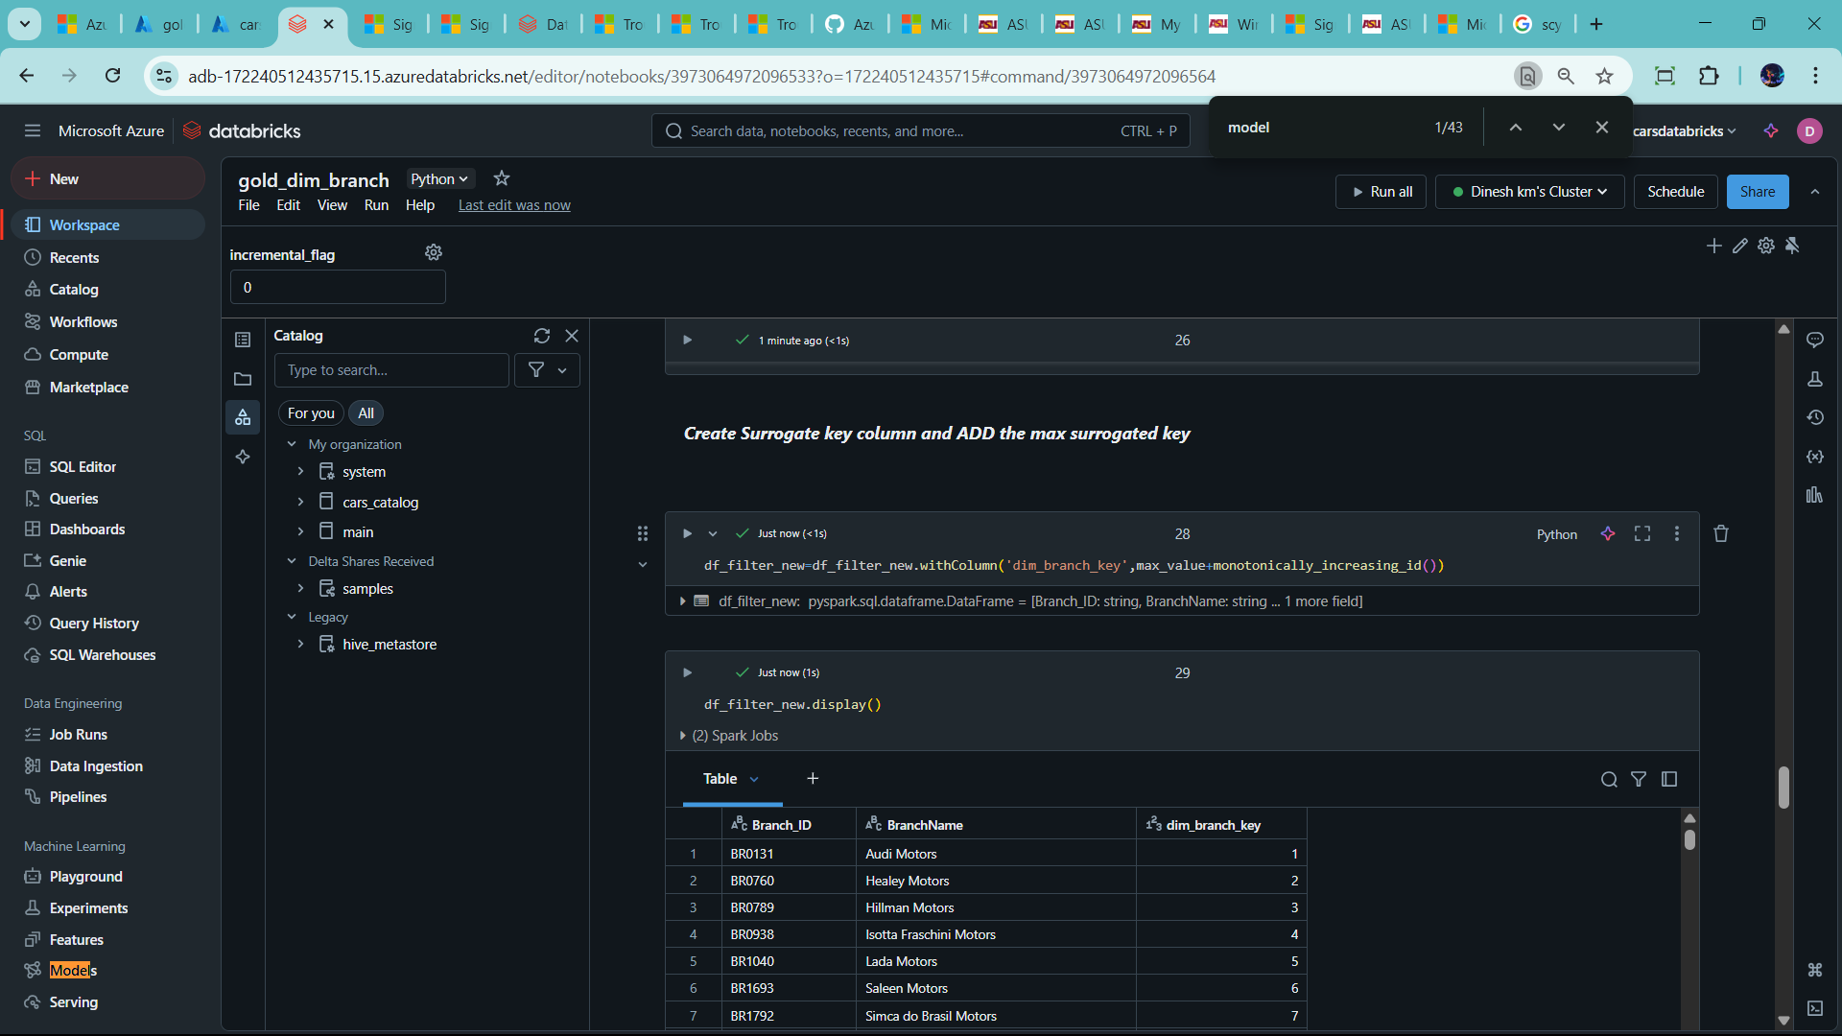

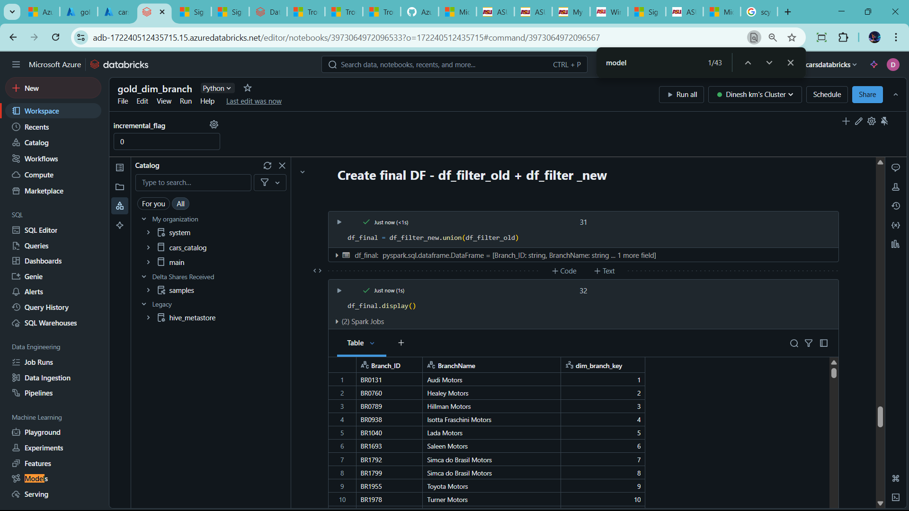

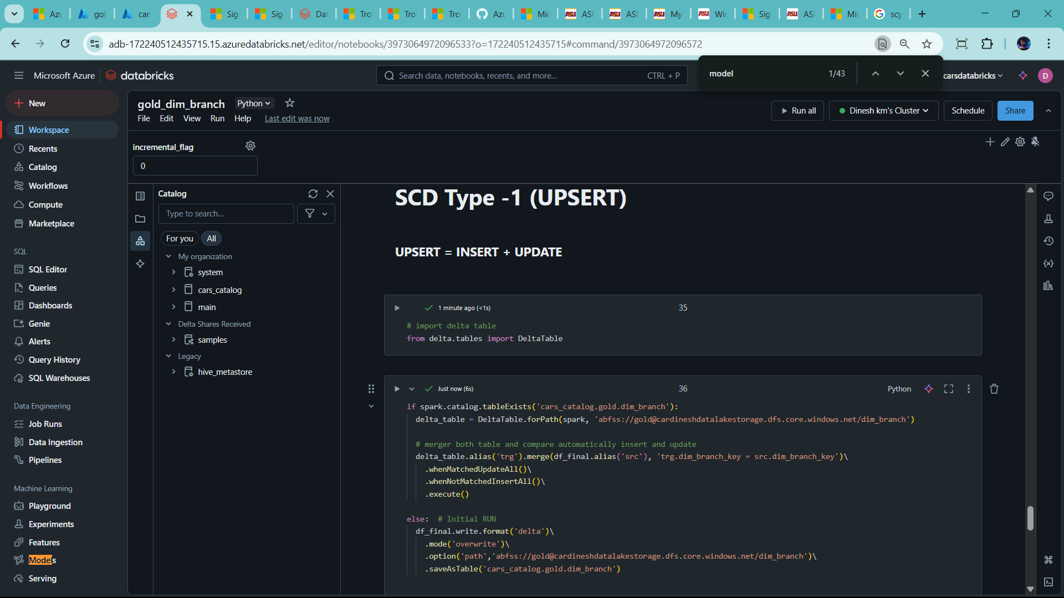

-🡪 Now Create Another Dimension table – dim_dealer

🡪copy the clone the another gold_dim_branch

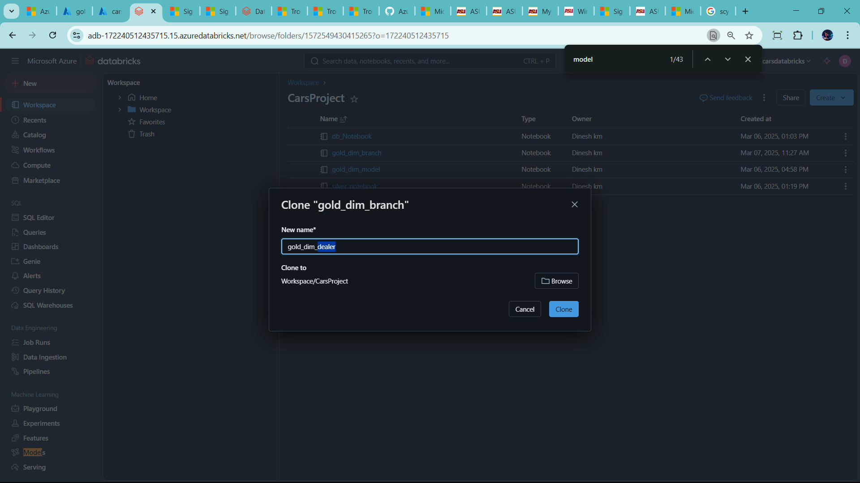

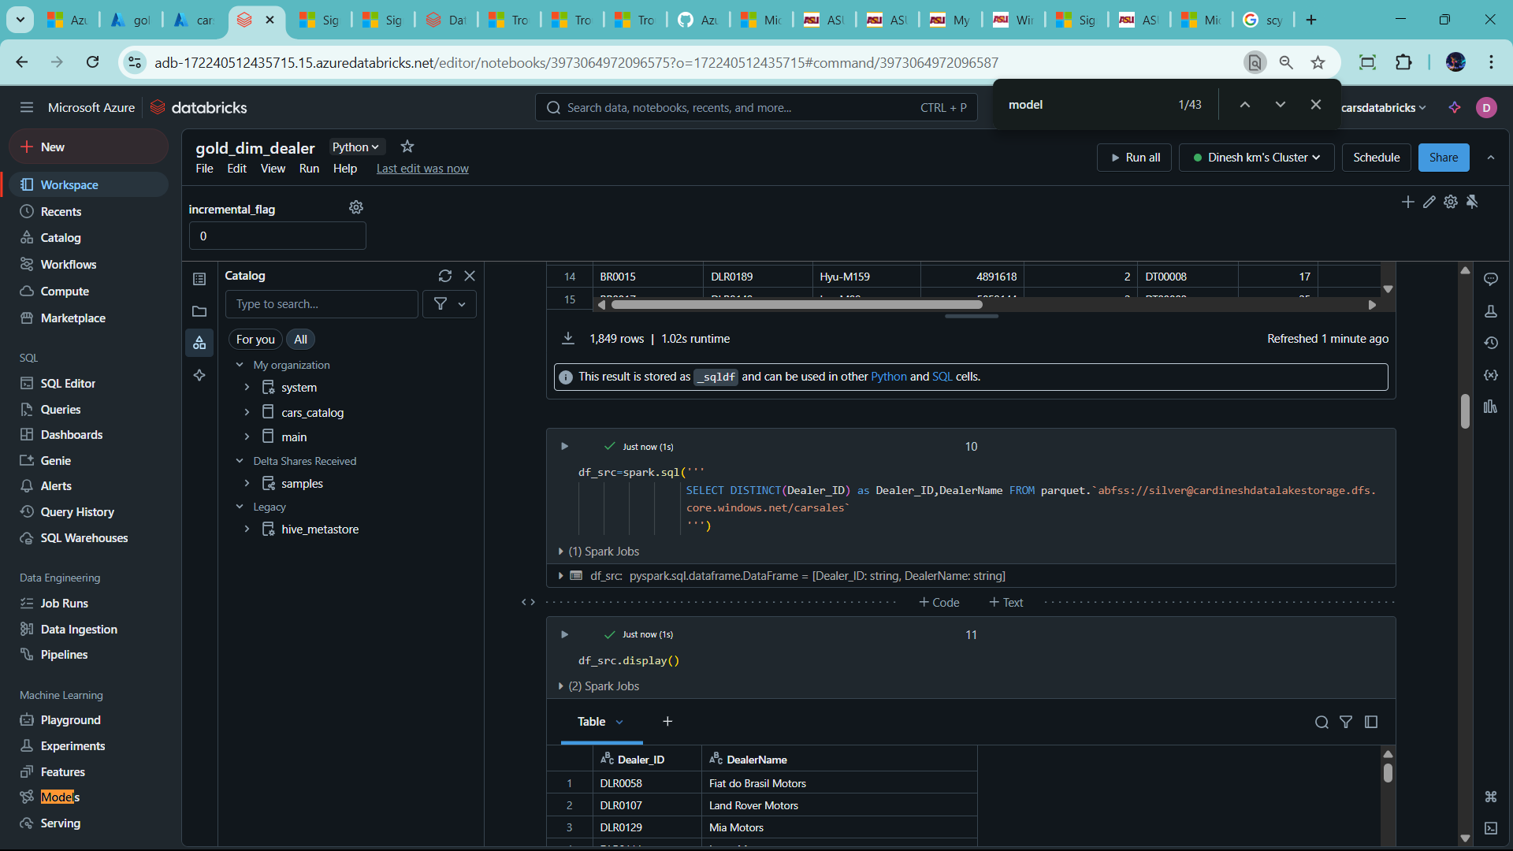

--Change dim_date as well create another clone file for dim_dealer

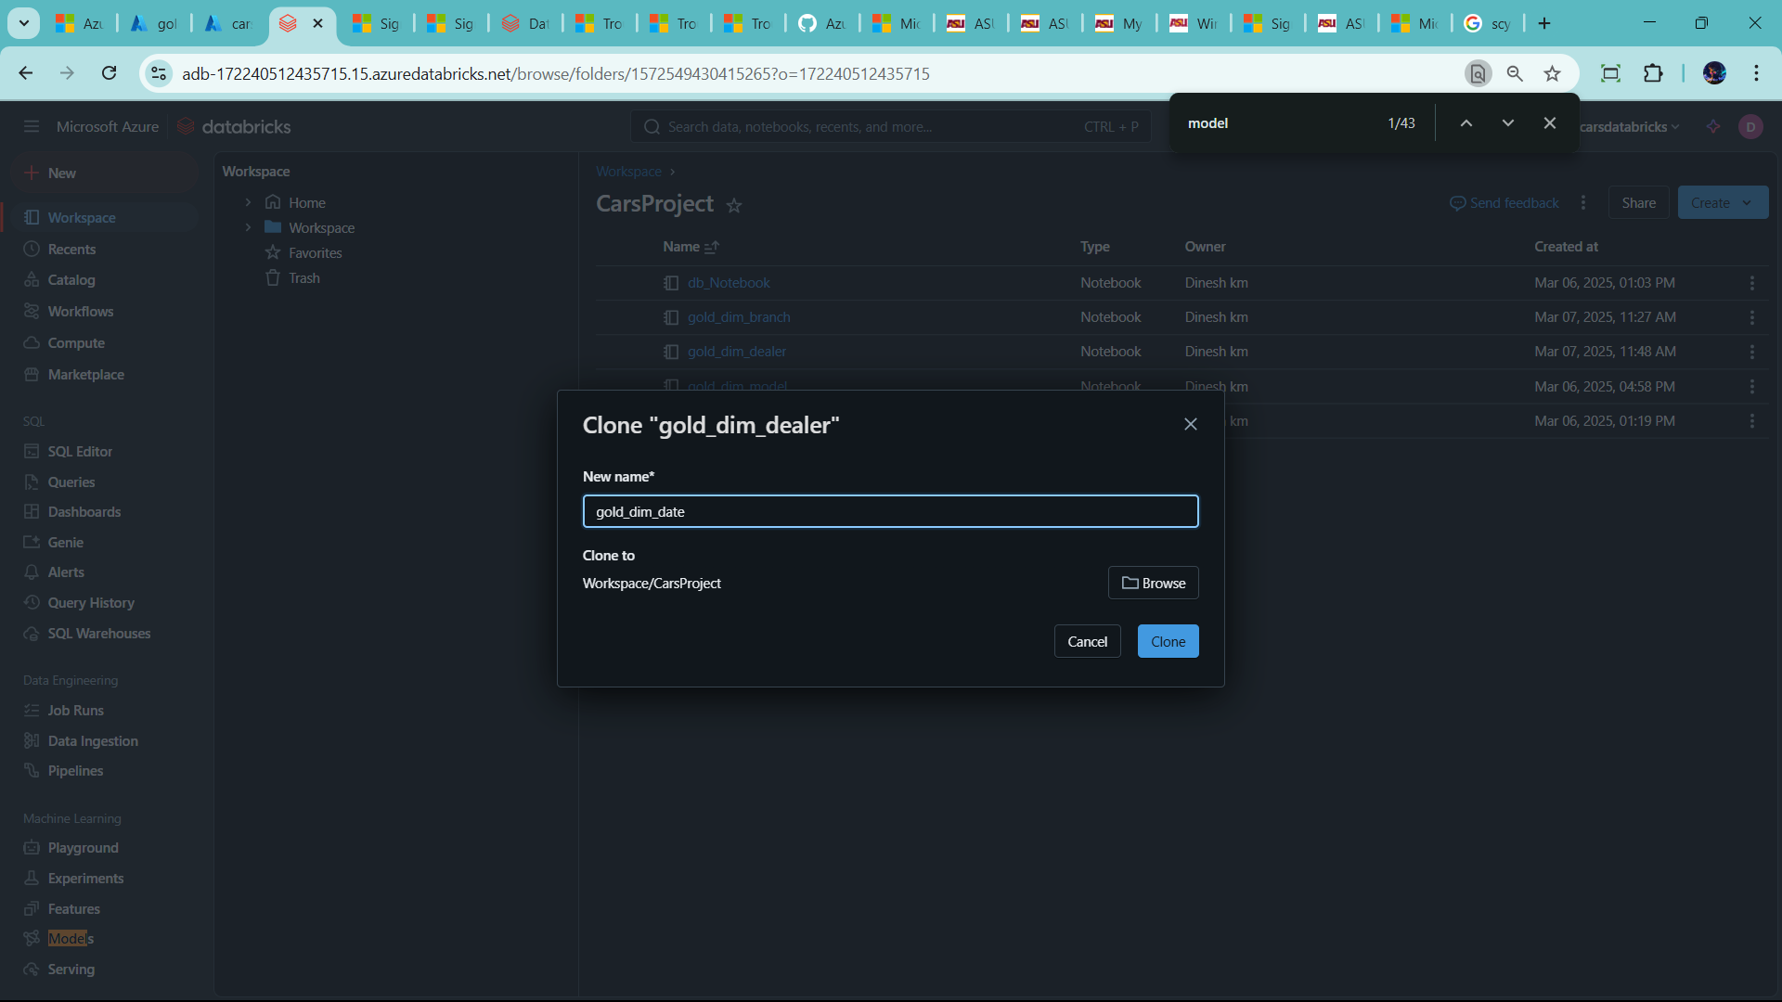

--use only one column date id

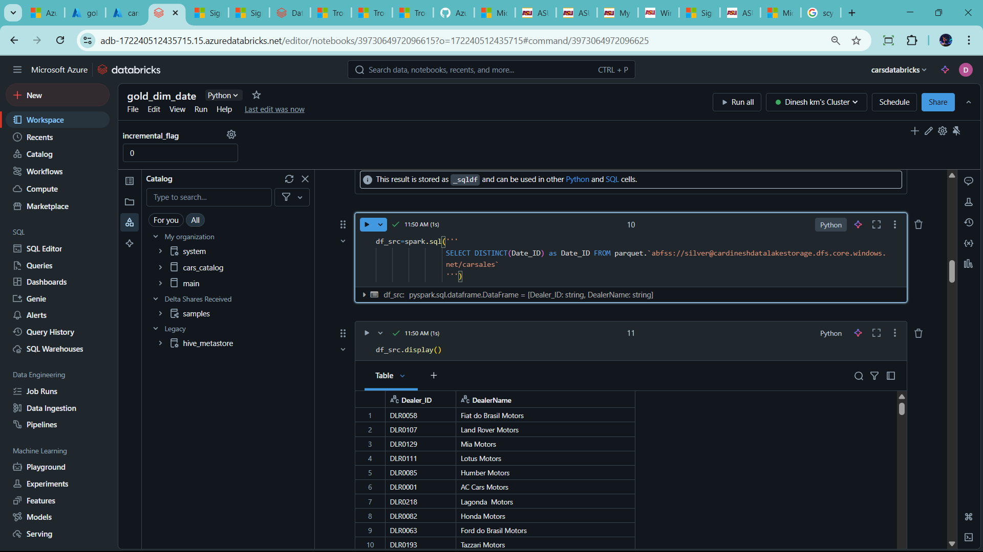

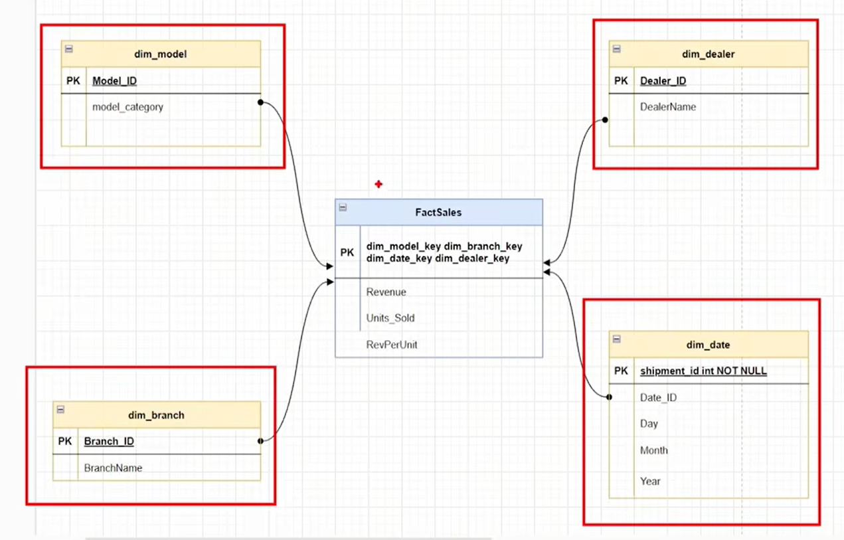

--Create all dim table as above 🡪 now create Fact table

🡪 create new notebook 🡪 name as gold_fact_sales

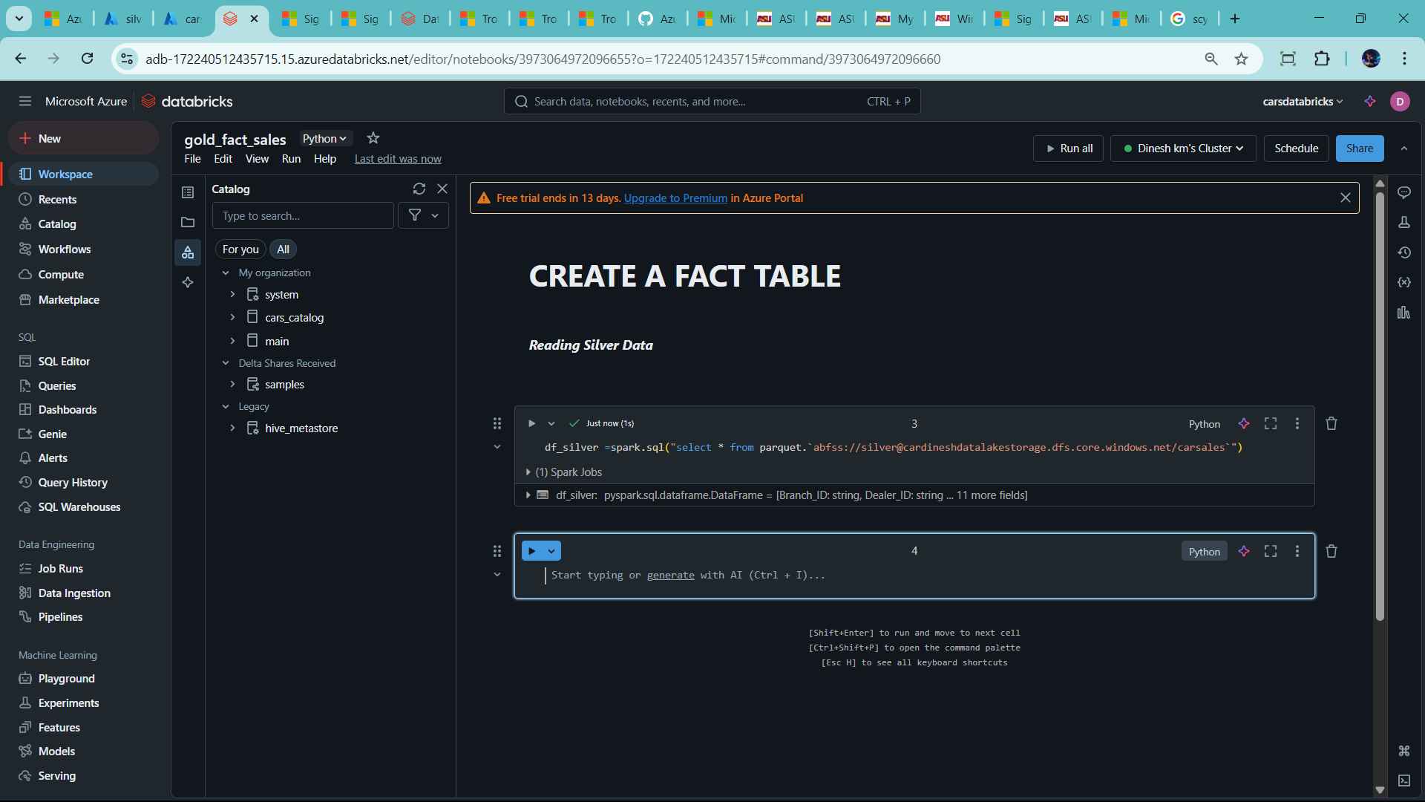

🡪retrvie the source data/silver

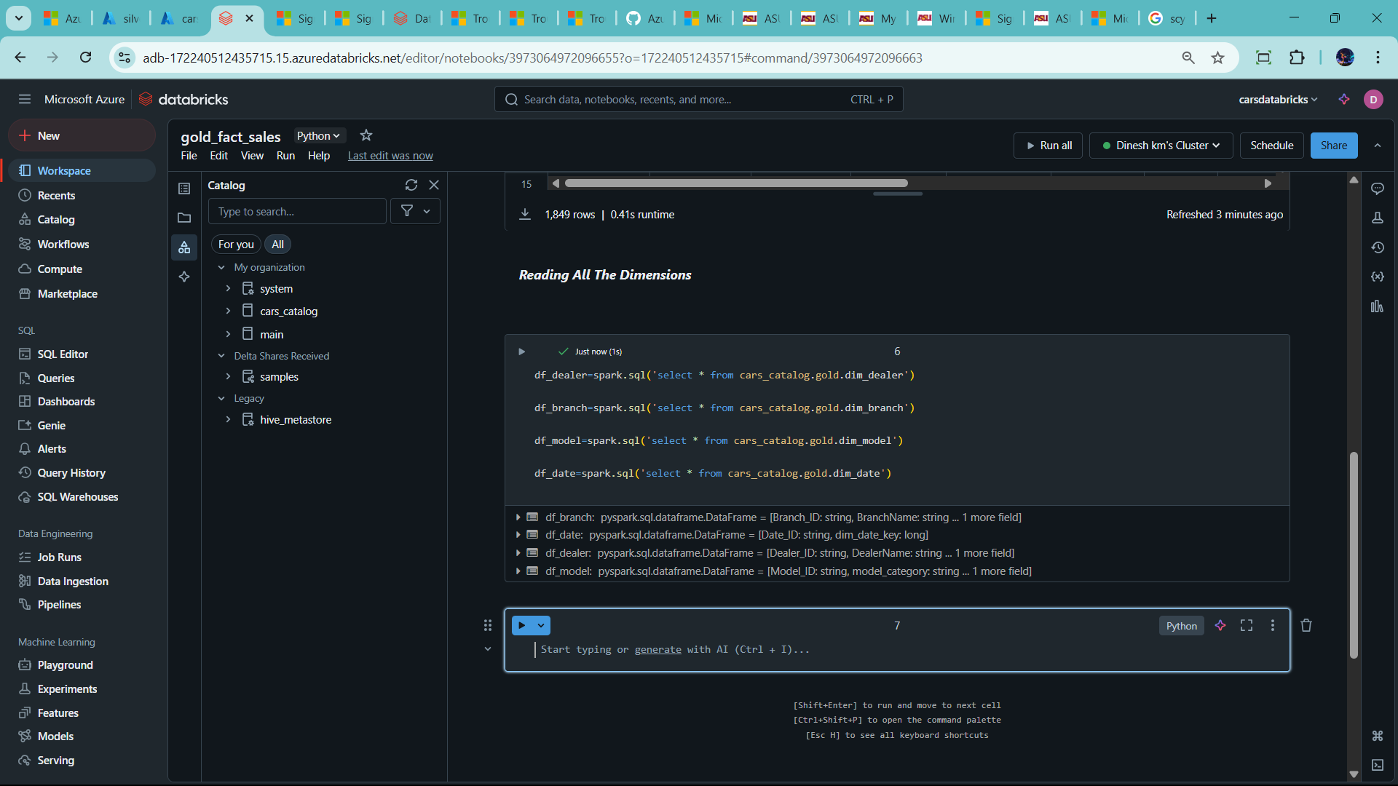

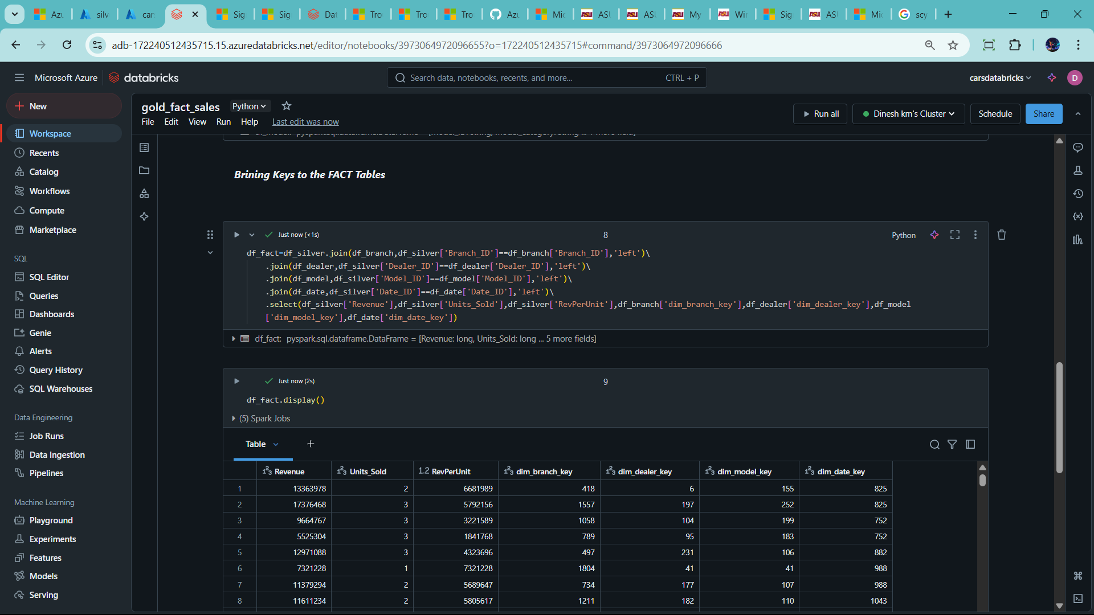

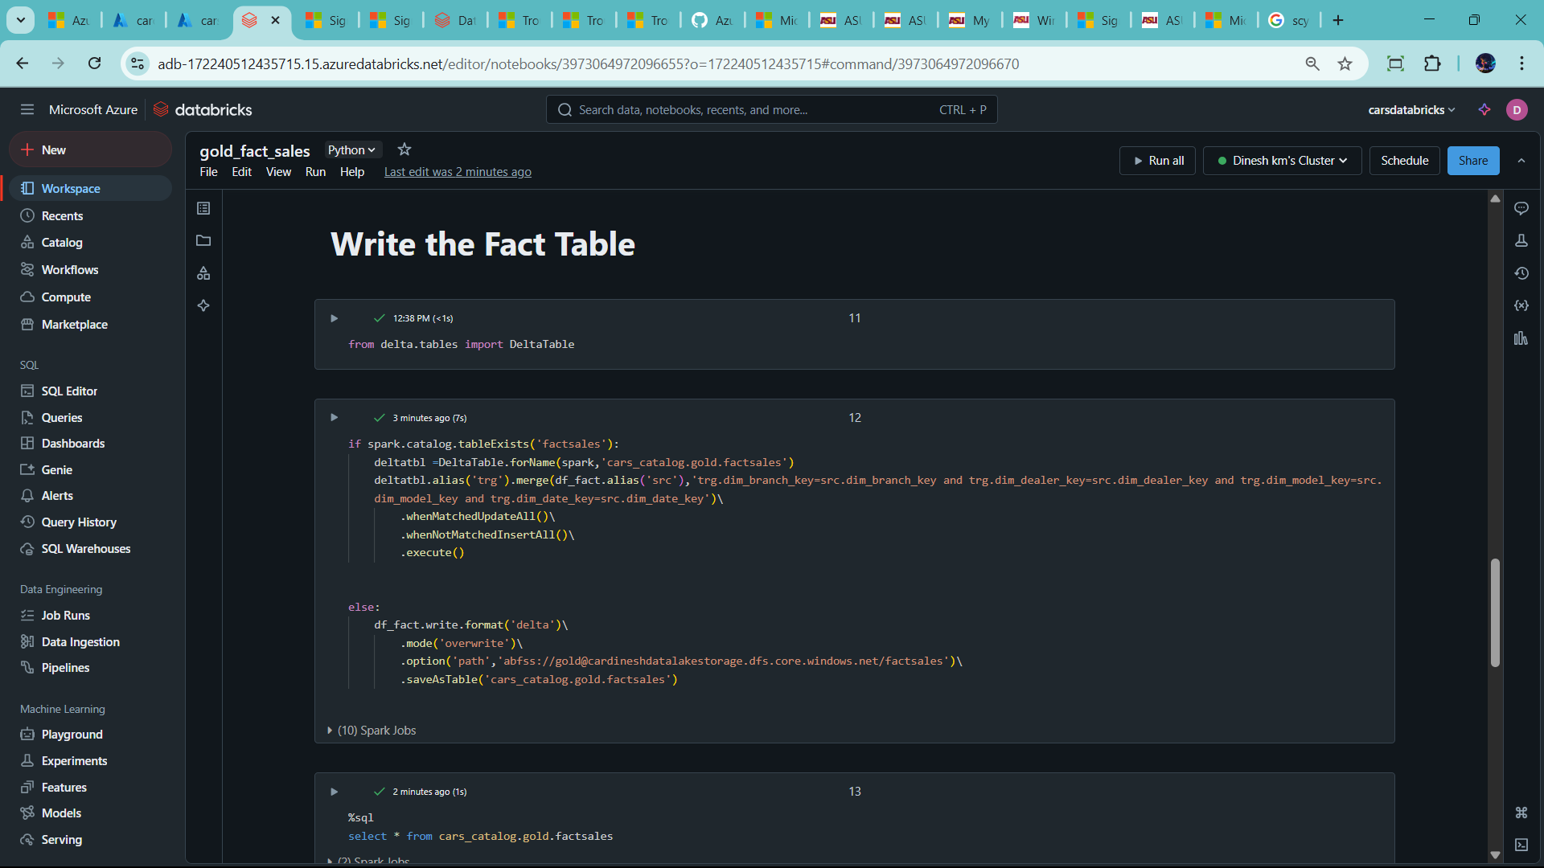

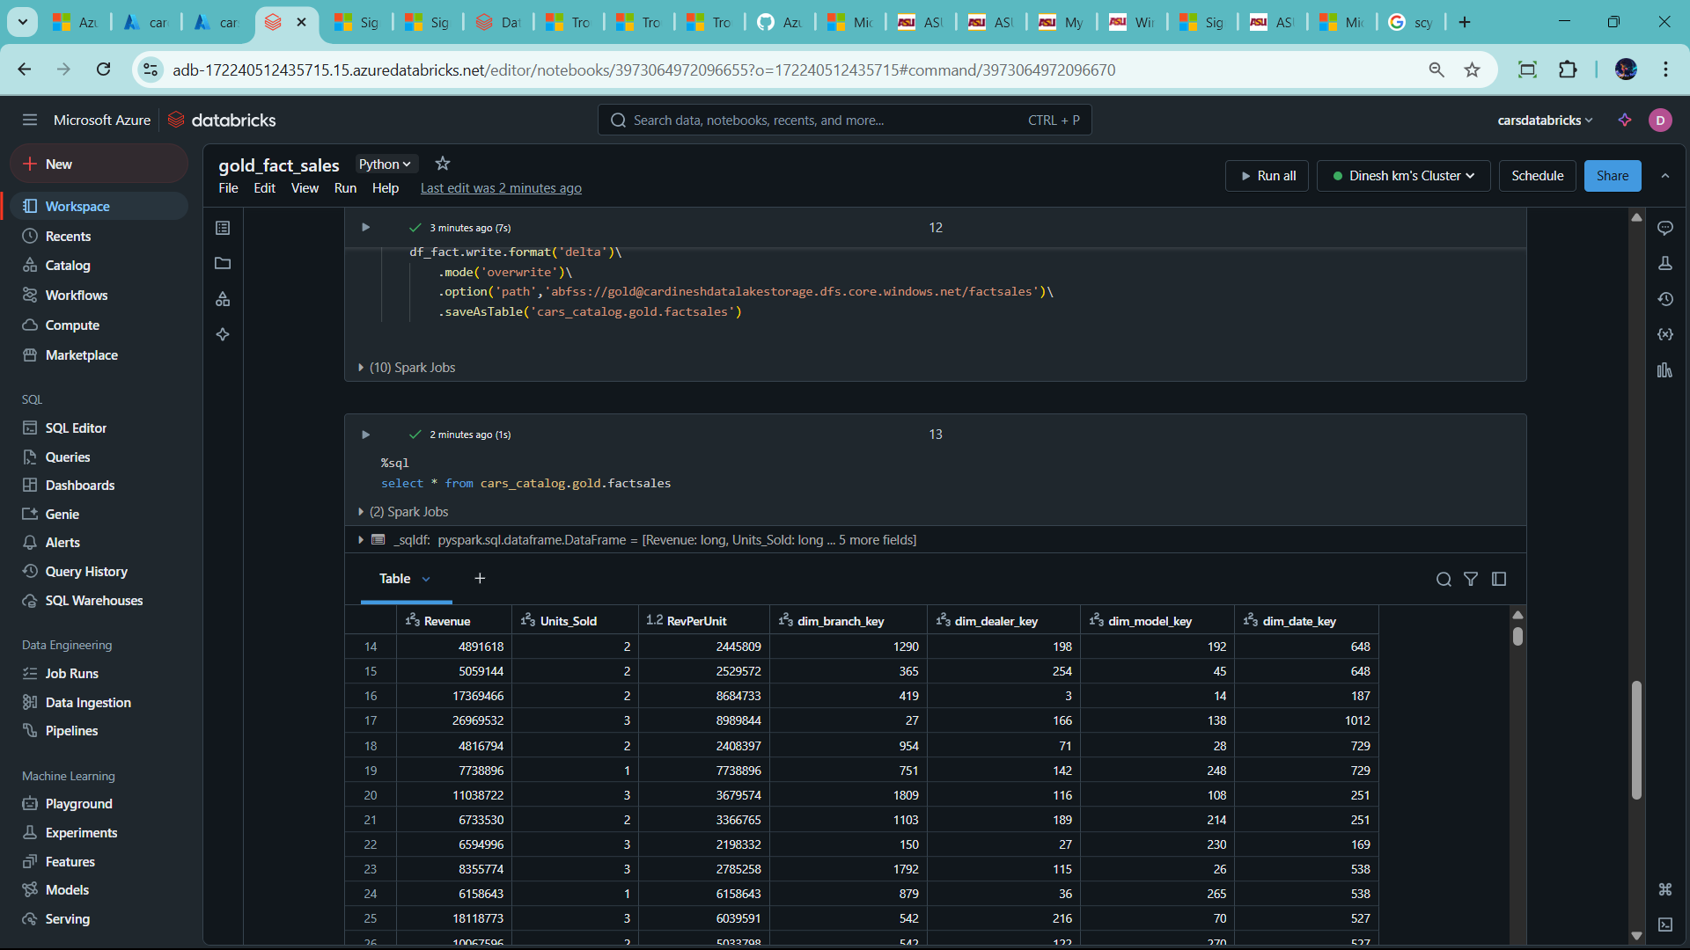

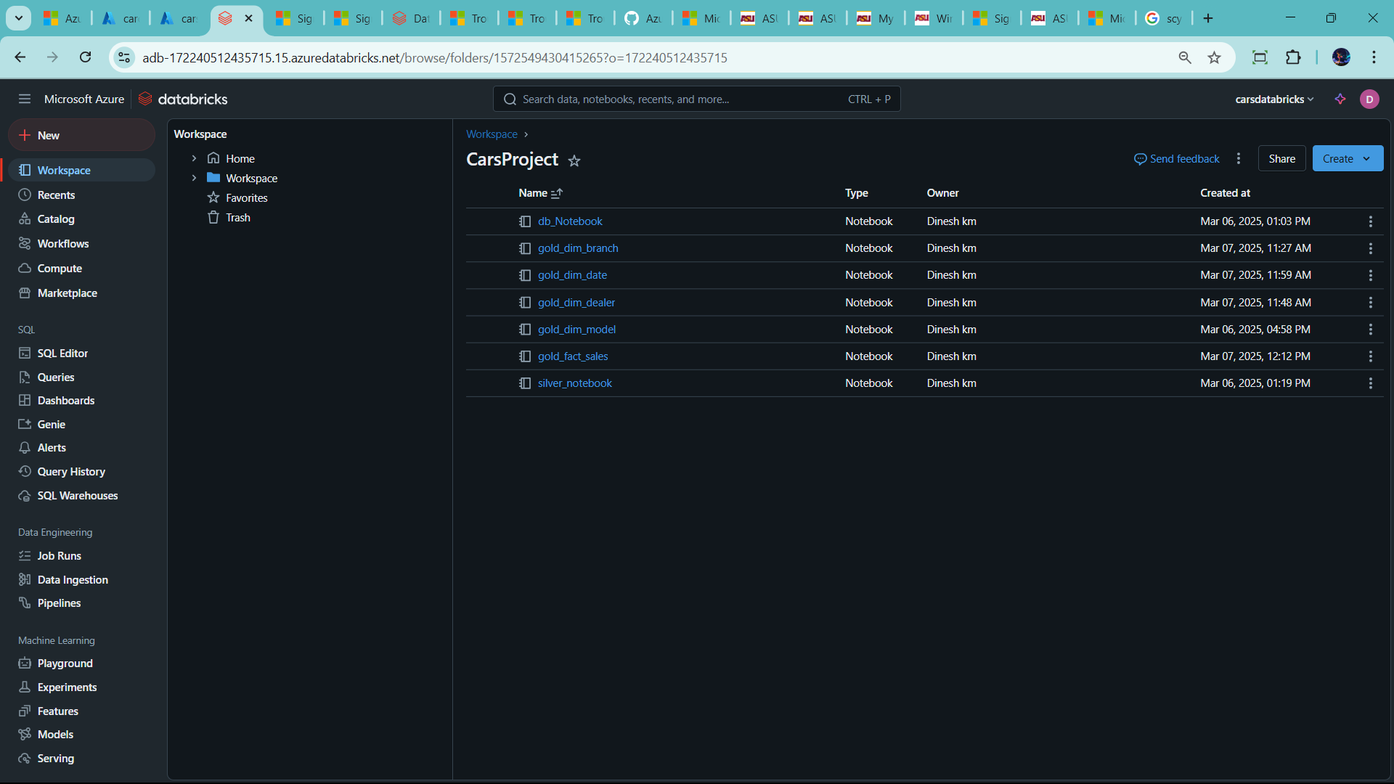

**🡪Now Create WorkFlow in DataBricks**

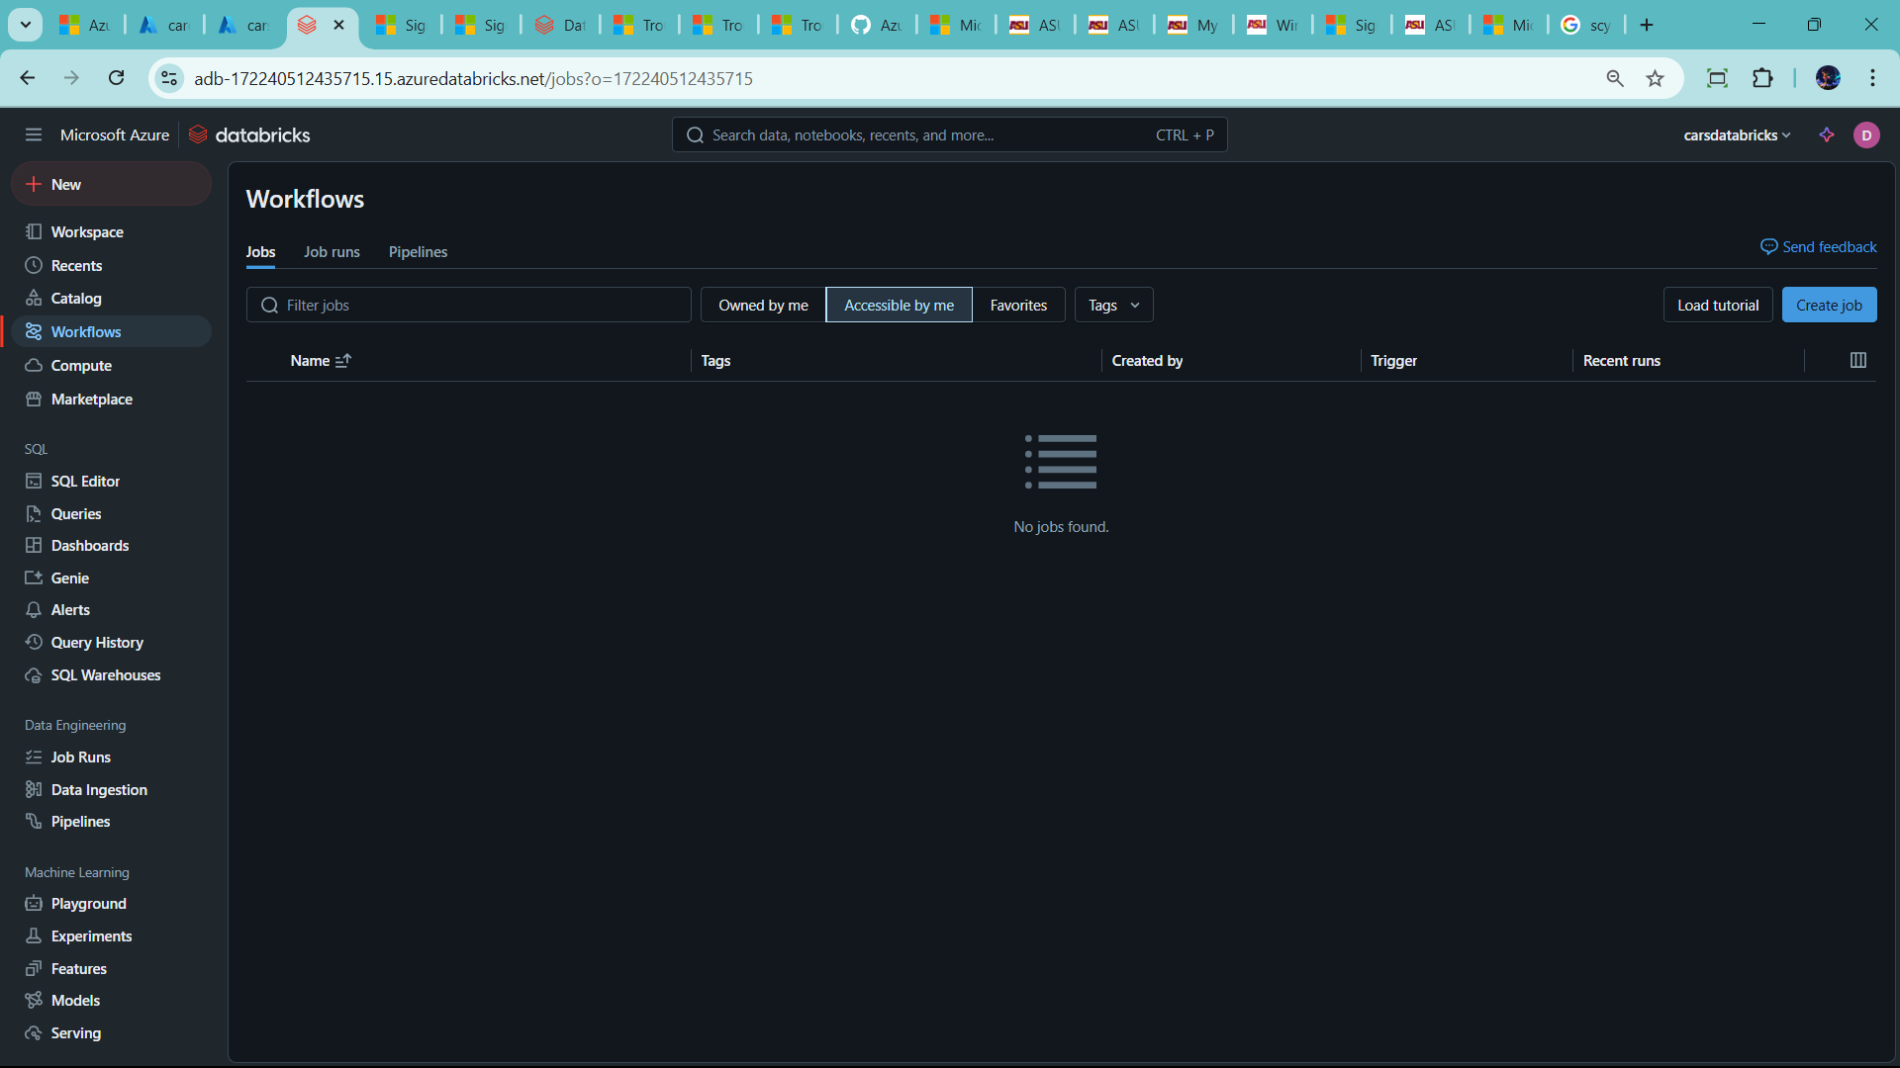

* **Create job**

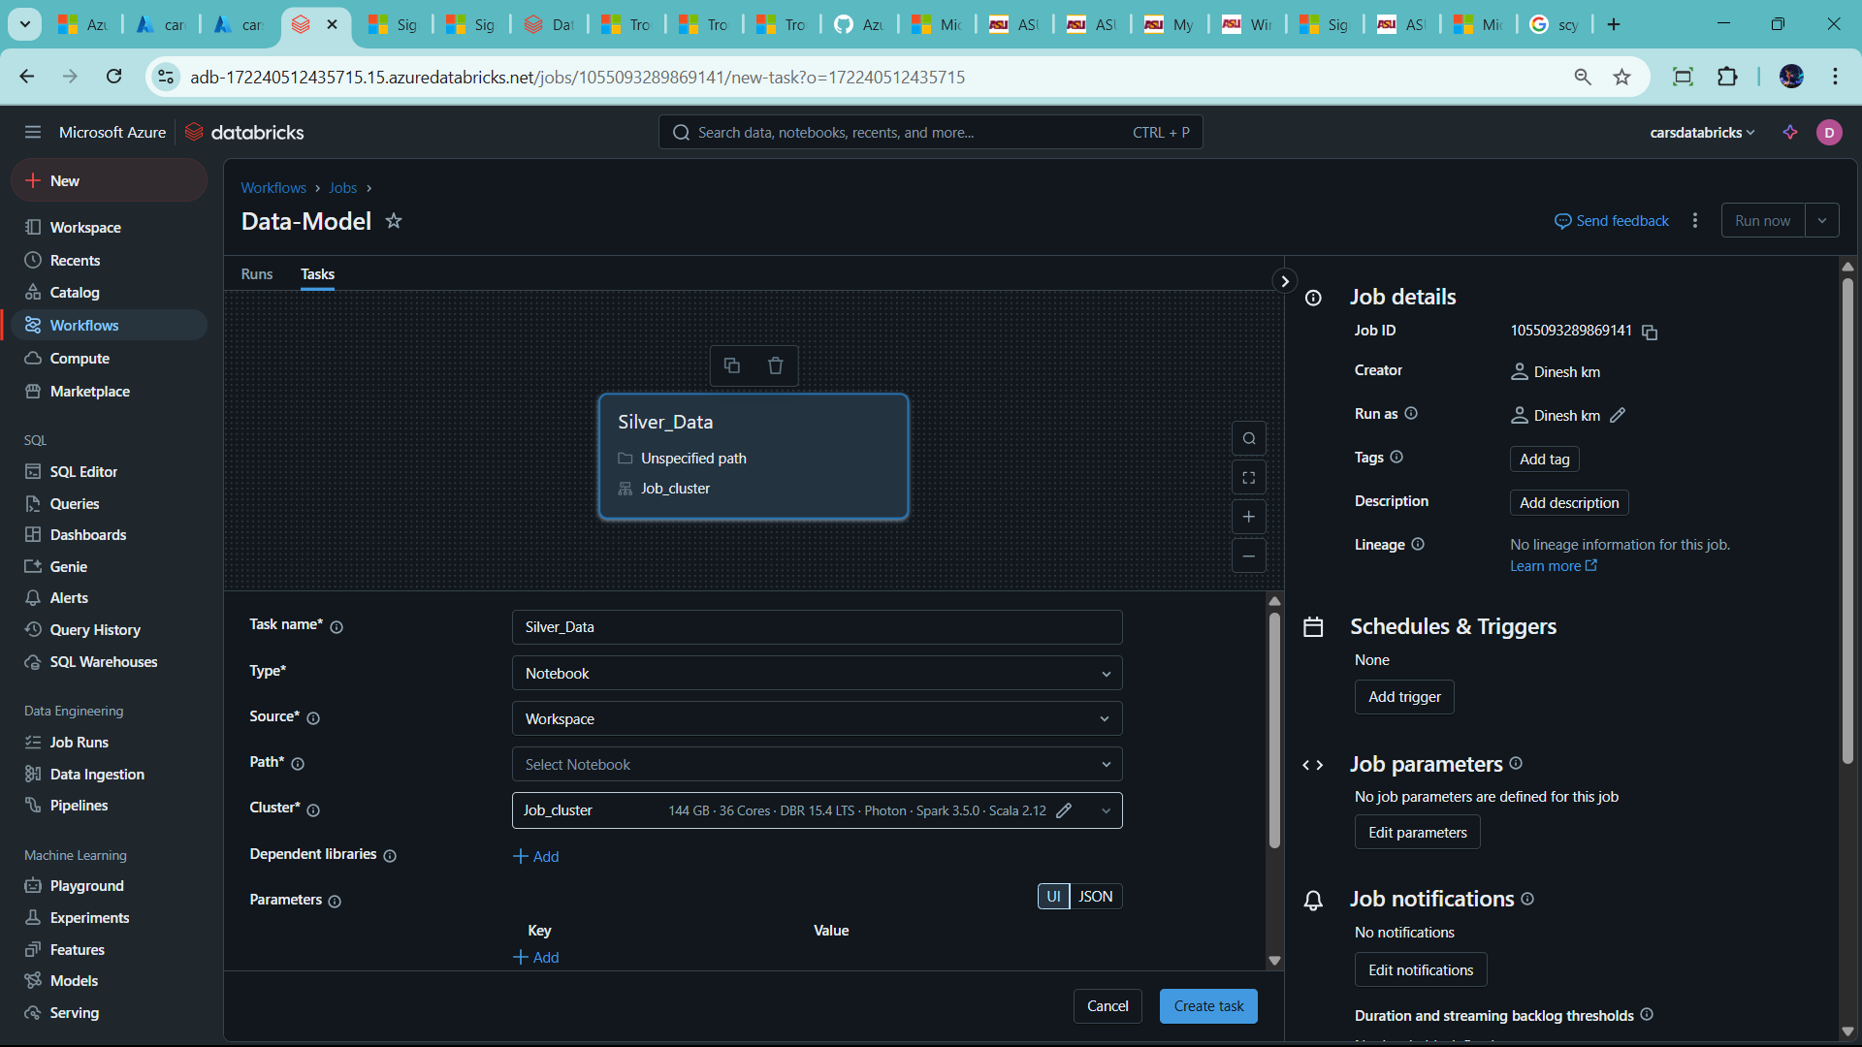

🡪name as Data-model

* Task name – Silver_data
* Click path – choose silver_notebook

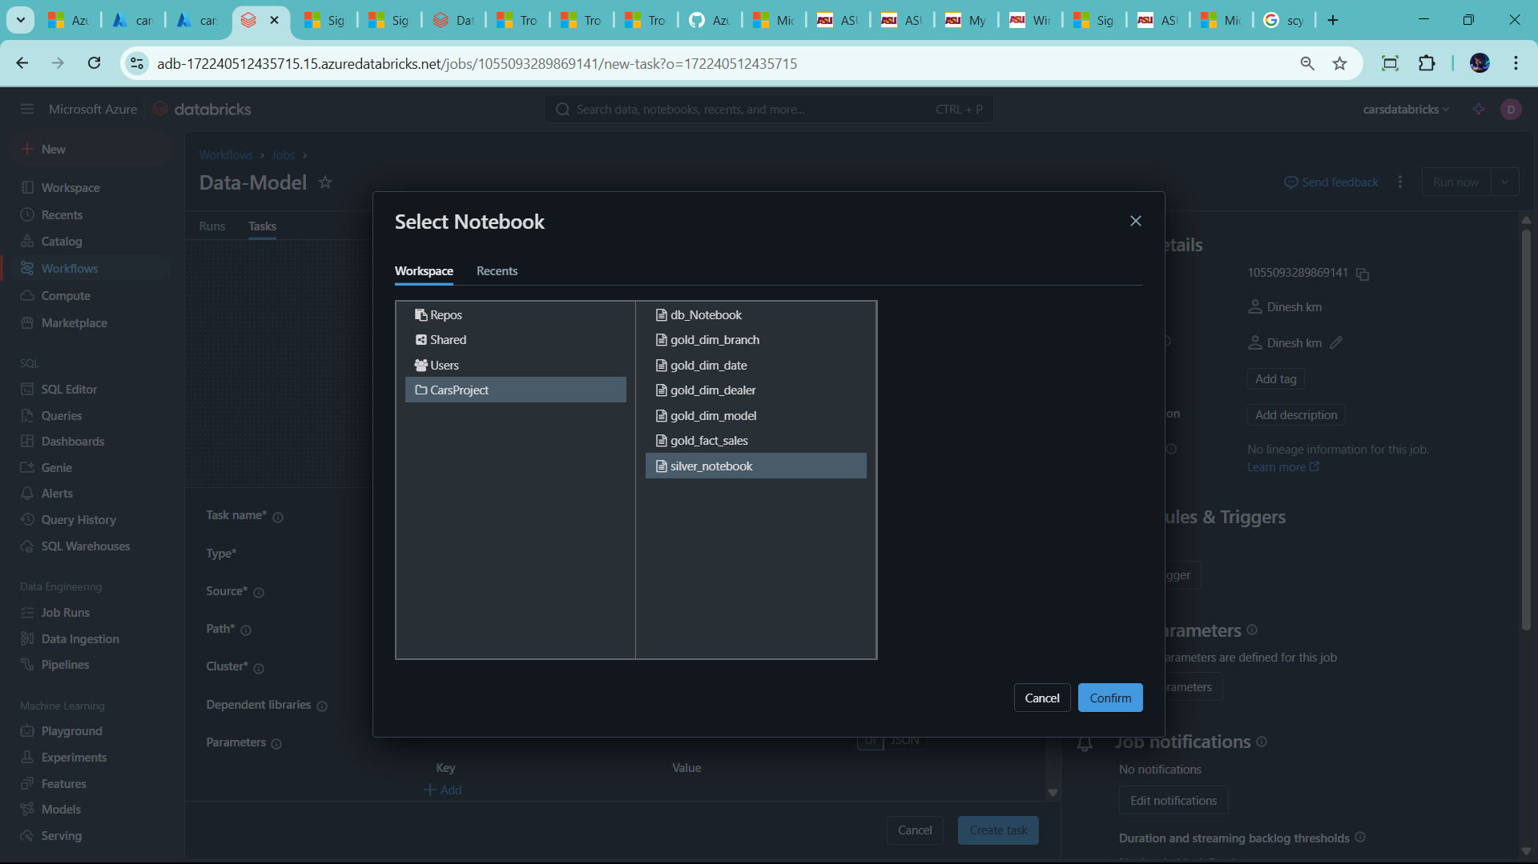

🡪chose cluse as well

🡪click create task

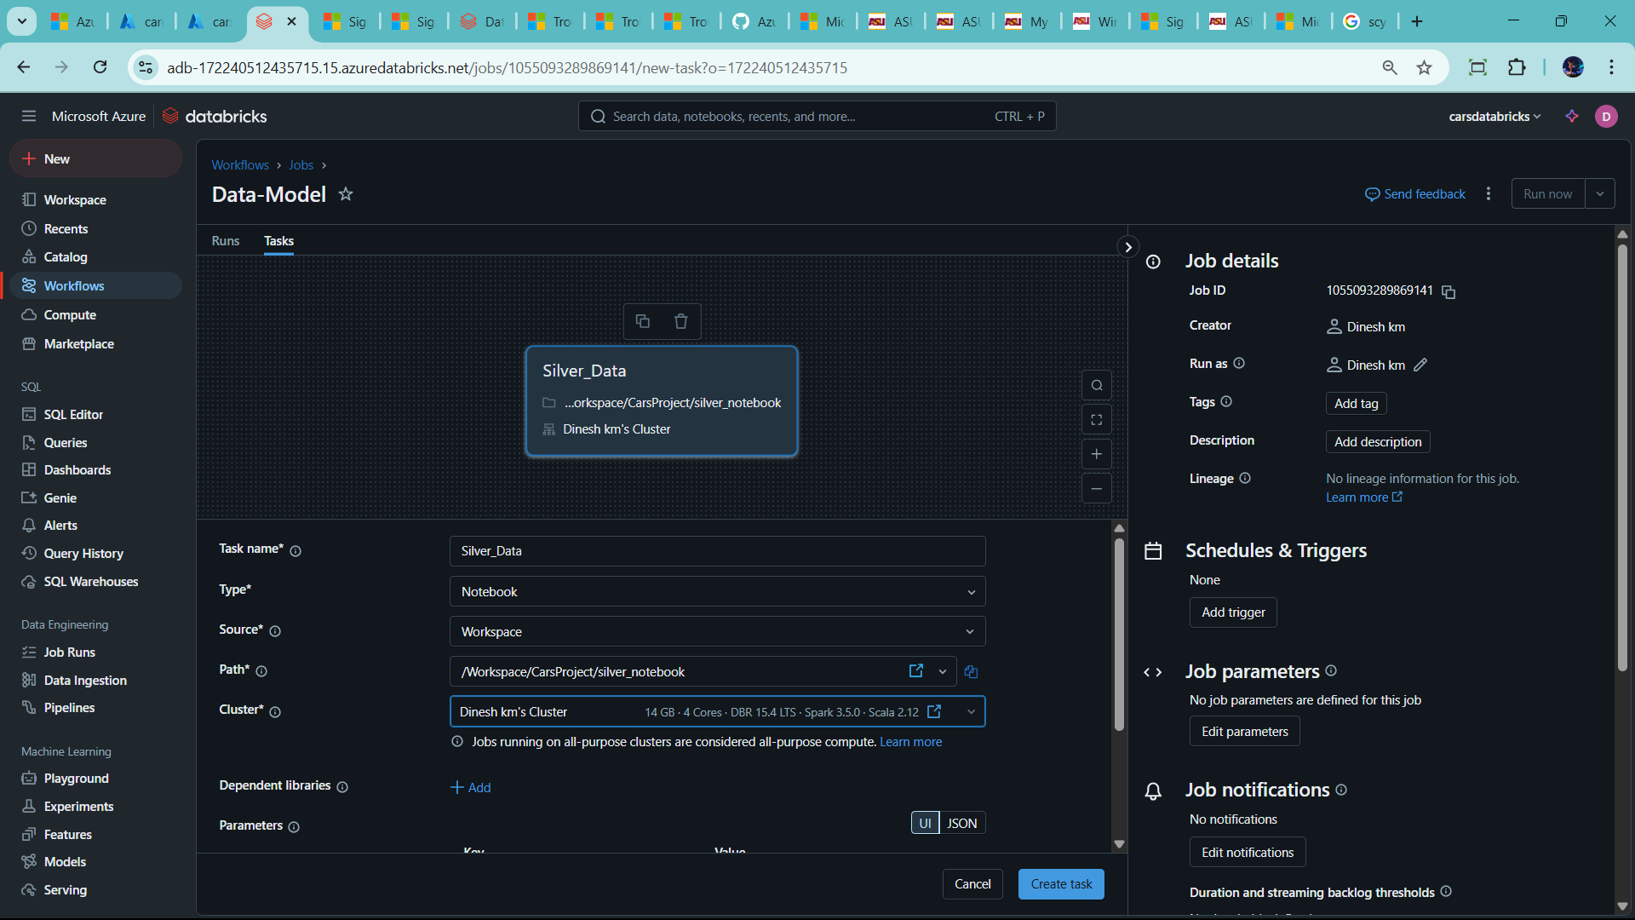

--click add task dim model

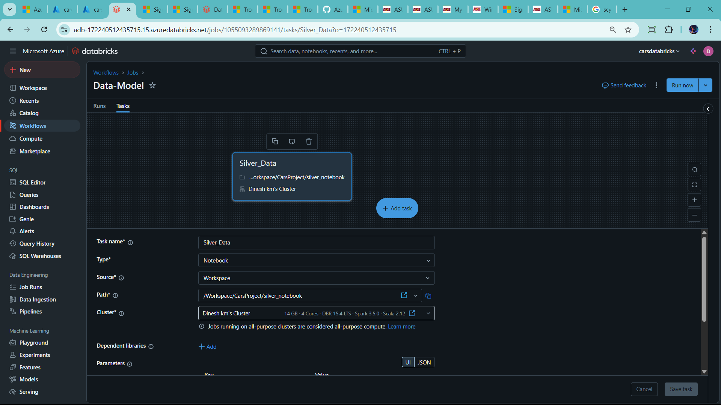

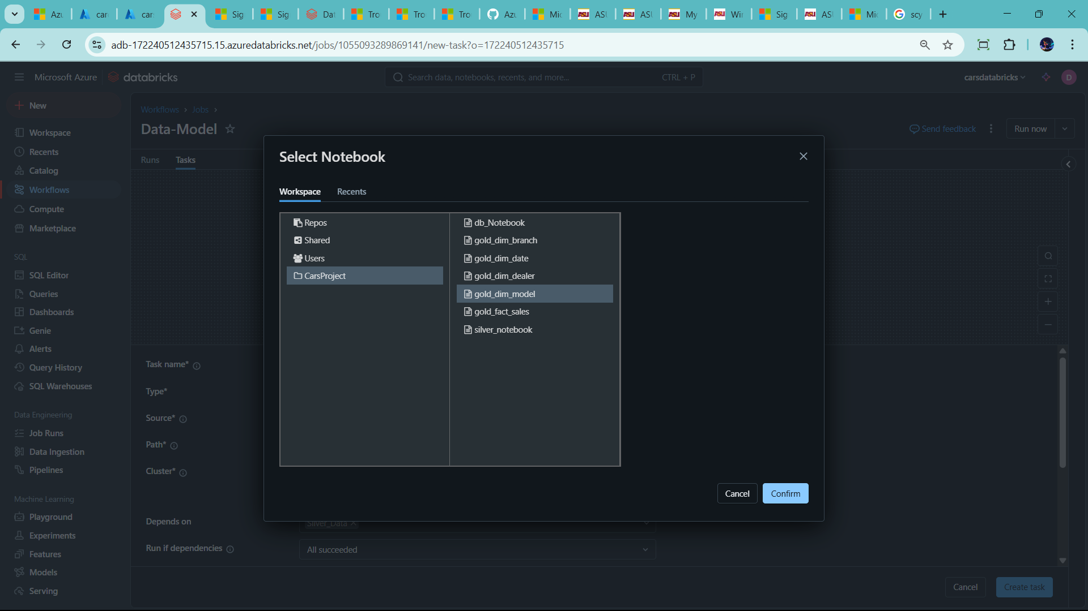

🡪add parameter 🡪incremental_flag

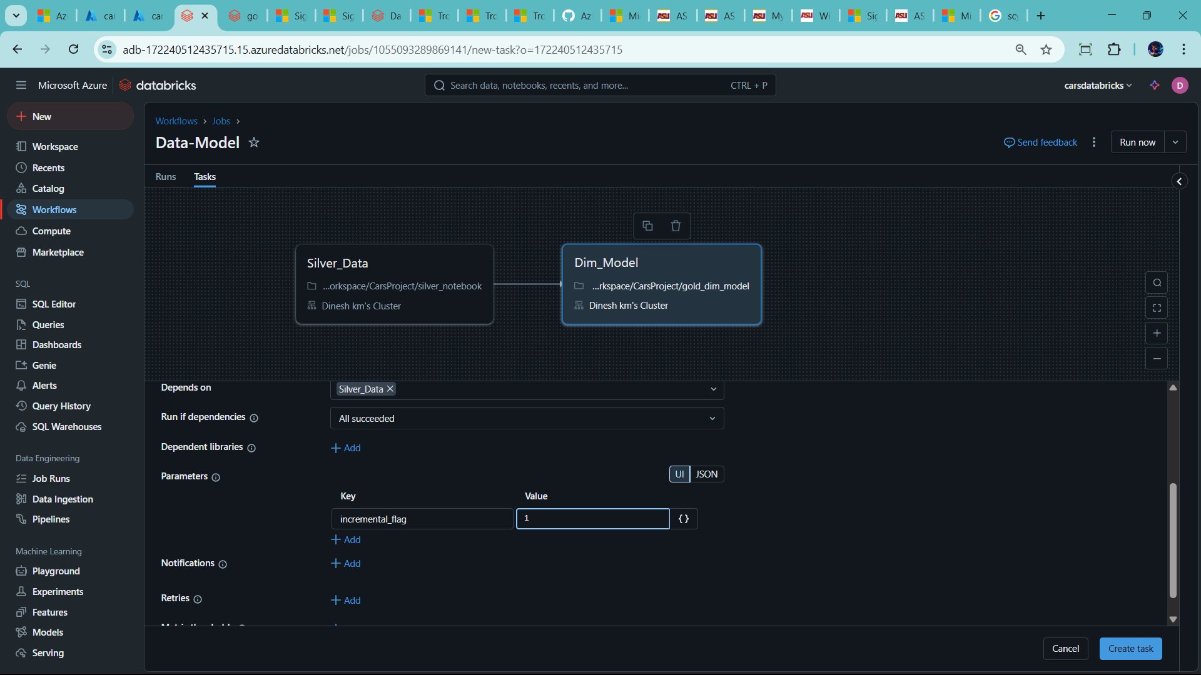

--click create

🡪same as other Dim assign task

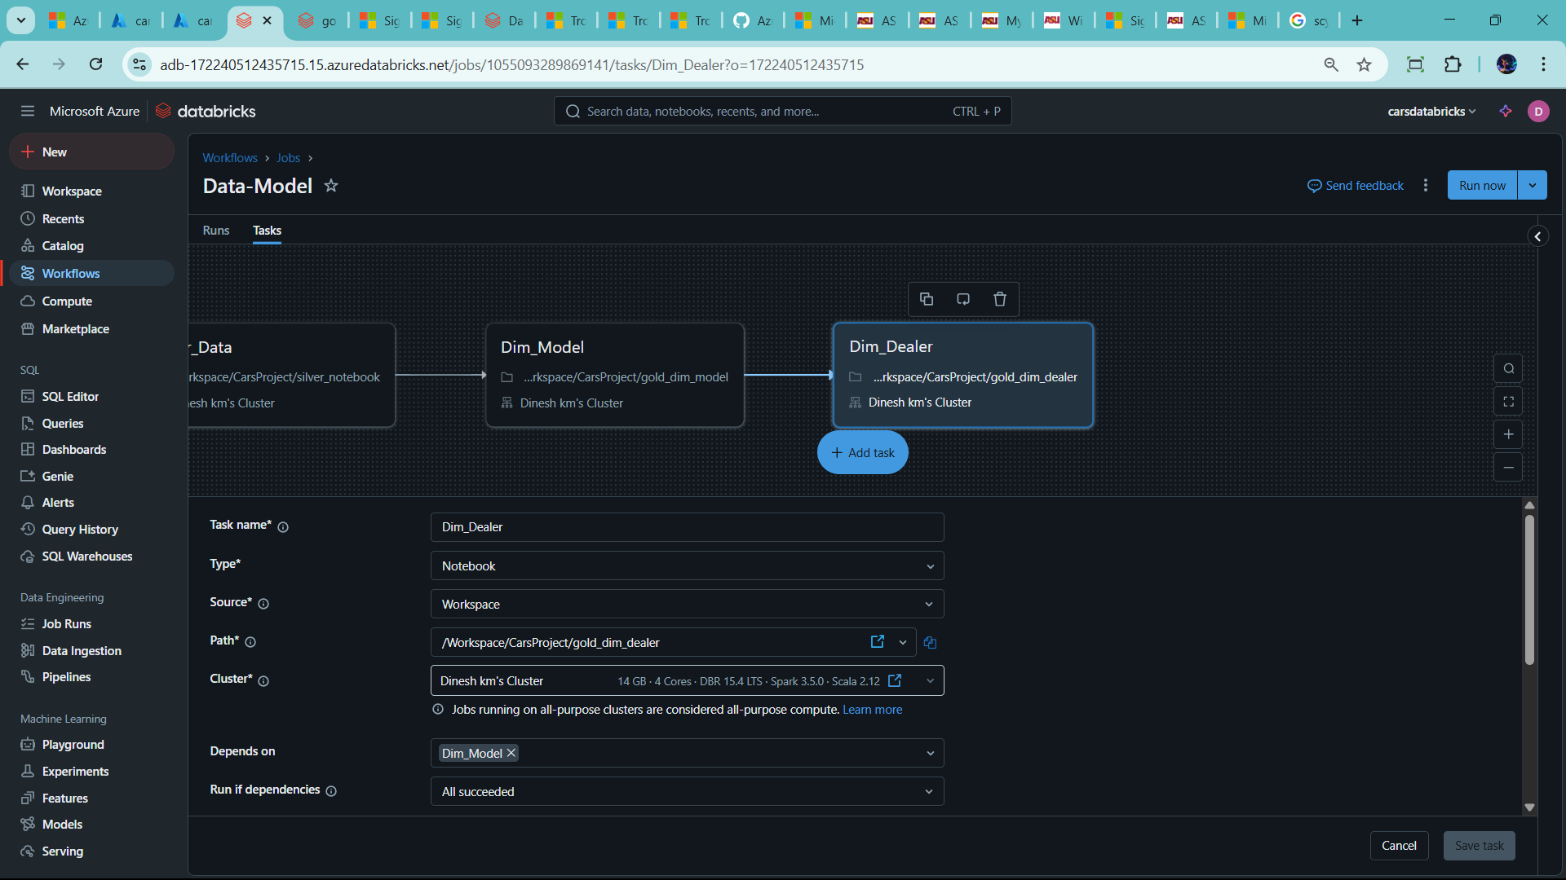

--create another task Dim_Branch

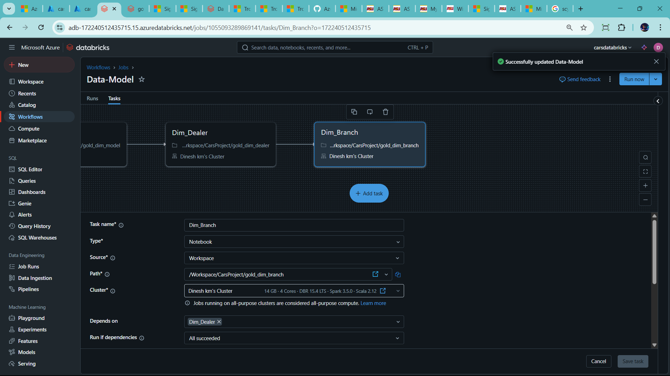

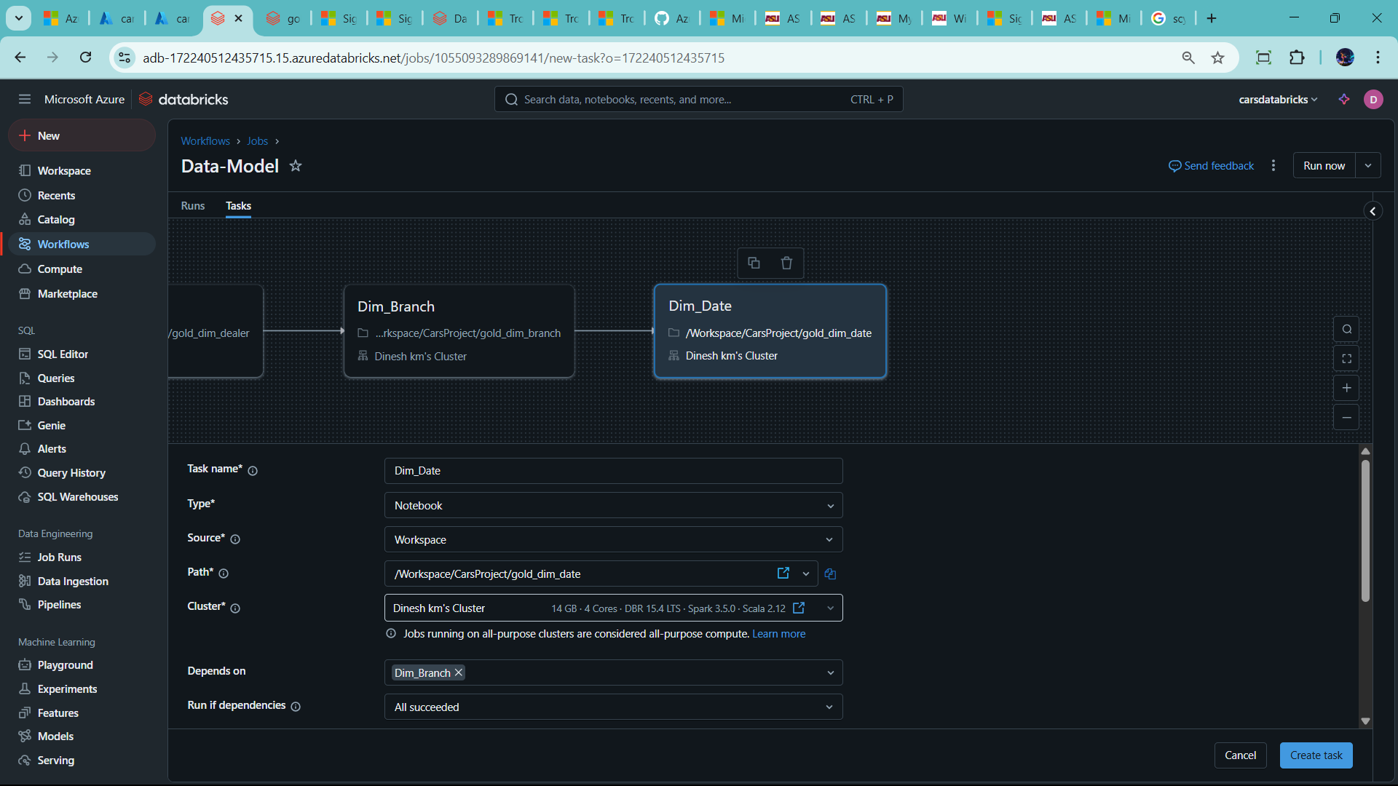

--Create task as fact_sales notebook as well

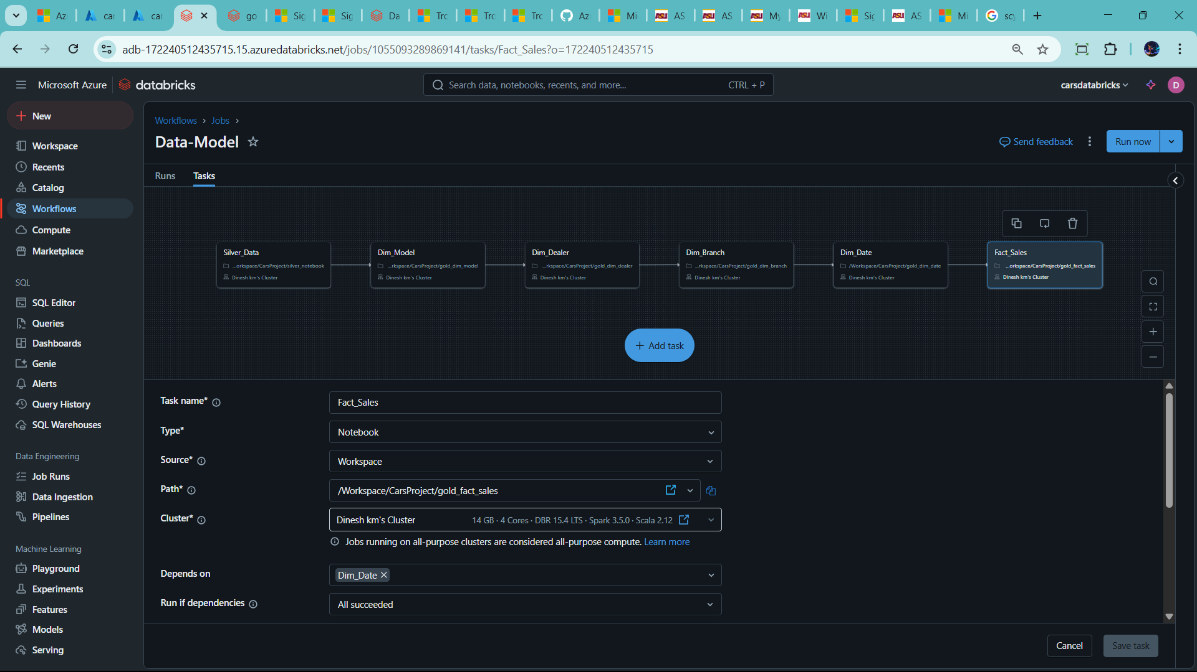

🡪I want some flow run in parallel

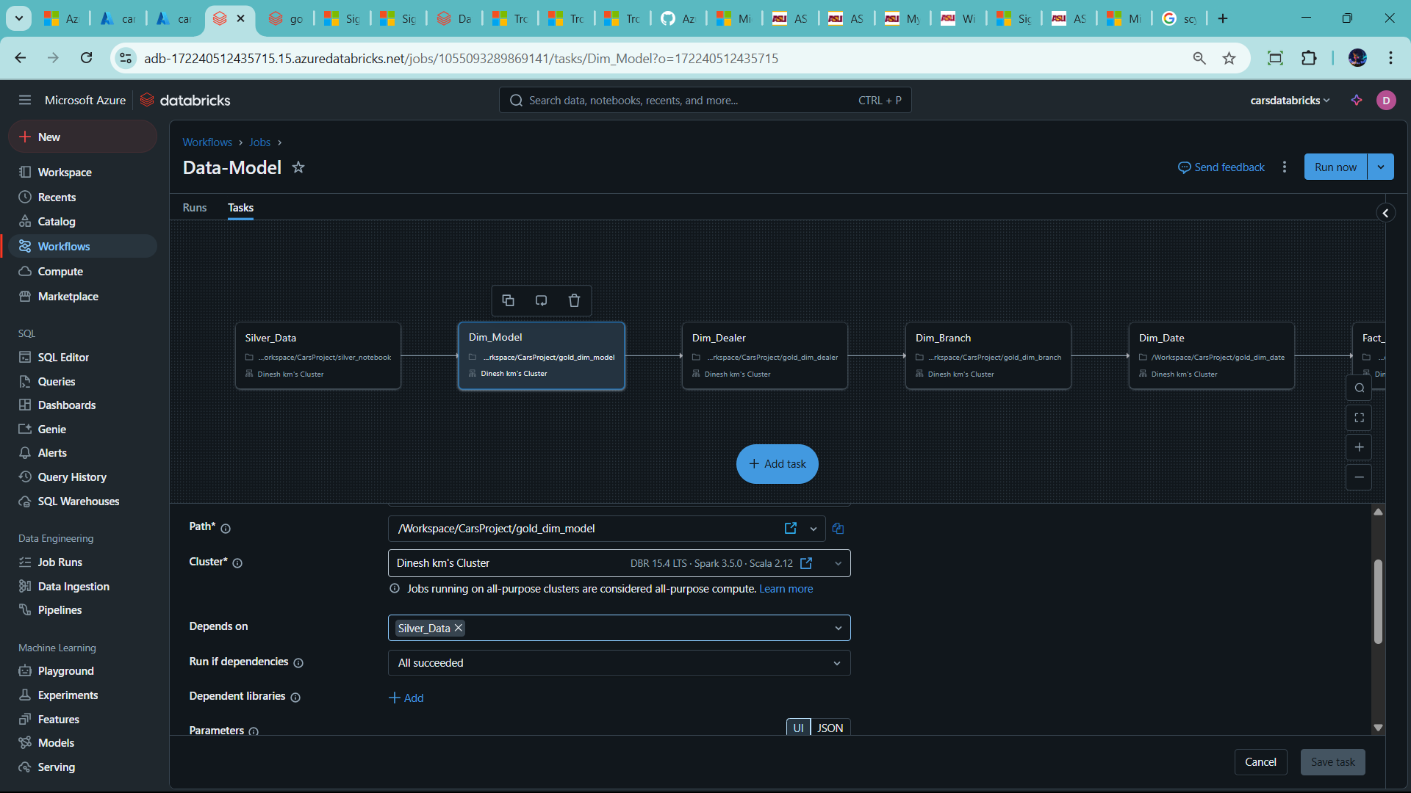

--click Depends on 🡪 choose silver data

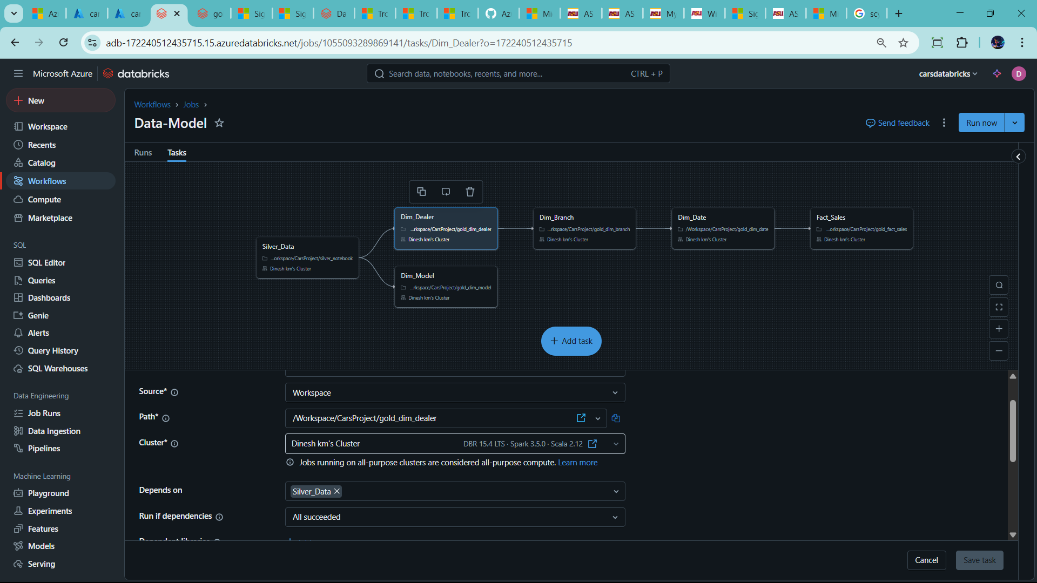

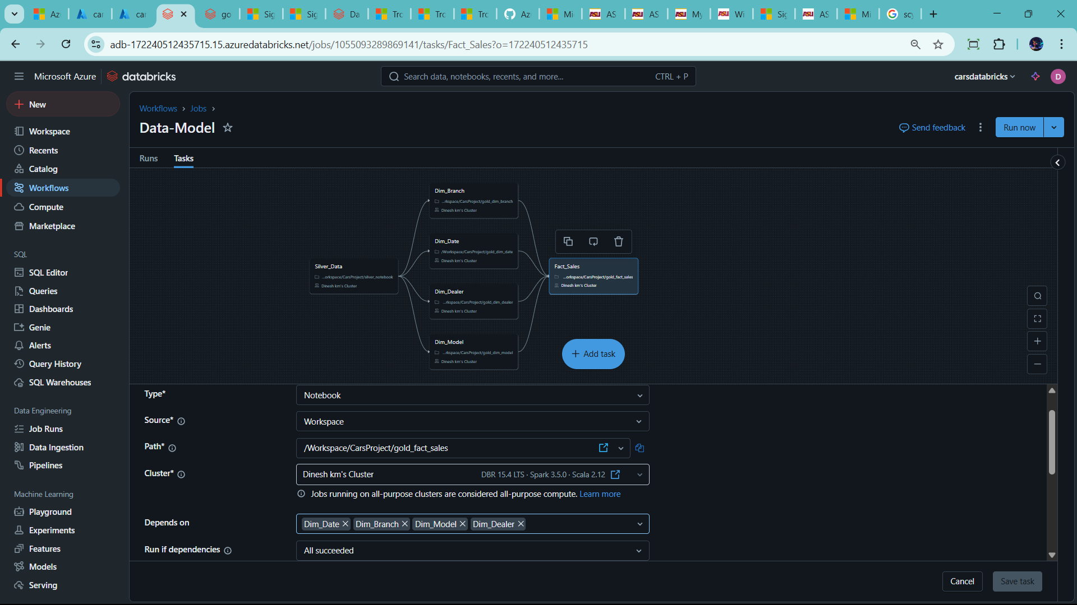🡪merge all dim task in fact task

--finally click run

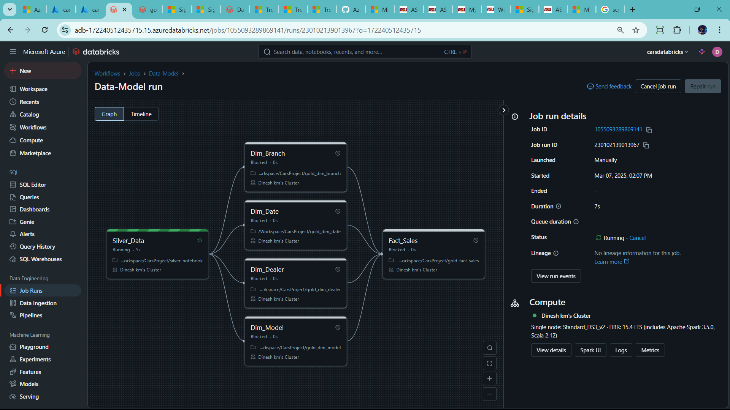

🡪go to SQL query editor check table

🡪Success

🡪Try incremental load method

Go data factory

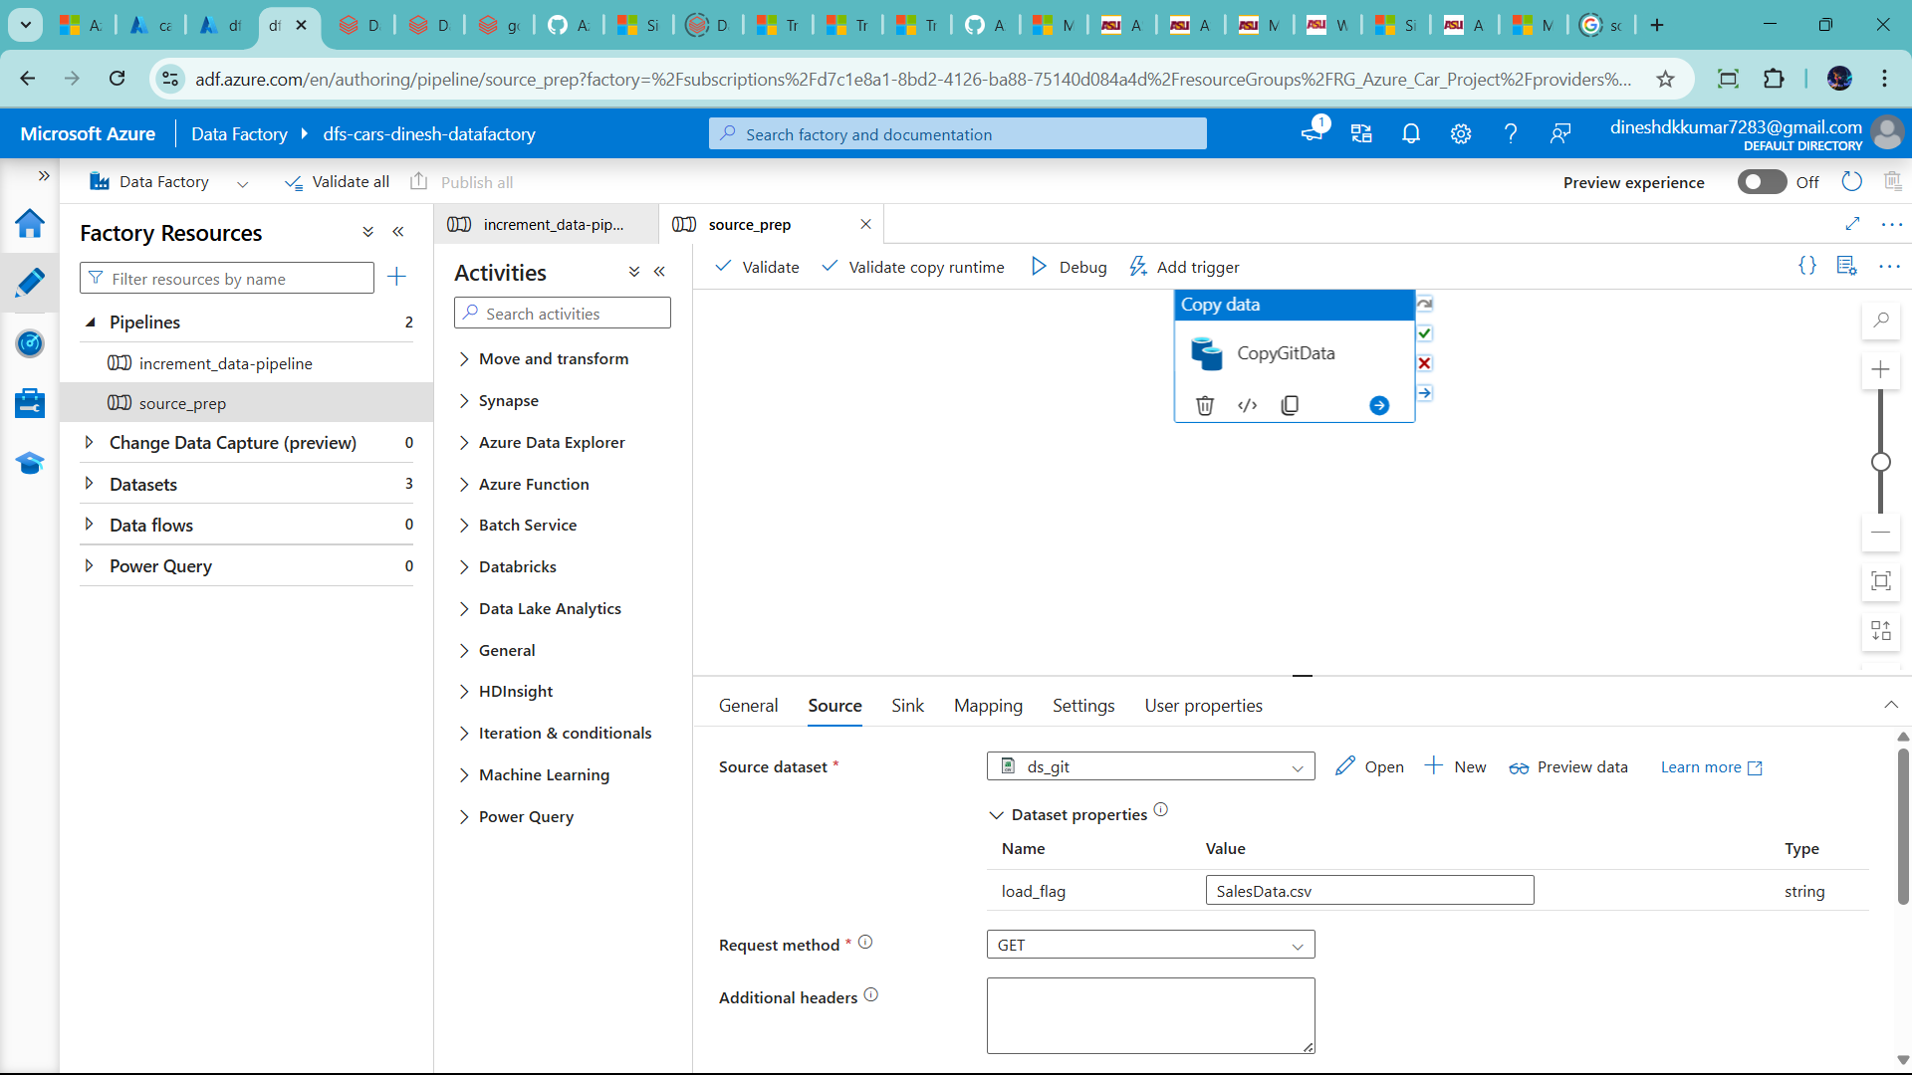

They have new data and old data with updated

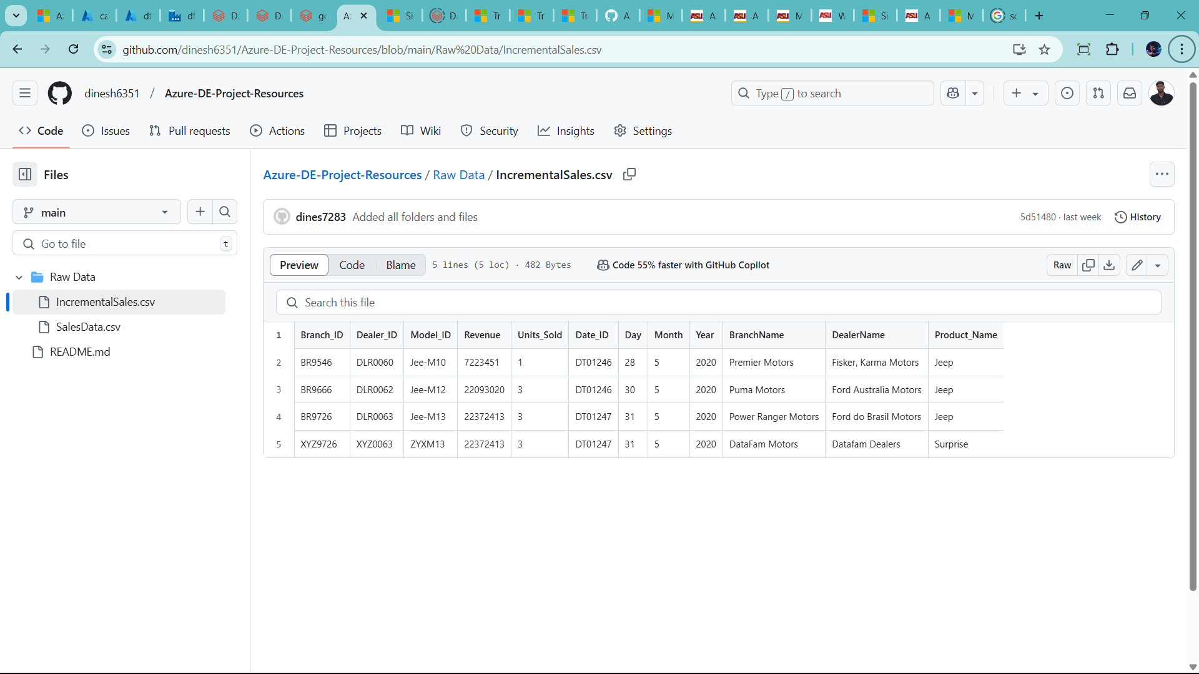

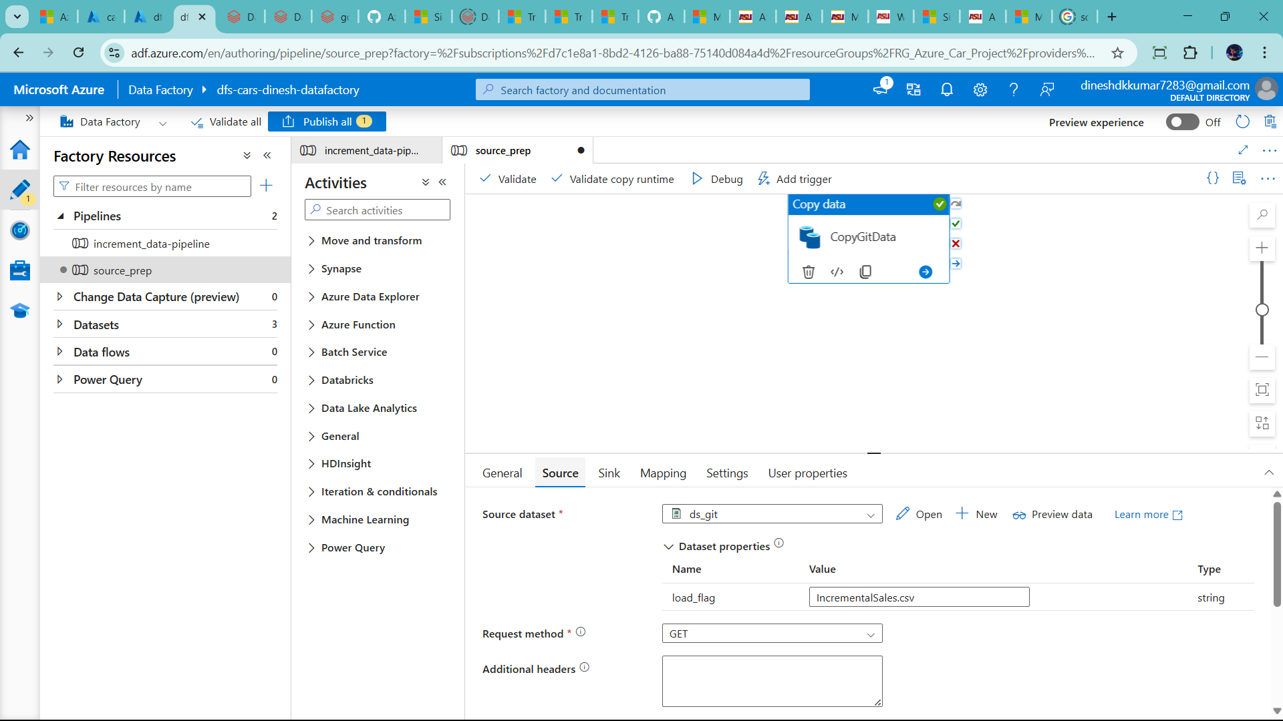

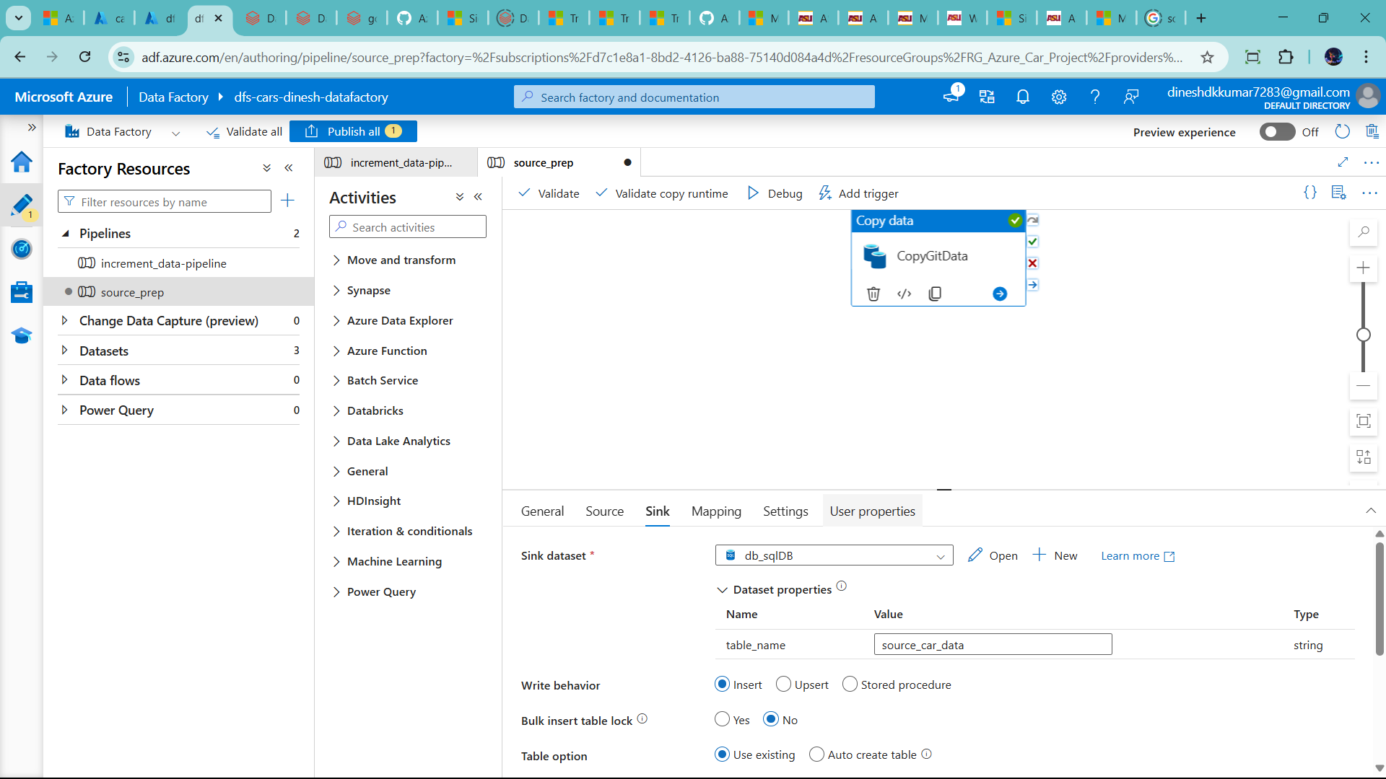

Now run

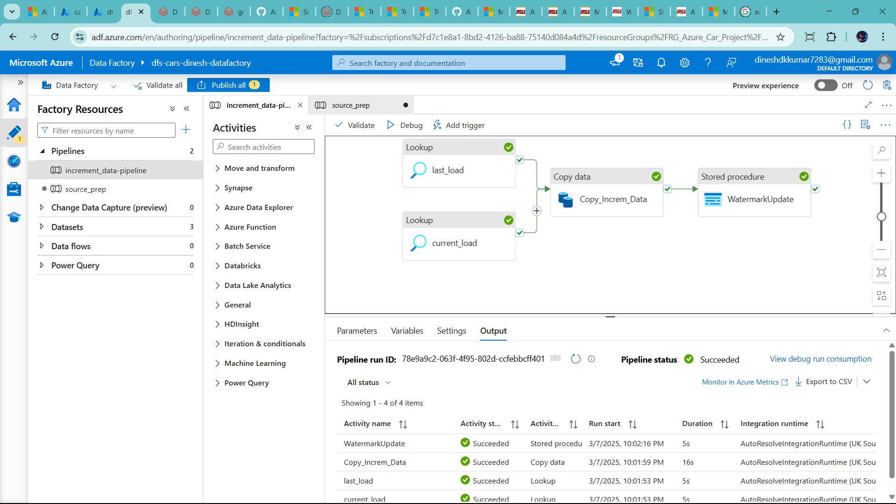

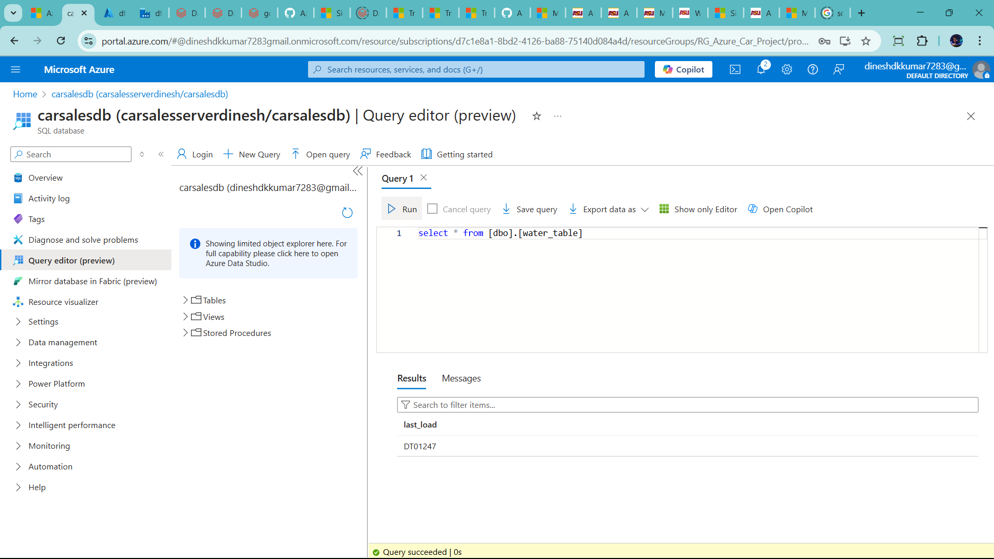

* Run work flow in databricks
* Small mistake to miss add +1 in else as well
* Apply all dim table

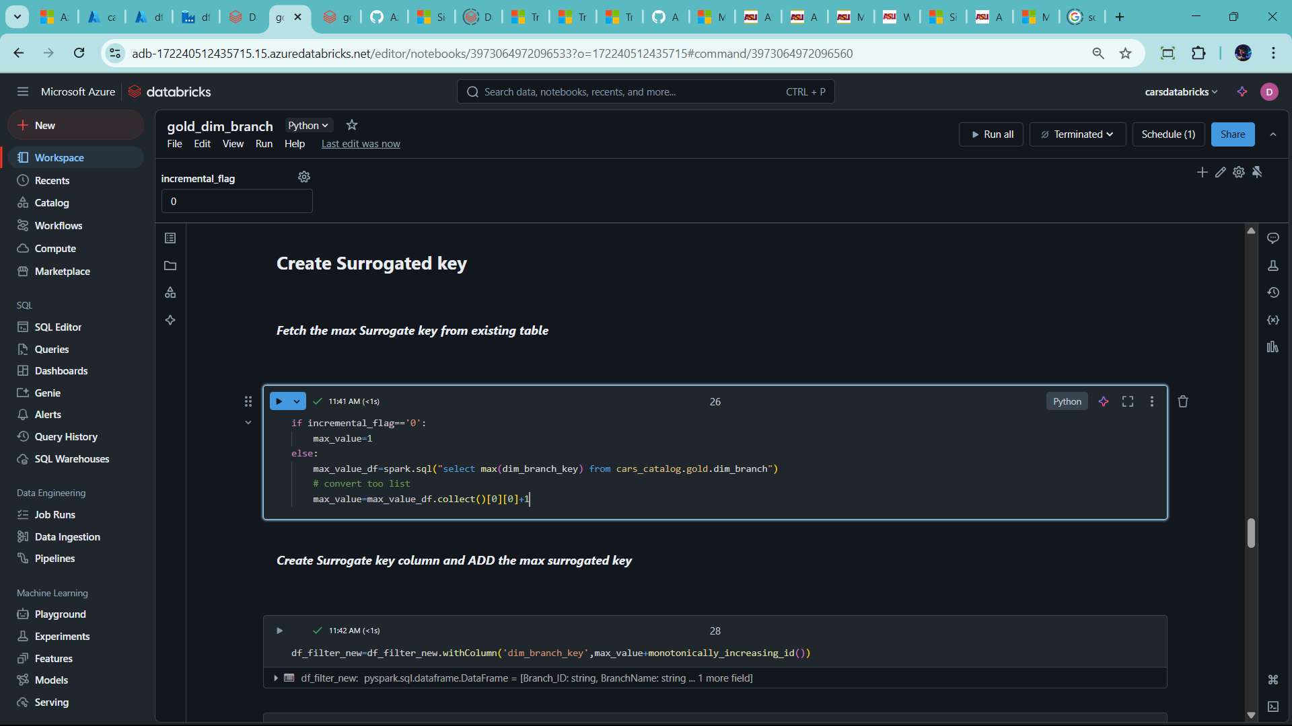

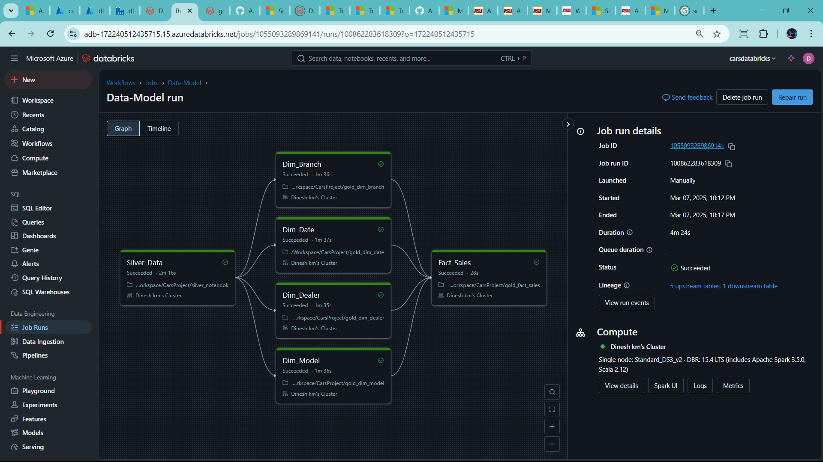

🡪Also use notebook in Data factory as well

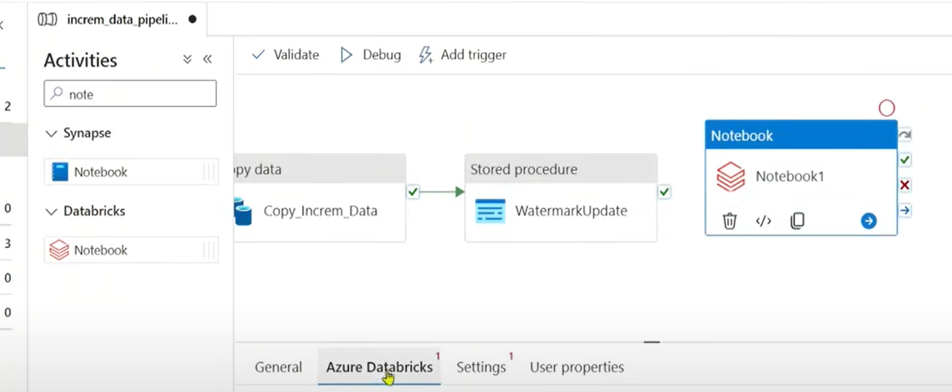

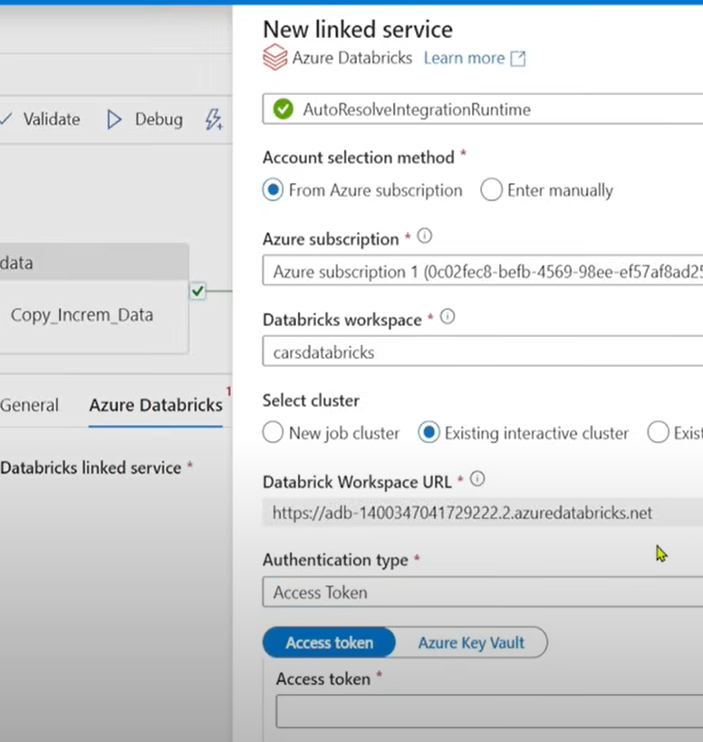

Find access token

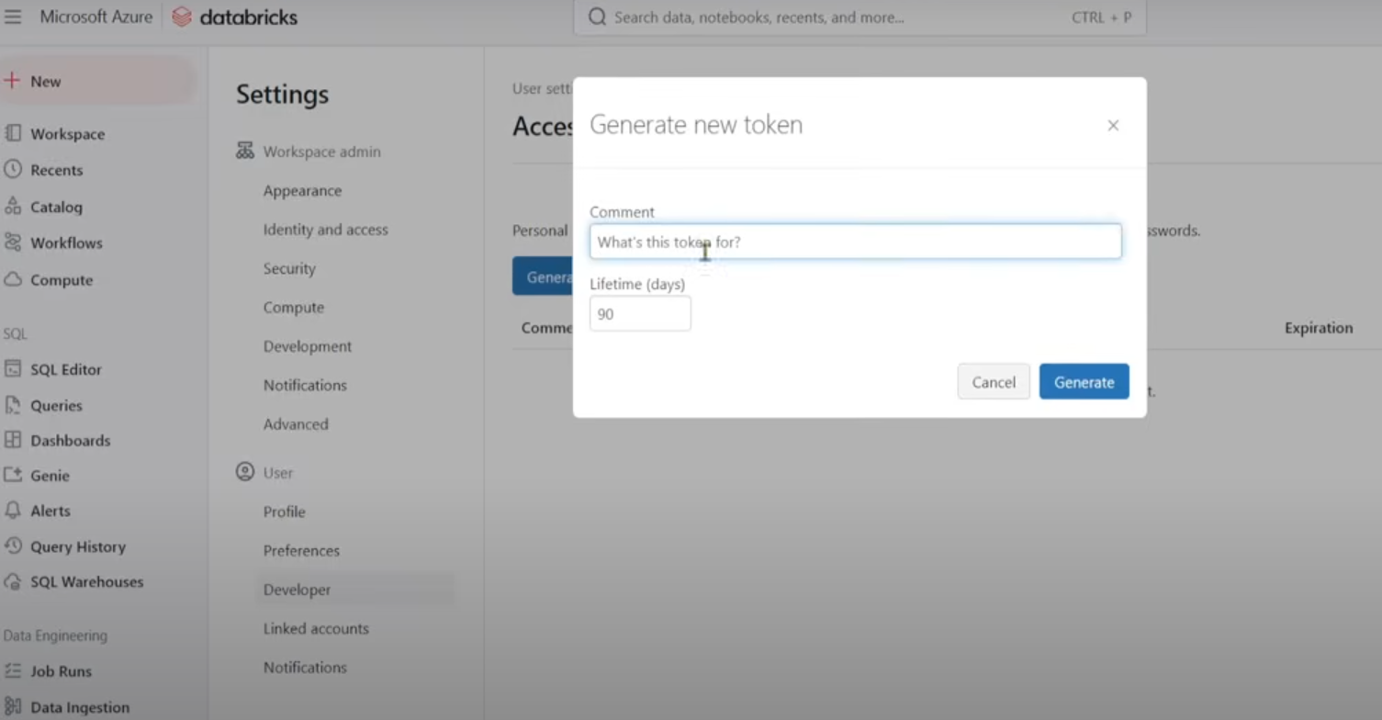

Successful connect

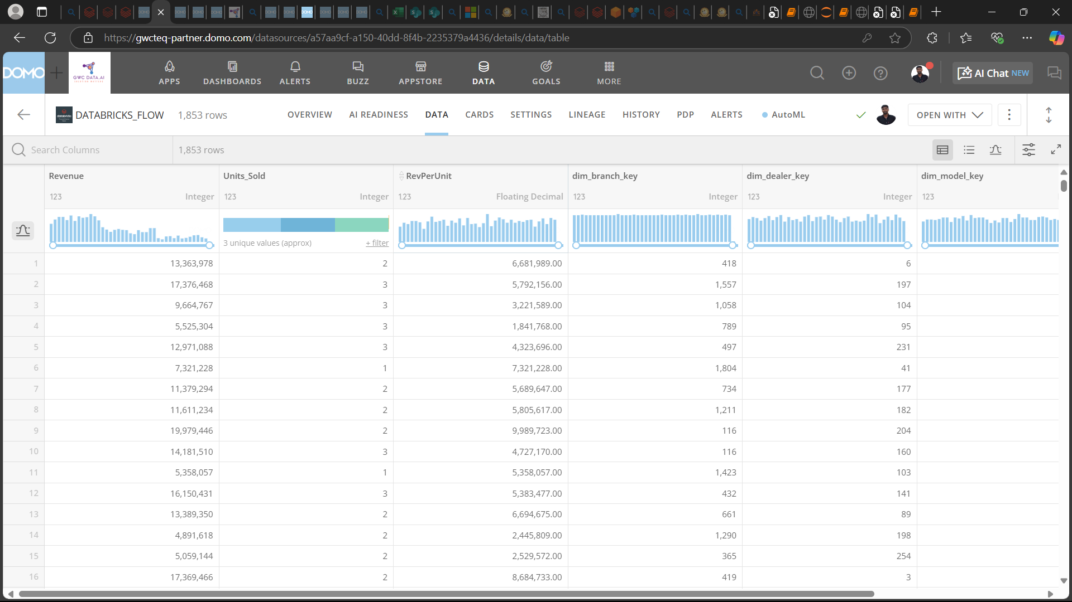

🡪Follow this step connect databrick in DOMO

**1. Enable Databricks SQL Warehouse**

Ensure that your **Databricks SQL Warehouse** (formerly SQL Endpoint) is enabled:

* Go to **Databricks Workspace** > **SQL** > **SQL Warehouses**.
* Start or create a new SQL Warehouse.
* Copy the **Server Hostname**, **Port**, and **HTTP Path** from the **Connection Details**.

**2. Get Authentication Credentials**

* You need an **Access Token** from Databricks.
* In **Databricks**, go to **User Settings** > **Access Tokens** > **Generate New Token**.
* Copy and save the token securely.

**3. Connect Databricks to Domo**

1. **Go to Domo** > **Data Center** > **Connectors**.
2. Search for **Databricks Connector** and select it.
3. Click **Get the Data**.
4. Fill in the connection details:
   * **Host**: <Databricks Server Hostname>
   * **Port**: 443
   * **HTTP Path**: <Databricks HTTP Path>
   * **Token**: <Databricks Access Token>
5. Click **Connect**.

**4. Configure Data Import**

* Choose the **Databricks database** and **table** you want to pull into Domo.
* Set up **Query Mode** (Predefined Query or Custom SQL).
* Define a **Schedule** for data updates.
* Click **Save & Run**.

**5. Verify and Use the Data**

* Once the data is imported, it appears as a **Domo dataset**.
* Use it in **Domo Analyzer, Cards, or Dashboards**.

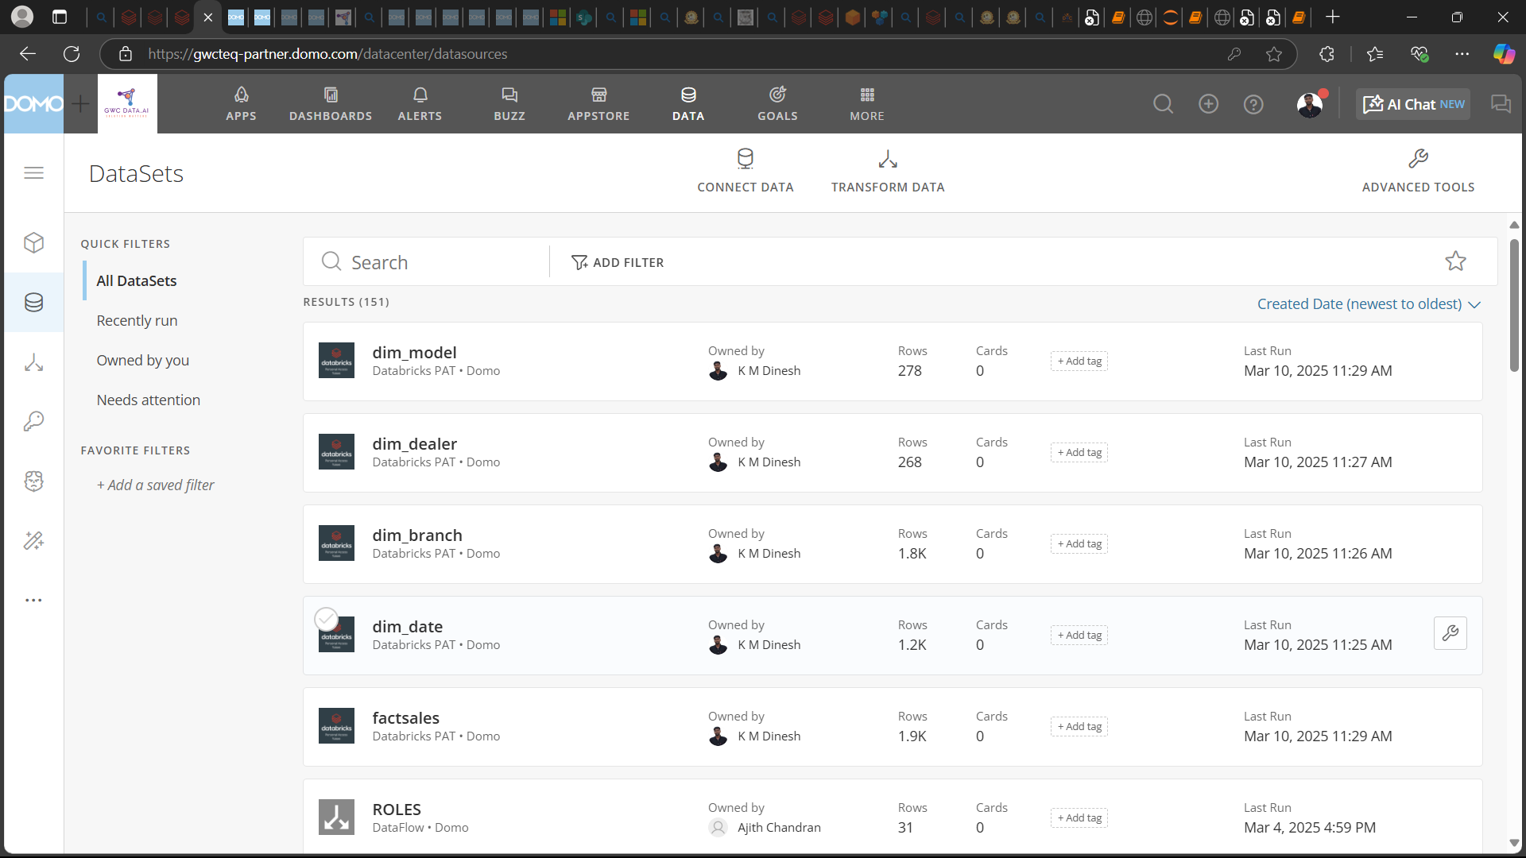

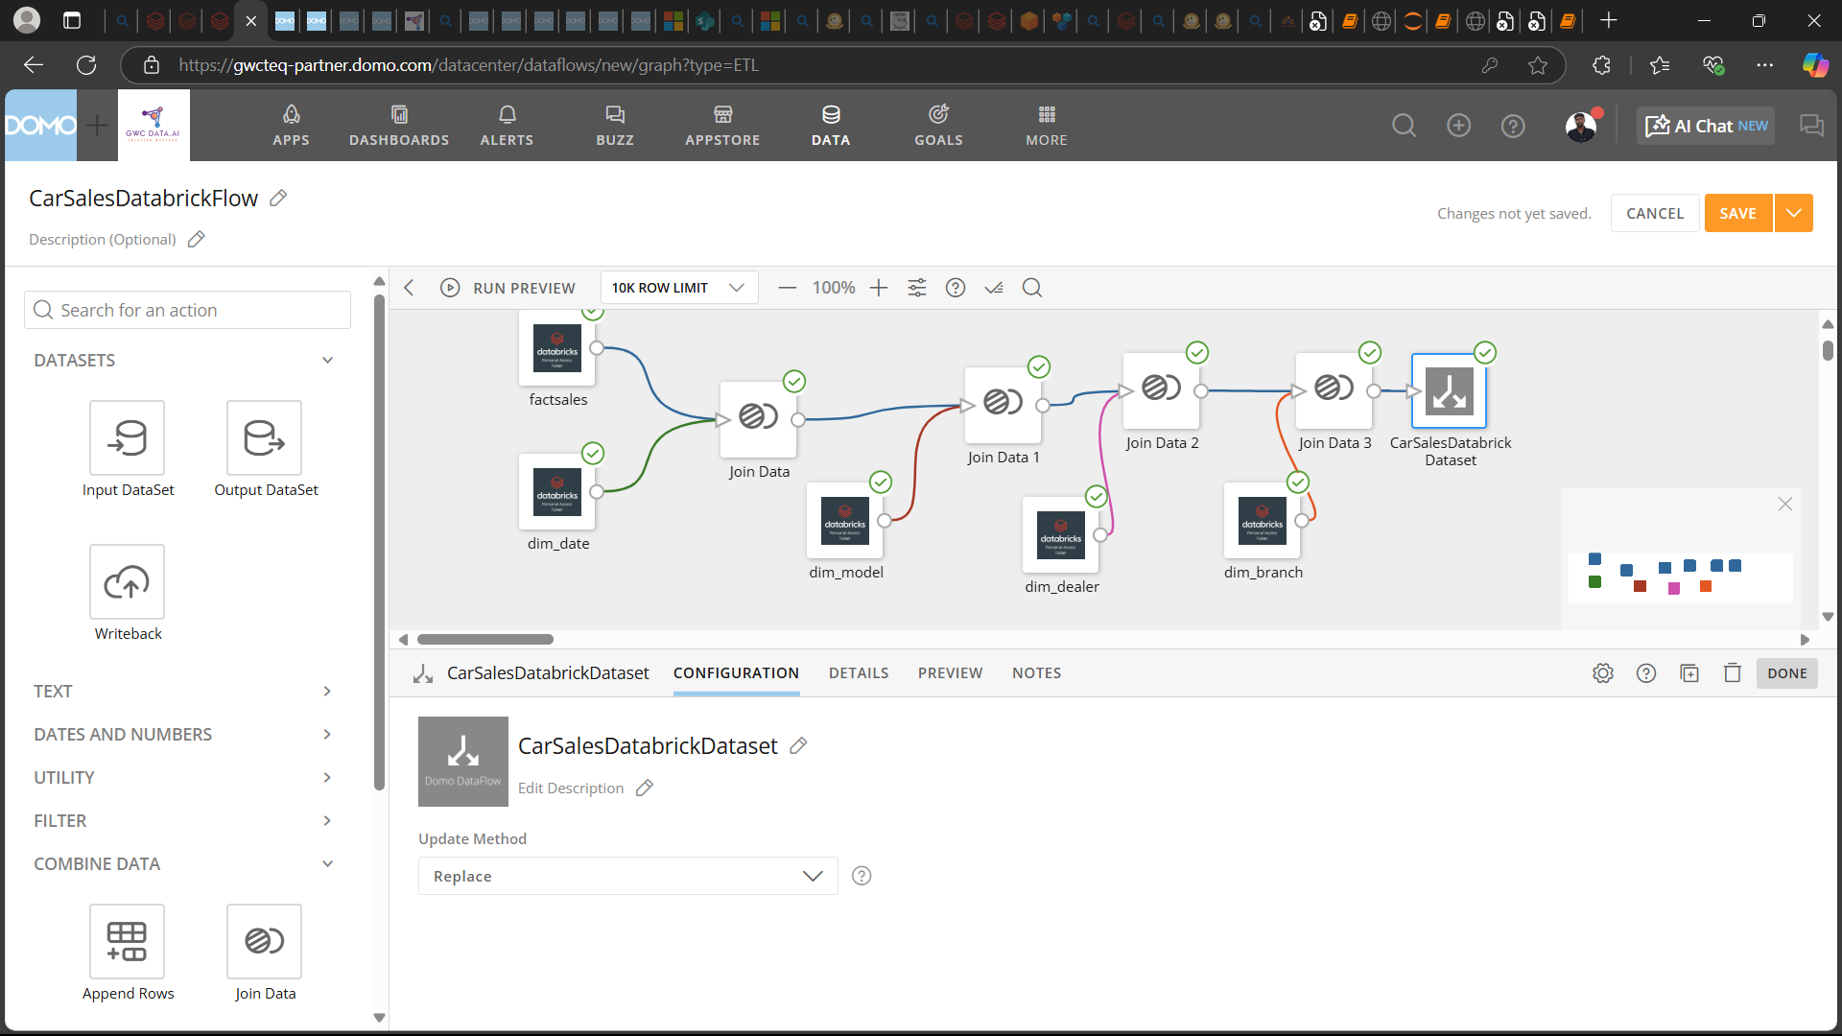

Dashboard

